**VideoSplitter Application**



**About**

**VideoSplitter** is an app designed to let you easily retrieve images from .MP4’s and AVI’s. It’s perfect for splitting your latest Vine, Instagram or any other video for that matter for the pictures!

**Requirements**

Windows XP or above. Microsoft .NET 4 Framework

Currently supports .MP4 and AVI film.

**Usage**

**Step 1. Install the app from here -** <http://50.137.137.79/VideoSplitter/>

**Step 2. Start the app and select “Split Video”**

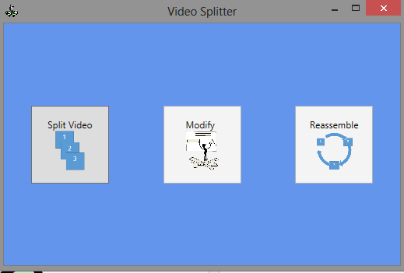

**Step 3. Select your video from the “Open File Dialog”**

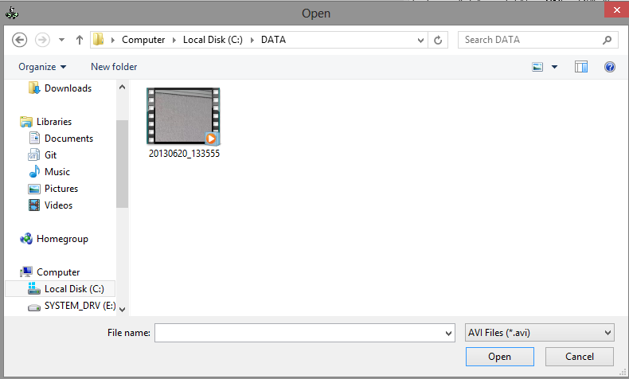

**Step 4. Select where you want your images to go**

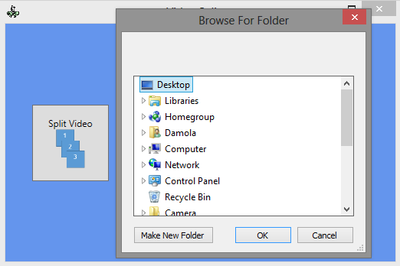

**Step 5. VideoSplitter works its magic!**

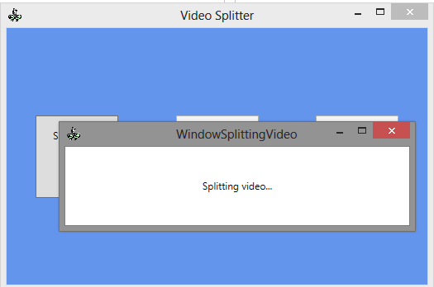

**Step 6. Enjoy! Modification and reassemble capabilities coming soon!**

