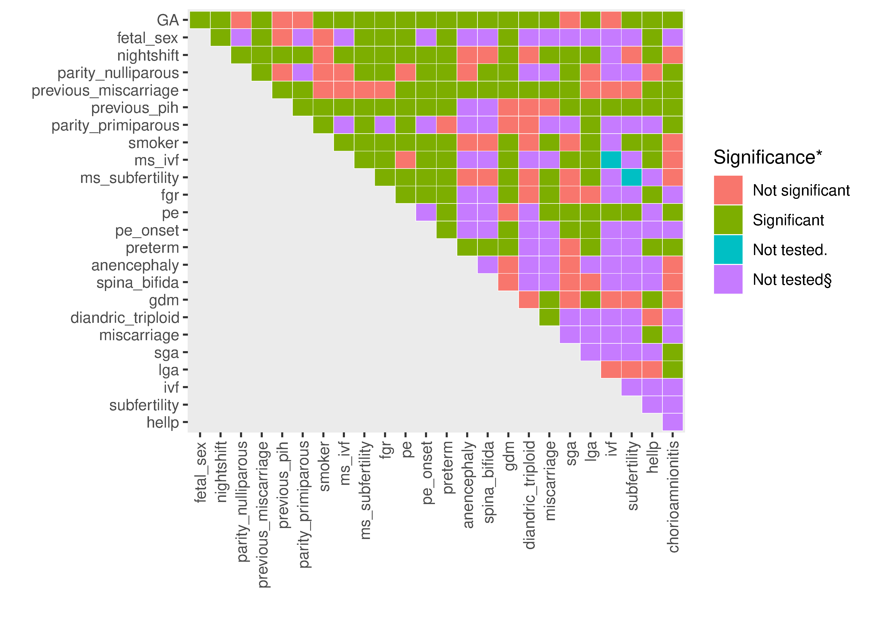

Figure S. Correlation matrix among phenotypes and GA across all datasets after imputation. The x-axis shows 22 phenotypes and 2 missingness indicator (prefixed by “ms_”), while the y-axis also includes GA. (*), significant if FDR ≤0.05; (.), between variable and its missingness indicator; (§), perfect separation. FDR, false discovery rate; GA, gestational age.

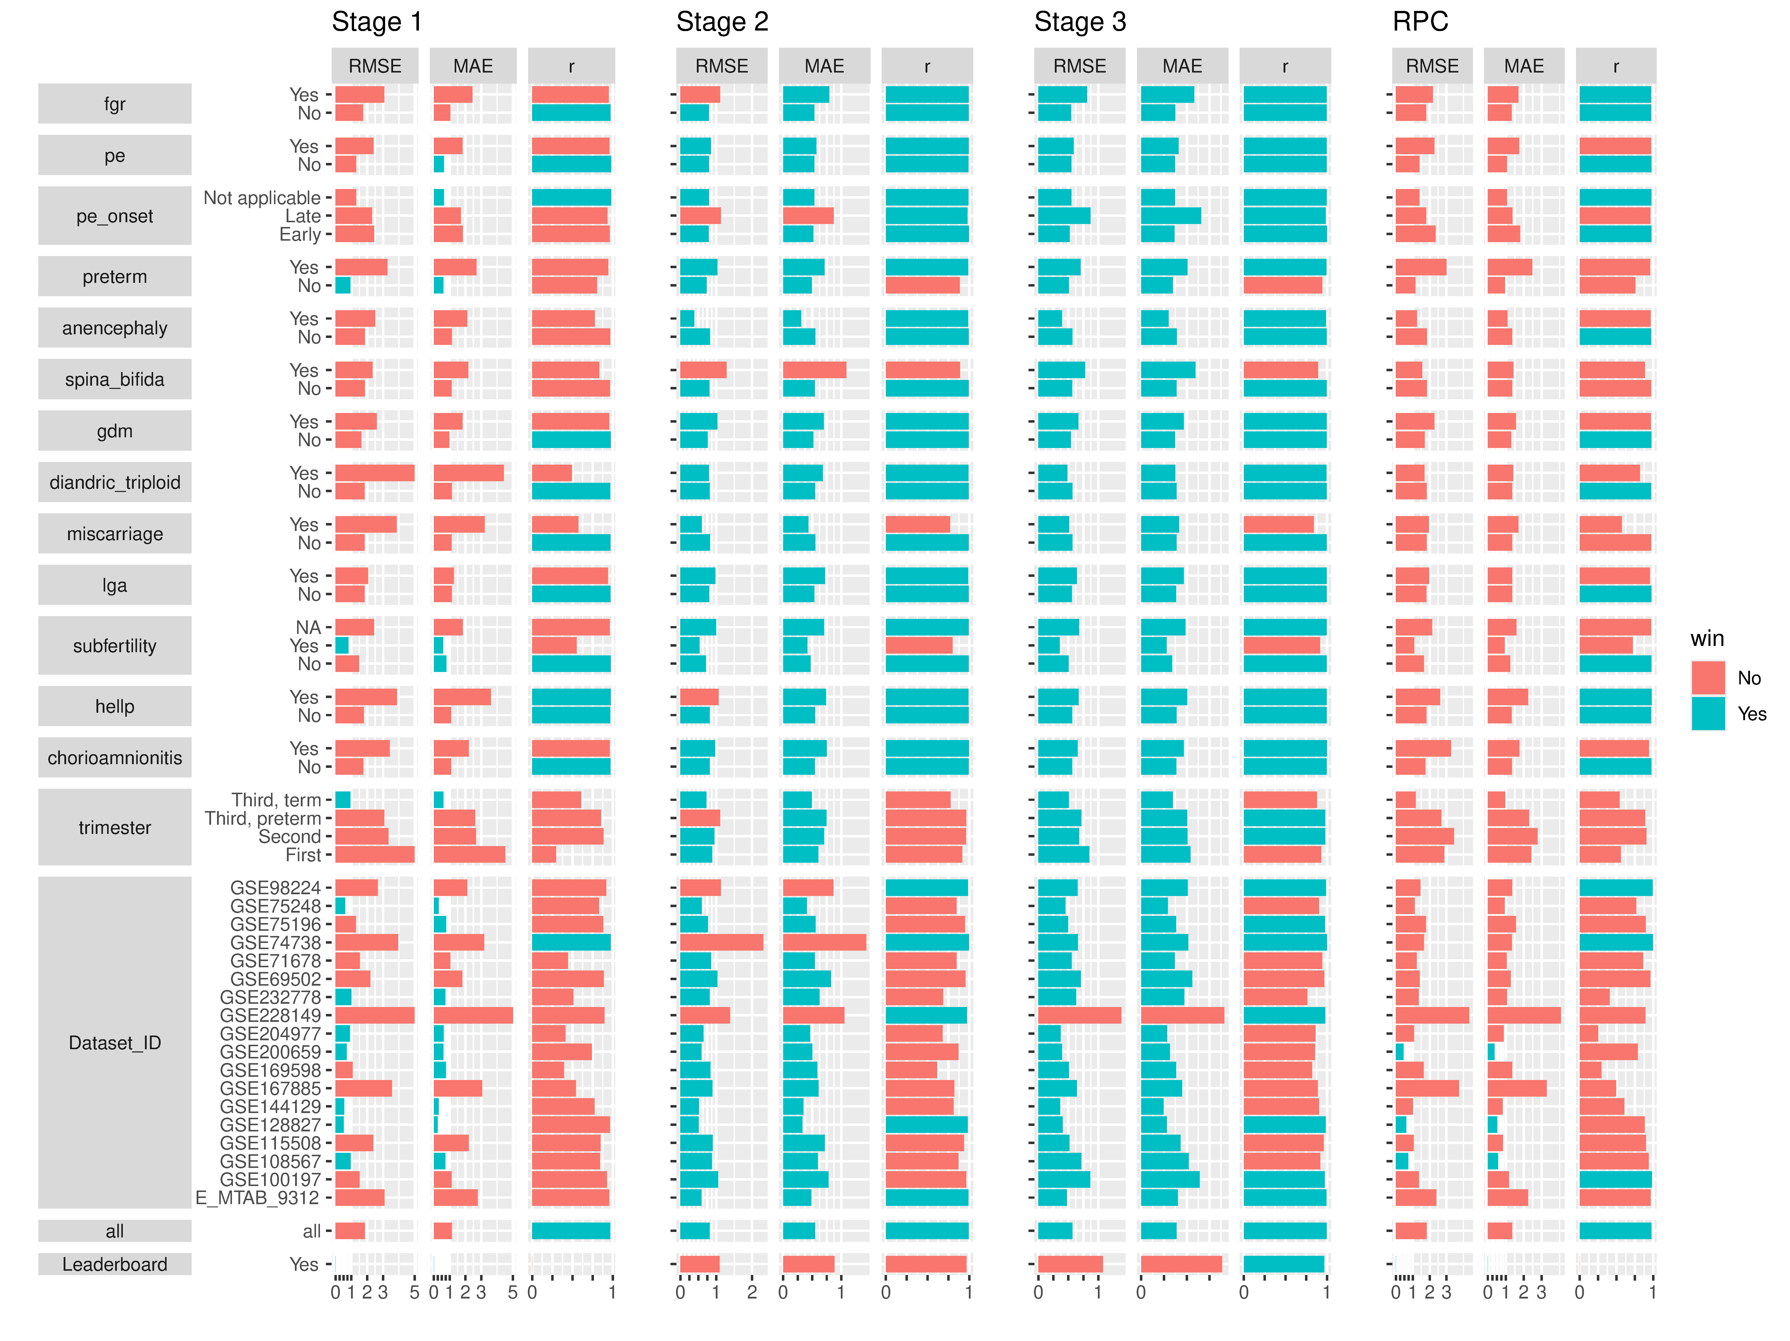

Figure S2. Predictive performance across different phenotypes, trimesters, and datasets. The performance of our final model is shown as stage 3. Winning criterion for each metric was determined from the top performer in the validation set (leaderboard) for task 1, i.e., RMSE <0.997, MAE <0.743, *r* >0.970. MAE, mean absolute error (weeks); *r*, Pearson’s correlation coefficient; RPC, robust placental clock; RMSE, root mean squared-error (weeks).