

**Student Name:** Herdy Cen

**Date Submitted:** 3rd February 2020

**Degree Title:** Computing and Information Systems

**Subject:** Information Systems Management

**Local Institution:** Singapore Institute of Management

**Student ID:** 170280563

Table of Contents

Question 1 (1322 words) 3

Introduction 3

Body 4

Conclusion 6

Question 2 (834 words) 7

Introduction 7

Body 8

Conclusion 10

References 11

# Question 1 (1322 words)

## Introduction

Social network is a website network that chains individuals and their personal relations based on their interests and preferences. It allows people to share their own knowledge to others for either personal or business endeavour (Rouse 2019). Some would also make use of it to extend their connection. In the present there are plenty instances of social network. However, few of the well-known examples of social network are Facebook, LinkedIn and Instagram (Kenton 2019).

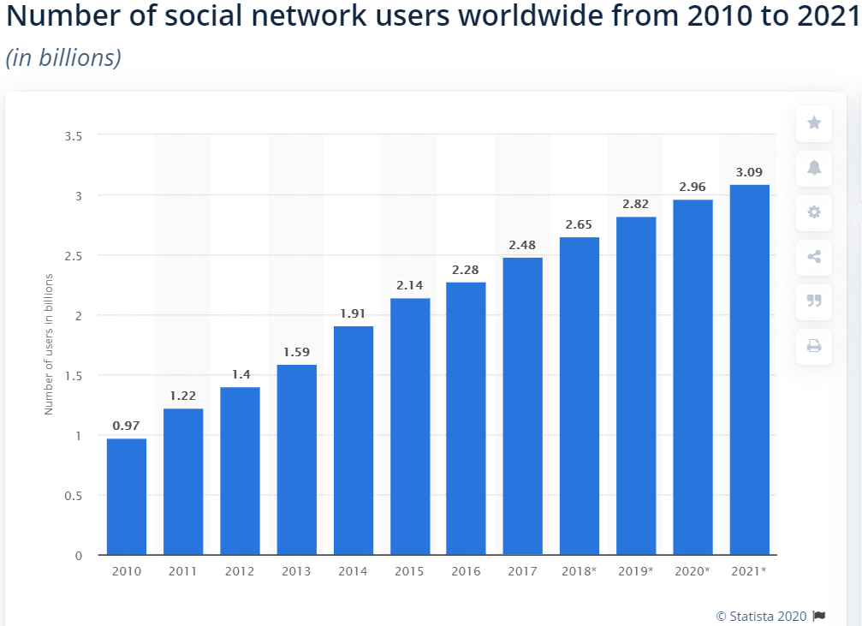

Figure 1.1: User growth in social network (Clement 2019)

For the last few years, its popularity has been rocketing up. As pictured in figure 1.1, there had been a steadily promising increase with at least a hundred million of users annually. However, even with its capability of connecting people, social network is sometimes suspected to be overcontrolling and caused them to be doubted by public. Hence, it has been examined and monitored regularly to cope with existing regulations and laws.

## Body

Over the past few years, social network has been gaining popularities along with the growth of the Internet. Through its vast development, social network has now been supporting and covering almost every existing aspect in daily life. In social network, there are few benefit and disadvantages.

Starting from the advantages, social network provides a worldwide connectivity for global users (Blake 2019). This enables them to conveniently access the gate of networking from anywhere in the world and anytime. For instance, it assists users in connecting with relatives even if they are from the other end of the world.

With its global coverage, real-time communication is made possible through messaging feature. Communication here is not limited only to texting, but it also includes video call and voice mail. This idea of sharing gives accessibility to public to interact with each other by using their own account in the platform. For example, Facebook’s messenger and Whatsapp with a bunch of up-to-date communication features.

Social network can also group a certain group of people into one according to their mutual interest stated in their personal details. Ideally, members from each mutual group will be able to share, discuss and collaborate by using their own ideas. This could then possibly be developed into something even bigger like a community or fan base.

Moving on to another important aspect, social network has a capability of being an intermediary in fundraising. In fact, according to the State-Peer-to-Peer Fundraising 2017, 21% of peer-to-peer fundraising dollars raised are the result of a direct click-through on social media (McCall 2019). In collecting fund for those who need, particular social networks help in boosting the outreach possibility to ever-growing individuals who are eager to support.

In this current trend, there is a rocketing number of influencers on social networking platforms, particularly in Instagram. This is another form of marketing called influencer marketing which is a form of collaboration between a business and an influential person to promote a product, service or campaign (Newberry 2019).

Through influencer, it is much easier to reach the end consumer. Moreover, there is a high percentage of 71% where consumers are more likely to have positive views on a certain brand that is promoted by influencer and this type of marketing is expected to have its budget be doubled in the next five years (Thatcher 2019).

On the other hand, social network also carries few disadvantages. The first and probably the most likely drawbacks to keep happening is the risks of intentional or unintentional exposing of personal or private information stored in the social network platform. The moment when people register for a digital account on certain platform, their own personal data is recorded in the database. Their data are used to tailor the preferred main layout and other things.

However, there might be some percentages of chance where this information could be used against the data regulation. For instance, the last year’s scandal on Facebook’s data privacy. There were around 20 problems of data privacy caused by Facebook (Burt 2019). In particular, one of the worst cases is the breach of almost 50 million of Facebook accounts on 25September which caused the attackers to be able to view the accounts and steal the access token. It was believed to be the largest breach in Facebook’s history (Wong 2018).

Another example of disadvantage would be the anonymous account of user that lead to disturbing and toxic behaviours. Social network does not require legal documents to confirm their registration on the platform. All it needs are mostly an email, phone number, account name and password. This practice of creating a fake account has been around for the past few years.

In Facebook, it is a common occurrence with around half of all existing accounts are fake according to Aaron Greenspan, a former classmate of Mark Zuckerberg (Matyus 2019). For LinkedIn, they had blocked or removed 21.6 million fake accounts on the first half year of 2019 (Levy 2019).

In addition to the fake accounts, there are also few cases where irresponsible people intentionally act as a certain person to perform a fraud through identity theft. It is caused by the lack of consumer knowledge regarding protecting online identity, lack of trust in social network provider and lack of policing standards (Lewis 2019).

Identity theft had been a threat in many aspects with examples of financial, medical, criminal, driving license and tax (Irshad and Soomro 2018). On top of that, personal credit card details, bank accounts and mailing address are the most vulnerable information that usually get stolen.

Moving on to the most common problem that may arise from social network which is cyberbullying. It is an action of threatening or intimidating a certain person through the use of social networking platform. One of the most popular application where cyberbullying happens is a photo and video sharing social networking called Instagram with almost half of the total of 10,000 British teens as the victim (Gibbs 2018).

For every disadvantage listed in the previous few paragraphs, social network can be improved in relatively many ways. The most basic way is through the conventional human law. Social network is just another category which is possibly be regulated and restricted through law similar to the other aspects like politics and technologies.

Law exists as an invisible barrier to separate right and wrong in general terms. By adopting suitable law to regulate social network, it has a higher potential of gaining trust and reliability from the users. It can also build a sturdy form of trust between users and social network.

From the user’s side, there should an increase of awareness in their digital surrounding. On the other words, the trust should not be given easily just through the interaction in the social networking world. For instance, granting access to personal account or giving private data in return for what the impersonator might offer or ask.

On the other hand, the social networking platform could have taken feedbacks from the users on how to improve the user experience. Also, multi-layer security should be reviewed and updated accordingly to prevent any leak on the existing personal data of each existing user (Castillo 2018). Additionally, it would be better if the platform itself could provide an alert before a user sending out their private information.

Furthermore, as the time goes by, there will be some direct and indirect adjustments on fixing the problems happening with social network especially from the government.

## Conclusion

In summary, social network has two sides which can be viewed from different perspectives. Depending on the point of view, it can appear as a promising application for the future time, or it can be considered as a potential threat leading to the exploitation of personal data in the network.

Nonetheless, social network is expected to keep expanding and strengthening its influence in major life aspects. Even with its flaws, there are still tons of active positive users creating a promising future for social networks platform.

# Question 2 (834 words)

## Introduction

Information systems is a combination of interrelated components of software, hardware, networks and people working together to collect, sort, process, analyse and store any kind of information to support decision making in an organization.

An organization should be supported by any form of information systems to increase their productivity and efficiency. It is often compared with the conventional databases and papers. Basically, both conventional version and information systems differ because it provides and tailor the appropriate data to meet each user’s preferences and needs. Also, it presents real-time information which is easier to manage and updated accordingly (Sylvan 2017).

For every management levels and departments, information systems always come in handy and adapted to the requirements. There are five hierarchical types of Information Systems commonly which serve different levels of users in an organization starting from the most basic to the highest type. The Decision Support System (DSS) will be further discussed due to its subtle role in an organization.

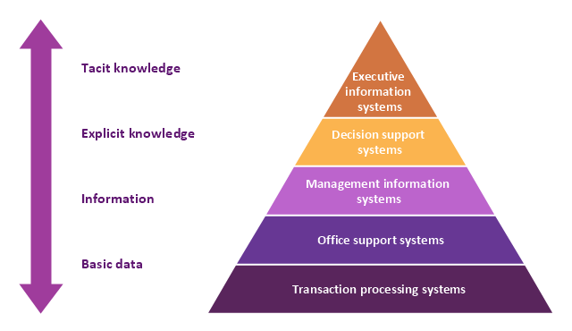

Figure 2.1: Five-level Pyramid Diagram of Information Systems

(Source: Conceptdraw.com)

## Body

Decision support system is a type of information system that gather and analyse the output from both Management Information System and Transaction Processing System to produce a justified decision which is beneficial for the organization.

It is also leaning more towards analytical compared to the other type of information systems. Usually, this system is used by middle managers to assist them in their daily routine of dynamic decision making.

According to Power (2018), by implementing decision support system, one can grasp a competitive advantage over the other competitors in the industry. This system would also help in reducing the time required to go through one full cycle of decision making. Through historical and organizational data sets, this system will be able to generate a statistical model or predictive graph which will then be displayed to end users.

However, the capability of a decision support system is limited by few factors. Often, decision support system is taken into account when calculating the overall performance of an organization and according to an investigation by Ben-Zvi on 2010 (cited in Brauner et al. 2019), some of the developed decision support systems were not effective, despite significant development efforts.

The first disadvantage would be the amount of data the system can process at certain time and the quantifiability of the acquired data. If there is too much information to be combined and processed, the capability of the system will be limited. For instance, a manufacturer pondering the introduction of a new product cannot do so without first deciding on a price for the product (Inc.com n.d.).

On the other hand, the quality of the data also highly influences the decision result. Since decision support system takes in input from various sources, it is fairly possible to get batches of information with unreliable level of quality. These types of data will then be accounted for altering the result to be less accurate.

Also, sometimes when one organization relies too much on its decision support system, it will require lots of time to perform the maintenance whenever the system is down. During the maintenance process, the system will not be able to operate and thus the decision output will remain postponed until it is fixed.

Last, but not least, even though it can automate the decision-making process, it still deemed as a supporting tool. For every output generated by the system, the middle managers are still required to decide on whether the decision has a high feasibility of application. The next step will be proceeded only if the decision is considered to have the capabilities of maximizing the returns while achieving the desired result (Logic 2019).

Despite its drawbacks, there two ways in which those can be overcame. Firstly, through the input itself. By acquiring data from a more reliable source, the decision quality would be greatly improved. On top of that, redundant data should be filtered out by focusing more on the expected result.

Next, every decision support system should be tailored according to its main function and industry. It is to provide a more accurate result and time-saving process. For instance, decision support system in sales department should be able to determine the suitable input of either orders received, or items shipped. Both of them are highly preferable for each different type of situations with minor factors such as order cancellations, shipping time and number of orders (Geurts 1994).

## Conclusion

In summary, with the rapid growth of the Internet, information system has been the main preference of organizations to cut cost and increase revenue. Particularly in decision support system, every leader in organization can obtain rational, measurable and scientific data to help them in making a decision.

Decision support system offer few potential advantages that come with some drawbacks. While most of them are related to the probability of having low quality of data as input, there exists some ways in which the system can be improved to meet the user expectations and requirements. Depending on each organization, this information system can be updated and adjusted accordingly.

# References

Brauner, P., Ziefle, M., Philipsen, R., Valdez, C.A., 2019. What happens when decision support systems fail? The importance of usability on performance in erroneous systems. Behaviour and Information Technology. Available at: https://www.researchgate.net/publication/331385435_What_happens_when_decision _support_systems_fail_The_importance_of_usability_on_performance_in_erroneous _systems [Accessed January 20, 2020]

Burt, A., 2019. Can Facebook Ever Be Fixed? *Harvard Business Review*. Available at: https://hbr.org/2019/04/can-facebook-ever-be-fixed [Accessed January 18, 2020].

Castillo, M., 2018. The six ways Facebook plans to prevent another Cambridge Analytica incident. *CNBC*. Available at: https://www.cnbc.com/2018/03/21/the-six-ways- facebook-plans-to-prevent-another-cambridge-analytica-incident.html [Accessed January 19, 2020].

Clement, J., 2019. Number of social media users worldwide 2010-2021. *Statista*. Available at: https://www.statista.com/statistics/278414/number-of-worldwide-social-network- users/ [Accessed January 17, 2020].

Conceptdraw.com, n.d. 4 Level pyramid model diagram - Information systems types: 5 Level pyramid model diagram - Information systems types: Pyramid Diagram: Management Information System. *https://www.conceptdraw.com*. Available at: https://www.conceptdraw.com/examples/management-information-system [Accessed January 19, 2020].

Geurts, M.D., 1994. Data Problems in Decision Support Systems. Brigham Young University. Available at: https://ieeexplore.ieee.org/document/323356 [Accessed January 20, 2020]

Gibbs, C., 2018. Instagram is the worst social network for cyber bullying: study. *nydailynews.com*. Available at: https://www.nydailynews.com/life- style/instagram-worst-social-network-cyber-bullying-study-article-1.3339477 [Accessed January 18, 2020].

Inc.com, n.d. Decision Support Systems. *Inc.com*. Available at: https://www.inc.com/encyclopedia/decision-support-systems_pagen_2.html [Accessed January 19, 2020].

Irshad, S. and Soomro, R.T., 2018. Identity Theft and Social Media. *Research Gate.* Available at: https://www.researchgate.net/publication/323185128_Identity_Theft_and_Social _Media [Accessed January 19, 2020]

Kenton, W., 2019. Understanding Social Networking. *Investopedia*. Available at: https://www.investopedia.com/terms/s/social-networking.asp [Accessed January 14, 2020].

Levy, N., 2019. LinkedIn blocked 21.6M fake accounts in first half of year, as scrutiny of social media giants grows. *GeekWire*. Available at: https://www.geekwire.com/2019/linkedin-blocked-21-6m-fake-accounts-first-half- year-scrutiny-social-media-giants-grows/ [Accessed January 18, 2020].

Lewis, K., 2019. How Social Media Networks Facilitate Identity Theft and Fraud. *entrepreneurs*. Available at: https://www.eonetwork.org/octane- magazine/special- features/social-media-networks-facilitate-identity-theft-fraud [Accessed January 19, 2020].

Logic, R., 2019. Five Decision Support System Examples You Need to Know. *River Logic Blog*. Available at: https://blog.riverlogic.com/five-decision-support-system-examples [Accessed January 20, 2020].

Matyus, A., 2019. Why Fake Facebook, Twitter, LinkedIn Accounts Will Haunt Us For Years. *Digital Trends*. Available at: https://www.digitaltrends.com/social-media/why- fake-social-media-accounts-will-haunt-us/ [Accessed January 18, 2020].

McCall, K., 2019. How to Use Social Media for Fundraising. *Rival IQ*. Available at: https://www.rivaliq.com/blog/social-fundraising/ [Accessed January 17, 2020].

Newberry, C., 2019. Influencer Marketing in 2019: How to Work With Social Media Influencers. *Hootsuite Social Media Management*. Available at: https://blog.hootsuite.com/influencer-marketing/ [Accessed January 19, 2020].

Power, D.J., 2018. DSS Theory: What are the advantages and disadvantages of computerized decision support? Available at: https://pdfs.semanticscholar.org/842a/cc3fa24f22d21d6cf628bb15dc6221dd9dba.pdf? _ga=2.133358030.1749028332.1579440740-485223112.1579440740 [Accessed January 19, 2020]

Rouse, M., 2019. What is social network? - Definition from WhatIs.com. *SearchCIO*. Available at: https://searchcio.techtarget.com/definition/social-network [Accessed January 14, 2020].

Sylvan, R., 2017. Tangible Benefits of Information Systems. *Small Business - Chron.com*. Available at: https://smallbusiness.chron.com/tangible-benefits-information-systems- 50155.html [Accessed January 19, 2020].

Thatcher, M., 2019. What Are Social Media Influencers and How Do I Find Them? *Boostability*. Available at: https://www.boostability.com/what-are-social- media-influencers-and-how-do-i-find-them/ [Accessed January 19, 2020].

Wong, J.C., 2018. Facebook says nearly 50m users compromised in huge security breach. *The Guardian*. Available at: https://www.theguardian.com/technology/2018/sep/28/facebook-50-million-user- accounts-security-berach [Accessed January 18, 2020].