

**Student Name:** Herdy Cen

**Date Submitted:** 16th March 2020

**Degree Title:** Computing and Information Systems

**Subject:** Information Systems Management

**Local Institution:** Singapore Institute of Management

**Student ID:** 170280563

Table of Contents

Question 1 (1914 words) 1

Abstract 1

Introduction 2

Methodology for Literature Review 2

Literature Review 3

Examples 8

E-Procurement Service 8

Educational Support Systems 10

Advantages and Disadvantages 11

Summary and Conclusion 12

Question 2 (1509 words) 13

Abstract 13

Introduction 14

Literature review 15

Examples 16

Artificial Intelligence 16

Internet of Things (IoT) 17

Advantages and Disadvantages 18

Summary and Conclusion 19

References 20

# Question 1 (1914 words)

## Abstract

Technology had developed and adjusted over the time according to the users’ preferences. Initially, users will face a problem deciding if they should implement a certain system for their benefit. Technology Acceptance Model (TAM) was introduced to tackle this problem. This very useful model is widely used and further modified to facilitate certain application. In this report, Technology Acceptance Model (TAM) which was originally proposed by Davis (1986) on his Doctoral thesis, will be assessed and discussed critically together with examples and case studies.

*Keywords: Technology acceptance model, Information systems, Information technology, Usefulness, Ease of use*

## Introduction

Information technology and systems are highly applicable to mostly every aspects of life. Both are widely used and implemented to assist people in minimising their daily workload. Once applied, it will present a stable increasing growth in company’s competitive advantage.

However, the early implementation is costly and there is a low percentage of the success rate. Hence, in 1985, Fred Davis suggested the Technology Acceptance Model (TAM) which examines the mediating role of *perceived ease of use* and *perceived usefulness* in their relation between systems characteristics and the probability of system use (Legris et al 2001).

Technology Acceptance Model (TAM) is defined as a system predicting model to test whether the proposed system is worth implementing and can be accepted by major users. There are two main important variables according to Davis (1989) which are *perceived usefulness* and *perceived ease of use*. Along the development process, the model is associated with other factors to ease the implementation of other types of system.

## Methodology for Literature Review

In order to perform a thorough research on Technology Acceptance Model (TAM), a literature review will be conducted through online database. Articles and papers regarding the topic will be searched among few digital library websites or online paper sharing platform, namely:

1. Academia,
2. Researchgate,
3. PubsOnLine,
4. JSTOR,
5. Elsevier,
6. ScienceDirect.

Sources with a high relevancy with the assessed topic will be analysed thoroughly and visualized in the paper.

## Literature Review

Originally, Technology Acceptance Model (TAM) is introduced by Davis (1989) through his thesis as shown in figure 1.2 below which is adapted from the Theory of Reasoned Action in figure 1.1. It has been widely used and steadily adapted for more than three decades. There are two main beliefs in TAM; *perceived usefulness* and *perceived ease of use*.

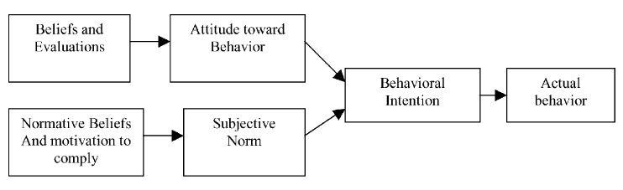

Figure 1.1: Theory of Reasoned Action (Legris et al. 2001, p.192).

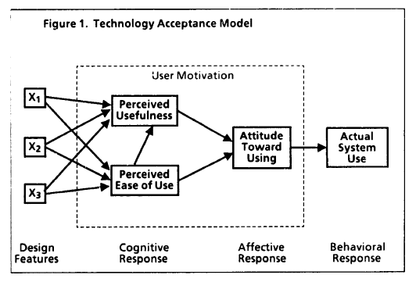

Figure 1.2: Original Technology Acceptance Model (Davis 1986, p.24).

*Perceived usefulness* has a definition of “the degree to which an individual believes that using a particular system would enhance his or her job performance.” The other belief, *perceived ease of use* is defined as “the degree to which an individual believes that using a particular system would be free of physical and mental effort.” Additionally, it is hypothesized to have a significant direct effect on *perceived usefulness*, since, all else being equal, a system which is easier to use will result in increased job performance for the user (Davis 1986, p.26).

Few years after, few other researchers published papers with reference the original TAM with extension towards few other major subjects such as the adoption of digital education and virtual reality hardware. As a matter of fact, TAM has become so popular that it has been cited in most of the research that deals with user acceptance of technology (Marangunić and Granić 2014, p.86).

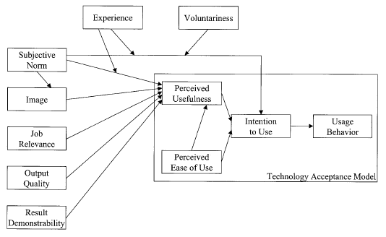

Figure 1.3: Technology Acceptance Model 2 (Venkatesh and Davis 2000, p.188).

As pictured on figure 1.3, TAM is further modified into TAM 2 by Venkatesh and Davis on 2000. The refinement includes other variables and modify the relationships that were initially formulated (Marangunić and Granić 2014, p.86). This modification is tested using the longitudinal data collected regarding four different systems at four organizations (Venkatesh and Bala 2008, p.186). One of the most distinctive change is the additional input variables for *perceived usefulness* below:

1. *Subjective norm*: a social influence factor which is defined as a “person’s perception that most people who are important to him think he should or should not perform the behaviour in question.” (Venkatesh and Davis 2000, p.187). Moreover, this variable has two underlying related variables which are:
2. *Experience*: defined as the familiarity towards the system which could directly affect the subjective norm to subside over time (Venkatesh and Davis 2000, p.189).
3. *Voluntariness*: refers to “the extent to which potential adopters perceive the adoption decision to be non-mandatory.” (Venkatesh and Davis 2000, p.188).
4. *Image*: the desire of individuals to establish or maintain a favourable image among others in the social group.
5. *Job relevance:* a function of the importance within one’s job of the set of tasks the system is capable of supporting (Venkatesh and Davis 2000, p.191).
6. *Output quality:* a variable to measure the system’s capability and value by considering how well it could perform a set of tasks and how high the performance’s quality is.
7. *Result demonstrability:* defined as the “tangibility of the results of using the innovation.” (Moore and Benbasat cited in Venkatesh and Davis 2000).

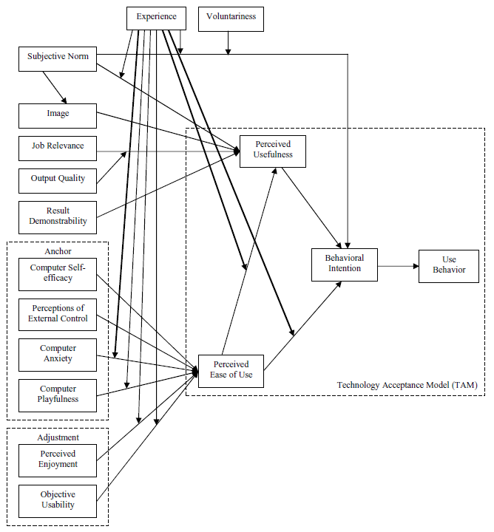

Figure 1.4: Technology Acceptance Model 3 (Venkatesh and Bala 2008).

Furthermore, in May 2008, TAM 3 is introduced by Venkatesh and Bala. Additionally, the variable *experience* is correlated with other variables such as the newly introduced *computer anxiety* and *perceived ease of use*. These improvements seem to be a step to make the model’s variable to be much more mutually related.

Mainly, there are few variables introduced as the inputs for *perceived ease of use.* These variables are categorized accordingly into *anchor* and *adjustment.* According to Venkatesh and Bala (2008, p.279-280), individuals mostly form perceived ease of use about a specific system by anchoring their perceptions to the different general computer beliefs and later adjusting their perceptions of ease of use based on hands-on experience with the specific system. *Anchor* is divided into few variables below.

1. *Computer self-efficacy*: defined as the degree to which an individual believes that he or she has the ability to perform a specific task/job using the computer (Compeau and Higgins cited in Venkatesh and Bala 2008, p.279).
2. *Perceptions of external control:* refers to a degree to which an individual believes that organizational and technical resources exist to support the use of the system (Venkatesh et al. 2003).
3. *Computer anxiety:* is a fear of failure for individual when they are faced with the possibility of using the technology or system.
4. *Computer playfulness:* is used to indicate the tendency of an individual to interact spontaneously with a computer. It could be considered as either state of mind or an individual’s trait (Hackbarth et al. 2003).

The other new variable, *adjustment,* is consisted of two variables as the following:

1. *Perceived enjoyment:* is an individual difference variable that is system independent. It is defined as the extent to which the activity of using a specific system is perceived to be enjoyable in its own right, aside from any performance consequences resulting from system use (Venkatesh 2000, p. 351).
2. *Objective usability:* is defined as a construct that allows for a comparison of systems based on the actual level (rather than perceptions) of effort required to complete specific tasks (Venkatesh 2000, p.350-351).

In TAM 3, there is no cross-over effects in which the determinants of perceived ease of use would be influencing perceived usefulness as suggested by Venkatesh and Bala (2008).

## Examples

### E-Procurement Service

*\*Mostly cited from Ramkumar et al. 2019*

Ramkumar et al., in his paper, extended TAM with system quality considerations in the context of e-procurement services. This context is defined as online supply management solutions that are offered in a software-as-a-service (SaaS) environment. This type of e-procurement is focused due to the increasing popularity of its scalability and flexibility. It is stated that there had never been any published research on integrating TAM with this topic.

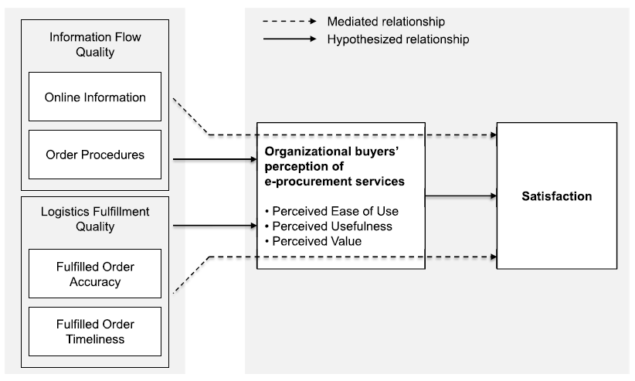

Figure 1.5: E-procurement Research Model (Rankumar et al. 2019).

As shown in figure 1.5, there are four main valuable properties in the system model. Both are grouped as information flow quality and logistics fulfilment quality and defined further below:

1. *Online information:* refers to useful data provided by suppliers on their products and services in the e-procurement system.
2. *Online procedures:* refers to the efficiency and effectiveness of the processes underlying e-procurement services.
3. *Fulfilled order accuracy:* is referred to the shipment containing the specified items in the correct quantity and quality.
4. *Fulfilled order timeliness:* is referred to the degree to which items are delivered on the promised time, the time elapsed between placing and receiving an order, and the lack of backorders.

TAM here is applied and modified in such a way that it is highly applicable to aid and complement e-procurement services.

### Educational Support Systems

*\*Mostly cited from Akinde 2016*

Educational Support System (ESS) are information, communication and telecommunication technologies, hardware and equipment that are deployed for instructional purposes. These systems are used in institutions of higher learning all over the world as tools to support the educational objectives of teaching, learning and research.

The success of ESS have been proven to show positive impact on the learning environment and students generally. It also allows educators to have more control over their teaching, to analyse problem critically and to collaborate.

Particularly in this article, ESS is analysed as a part of application systems in universities in Nigeria. By implementing TAM 1 as a framework, figure 1.6 extends it to explain the use of ESS. This figure shows attitude of educators and infrastructural support affecting the use of ESS for teaching. Just as in TAM 1, attitude may be affected by *perceived ease of use.* Similar to the previous example, figure 1.6 is also referenced from TAM but with a few slight changes and adjustments to suit the requirements.

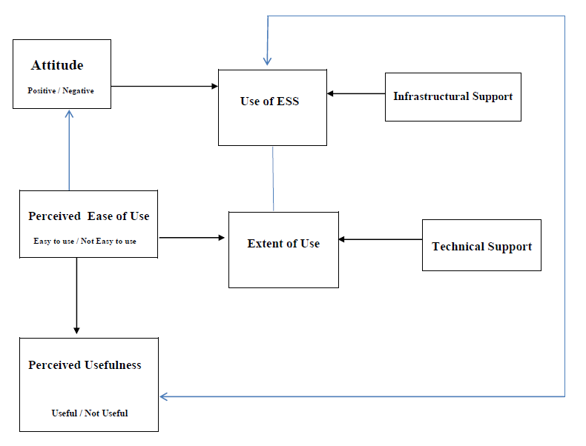

Figure 1.6: The Proposed Library Educators’ ESS Use Model

## Advantages and Disadvantages

By implementing Technology Acceptance Model (TAM), there are two benefits it could provide for the system assessment. The most visible advantage would be the predicted outcome of the system’s prospect. Before implementing a new system, an organization would be more likely to have a predicted success rate result once it is applied. TAM is also implemented as a standard framework to test a particular system and thus give a sense of an obligation to use it as a base research model.

On the other hands, however, the application of this model would also bring few limitations and drawbacks as follows:

1. Various considerations need to be taken into account in order to apply theoretical framework and researchers need to be acutely aware of multiple limitations which are inherent in endeavouring to do so (Ajibade 2018, p.4).
2. Underlines of behaviour cannot be reliably quantified in an empirical investigation (Ajibade 2018, p.4).
3. It is extremely problematic to measure behaviour as hidden personality traits often motivate behaviour (Ajibade 2018, p.4). This could lead to inaccurate result from the model.

There are two main basic steps which could be taken to overcome and minimise the disadvantages from TAM. Both are increasing the staffs’ IT skills proficiency and experience up to date with the current technology trend and stabilising the company’s guidelines and regulations regarding the operation and deployment of existing and upcoming technologies.

## Summary and Conclusion

Overall, TAM had been widely spread across the world and implemented by mass public. It also had been developed, improved and adapted according to different requirements. Initially, before introducing a new technology, it has to be assessed with TAM thoroughly. This is done to predict the estimated outcome upon the implementation of the system.

If the result shows a divergence from the expected output, the proposed system should be further revised and adjusted. However, if it encounters a positive result, the introduced technology can proceed to the next stage safely.

In terms of improvement, the potential is unlimited. There are a lot of untouched major aspects it could extend. For the existing one such as business and e-commerce, TAM can be refined to meet the expectation of its subcategories namely e-procurement services educational support systems and e-business decision support systems.

# Question 2 (1509 words)

## Abstract

The implementation of Information systems had been around for few decades. Almost every life aspect is influenced and enhanced by the presence of Information Systems. Not to mention that healthcare has also been receiving the impact thoroughly. Information systems have redefined and revolutionised healthcare in majority. The elaboration will be reviewed discussed based on the existing research in the context below. The main goal of this paper is to provide a sufficient in-depth work of the impact of IS in healthcare, how it had been done so far and how it would still be maintained or even improved in the future.

*Keywords: Revolutionised healthcare, Information systems, Internet of Things, Artificial Intelligence, 3D Printing*

## Introduction

Information systems (IS) is a group of integrated and interrelated set of components; hardware, software and human resources with a function of collecting, analysing, storing and processing any kind of information into valuable data. These sets of data would then be utilised as a knowledge representation for input of any other systems.

It is undeniable that IS have a strong influence in areas such as business, technologies, economy, education and other popular aspects. Even though healthcare is not as widely impacted as the others, it still has vital impacts to communities. Through the implementation of IS, the improvement created has been so significant.

Healthcare itself is defined as a set of services and treatments with an orientation towards health in which those are performed through the diagnosis, discovery, treatment and prevention of any kind of illness, disease and injury.

Nowadays, healthcare is being steadily enhanced as a result of the application of Information Systems. There are few technologies currently widely used all over the world. IS in healthcare is highly appraised for being able to elevate the functionality of healthcare. However, it is beyond doubt that there exist few disadvantages to its implementation.

## Literature review

The emergence of technology in healthcare started from 60 years ago with shared accounting systems as the beginning (Grandia 2014). It then expanded into financial and administrative systems which was further expanded into other departments.

In recent years, there is an increasingly obvious need for a broader perspective on the quality of health services. This demand is happening because of the belief of the importance of health. The health of each individual is directly proportional to their perception about their own position in life in the context of the culture and system (Novak and Djordjevic 2019, p.74).

The current use of IS in healthcare is now highly related to clinical decision support with fairly sufficient amount of data. It is also used to leverage the assistance for human workload. Other areas are also fairly influenced such as medical expenses system and health monitoring system.

According to Dodziuk (2016), 3D Printing applications in personalized medicine are booming. Personalized medicine here refers to body and bone implants. 3D Printing itself is a modification of an old inject printer and is rapidly changing and expanding. It simply works by laying down successive layers of material in different shapes directly on top of one another with a direction from computer program.

In a paper written by Darshan and Anandakumar (2015), Internet of Things (IoT) is elaborated with a relation to healthcare. They suggested that IoT has enormous advantages over traditional health monitoring system. It is able to perform a 24/7 monitoring of patients’ health and thus the health state of a patient can be supervised uninterruptedly such that critical illness can be detected at an instant time so that applicable actions can be taken.

To wrap it up, Information Systems, along with its other adapted and modified form, can assist healthcare by providing it an option to develop to a greater extent. Different tools are suitable for different needs in each area. These tools would provide much more efficiency and effectivity and would improve value in healthcare. Nonetheless, the potential of Information Systems is not limited to the current capabilities and is highly possible be enhanced further.

## Examples

### Artificial Intelligence

*\*Mostly cited from Matheny et al. 2019 and Burgess 2018*

AI is being used in healthcare to mainly provide highly reliable assistance. Healthcare AI tools have the capability to impact trust in the healthcare system on a national scale, especially if these tools lead to worse outcomes for some patients or result in increasing inequities. Through a better understanding of AI and how it can be used in an ethical, targeted way, healthcare organizations can more easily collect and interpret data, ultimately leading to earlier diagnosis and new disease discovery, among other benefits (Burgess 2018, p.2).

It should start from identifying key areas to be improved by AI tools, addressing existing inequities and predicting the outcomes for implementing AI in regards for all patients. For instance, when developing, validating, and implementing AI tools that aim to promote behaviour change to address chronic conditions such as obesity, heart disease, and diabetes, it is critical to engage behavioural scientists to ensure the tools account for behavioural theory and principles to promote change.

Among all the current application of AI tools in healthcare, diagnosis would be elaborated further as an example due to its stable functional use in this area. In diagnosis, AI tools are used to detect and provide visible outputs such as images and movements. Some even said that Artificial Intelligence is on par with human experts in medical diagnosis (Davis 2019).

In this medical image interpretation, AI relies on Deep Learning to use labelled images as inputs for the algorithms to classify the result based on its similarity of certain features (Davis 2019). Along the time, this AI tools are very likely to be improved vastly and certain departments in healthcare would be adjusted accordingly. Possible roles in healthcare that might be disrupted by this diagnostic image interpretation are radiologists, dermatologists, pathologists and cardiologists (Matheny et al. 2019, p.65).

### Internet of Things (IoT)

*\*Mostly cited from Zeadally 2019*

Internet of Things (IoT) had been having an explosive growth in its own adoption and deployment. Healthcare professionals in many countries have always been interested in solutions that can reduce healthcare costs and improve the efficiency of healthcare search delivery.

An IoT infrastructure can provide the connectivity required by the healthcare system infrastructure. IoT technologies can efficiently deliver the healthcare benefits mentioned earlier leading to a better healthcare system in general. It is also stated that, among all industries, healthcare has been one of the fastest to adopt IoT.

Wearable devices have been gaining popularity ever since it is introduced around 2006 (Online.grace.edu 2016). These devices are designed to collect the data of users’ personal health and exercise (Phaneuf 2020). One of the examples which is currently widely used in daily life is a fitness band.

Among the available brands in the market, Fitbit is the most famous and widely owned. It was called Fitbit Flex in figure 2.1 and first released on 2013. It has the feature to track movement 24 hours daily. IS here contributes in collecting and analysing user’s personal data; sleep time, walking steps and calories to provide a thorough result (Bennett 2016). Moreover, price wise, it is highly affordable with a cost of US$100.

This is just one of the most famous IoT for healthcare. There are still others with different features and capabilities such as blood pressure monitors and biosensors.

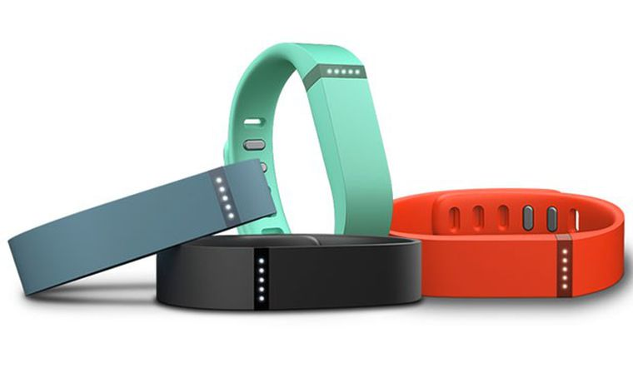

Figure 2.1: Fitbit Flex (Nosowitz 2013)

## Advantages and Disadvantages

In healthcare, IS surely yield tons of positive improvements and developments. Those advantages of IS implementation are listed and briefly elaborated below:

1. Data sharing of patients’ health records; medications taken, allergies, personal data and disease history. This would reduce the ambiguity of the patients’ diagnosis and medication.
2. Outcome tracking to provide justified decisions accordingly. With a clear and reasonable result, the next action can be more precise.
3. Overall time required to perform a certain task would be able to be shortened and thus resulting in a much more efficient and effective workload.

On the other hands, IS could also bring negative impact on its implementation for healthcare, such as:

1. Initially, the implementation of Information Systems is a hefty work to be done. It would require a long-term planning, sturdy infrastructure design and costly monthly or annually maintenance.
2. The risk of patients’ personal data violation due to the increasing amount of health information exchanged electronically (Menachemi and Collum 2011).
3. Over-dependency on the technology could lead to unreliable actions if medical error happens.

## Summary and Conclusion

In conclusion, Information Systems have the potential to elevate the overall function of healthcare. It could be used for administration, medication and decision making. Through its many forms of implementation, Information systems brought a promising future. Those forms would be AI, IoT, Blockchain, Big Data, 3D Printing, Robotic Process Automation, Edge Computing and Machine Learning.

Information Systems, indeed, bring both advantages and disadvantages along with its limitation. Benefits provided vary from data administration efficiency and accuracy to highly reliable decision-making process. However, drawbacks could come from both technical and individual fault.

The capability of Information Systems in healthcare is limited according to the trust level between the medical staff with the system. The higher the trust, the wider the system’s range is allowed to cover. On the contrary, with low to no trust, the system would just stay as it is even with the possibility to aid more in healthcare.

# References

Ajibade, P., 2018. Technology Acceptance Model Limitations and Criticisms: Exploring the Practical Applications and Use in Technology-related studies, Mixed-method, and Qualitative Researches. Available at: https://digitalcommons.unl.edu/cgi/viewcontent.cgi?article=5294&context=libphilpra c [Accessed February 18, 2020].

Akinde, T.A., 2016. Theoretical modelling to explain lecturers’ use of educational support system for teaching in university-based library schools in Nigeria: extending the Technology Acceptance Model (TAM). Available at: https://www.researchgate.net/publication/313837749_Theoretical_Modelling_to_Exp lain_Lecturers'_Use_of_Educational_Support_Systems_for_Teaching_in_University- based_Library_Schools_in_Nigeria_Extending_the_Technology_Acceptance_Model _TAM [Accessed February 19, 2020].

Bennett, B., 2016. The $99.95 Fitbit Flex is feature-packed, powerful, and comfortable. *CNET*. Available at: https://www.cnet.com/reviews/fitbit-flex-review/

[Accessed February 20, 2020].

Burgess, K., 2018. Artificial Intelligence in health care: What you need to know. Available at: https://www.thefreelibrary.com/Artificial+intelligence+in+health+care%3A+What+y ou+need+to+know.-a0563428355 [Accessed February 24, 2020]

Darshan, K. R., Anandakumar, K. R., 2015. A Comprehensive Review on Usage of Internet of Things (IoT) in Healthcare System. Available at: https://www.researchgate.net/publication/305323399_Ax_comprehensive_review_on_ usage_of_Internet_of_Things_IoT_in_healthcare_system

[Accessed February 24, 2020].

Davis, F.D, 1986. A technology acceptance model for empirically testing new end-user information systems: theory and results. Available at: https://dspace.mit.edu/handle/1721.1/15192 [Accessed February 17, 2020].

Davis, F.D, 1989. Perceived Usefulness, Perceived Ease of Use, and User Acceptance of Information Technology. Available at: https://www.jstor.org/stable/pdf/249008.pdf?refreqid=excelsior%3A8e1664399cada3 0ae4fc4c0ff6178672 [Accessed February 17, 2020].

Davis, N., 2019. AI equal with human experts in medical diagnosis, study finds. *The Guardian*. Available at: https://www.theguardian.com/technology/2019/sep/24/ai-equal-with- human-experts-in-medical-diagnosis-study-finds [Accessed February 24, 2020].

Grandia, L., 2014. Healthcare Information Systems: Past, Present, Future. *Health Catalyst*. Available at: https://www.healthcatalyst.com/insights/healthcare-information- systems-past-present-future [Accessed February 20, 2020].

Hackbarth, G., Grover, V., Yi, M.Y., 2003. Computer playfulness and anxiety: positive and negative mediators of the system experience effect on perceived ease of use. Available at: https://www.sciencedirect.com/science/article/pii/S037872060200006X [Accessed February 18, 2020].

Legris, p., Ingham, P., Collerette, P., 2001. Why do people use information technology? A critical review of the technology acceptance model. Available at: https://www.researchgate.net/publication/222398924_Why_do_people_use_informati on_technology_A_critical_review_of_the_technology_acceptance_model

[Accessed February 17, 2020].

Marangunić, N. & Granić, A., 2014. Technology acceptance model: a literature review from 1986 to 2013. Available at: https://link.springer.com/article/10.1007/s10209- 014-0348-1 [Accessed February 17, 2020].

Matheny, M., Israni, S.T., Ahmed, M., Whicher, D., 2019. Artificial Intelligence in Health Care: The Hope, the Hype, the Promise, the Peril. Available at: https://nam.edu/wp- content/uploads/2019/12/AI-in-Health-Care-PREPUB-FINAL.pdf

[Accessed February 20, 2020].

Menachemi, N. & Collum, T.H., 2011. Benefits and drawbacks of electronic health record systems. *Risk management and healthcare policy*. Available at: https://www.ncbi.nlm.nih.gov/pmc/articles/PMC3270933/

[Accessed February 20, 2020].

Nosowitz, D., 2013. CES 2013: Fitbit's New Flex Wristband Never Leaves Your Person. *Popular Science*. Available at: https://www.popsci.com/gadgets/article/2013- 01/ces-2013-fitbits-new-flex-wristband-never-leaves-your-person/

[Accessed February 20, 2020].

Novak, S., Djordjevic, N., 2019. Information systems for evaluation of healthcare expenditure and health monitoring. Available at: https://www.sciencedirect.com/science/article/pii/S037843711930010X

[Accessed at February 20, 2020].

Online.grace.edu, 2016. The Past, Present and Future of Wearable Technology. *Grace College Online*. Available at: https://online.grace.edu/news/business/the-past-present-future- of-wearable-technology/ [Accessed February 20, 2020].

Phaneuf, A., 2020. Latest trends in medical monitoring devices and wearable health technology. *Business Insider*. Available at: https://www.businessinsider.com/wearable-technology-healthcare-medical- devices?IR=T [Accessed February 20, 2020].

Ramkumar, M., Schoenherr, T., Wagner, S.M., Jenamami, M., 2019. Q-TAM: A quality technology acceptance model for predicting organizational buyers’ continuance intentions for e-procurement services. Available at: https://www.sciencedirect.com/science/article/pii/S0925527319302099

[Accessed February 17, 2020].

Venkatesh, V., 2000. Determinants of Perceived Ease of Use: Integrating Control, Intrinsic Motivation, and Emotion into the Technology Acceptance Model. Available at: https://www.jstor.org/stable/23011042?seq=1#metadata_info_tab_contents [Accessed February 18, 2020].

Venkatesh, V., Davis, F.D., 2000. A Theoretical Extension of the Technology Acceptance Model: Four Longitudinal Field Studies. Available at: https://pubsonline.informs.org/doi/abs/10.1287/mnsc.46.2.186.11926

[Accessed February 17, 2020].

Venkatesh, V., Morris, M.G., Davis, G.B., Davis, F.D, 2003. User acceptance of Information Technology: Toward a Unified View. Available at: https://www.jstor.org/stable/pdf/30036540.pdf?refreqid=excelsior%3A27b8e0ba7983 59b0fc7771c495f45d78 [Accessed February 17, 2020].

Venkatesh, V., Bala, H., 2008. Technology Acceptance Model 3 and a Research Agenda on Interventions. Available at: https://www.academia.edu/9829534/Technology_Acceptance_Model_3_and_a_Resea rch_Agenda_on_Interventions [Accessed February 17, 2020].