welcome to goodmood

contact us

what is goodmood?

goodmood

mood scale

mood chart

mood history

mood boost

track your emotions | improve your mood



Username

Type your username

Password

Type your password



Forgot password?

New User? Register for a New Account

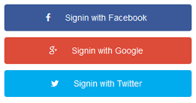





good

how are you feeling right now?

contact us

what is goodmood?

goodmood

mood scale

mood chart

mood history

mood boost

Sign Up

Login





let’s get more specific.

contact us

what is goodmood?

goodmood

mood scale

mood history

mood boost

Sign Up

Login

`

mood wheel

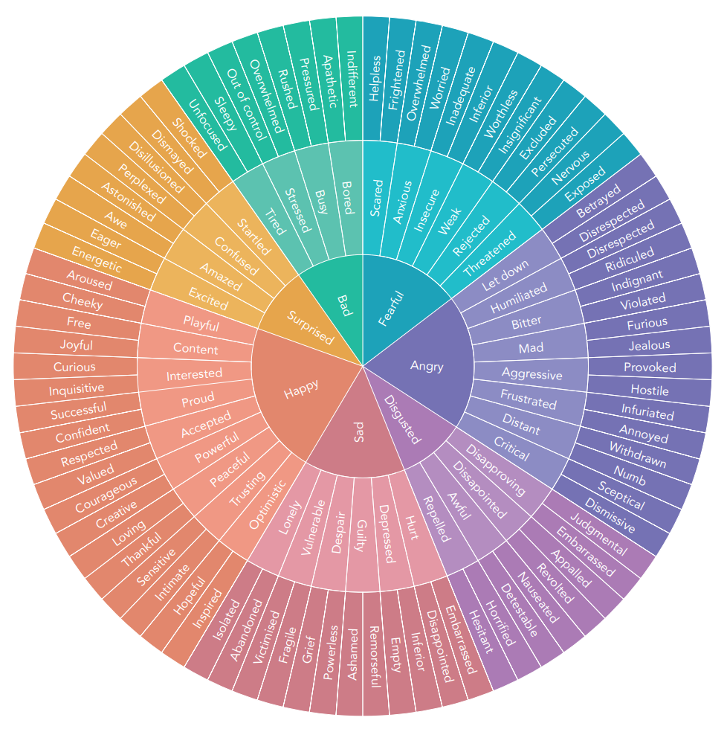





simple exercises to help you feel better.

contact us

what is goodmood?

goodmood

mood scale

mood chart

mood history

mood boost

Sign Up

Login

breathe

mindfulness practice



meditation

mindfulness



let’s check your progress.

contact us

what is goodmood?

goodmood

mood scale

mood history

mood boost

Sign Up

Login

mood wheel

week

½ year

month

1 year

max

7 days

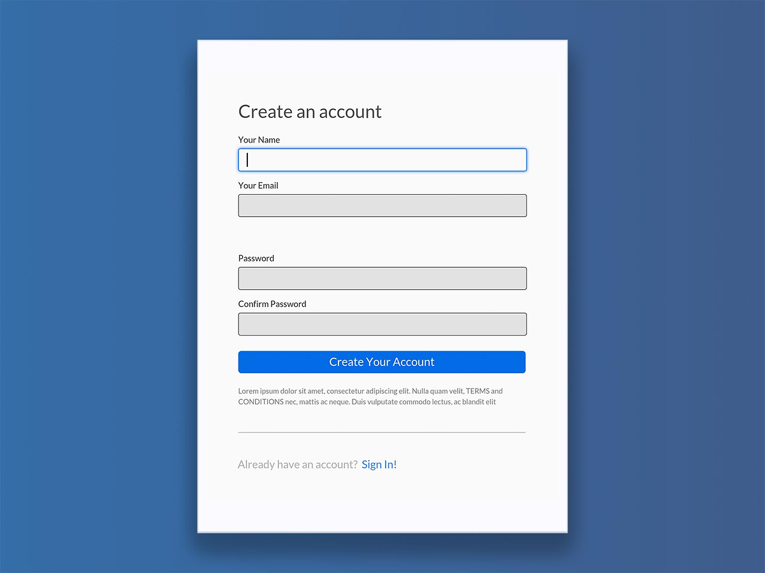

let’s get started.

contact us

what is goodmood?

goodmood

mood scale

mood boost

Sign Up

Login

mood wheel

mood history

7 days