PIZZA SALES SQL QUERIES
- KPI’s

- Total Revenue

select
sum(total_price) as total_revenue
from pizza_sales;

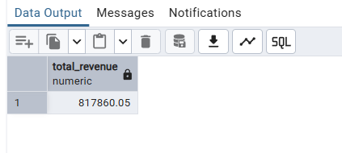
- Average Order Value

select
round(sum(total_price)/count(distinct order_id), 2) as average_order_value
from pizza_sales
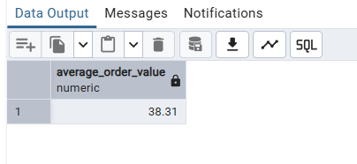
- Total Pizzas Sold

select
sum(quantity) as total_pizza_sold
from pizza_sales;
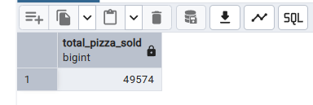
- Total Pizzas Sold
select
count(distinct order_id) as total_orders
from pizza_sales;

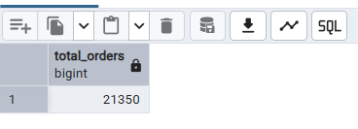
- Average Pizzas Per Order
select
round(cast(sum(quantity) as decimal(10,2)) / count(distinct order_id), 2) as Average_pizzas_per_order
from pizza_sales;
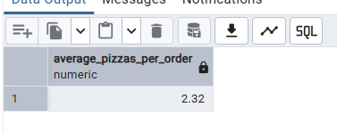

- CHARTS REQUIREMENT

- Daily Trend for Total Orders:
select
to_char(order_date, 'FMDay') as day_is,
count(distinct order_id) as total_orders
from pizza_sales
group by
to_char(order_date, 'FMDay'),
extract(isodow from order_date)
order by extract(isodow from order_date);

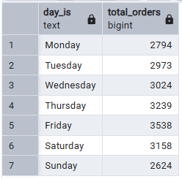
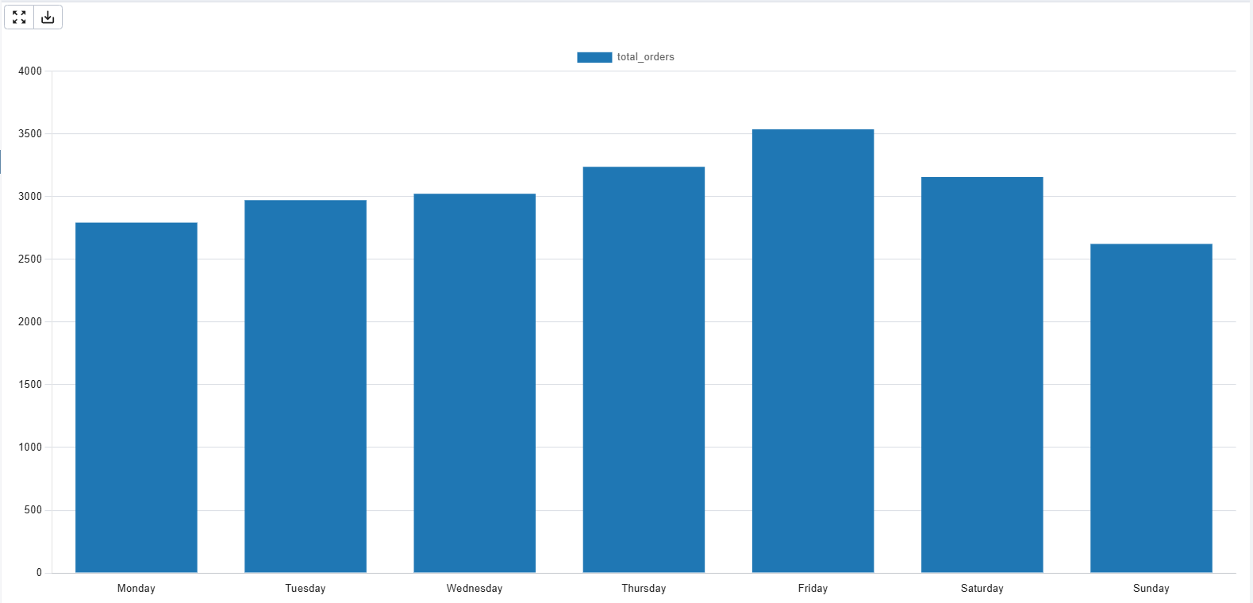
- Hourly Trend for Total Orders:

select
extract(hour from order_time) as hour_is,
count(distinct order_id) as total_orders
from pizza_sales
group by extract(hour from order_time)
order by extract(hour from order_time);

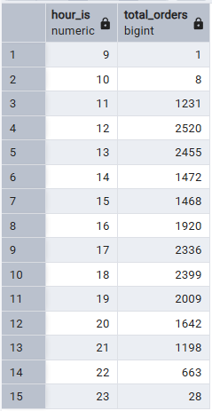
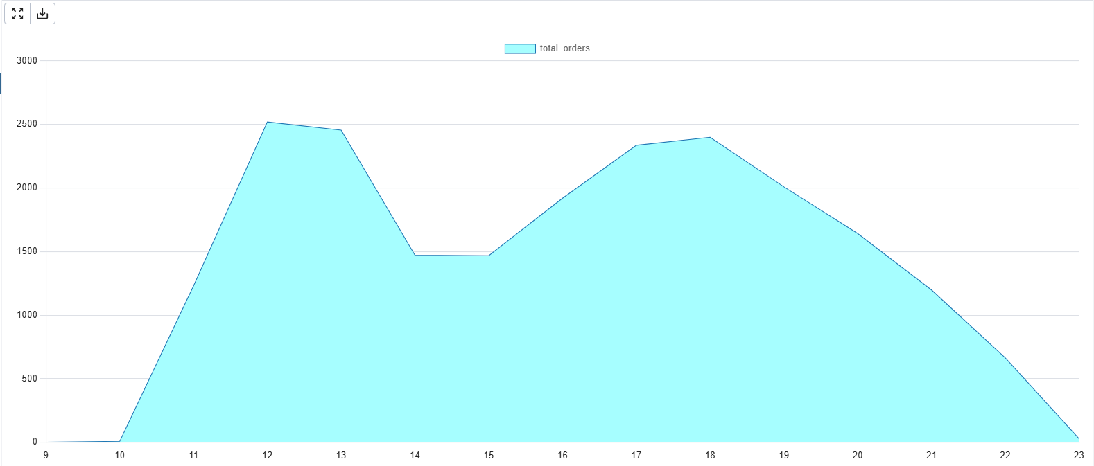
- Percentage of Sales by Pizza Category

select
pizza_category,
sum(total_price) as total_sales,
round(sum(total_price) * 100 / (select sum(total_price) from pizza_sales), 2) as percentage_share
from pizza_sales
group by pizza_category;

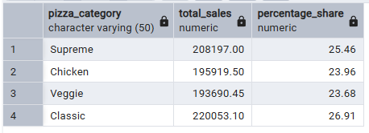
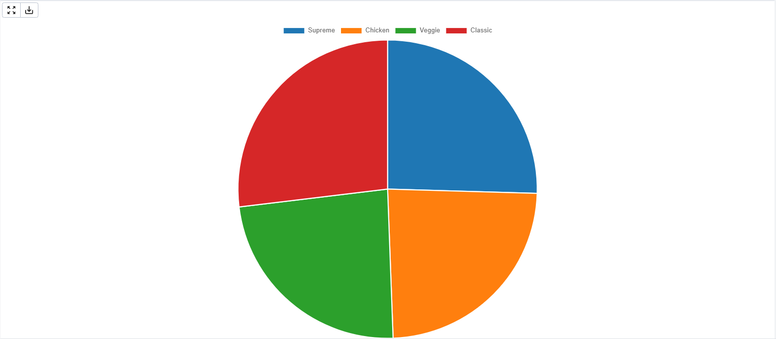
- Percentage of Sales by Pizza Size:

select
pizza_size,
sum(total_price) as total_sales,
round(sum(total_price) * 100 / (select sum(total_price) from pizza_sales), 2) as percentage_of_sales_by_size
from pizza_sales
group by pizza_size
order by percentage_of_sales_by_size desc;
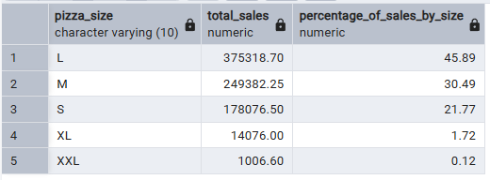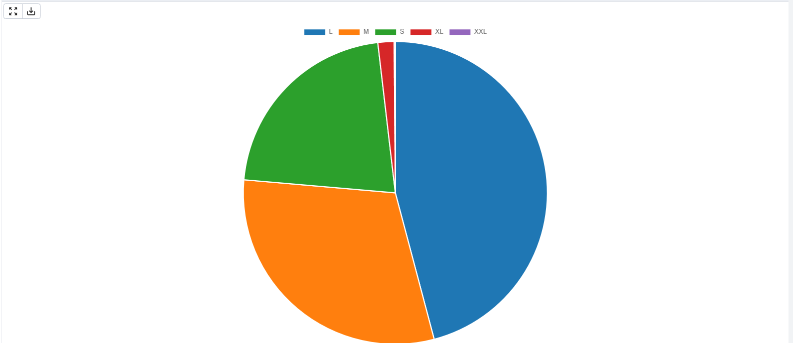
- Total Pizzas Sold by Pizza Category:

select
pizza_category,
sum(quantity) as total_pizza_sold
from pizza_sales
group by pizza_category;

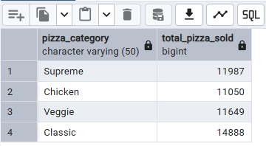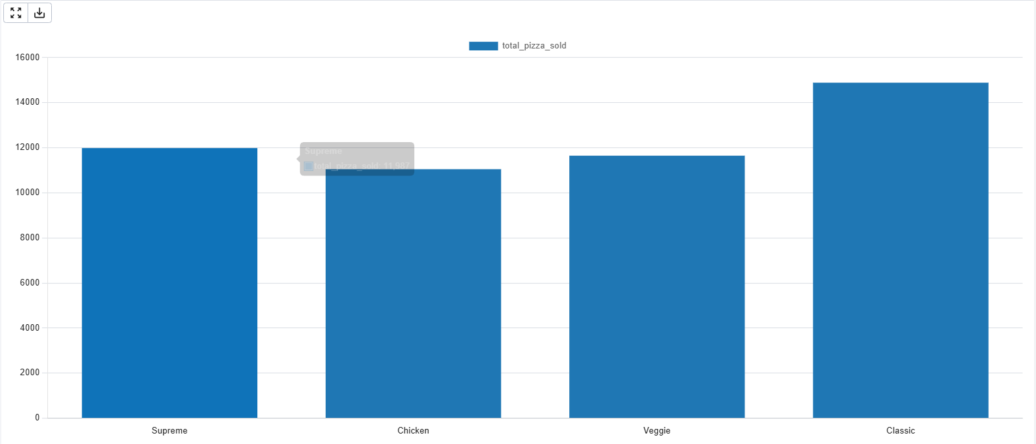
- Top 5 Best Sellers by Total Pizzas Sold

select
pizza_name,
sum(quantity) as total_pizza_sold
from pizza_sales
group by pizza_name
order by total_pizza_sold desc
limit 5;

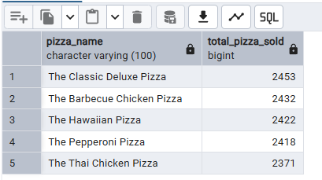

- Bottom 5 Worst Sellers by Total Pizzas Sold

select
pizza_name,
sum(quantity) as total_pizza_sold
from pizza_sales
group by pizza_name
order by total_pizza_sold asc
limit 5;



