ZIDIO DEVELOPMENT | DATA SCIENCE & ANALYTICS INTERNSHIP PROJECT
PROJECT REPORT
RetailPulse
Power BI Retail Analytics Dashboard
Sales, product, customer, market and returns analytics on 1 million+ retail transactions

Project | RetailPulse: Power BI Analytics
Domain | Data Science and Analytics
Organisation | Zidio Development
Dataset | Online Retail II (UCI), December 2009 to December 2011
Tools | Power BI Desktop (Power Query, Data Modeling, DAX, Dashboard)
Prepared by | Soumen Biswas
Date | 03/11/2026
GitHub repository | https://github.com/hereissoumenbiswas/RetailPulse_Analytics_Dashboard_PowerBI
Live dashboard

This report documents the design, build and findings of the RetailPulse Power BI project, completed as part of the Data Science and Analytics internship at Zidio Development.

Contents
1 Executive Summary | 6 Data Preparation and DAX Measures
2 Project Overview | 7 Dashboard Design and Screenshots
3 Dataset and Data Understanding | 8 Key Findings and Recommendations
4 Technology Stack | 9 Conclusion and Future Work
5 Solution Architecture and Data Model

1. Executive Summary
RetailPulse is a Power BI analytics solution built on the Online Retail II dataset, which records the transactions of a UK-based online retailer between 1 December 2009 and 9 December 2011. The project converts about 1.07 million raw invoice lines into a validated data model and a ten-page interactive dashboard that answers practical questions on sales performance, products, customers, markets, profitability and returns.

The solution follows a standard analytics lifecycle. Two CSV files were loaded and combined in Power Query, cleaned and enriched with calculated columns, modelled as a star schema, and analysed with a library of DAX measures. The resulting report uses four slicers (year, quarter, month and country) and cross-filtering, and the work is documented in a GitHub repository.

Headline results (gross sales, before returns): total revenue of £20.48M from about 40,000 orders, an average order value of about £511 and an estimated profit of £7.17M. Revenue is concentrated in the United Kingdom (about 85%), peaks every November, and 72.39% of the 5,879 identified customers are repeat buyers. Profit is estimated with an assumed 65% cost rate because the dataset contains no cost data.

£20.48M  Total revenue (gross) | £7.17M  Estimated profit | ≈ 40K  Orders | 5,879  Identified customers | 72.39%  Repeat customers

2. Project Overview

2.1. Background and problem statement
A retailer records thousands of invoice lines every month, but the raw rows do not show what is selling, who is buying, or where revenue is lost. Managers need one trusted view of performance with consistent definitions. This project was assigned as the Power BI track of the RetailPulse project in the Data Science and Analytics internship at Zidio Development.

2.2. Objectives
- Reliable data pipeline: combine two source files (1,067,371 rows) into one table with no lost or double-counted rows, and read every date correctly.
- Sound data model: build a star schema with Date and Customers dimension tables and one-to-many relationships.
- Performance tracking: report revenue, orders, average order value, estimated profit and margin, month-over-month growth and seasonality.
- Products and markets: identify the best-selling products and the countries that drive revenue.
- Customer insight: segment customers by recency and number of orders (Champions, Loyal, New / Recent, At Risk, Lost).
- Returns monitoring: measure returned value, net revenue and the products and months where returns occur.
- Usable delivery: provide ten interactive pages with a consistent theme and four slicers, backed by documentation and a GitHub repository.

2.3. Scope
No. | Scope
1 | Data loading, cleaning and transformation in Power Query
2 | Star-schema data modelling and relationships
3 | DAX tables, calculated columns and KPI measures
4 | Development of a ten-page interactive Power BI dashboard
5 | Documentation, GitHub repository and public sharing

2.4. Target users
Business and sales managers (performance and seasonality), marketing and retention teams (customer segments and At Risk customers), merchandising teams (product ranking and returns) and finance (revenue, estimated profit and growth).

3. Dataset and Data Understanding
Attribute | Detail
Source | Online Retail II, UCI Machine Learning Repository
Files | online_retail_09_10.csv and online_retail_10_11.csv
Period | 1 December 2009 to 9 December 2011 (December 2011 is incomplete)
Grain | One row per invoice line
Size | 1,067,371 rows loaded; 1,033,036 rows after removing 34,335 duplicate rows
Currency | Pounds sterling (GBP)
Source columns | InvoiceNo, StockCode, Description, Quantity, InvoiceDate, UnitPrice, CustomerID, Country

Data quality observations:
- Dates are stored as month/day/year, but the default regional setting reads them as day/month/year.
- Invoices starting with "C" are cancellations; some rows have zero or negative quantity or price.
- Some stock codes are service entries (postage, manual adjustments, fees), not products.
- Many rows have no CustomerID

4. Technology Stack
Layer | Technology | Role in the project
Source data | CSV files | Two files of raw retail transactions
Data preparation | Power Query | Load, locale-based date parsing, append, type setting, trimming, duplicate removal and custom columns
Data modelling | Power BI data model | Star schema, one-to-many relationships, date table
Calculation | DAX | Date and Customers tables, customer columns and KPI measures
Visualisation | Power BI Desktop | Ten report pages, slicers, cross-filtering and tooltips
Publishing | Google Drive | Public link to the interactive report
Documentation | GitHub, Markdown and Word | README, step notes and this report

5. Solution Architecture and Data Model

5.1. Architecture
Data moves through six stages, from the raw files to a shared report. Each stage is documented in the project repository.
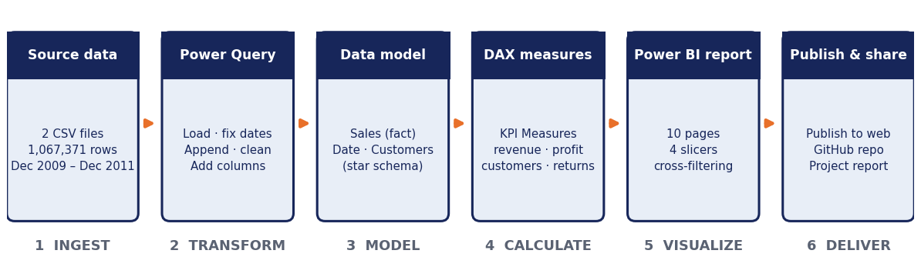
Figure 1: Solution architecture and data flow

5.2. Data model
The model is a star schema. The Sales fact table holds one row per invoice line. The Date and Customers dimension tables filter it through one-to-many relationships with a single filter direction. A separate KPI Measures table stores the DAX measures.
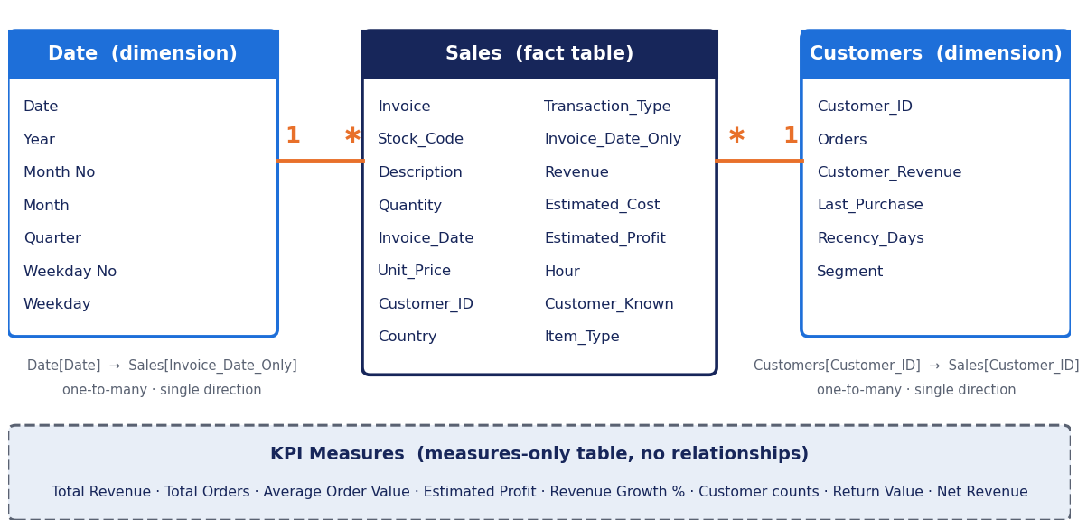
Figure 2: Star-schema data model
Relationship | Cardinality | Direction | Effect
Date[Date] to Sales[Invoice_Date_Only] | One-to-many | Single | Year, quarter, month and weekday filter sales
Customers[Customer_ID] to Sales[Customer_ID] | One-to-many | Single | Customer segments filter sales

5.3. Customer segmentation
Customers are grouped by recency (days since the last purchase, counted from the day after the last date in the data) and number of orders. The thresholds are assumptions, not values found in the data.
Segment | Rule | Customers | Share
Champions | Bought within 90 days and has 5 or more orders | 1,620 | 27.62%
Loyal | Bought within 90 days and has 2 to 4 orders | 900 | 15.33%
New / Recent | Bought within 90 days and has 1 order | 370 | 6.21%
At Risk | Last purchase 91 to 180 days ago | 588 | 10.00%
Lost | Last purchase more than 180 days ago | 2,400 | 40.84%

6. Data Preparation and DAX Measures

6.1. Data preparation in Power Query
Step | Action | Reason
Load and combine | Loaded both CSV files; used Append Queries as New to create the Sales table; switched off loading for the two source queries | One table, no double counting
Fix dates | Read InvoiceDate as Date/Time with the English (United States) locale | Month/day/year dates were misread as day/month/year
Rename and type | Renamed columns (for example UnitPrice to Unit_Price) and set data types | Simple formulas and correct calculations
Trim and de-duplicate | Trimmed text in Description; removed 34,335 duplicate rows | Consistent names; no sale counted twice
Enrich | Added eight calculated columns (below) | Classification, revenue and flags used by the measures

Column | Logic | Purpose
Transaction_Type | Invoice starts with "C" gives Return; zero or negative quantity or price gives Adjustment; otherwise Sale | Separates sales from returns and adjustments
Invoice_Date_Only | DateTime.Date([Invoice_Date]) | Date without time, links to the Date table
Revenue | Quantity * Unit_Price | Value of each line
Estimated_Cost, Estimated_Profit | Cost = 65% of revenue; profit = revenue minus cost | Estimated profitability (no cost data exists)
Hour | Hour of Invoice_Date | Time-of-day analysis
Customer_Known | No when Customer_ID is blank, otherwise Yes | Keeps unknown customers out of customer analysis
Item_Type | Stock code starting with a digit is Product, otherwise Non-product | Excludes postage and fees from product rankings

6.2. DAX tables and measures
The Date table is generated with CALENDAR over the full sales date range, and the Customers table lists each identified customer with Orders, Customer_Revenue, Last_Purchase, Recency_Days and Segment. All KPIs are stored as measures in the KPI Measures table so that the same number has the same meaning on every page.
Group | Measures | Definition
Sales | Total Revenue, Total Orders, Total Quantity Sold, Average Order Value | Sale rows only (gross, before returns); average order value is revenue divided by orders
Profit | Total Estimated Profit, Estimated Profit Margin % | Estimated profit of sale rows and its share of revenue
Growth | Previous Month Revenue, Revenue Growth % | Month-over-month change using the Date table
Customers | Total Customers, Repeat Customers, At Risk Customers, Lost Customers | Counts from the Customers table (repeat means 2 or more orders)
Returns | Return Value, Net Revenue, Net Units Sold, Return Rate % | Returned value, and sales net of returns

Total Revenue =
CALCULATE(SUM(Sales[Revenue]), Sales[Transaction_Type] = "Sale")

7. Dashboard Design and Screenshots
The dashboard has ten pages that share one design: a dark blue title banner, KPI cards at the top and blue charts. Pages 2 to 10 carry the same four slicers (Year, Quarter, Month and Country). Clicking a bar, slice or point filters the other visuals on the same page, and hovering shows tooltips. Each page answers one business question; the findings are listed in Section 8.

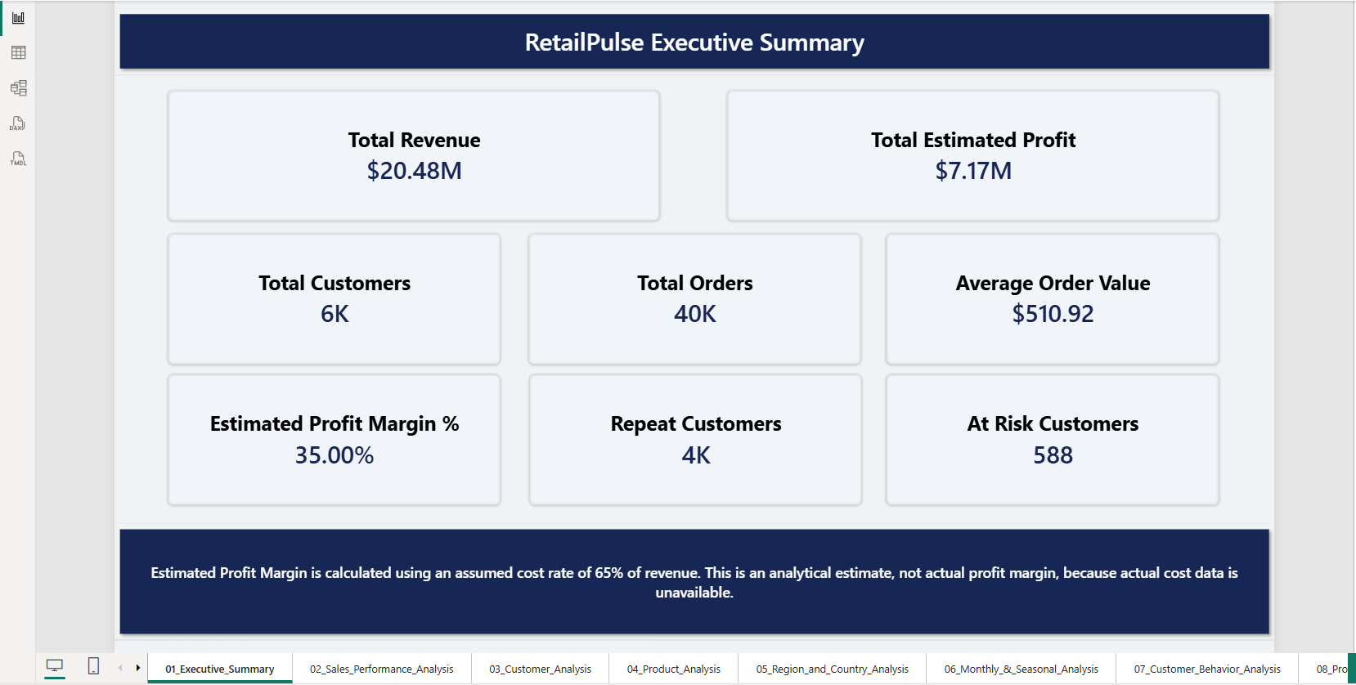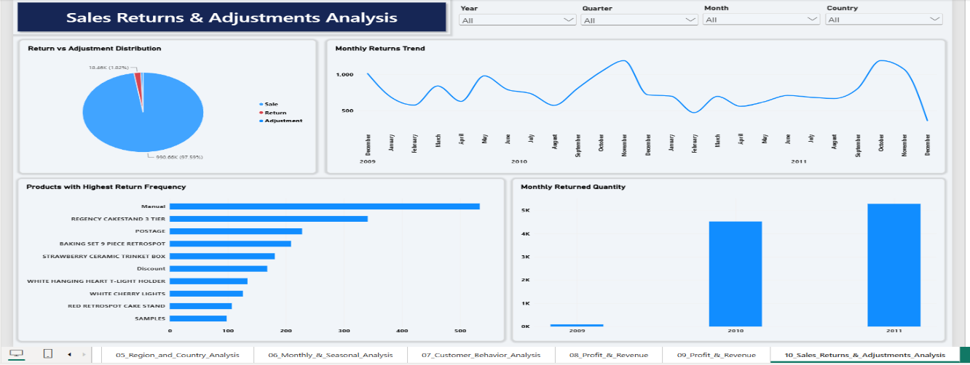
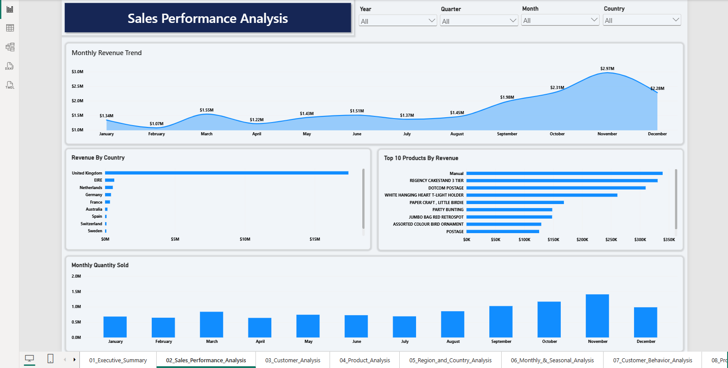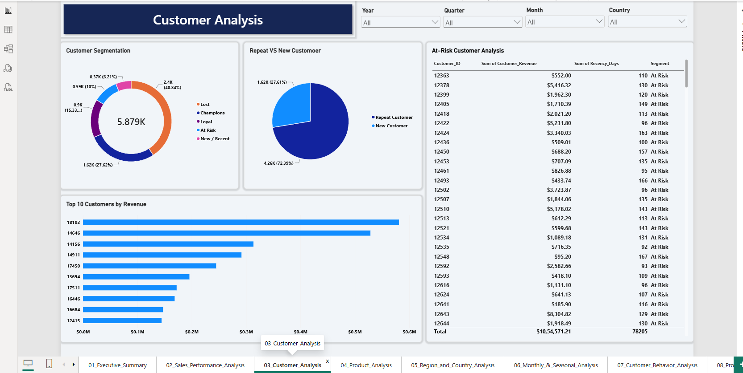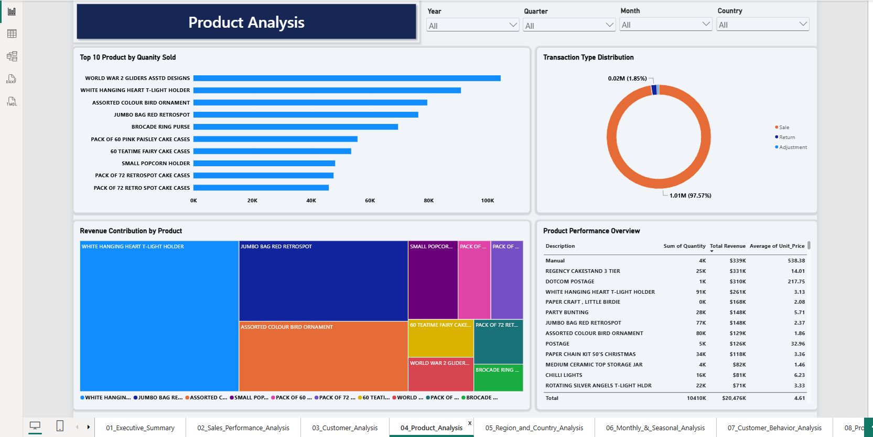

8. Key Findings and Recommendations
Page | Question | Finding
1 Executive Summary | How is the business doing? | £20.48M revenue from about 40K orders; average order value £510.92; estimated profit £7.17M (35% assumed margin); 5,879 identified customers, of which 588 are At Risk.
2 Sales Performance | How do sales vary by month, country and product? | Added across years, revenue is lowest in February (£1.07M) and highest in November (£2.97M), rising from September. The United Kingdom is by far the largest market.
3 Customer Analysis | Who are the customers? | 40.84% of customers are Lost, 27.62% Champions, 15.33% Loyal, 10% At Risk and 6.21% New / Recent; 72.39% have ordered more than once.
4 Product Analysis | Which products sell most? | WORLD WAR 2 GLIDERS ASSTD DESIGNS has the highest volume; WHITE HANGING HEART T-LIGHT HOLDER sells 91K units. REGENCY CAKESTAND 3 TIER (£331K) and the T-light holder (£261K) lead product revenue. About 2% of rows are returns.
5 Region and Country | Which markets matter? | United Kingdom: £17.41M (about 85% of revenue) and 36,535 orders. Next: EIRE (Ireland) £0.66M, Netherlands £0.55M, Germany £0.43M, France £0.35M.
6 Monthly and Seasonal | When do sales peak? | Revenue peaks every November and Q4 is the strongest quarter in 2010 and 2011. The fall at the end of 2011 reflects only nine days of data.
7 Customer Behavior | How do customers buy? | 72.39% repeat purchase rate. Champions generate roughly three quarters of customer revenue, and a handful of customers place well over 100 orders.
8 Profit and Revenue | How much profit is estimated? | £7.17M estimated profit at 35%. The margin is identical for every product and country because cost is a single assumption, so compare profit amounts, not margins.
9 Profit by Year and Type | How do years and transaction types compare? | Revenue and estimated profit by year and by transaction type. 2009 contains only December, so yearly totals are not like-for-like.
10 Returns and Adjustments | Where do returns occur? | Returns and adjustments are a small share of rows (about 2%), follow the autumn sales peak, and REGENCY CAKESTAND 3 TIER is the most frequently returned product.

Recommendations
- Run a win-back campaign for the 588 At Risk customers (last purchase 91 to 180 days ago).
- Plan stock, staffing and promotions ahead of the September to November peak.
- Reduce dependence on the United Kingdom (about 85% of revenue) by developing Ireland, the Netherlands, Germany and France.
- Investigate the causes of returns for frequently returned products, and capture real cost data to replace the estimated margin.

9. Conclusion and Future Work
The project met its objectives. Two raw files with more than one million rows were turned into a validated star-schema model, a documented set of DAX measures and a ten-page interactive dashboard. The report shows a business that is highly seasonal, dependent on the United Kingdom and on a small group of repeat customers, and it identifies concrete actions: win back At Risk customers, prepare for the autumn peak, widen the market base and reduce returns.
Key learnings:
- Check data immediately after loading: regional settings silently changed the meaning of every date.
- Model design decides what slicers do: relationship direction and a proper Date table matter more than visuals.
- State every assumption (estimated cost, segment thresholds) where the numbers are shown.
- Reconcile each number against the source before publishing.
Future work:
- Add a Products dimension and use real cost and stock data for true profit and inventory risk.
- Add demand forecasting and churn prediction models, as in the full RetailPulse brief.
- Add drill-through, bookmarks and tooltip pages for deeper exploration.
- Set up scheduled refresh, row-level security and automated data-quality tests.

