Assigment:

In this lab, we have to do the camera calibration and harris corner detection an compare the results with the corners that detected by human-eyes. For this task, dijitally created images are not a good choices because the sharp and clear edges may descrease the performance the harris corner. Because harris corner take the double values of points into consider and integer images could be created by rounding up and down which can give bad results. Therefore, the real-world taken cube image is chosen as a test candidate. Below you can see the picture.
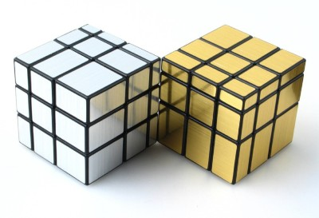

To compare two methods, we have to start with Harris Corner detection. Luckily, MATLAB has built-in function that provides the harris corners with the corners = detectHarrisFeatures(img);
statement. Below you can see the results of the Harris Corner of Black-White image.

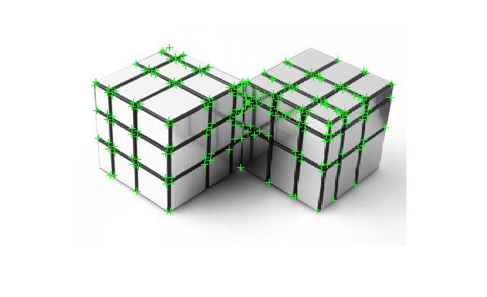

As you can see, harris corners create four different point for top corners, and some cases this may be unwanted result. To see the difference, we should consider the result of Calibration. To calibrate the image first we should detect edges with canny (preferable) and make line detection.

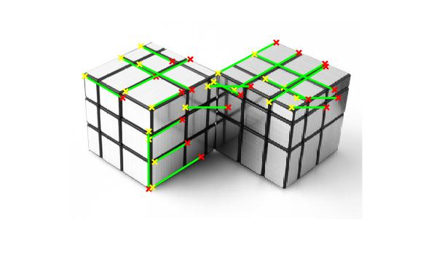

In above, you can see the detected 21 lines after doing hough transform, hough peaks and accumulator. Of course proper and optimized parameters will give better results but it is enough to see the difference between two method. The next task is picking eight difference intersecting point in the image to compare. However, to obtain best results, I updated the code and pick each two line pair from the sets of 21 lines. Expectedly, some of this pairs is not intersecting and will result in irrelevant corners. Still, we can easily detect whether the which one is the correct and which one is not. Below, you can see Harris Corners in purple color. As I said, ignore the irrelevant outcomes.

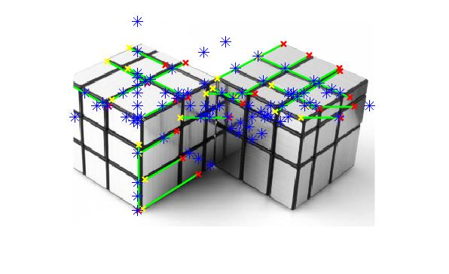

From the possible 210 candidates I choice eight different Harris Corners which I highly suspected it is intersecting point. Below, you can see the 2 value Cartesian coordinates of eight selected point.

[224.1,59.79],[240.1,106],[324.2,78.66],[318.3,76.04],
[121.3,73.62],[247.2,60.68],[115.1,76.71],[283.3,60.45]

The pairs of two detected lines which gives the above results is listed below.

# [14,17],[5,10],[19,20],[12,20],[16,18],[4,18],[6,18],[2,20]

Also, you can see the line equations of these 21 lines with trigonometric form.
X* cos(theta) + y*sin(theta) = rho
Eq of 1 is x 0.5000 + y 0.8660 = 194.0000
Eq of 2 is x 0.5000 + y 0.8660 = 194.0000
Eq of 3 is x 1.0000 + y 0.0000 = 106.0000
Eq of 4 is x 0.4384 + y -0.8988 = 10.0000
Eq of 5 is x 0.4384 + y -0.8988 = 10.0000
Eq of 6 is x 0.4772 + y -0.8788 = -12.5000
Eq of 7 is x 0.5000 + y -0.8660 = -57.0000
Eq of 8 is x 0.0000 + y -1.0000 = -90.0000
Eq of 9 is x 0.0000 + y -1.0000 = -119.0000
Eq of 10 is x 0.0000 + y -1.0000 = -119.0000
Eq of 11 is x 0.5000 + y 0.8660 = 225.0000
Eq of 12 is x 0.5000 + y 0.8660 = 225.0000
Eq of 13 is x 0.4617 + y 0.8870 = 156.5000
Eq of 14 is x 0.4617 + y 0.8870 = 156.5000
Eq of 15 is x 0.0000 + y -1.0000 = -106.0000
Eq of 16 is x 0.4384 + y -0.8988 = -13.0000
Eq of 17 is x 0.4305 + y -0.9026 = 42.5000
Eq of 18 is x 0.4462 + y 0.8949 = 120.0000
Eq of 19 is x 0.5299 + y 0.8480 = 238.5000
Eq of 20 is x 0.4067 + y -0.9135 = 60.0000
Eq of 21 is x 0.5299 + y 0.8480 = 253.0000

And lastly, the following figures are the zoomed illustration of Calibrated corners. The plotting Harris and calibration on the same image is not preferred to avoiding visual pollution.
Please check below figures. Blue for calibration point, green for harris corner and magento for plotting lines.

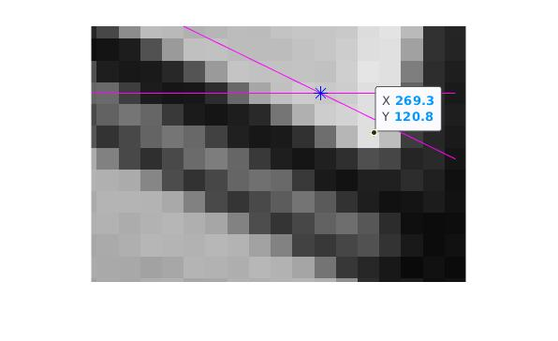
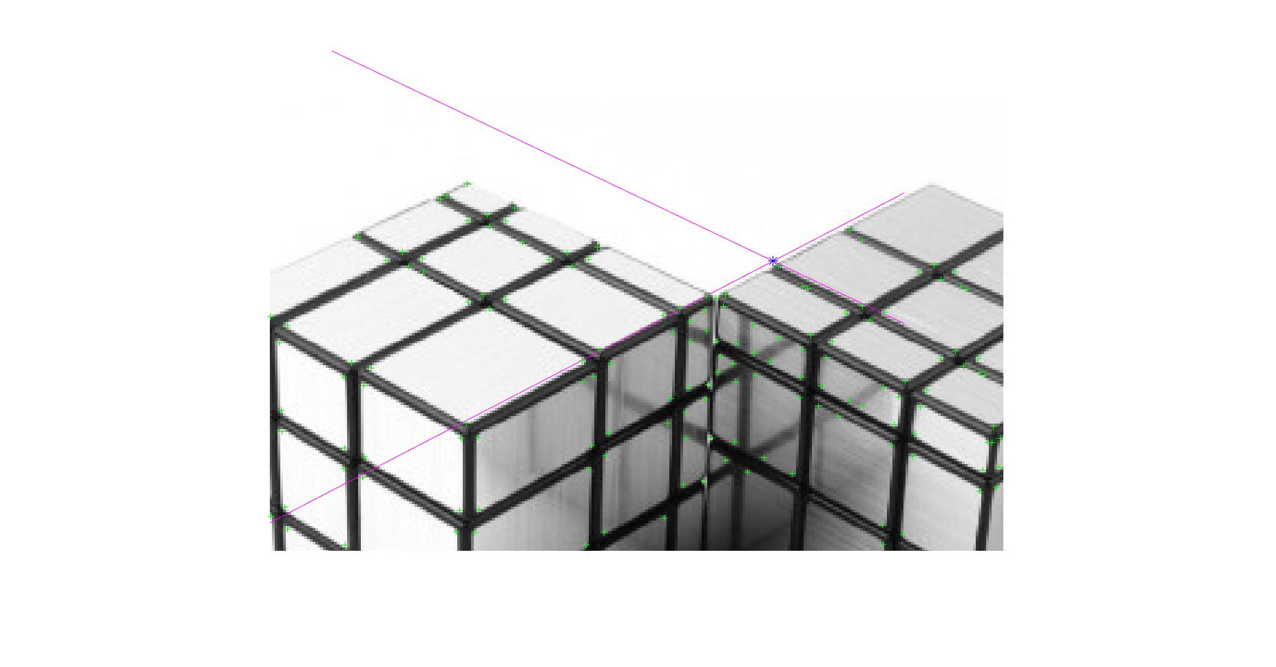
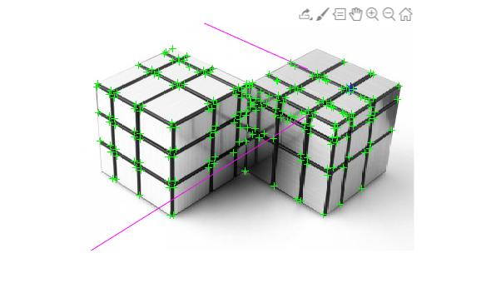
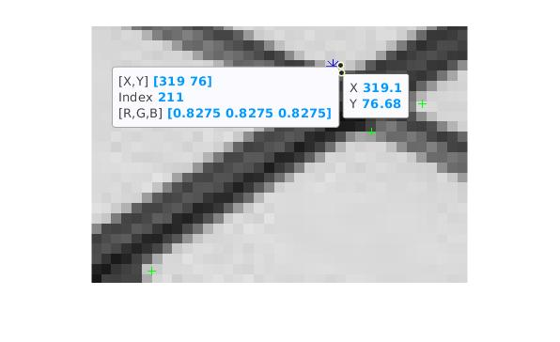
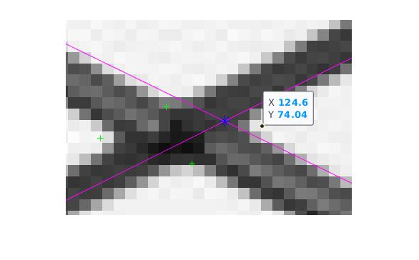
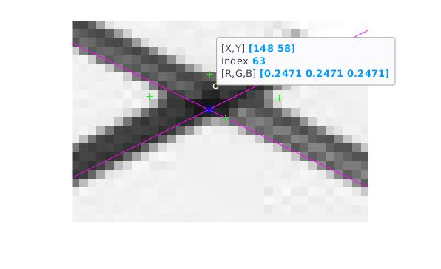
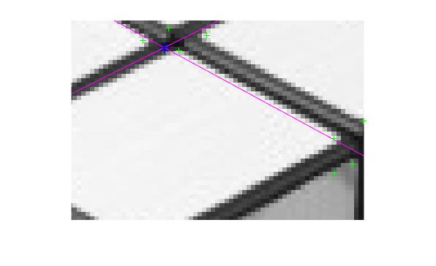

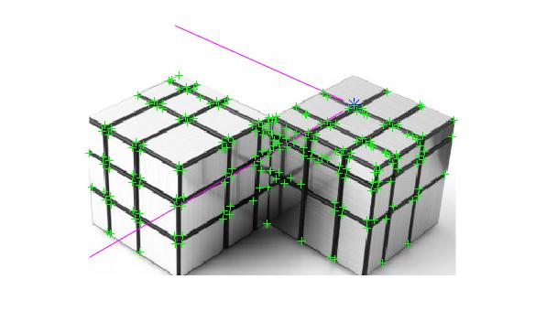

Next task is comparing these Harris corners and calibration corners with our human-decided corners. The comparison will follow and sub-categorize in three criteria; elapsed time and error and mean square error.

Time performance:

To find all harris corners : Elapsed time is 0.135588 seconds. (by built in function)
To find all harris corners : Elapsed time is 1.535588 seconds. (user-made)
To find a calibration point: Elapsed time is 0.059656 seconds.
There were 210 cablibration points by combination of 21 lines with 2 so approxiamtely,
To find a calibration point: Elapsed time is 1.2527760 seconds. (user-made)

To conclude we can say, I could implement Harris for better time performance, there is no direct comparison between harris and calibration because built-in calibraiton is not the case yet.

Accuracy Performance by Error Mean Square Error:

For Calibration Corners:

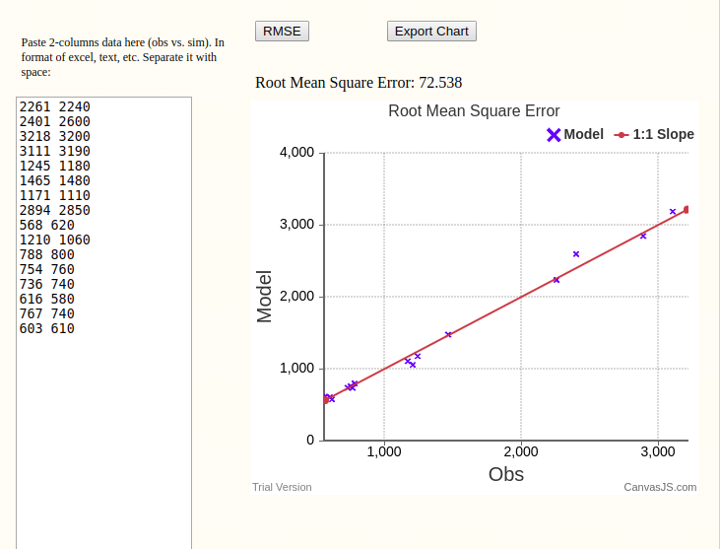

Above you can see the calibration point and the best candidate value for be a corner on my own decision. In other saying while simulation is the results of the code, the observation is manually selected pixels. There are 16 different data for each x and y coordinate for eight point. Obviously the error rate is 72.538. The tool is web based square mean error calculator. (https://agrimetsoft.com/calculators/Root%20Mean%20Square%20Error)

For Harris Corners

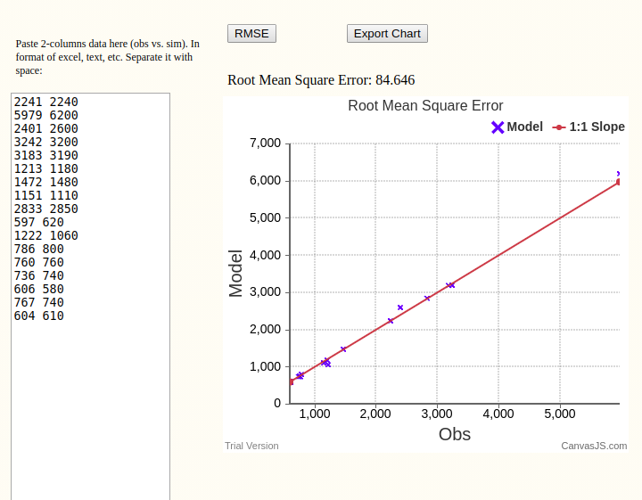
Apparently, the with the 84.656 root mean square error rate for Harris Corners, Calibrating technique is much better than Harris corners in this criteria. We may expect better results in calibration.

Conclusion:

The calibration technique is likely to give better candidates for corners and real-world images. Because in real world the corner is not a single point but an area and its center. Therefore calibration can reach more sensible result. However, for digital created perfect cornered images, Harris would be better choice in terms of accuracy and time. Because, Calibration use the double plane which cannot map the original image all the time.

