The task was calculate the optical flow of given sequence and represent the optical flow visually. In this report, we will discuss about how frame size and local filtering effects the accuracy of the optical flow of the image. In this task, for determining the displacements of pixes, Lucas- Kanade method has been used.
Below, you can find the six different result of three different sequence for (k=10, k=20 and k=30) of out experiment with Gaussian and local filtering.

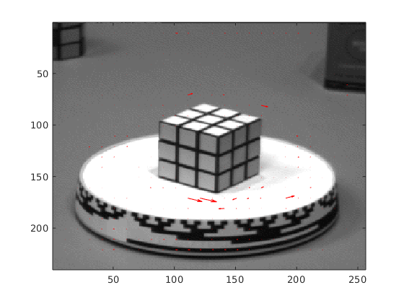
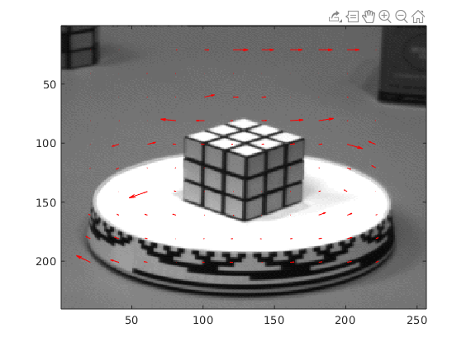

Figure1. Rubic k=10, local filtered

Figure2. Rubic k=20, local filtered

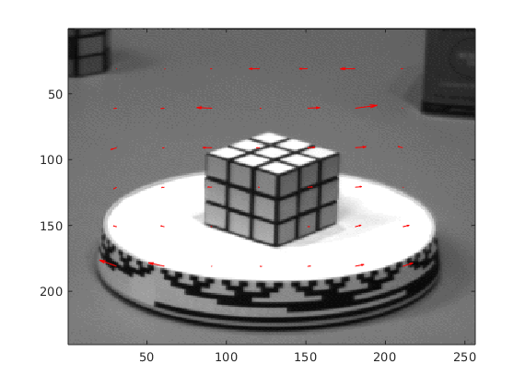

Figure3. Rubic k=30, gauss filtered

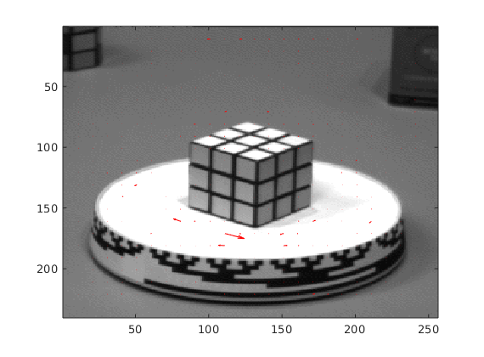

Figure4. Rubic k=10, No local filter

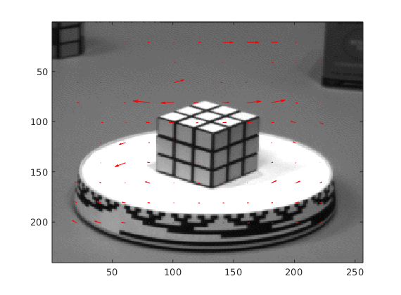

Figure5. Rubic k=20, No local filter

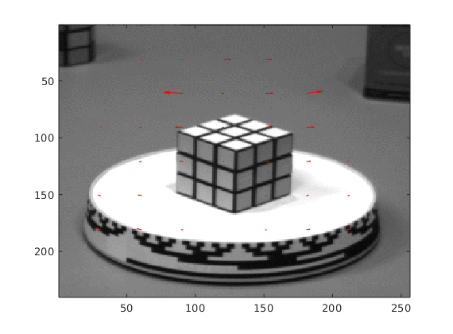

Figure6. Rubic k=30, No local filter

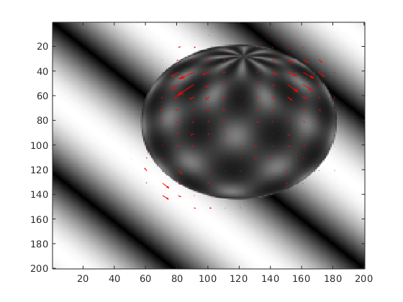

Figure7. Sphere k=10, local filtered

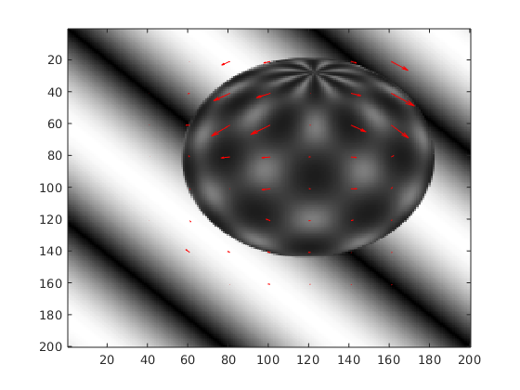

Figure8. Sphere k=20, local filtered

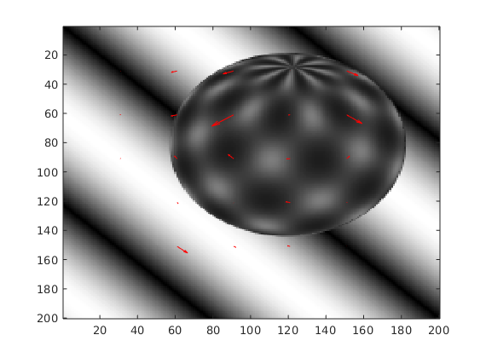

Figure9. Sphere k=30, gauss filtered

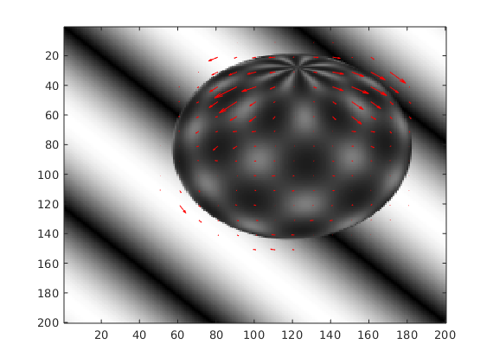

Figure10. Sphere k=10, No local filter

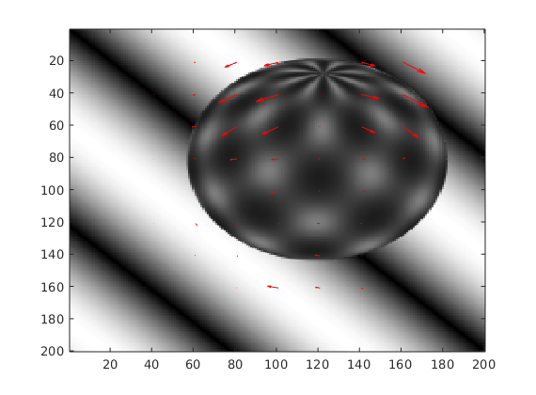

Figure11. Sphere k=20, No local filter

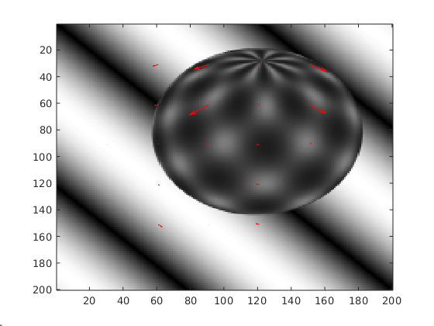

Figure12. Sphere k=30, No local filter

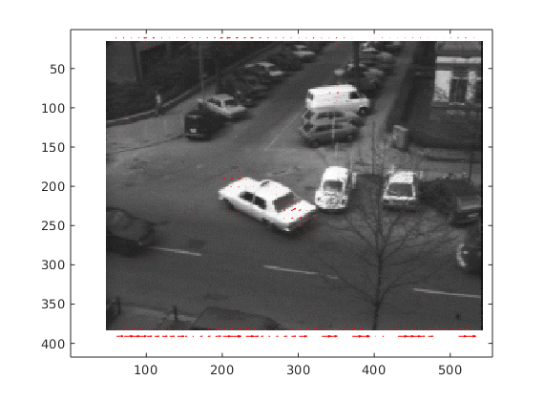

Figure11. Taxi k=10, local filtered

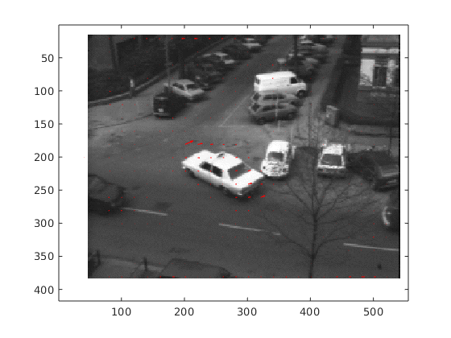

Figure11. Taxi k=20, local filtered

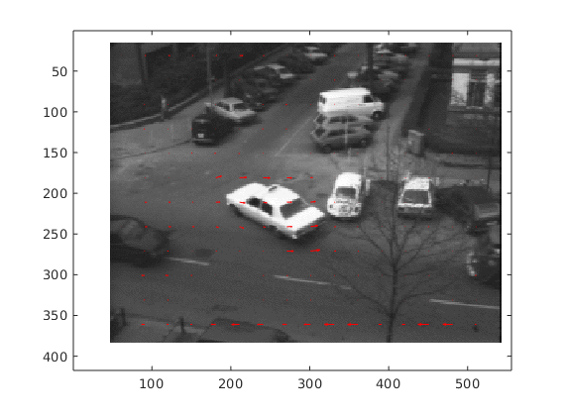

Figure12. Taxi k=30, gauss filtered

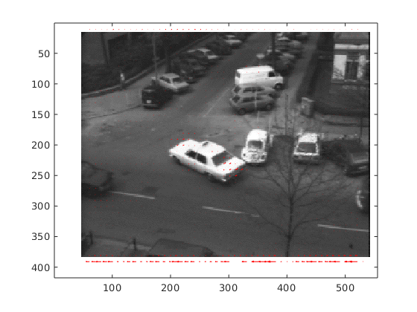

Figure13. Taxi k=10, No local filter

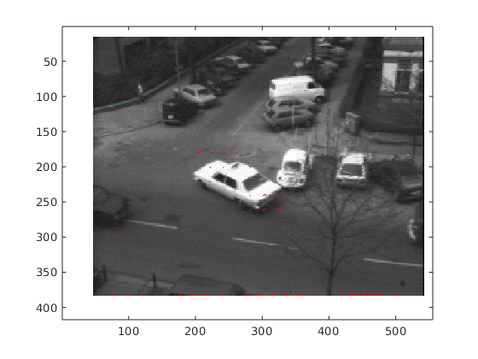

Figure14. Taxi k=20, No local filter

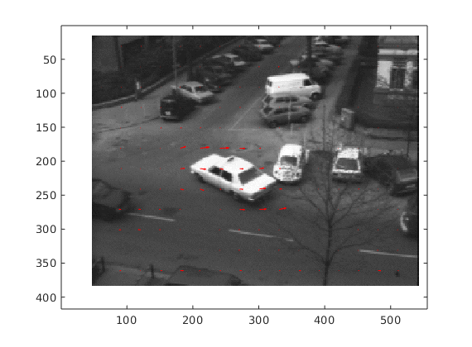

Figure15. Taxi k=30, No local filter

Conclusion

Above, we share the results of all combination of parameters local filtering and k frame size to investigate how these metrics effects our accuracy. We can say we expected to see frequent and smaller arrows with lower k values. The main reason behind this expectation, is the working mechanism of the algorithm. K value is stands for frame size and in this algorithm we analyze the consecutive two image frame by frame. The bigger k value means less separation and more area to analyze. Therefore it makes sense to expect more arrows for k=10 value with less detailed manner. When we look at the results, we can say results support our expectations.
Above, we also compare the results with and without filtering. In Lucas-Kannada algoritm, two smoothing filter has been used; local box filtering and Gaussian filtering. All filtering operations is made by MATLAB’s built-in functions. By looking the results, we can easily say, smoothing operation is essential to increase accuracy of optical flow. Also, we can say, gauss filtering give more proper results than box filtering. All the performance metrics is based on accuracy and frequency of displaying of arrows. Any time performance model has not been followed.

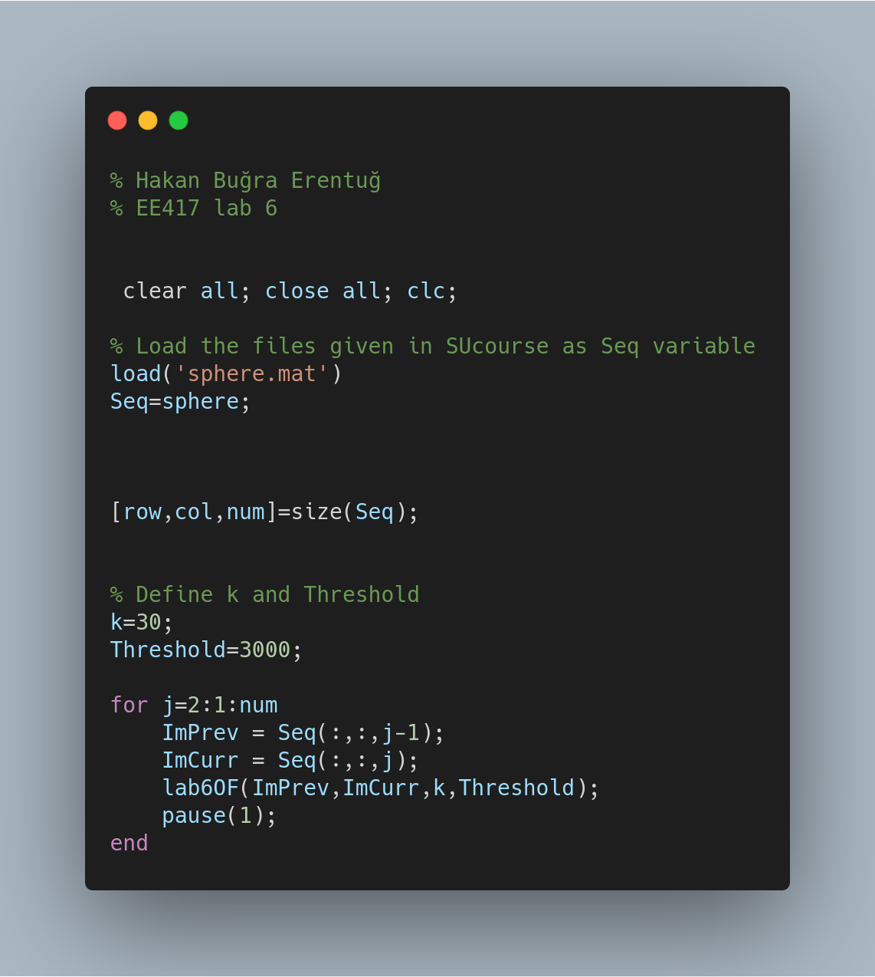
Appendices:
