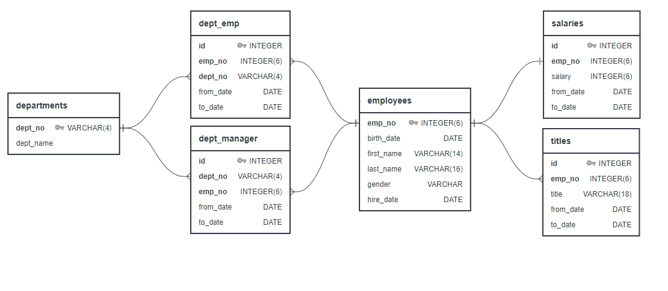

**\***

**\***

**\***

|  |  |  |  |
| --- | --- | --- | --- |
|  | **UNIQUE** | **DUP** | **TTL** |
| departments | 9 | - | **9** |
| dept_emp | 300,024 | 31,579 | **331,603** |
| dept_manager | 9 | 15 | **24** |
| employees | 300,024 | - | **300,024** |
| salaries | 300,024 | - | **300,024** |
| titles | 300,024 | 143,284 | **443,308** |



**❶**

**\***

**\***

**\***

**1. List the following details of each employee:**

employee number  
last name  
first name  
gender  
salary

|  |  |  |  |
| --- | --- | --- | --- |
|  | **UNIQUE** | **DUP** | **TTL** |
| departments | 9 | - | **9** |
| dept_emp | 300,024 | 31,579 | **331,603** |
| dept_manager | 9 | 15 | **24** |
| employees | 300,024 | - | **300,024** |
| salaries | 300,024 | - | **300,024** |
| titles | 300,024 | 143,284 | **443,308** |

**❷**



**\***

**\***

**\***

**2. List employees who were hired in 1986.**

|  |  |  |  |
| --- | --- | --- | --- |
|  | **UNIQUE** | **DUP** | **TTL** |
| departments | 9 | - | **9** |
| dept_emp | 300,024 | 31,579 | **331,603** |
| dept_manager | 9 | 15 | **24** |
| employees | 300,024 | - | **300,024** |
| salaries | 300,024 | - | **300,024** |
| titles | 300,024 | 143,284 | **443,308** |



**❸**

**\***

**\***

**\***

**3. List the manager of each department with the following information:**

department number  
department name  
manager employee number  
last name  
first name  
start date  
end date

|  |  |  |  |
| --- | --- | --- | --- |
|  | **UNIQUE** | **DUP** | **TTL** |
| departments | 9 | - | **9** |
| dept_emp | 300,024 | 31,579 | **331,603** |
| dept_manager | 9 | 15 | **24** |
| employees | 300,024 | - | **300,024** |
| salaries | 300,024 | - | **300,024** |
| titles | 300,024 | 143,284 | **443,308** |



**❹**

**\***

**\***

**\***

**4. List the department of each employee with the following information:**

employee number  
last name  
first name  
department name

|  |  |  |  |
| --- | --- | --- | --- |
|  | **UNIQUE** | **DUP** | **TTL** |
| departments | 9 | - | **9** |
| dept_emp | 300,024 | 31,579 | **331,603** |
| dept_manager | 9 | 15 | **24** |
| employees | 300,024 | - | **300,024** |
| salaries | 300,024 | - | **300,024** |
| titles | 300,024 | 143,284 | **443,308** |



**❺**

**\***

**\***

**\***

**5. List all employees whose:**

first name = “Hercules”  
last name **begins with** “B”

|  |  |  |  |
| --- | --- | --- | --- |
|  | **UNIQUE** | **DUP** | **TTL** |
| departments | 9 | - | **9** |
| dept_emp | 300,024 | 31,579 | **331,603** |
| dept_manager | 9 | 15 | **24** |
| employees | 300,024 | - | **300,024** |
| salaries | 300,024 | - | **300,024** |
| titles | 300,024 | 143,284 | **443,308** |



**❻**

**\***

**\***

**\***

**6. List the following details of each employee:**

employee number  
last name  
first name  
department name = “Sales”

|  |  |  |  |
| --- | --- | --- | --- |
|  | **UNIQUE** | **DUP** | **TTL** |
| departments | 9 | - | **9** |
| dept_emp | 300,024 | 31,579 | **331,603** |
| dept_manager | 9 | 15 | **24** |
| employees | 300,024 | - | **300,024** |
| salaries | 300,024 | - | **300,024** |
| titles | 300,024 | 143,284 | **443,308** |



**❼**

**\***

**\***

**\***

**7. List the following details of each employee:**

employee number  
last name  
first name  
department name = “Sales” **AND** “Development”

|  |  |  |  |
| --- | --- | --- | --- |
|  | **UNIQUE** | **DUP** | **TTL** |
| departments | 9 | - | **9** |
| dept_emp | 300,024 | 31,579 | **331,603** |
| dept_manager | 9 | 15 | **24** |
| employees | 300,024 | - | **300,024** |
| salaries | 300,024 | - | **300,024** |
| titles | 300,024 | 143,284 | **443,308** |



**❽**

**\***

**\***

**\***

**8. In descending order, list the frequency count of employee last names, i.e., how many employees share each last name.** last name  
 count of last name

|  |  |  |  |
| --- | --- | --- | --- |
|  | **UNIQUE** | **DUP** | **TTL** |
| departments | 9 | - | **9** |
| dept_emp | 300,024 | 31,579 | **331,603** |
| dept_manager | 9 | 15 | **24** |
| employees | 300,024 | - | **300,024** |
| salaries | 300,024 | - | **300,024** |
| titles | 300,024 | 143,284 | **443,308** |