Data Science Capstone Project

Heriberto Encinas Lopez

Contents

Introduction 1

Data 2

Methodology 2

Initial Data Processing 3

Exploratory Analysis 4

Date of Transaction 4

House Age 5

Distance to nearest MRT station 7

Number of convenience stores 8

Latitude and Longitude 10

Final Data Preparation 12

Final Data Modeling 13

Results 14

Discussion 15

Conclusion 15

Appendix A 15

Appendix B 21

# Introduction

This data science capstone project will try to analyze and then solve the following problem: Real state valuation. Real state valuation is the task of assigning a monetary value to a specific property based on its attributes. These attributes relate to different aspects of the property such as: location, distance to convenience stores, size, neighborhood, etc.

Real state valuation is a complex and dynamic problem that can be affected by a variety of external factors such as: the economy, neighborhood crime rates, geology, etc. Every single aspect of everyday life can influence the value of a given house. Is it located in a decent neighborhood? Is it the right size? How old is it? The answers to these questions will probably have a direct impact on the property's final price.

This problem is of interest for the two following groups: 1) Real state agencies and 2) potential buyers (clients). For real state agencies, understanding the nuances around each of the properties they offer may help them achieve better profits when purchasing/selling a specific property. On the other hand, for potential buyers or clients, a deeper understanding of how different factors affect the price of a property may help make more appropriate decisions when purchasing/selling a specific property.

The formal definition of the problem is as follows: Can we accurately predict the price of a given property using information such as, house age and/or location?

# Data

The data that will be used in this project is the so called “Real Estate Valuation Data Set”. This data set was obtained from the well-known UCI Machine Learning Repository. This is a multivariate data set with 414 instances. The number of attributes for each instance is 7 and there are no missing values. This data set is usually associated with Regression tasks (such as ours).

The following table describes the data set in more detail:

|  |  |  |
| --- | --- | --- |
| **Attribute name** | **Description** | **Attribute type** |
| No | Instance number, identifier | Numeric: Integer |
| X1 transaction date | The date the transaction was made | Numeric: Real |
| X2 house age | House age in years | Numeric: Real |
| X3 distance to the nearest MRT station | Distance to nearest subway station | Numeric: Real |
| X4 number of convenience stores | Number of convenience stores | Numeric: Integer |
| X5 latitude | Latitude | Numeric: Real |
| X6 longitude | Longitude | Numeric: Real |
| Y house price of unit area | House price of unit area | Numeric: Real |

As we can see, most of the attributes are real values, with a few exceptions that are expressed in integer. Also, most of the attributes relate to location information. Finally, the target value is a numeric (real) value which indicates the price per unit area for a given property.

In the following section this dataset will be preprocessed and analyzed further.

# Methodology

In this section I will go over the whole process of data science. This section is divided into the following subsections: initial data processing, exploratory analysis, final data processing and data modeling.

## Initial Data Processing

In this stage of the process we did some initial transformations to the data so we could handle it easier. First, we checked the data was complete (no missing values), which was the case (corresponding with what is stated in the UCI Machine Learning Repository website).

Then we dropped the first column of our data, the reasoning behind this is that this column is just an identifier and therefore, does not provide any statistical insight.

After that we proceeded to analyze the basis statistical information for the data. The following table shows that information:

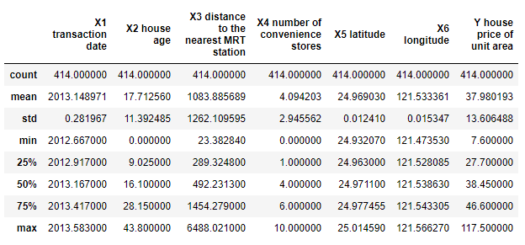

As we can see, there are 414 instances for all columns (which confirms what is stated on the UCI Machine Learning Repository). Additionally, if we analyze the mean values for all columns, we will notice the following: 1) Most of the properties were sold around January 2013. 2) Most of the houses have an age close to 17.7 years. 3) Most of the houses are located within 1100 meters of an MRT station. 4) Most of the houses have around 4 convenience stores nearby. And 5) the average house price of unit area is 37.9.

After that, we modified the names for all columns to make them easier to read and understand. The following names were chosen:

|  |  |
| --- | --- |
| **Original name** | **New name** |
| X1 transaction date | date |
| X2 house age | age |
| X3 distance to the nearest MRT station | mrt |
| X4 number of convenience stores | stores |
| X5 latitude | latitude |
| X6 longitude | longitude |
| Y house price of unit area | price |

## Exploratory Analysis

In order to further understand the data, we will do an exploratory analysis. In this analysis, we will segment our data and explore each of its attributes to see how they relate to our target value. We expect that some of the attributes may have a high impact on the target value whereas some other attributes may have a lower (or nonexistent) impact.

### Date of Transaction

The first attribute we will explore is Date. We will plot the data for both date and price, and we will analyze it to see if there is any relationship between these two. The following plot was obtained:

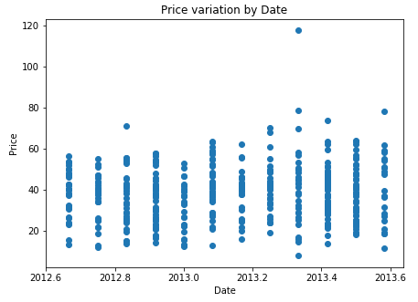

As we can see from the previous plot, it appears that prices do not tend to vary significantly with time. We can see a slight tendency to increase (which is expected) but the overall variation over time seems small. However, there are two things we can notice: 1) there are some outliers: some properties were sold a higher price relative to the rest of the houses. And 2) the biggest increase in prices is reported between 2013.2 and 2013.4: This may have happened for a variety of reasons that cannot be determined using the available data (e.g. economic changes). However, we can see prices stabilized again after 2013.4.

A better way to visualize the general tendency of the data would be to try and fit a line to it, which is exactly what we'll do next:

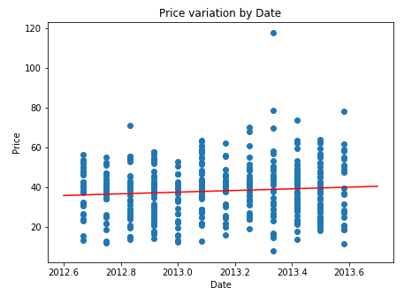

As we can see from the previous plot, the line shows a general trend of increasing prices over time. However, and as we mentioned before, this trend produces small changes over time which is reflected by the line's small slope. This makes sense. Most of our data sits between 2012.6 and 2013.6 which is only a year. It would be weird to see drastic price variations in such a small period (this is, unless something important happened).

### House Age

The second attribute we will explore is House age. Once again, let's plot the data to see if we can find any trend. The following plot was obtained:

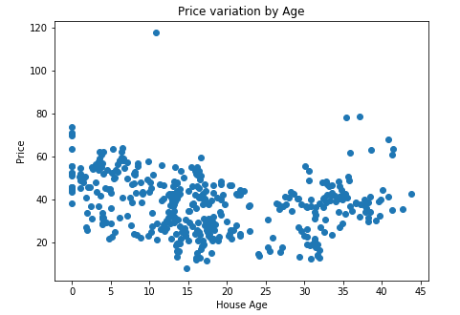

This data looks a little different. However, we can also identify a trend. We can see that for "younger" houses prices seem to be higher than for old houses (with some exceptions). Like the previous section we will fit a line to our data to see the general trend.

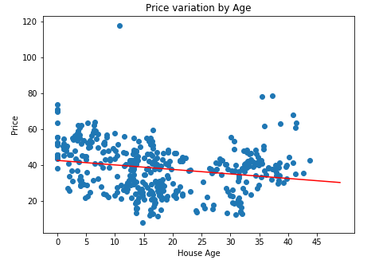

It appears our assessment was correct. The line shows a general trend of decreasing prices with age. Also, the line has a more pronounced slope which implies that house age has a bigger impact on price. This also makes sense, older houses are cheaper than newer ones, right? Of course, this is not the only factor that affects price, but instead is just a small piece of a bigger puzzle.

### Distance to nearest MRT station

Now, we will explore the Distance to nearest MRT station. Let's see how the data looks like:

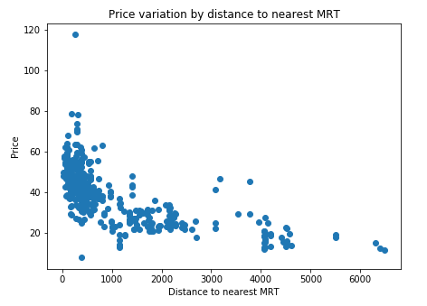

This is a very interesting plot. The data shows what is called an exponential shape. This is, prices decrease exponentially as the distance to the nearest MRT increases. We can see houses that are closer to a MRT have a significantly higher price than those that are far. Again, for visualization purposes, let's fit a line to our data to see the general trend.

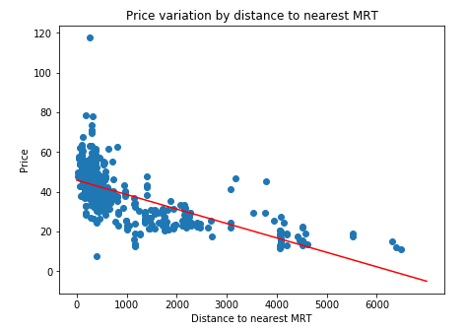

And our line just confirms what we already noticed. Distance to nearest MRT seems to have a high impact on the house's price. This, again, makes a lot of sense. Living close to an MRT or other type of public services is considered a commodity, thus, houses which are located close to them will have a price that considers such commodity.

### Number of convenience stores

Now, let's explore the data related to the number of convenience stores near each property:

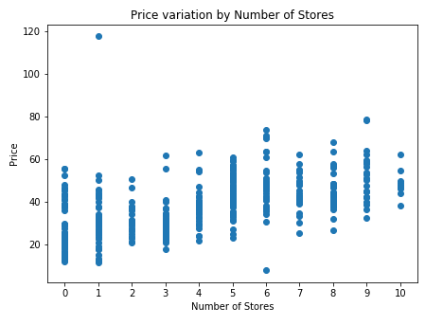

Here, the plot shows a trend of increasing prices with increasing number of convenience stores. Again, let's plot a line for the general trend:

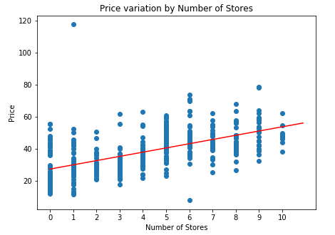

As expected, the line reflects the increasing trend that we mentioned before. The reasoning behind this is similar to the one we gave for MRT stations. Having more convenience stores nearby is a commodity, the less convenience stores there are nearby the further we may need to go to find whatever we are looking for. Thus, having more options at a reasonable distance will increase the price of the property.

### Latitude and Longitude

Now, we will explore the latitude and longitude columns. We know latitude and longitude values are used to encode location, which is a relevant attribute when discussing a property's value. However, latitude and longitude values are not as easy to interpret as the attributes we've seen before.

One way we can change this and not lose information would be to translate these numerical values into addresses. And then extract relevant information from these addresses. The format for each address is as follows:

G2000, 民權路, 復興里, 大坪林, 新店區, 新北市, 23141, 臺灣

Unless you speak Chinese, this address does not provide much information. Let's try again with the raw response from the server:

{'place_id': 59822203, 'licence': 'Data © OpenStreetMap contributors, ODbL 1.0. <https://osm.org/copyright',> 'osm_type': 'node', 'osm_id': 4834782017, 'lat': '24.9830413', 'lon': '121.5402601', 'display_name': 'G2000, 民權路, 復興里, 大坪林, 新店區, 新北市, 23141, 臺灣', 'address': {'clothes': 'G2000', 'road': '民權路', 'city_district': '復興里', 'village': '大坪林', 'state_district': '新店區', 'state': '新北市', 'postcode': '23141', 'country': '臺灣', 'country_code': 'tw'}, 'boundingbox': ['24.9829413', '24.9831413', '121.5401601', '121.5403601']}

Now we can see the whole address structure. We will be focusing on the 'city_district' field for each address. Let's extract this value for all instances. The result looks like this (first 5 elements of the list):

復興里

大豐里

信義里

信義里

寶安里

To facilitate the understanding for those of us who can't speak Chinese, we will go ahead and obtain the pinyin corresponding words for all neighborhoods. The result looks like this:

fùxīnglǐ

dàfēnglǐ

xìnyìlǐ

xìnyìlǐ

bǎoānlǐ

The list is comprised of 60 unique city districts. The distribution of properties for all districts can be see in the following horizontal bar chart:

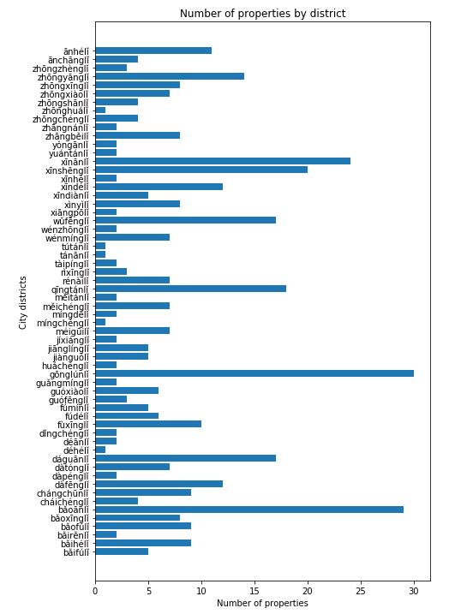

The horizontal bar chart shows most of the city districts have less than 15 properties. However, there are 7 districts which have 15 properties or more: xinanli, xinshengli, wufengli, qingtanli, gonglunli, daguanli and baoanli. Additionally, the district with most properties is gonglunli with something around 30 properties. Now, let's plot districts vs prices to see how these two relate.

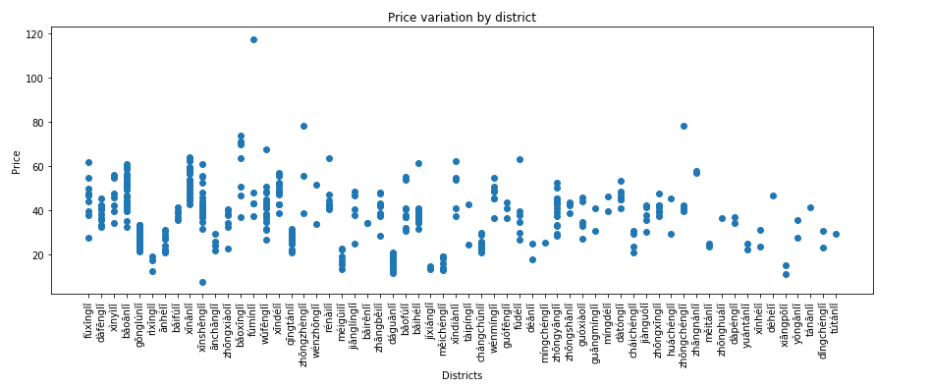

The graph shows a clear relationship between district and price. For some districts, houses are cheaper than for other districts. For example, the meiguili, daguanli and meichengli districts are clearly significantly cheaper than the xinanli, xindeli, and datongli districts. We can see a few outliers which, once again, indicate district is not the only factor that determines the final price.

## Final Data Preparation

In this section, we will build the final dataset that we will later use for modeling. The first thing we'll do is to get dummy variables for each of the city districts. These variables only represent membership to a given district. Therefore, if the first instance belongs to city district A: Column corresponding to city district A will be equal to one, all other columns will be equal to zero. The resulting data frame looks like this:

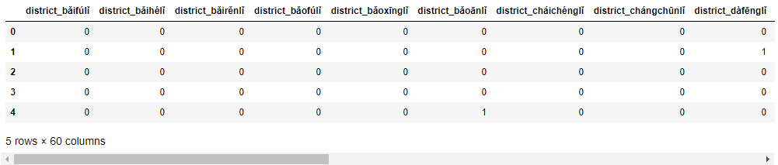

We then combine this data frame with the first four columns and the last column of the preprocessed data set to get the final dataset:

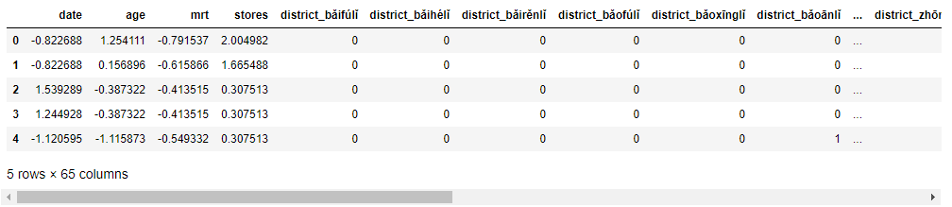

After that, the attributes for each instance where standardized (zero mean, unit variance) and the dataset we saved in a new csv file named: realstate_final.csv. Also, a non-standardized version realstate_final_0.csv was also saved (for reference).

## Final Data Modeling

In this subsection we will model the data using multiple linear regression tools, statistical python libraries. We will use the statmodels python library, which will provide us with an easy way to extract statistical insights from our model.

After loading the data and training the model we were able to obtain the statistical report that is present in Appendix A

This table shows statistical information about our model. From this table we can see the following

1. Dependent variable: price, our target is correct. We are using our data to try to predict price.

2. R-Squared: our model has an R-Squared value of 0.765. This is decent. This value needs to be close to one. Right now, this value means our model can explain 76% of the variability of the data.

3. Adj. R-Squared: this value is similar to the previous value, but it takes into account the number of variables we are using. The fact that this value is smaller than the previous one means we are using too many variables. Some of our variables are irrelevant.

4. F-statistic: this value indicates how significant our model is, the higher, the better.

Now, how can we improve the model? Let's start by trying to identify which of our variables are irrelevant. To do this, we will check the P values for each of the variables on the previous table.

We can see that our first 5 variables (const, date, age, mrt and stores) have a P value < 0.05 which is good. Any variable with a P value higher than that can be considered irrelevant, it is not contributing much to the model.

Let's go ahead and choose only variables with a P value < 0.05. The resulting set of variables is the following:

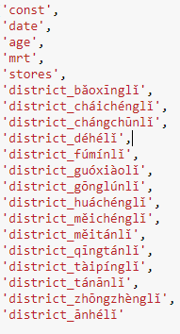

From this analysis, we can extract the following insights:

1. Date of transaction, house age, distance to mrt, and number of stores are very relevant when determining the property's price.

2. Location is relevant attribute. However, it appears this importance can be narrowed to a select group of districts. Specifically, 15 districts which are listed above.

We can analyze performance for the new model based on information present in Appendix B.

Things to note about our new model:

1. All the variables are relevant: all the variables have small P values which indicates they are relevant to the model.

2. The F-Statistic increased to 52.80 from 18. This model is more significant than our previous model. It is better.

This is a better model that can explain the almost the same percentage of variability in the data using a smaller number of variables and with a higher significance.

# Results

We were able to develop a significant model that is capable of explaining a decent percentage of variation within the data. It is possible that more complex models or more rich datasets achieve better results.

However, for our purposes we were able to find a model that performed well. To achieve better results I would suggest using more complex models such as K-Nearest Neighbors or Polynomial Regression.

The obtained results can be seen as the base to make further improvements, maybe using the well-known Sklearn library.

# Discussion

After analyzing the information, I would make the following suggestions:

1. First, I would recommend focusing on those districts that we pinpointed as the most relevant when determining the price.

2. I would also recommend exploring the possibility of gathering data related to other factors such as: How many schools the district has? How close it is to other transportation services such as bus, or airport, etc.? Including more of these variables will provide us with a better look at the whole picture.

3. Instead of latitude and longitude values try to get more meaningful information such as neighborhood, city district, village, etc. Attributes that segment the data into more meaningful subsets.

# Conclusion

This is the conclusion to my capstone project. In this project we took information related to real state for different properties in the city of New Taipei in Taiwan. The data set was processed, relevant information was extracted, and a multi-linear regression model was built.

From these models several insights were obtained: The relevancy of some variables was confirmed as was previously suspected during the exploratory analysis phase. In addition to this, for the location variable, a group of highly relevant city districts was identified.

We were able to build a significant model that requires less information than what we initially had. Additionally, we were able to pinpoint those attributes that have the most impact on the final price.

# Appendix A

|  |  |  |  |
| --- | --- | --- | --- |
| OLS Regression Results | | | |
| **Dep. Variable:** | price | **R-squared:** | 0.765 |
| **Model:** | OLS | **Adj. R-squared:** | 0.723 |
| **Method:** | Least Squares | **F-statistic:** | 18.11 |
| **Date:** | Tue, 16 Apr 2019 | **Prob (F-statistic):** | 5.08e-78 |
| **Time:** | 13:47:05 | **Log-Likelihood:** | -1367.7 |
| **No. Observations:** | 414 | **AIC:** | 2863. |
| **Df Residuals:** | 350 | **BIC:** | 3121. |
| **Df Model:** | 63 |  |  |
| **Covariance Type:** | nonrobust |  |  |

|  |  |  |  |  |  |  |
| --- | --- | --- | --- | --- | --- | --- |
|  | **coef** | **std err** | **t** | **P>|t|** | **[0.025** | **0.975]** |
| **const** | 38.7710 | 0.703 | 55.139 | 0.000 | 37.388 | 40.154 |
| **date** | 1.5154 | 0.380 | 3.988 | 0.000 | 0.768 | 2.263 |
| **age** | -2.9184 | 0.467 | -6.246 | 0.000 | -3.837 | -1.999 |
| **mrt** | -8.2957 | 2.068 | -4.011 | 0.000 | -12.363 | -4.228 |
| **stores** | 2.1409 | 1.084 | 1.974 | 0.049 | 0.008 | 4.274 |
| **district_bǎifúlǐ** | 3.4765 | 4.010 | 0.867 | 0.387 | -4.411 | 11.364 |
| **district_bǎihélǐ** | 1.2873 | 2.711 | 0.475 | 0.635 | -4.045 | 6.619 |
| **district_bǎirěnlǐ** | -1.6161 | 5.389 | -0.300 | 0.764 | -12.215 | 8.982 |
| **district_bǎofúlǐ** | -1.8056 | 2.732 | -0.661 | 0.509 | -7.179 | 3.567 |
| **district_bǎoxīnglǐ** | 14.3362 | 2.973 | 4.822 | 0.000 | 8.489 | 20.184 |
| **district_bǎoānlǐ** | 3.3313 | 2.137 | 1.559 | 0.120 | -0.871 | 7.533 |
| **district_cháichénglǐ** | -7.6935 | 3.576 | -2.151 | 0.032 | -14.727 | -0.660 |
| **district_chángchūnlǐ** | -11.8433 | 2.990 | -3.961 | 0.000 | -17.724 | -5.962 |
| **district_dàfēnglǐ** | -3.4699 | 2.597 | -1.336 | 0.182 | -8.577 | 1.638 |
| **district_dàpénglǐ** | -4.0341 | 5.030 | -0.802 | 0.423 | -13.926 | 5.858 |
| **district_dàtónglǐ** | 0.0130 | 3.366 | 0.004 | 0.997 | -6.607 | 6.633 |
| **district_dáguānlǐ** | 0.2904 | 4.364 | 0.067 | 0.947 | -8.293 | 8.874 |
| **district_déhélǐ** | 21.5958 | 7.515 | 2.874 | 0.004 | 6.816 | 36.376 |
| **district_déānlǐ** | 1.8769 | 5.884 | 0.319 | 0.750 | -9.696 | 13.449 |
| **district_dǐngchénglǐ** | -8.5484 | 5.053 | -1.692 | 0.092 | -18.487 | 1.390 |
| **district_fùxīnglǐ** | 0.6366 | 2.888 | 0.220 | 0.826 | -5.044 | 6.317 |
| **district_fúdélǐ** | 1.9456 | 3.334 | 0.584 | 0.560 | -4.612 | 8.503 |
| **district_fúmínlǐ** | 17.9110 | 3.866 | 4.633 | 0.000 | 10.308 | 25.514 |
| **district_guófēnglǐ** | -3.4186 | 4.423 | -0.773 | 0.440 | -12.118 | 5.281 |
| **district_guóxiàolǐ** | -8.2249 | 3.315 | -2.481 | 0.014 | -14.745 | -1.705 |
| **district_guǎngmínglǐ** | -6.8331 | 5.224 | -1.308 | 0.192 | -17.107 | 3.441 |
| **district_gōnglúnlǐ** | -5.3785 | 1.754 | -3.067 | 0.002 | -8.827 | -1.930 |
| **district_huáchénglǐ** | 16.7248 | 6.085 | 2.748 | 0.006 | 4.756 | 28.693 |
| **district_jiànguólǐ** | -3.0210 | 3.485 | -0.867 | 0.387 | -9.875 | 3.833 |
| **district_jiānglínglǐ** | -1.8768 | 3.603 | -0.521 | 0.603 | -8.962 | 5.209 |
| **district_jíxiánglǐ** | 1.4185 | 6.864 | 0.207 | 0.836 | -12.082 | 14.919 |
| **district_méigūilǐ** | 6.7833 | 5.401 | 1.256 | 0.210 | -3.838 | 17.405 |
| **district_míngchénglǐ** | 7.7978 | 7.984 | 0.977 | 0.329 | -7.904 | 23.500 |
| **district_míngdélǐ** | -0.7439 | 5.328 | -0.140 | 0.889 | -11.224 | 9.736 |
| **district_měichénglǐ** | -15.6097 | 3.152 | -4.952 | 0.000 | -21.809 | -9.410 |
| **district_měitánlǐ** | -11.3059 | 5.089 | -2.222 | 0.027 | -21.314 | -1.297 |
| **district_qīngtánlǐ** | -7.8177 | 1.978 | -3.951 | 0.000 | -11.709 | -3.927 |
| **district_rénàilǐ** | 2.3848 | 3.072 | 0.776 | 0.438 | -3.657 | 8.426 |
| **district_rìxīnglǐ** | 13.3099 | 7.956 | 1.673 | 0.095 | -2.337 | 28.957 |
| **district_tàipínglǐ** | -10.9366 | 5.240 | -2.087 | 0.038 | -21.242 | -0.631 |
| **district_tánānlǐ** | 20.9984 | 7.500 | 2.800 | 0.005 | 6.247 | 35.750 |
| **district_tútánlǐ** | 10.0187 | 7.723 | 1.297 | 0.195 | -5.170 | 25.207 |
| **district_wénmínglǐ** | -2.3890 | 3.287 | -0.727 | 0.468 | -8.853 | 4.075 |
| **district_wénzhōnglǐ** | -5.8617 | 5.315 | -1.103 | 0.271 | -16.314 | 4.591 |
| **district_wǔfēnglǐ** | -3.1267 | 2.415 | -1.295 | 0.196 | -7.876 | 1.623 |
| **district_xiāngpōlǐ** | 11.1805 | 9.246 | 1.209 | 0.227 | -7.004 | 29.365 |
| **district_xìnyìlǐ** | 2.2810 | 2.915 | 0.782 | 0.434 | -3.453 | 8.015 |
| **district_xīndiànlǐ** | 0.9516 | 3.728 | 0.255 | 0.799 | -6.380 | 8.283 |
| **district_xīndélǐ** | 1.3370 | 2.865 | 0.467 | 0.641 | -4.298 | 6.972 |
| **district_xīnhélǐ** | -3.8432 | 5.072 | -0.758 | 0.449 | -13.818 | 6.132 |
| **district_xīnshēnglǐ** | -2.2938 | 2.367 | -0.969 | 0.333 | -6.949 | 2.361 |
| **district_xīnānlǐ** | 4.5323 | 2.441 | 1.857 | 0.064 | -0.268 | 9.333 |
| **district_yuántánlǐ** | -0.1601 | 5.598 | -0.029 | 0.977 | -11.171 | 10.851 |
| **district_yǒngānlǐ** | -1.8739 | 5.070 | -0.370 | 0.712 | -11.846 | 8.098 |
| **district_zhāngběilǐ** | -3.4657 | 2.938 | -1.179 | 0.239 | -9.245 | 2.314 |
| **district_zhāngnánlǐ** | 5.4317 | 5.462 | 0.994 | 0.321 | -5.311 | 16.174 |
| **district_zhōngchénglǐ** | 7.6506 | 4.122 | 1.856 | 0.064 | -0.456 | 15.758 |
| **district_zhōnghuálǐ** | -1.9430 | 7.261 | -0.268 | 0.789 | -16.224 | 12.338 |
| **district_zhōngshānlǐ** | 4.7177 | 3.860 | 1.222 | 0.222 | -2.874 | 12.310 |
| **district_zhōngxiàolǐ** | -4.5456 | 2.771 | -1.640 | 0.102 | -9.996 | 0.905 |
| **district_zhōngxīnglǐ** | -3.0963 | 3.047 | -1.016 | 0.310 | -9.089 | 2.897 |
| **district_zhōngyānglǐ** | -2.6042 | 3.120 | -0.835 | 0.404 | -8.740 | 3.531 |
| **district_zhōngzhènglǐ** | 17.7897 | 4.348 | 4.091 | 0.000 | 9.238 | 26.342 |
| **district_ānchānglǐ** | -3.4831 | 3.985 | -0.874 | 0.383 | -11.320 | 4.354 |
| **district_ānhélǐ** | -10.3739 | 2.204 | -4.708 | 0.000 | -14.708 | -6.040 |

|  |  |  |  |
| --- | --- | --- | --- |
| **Omnibus:** | 195.235 | **Durbin-Watson:** | 2.151 |
| **Prob(Omnibus):** | 0.000 | **Jarque-Bera (JB):** | 4118.391 |
| **Skew:** | 1.493 | **Prob(JB):** | 0.00 |
| **Kurtosis:** | 18.160 | **Cond. No.** | 3.38e+16 |

# Appendix B

|  |  |  |  |
| --- | --- | --- | --- |
| OLS Regression Results | | | |
| **Dep. Variable:** | price | **R-squared:** | 0.718 |
| **Model:** | OLS | **Adj. R-squared:** | 0.704 |
| **Method:** | Least Squares | **F-statistic:** | 52.80 |
| **Date:** | Tue, 16 Apr 2019 | **Prob (F-statistic):** | 9.93e-96 |
| **Time:** | 14:08:54 | **Log-Likelihood:** | -1405.7 |
| **No. Observations:** | 414 | **AIC:** | 2851. |
| **Df Residuals:** | 394 | **BIC:** | 2932. |
| **Df Model:** | 19 |  |  |
| **Covariance Type:** | nonrobust |  |  |

|  |  |  |  |  |  |  |
| --- | --- | --- | --- | --- | --- | --- |
|  | **coef** | **std err** | **t** | **P>|t|** | **[0.025** | **0.975]** |
| **const** | 39.1124 | 0.435 | 89.974 | 0.000 | 38.258 | 39.967 |
| **date** | 1.4736 | 0.372 | 3.958 | 0.000 | 0.742 | 2.205 |
| **age** | -3.0322 | 0.384 | -7.900 | 0.000 | -3.787 | -2.278 |
| **mrt** | -6.8892 | 0.497 | -13.858 | 0.000 | -7.867 | -5.912 |
| **stores** | 2.7429 | 0.529 | 5.183 | 0.000 | 1.702 | 3.783 |
| **district_bǎoxīnglǐ** | 14.5688 | 2.676 | 5.444 | 0.000 | 9.307 | 19.830 |
| **district_cháichénglǐ** | -8.3603 | 3.734 | -2.239 | 0.026 | -15.702 | -1.019 |
| **district_chángchūnlǐ** | -11.2023 | 2.646 | -4.234 | 0.000 | -16.404 | -6.000 |
| **district_déhélǐ** | 19.7467 | 7.461 | 2.647 | 0.008 | 5.078 | 34.416 |
| **district_fúmínlǐ** | 18.9065 | 3.444 | 5.490 | 0.000 | 12.136 | 25.677 |
| **district_guóxiàolǐ** | -8.0470 | 3.061 | -2.629 | 0.009 | -14.065 | -2.029 |
| **district_gōnglúnlǐ** | -6.6564 | 1.477 | -4.508 | 0.000 | -9.559 | -3.753 |
| **district_huáchénglǐ** | 14.2528 | 5.345 | 2.667 | 0.008 | 3.744 | 24.761 |
| **district_měichénglǐ** | -15.0907 | 2.983 | -5.059 | 0.000 | -20.955 | -9.226 |
| **district_měitánlǐ** | -11.9195 | 5.295 | -2.251 | 0.025 | -22.330 | -1.509 |
| **district_qīngtánlǐ** | -8.1784 | 1.891 | -4.324 | 0.000 | -11.897 | -4.460 |
| **district_tàipínglǐ** | -10.6959 | 5.253 | -2.036 | 0.042 | -21.023 | -0.369 |
| **district_tánānlǐ** | 19.4843 | 7.482 | 2.604 | 0.010 | 4.775 | 34.194 |
| **district_zhōngzhènglǐ** | 18.0271 | 4.335 | 4.159 | 0.000 | 9.505 | 26.549 |
| **district_ānhélǐ** | -11.0290 | 2.291 | -4.814 | 0.000 | -15.533 | -6.525 |

|  |  |  |  |
| --- | --- | --- | --- |
| **Omnibus:** | 158.004 | **Durbin-Watson:** | 2.124 |
| **Prob(Omnibus):** | 0.000 | **Jarque-Bera (JB):** | 2289.236 |
| **Skew:** | 1.207 | **Prob(JB):** | 0.00 |
| **Kurtosis:** | 14.264 | **Cond. No.** | 26.3 |