- 环境

- Application Server : Jbooss
- Database: oracle
- Framework : Spring3.0 + Struts2.0
- UI component: Jquery 或者 easyUI
- Version control: git ( pro git ) or svm
6. My eclipse 6.0 以上

- 主界面

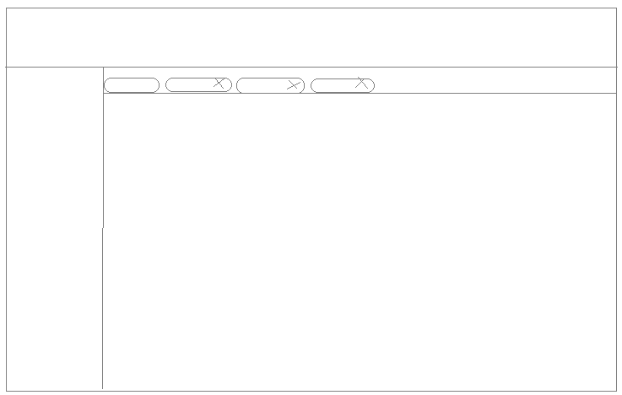

- Security : JAAS

- 权限

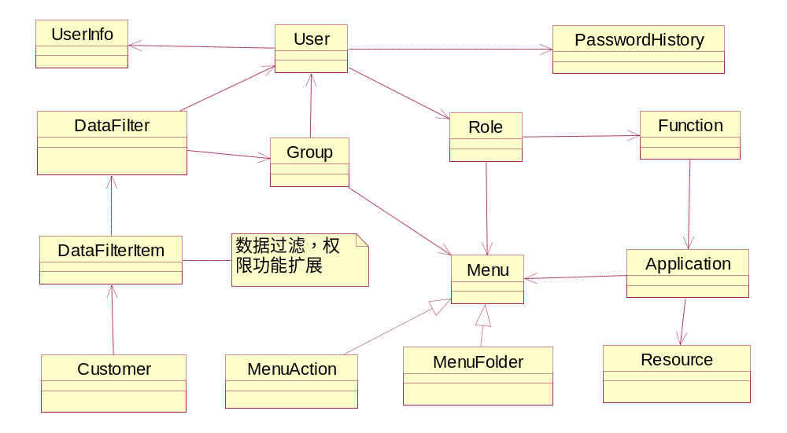
- 架构

Action-→actionForm , exception, security, validate

Delegate→transaction

BO→business object

DAO---jdbc

- 工作流

- 层次

BaseActon
| exception log4j
|

Processor
Datafile
Resource
Menu

Java project path configuration:

reascent
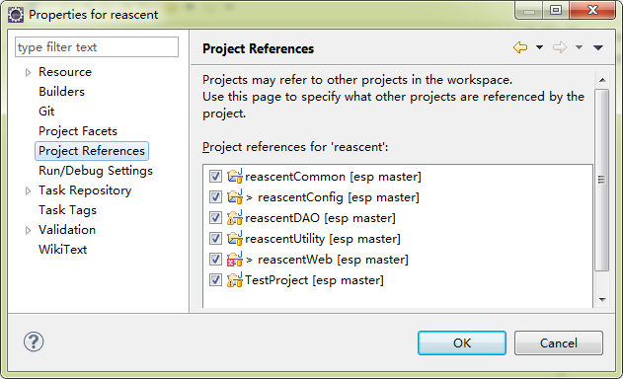

reascentCommon

reascentConfig
reascentDAO

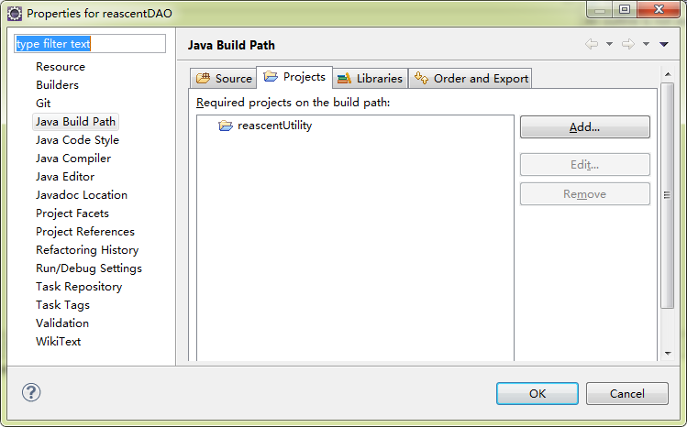

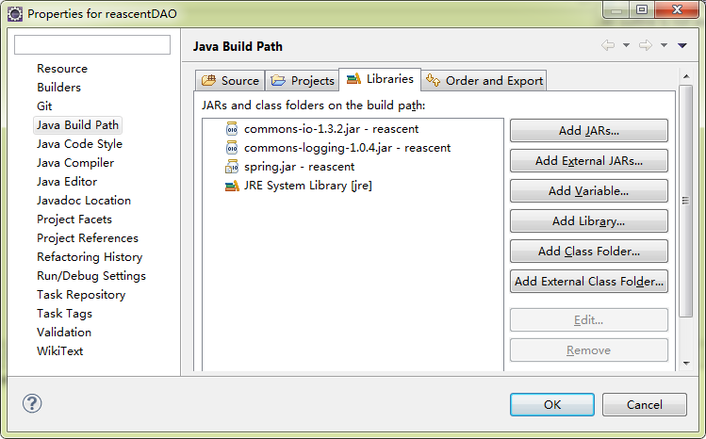

reascentUtility
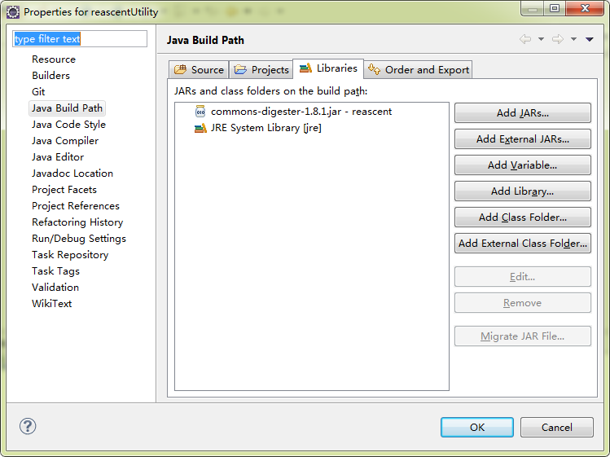

reascentWeb
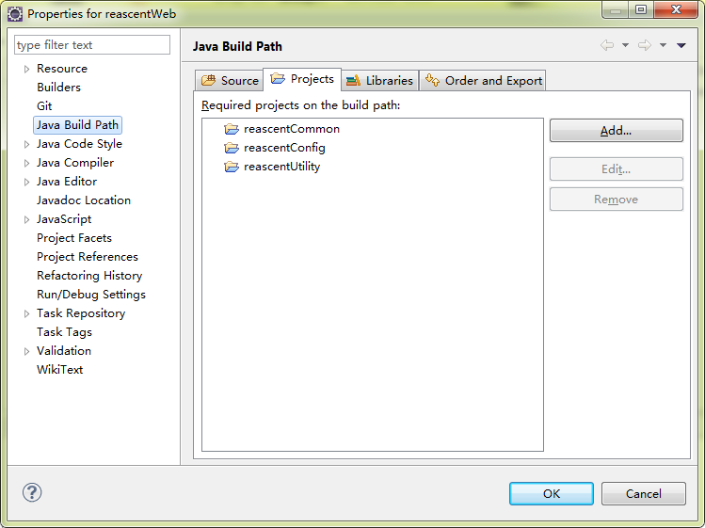

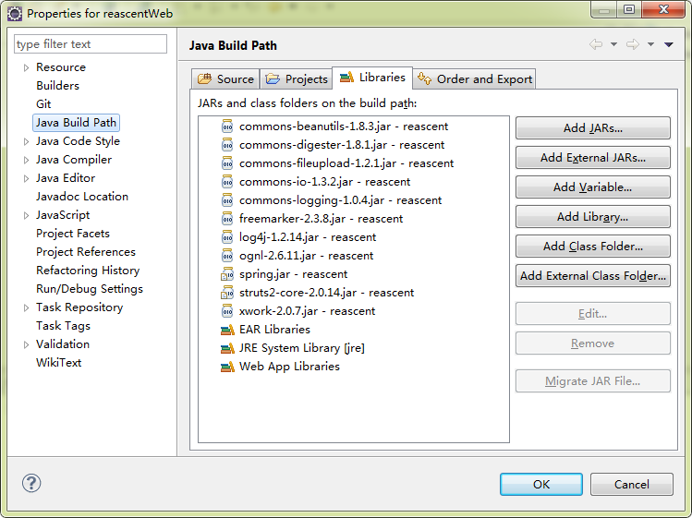

TestProject

