

LECTURER : DR. NOR HAFEIZAH BINTI HASSAN

QUESTION : 4.Staff registration and salary payment for a kindergarten

GROUP : GROUP 11 (ALPHA MALE)

GROUP MEMBERS :

|  |  |
| --- | --- |
| **Members ID** | **Members Name** |
| B032110302 | DINESHWAREN A/L RAJEN (L) |
| B032110400 | TARRSHAN A/L TAMILARASU |
| B032110409 | HERISH CHAUDRAY A/L RAVENTHERAN |
| B032110339 | SUREND A/L ESVARAN |

**2.0 SOURCE CODE**

//STAFF REGISTRATION AND SALARY CHECK FOR ALPHA MALE KINDERGARTEN

#include<iostream>

#include<fstream>

#include<stdlib.h>

#include<string>

using namespace std;

void login(); //function prototype for login

void registr(); // function prototype for registration

void payment1(string user); // function with argument of a user with type string

string user;

int main()

{

int choice;

cout << "///////////////////////////////////////////////////////////////////////\n\n\n";

cout << " ALPHA MALE Staff Portal \n\n";

cout << "///////////////////// MENU /////////////////////////////\n\n";

cout << "1.LOGIN" << endl;

cout << "2.REGISTER" << endl;

cout << "3.Exit" << endl; /// main menu display

cout << "\nEnter your choice :";

cin >> choice;

cout << endl;

switch (choice)//switch statement for choice entered by user

{

case 1:

login();

break;

case 2:

registr();

break;

case 3:

cout << "Hope to see you again\n\n";

break;

default:

system("cls");

cout << "Please ,Try again..\n" << endl; // error message when a bad choice is added

main();

}

}

void login() // function header of login type void

{

int count = 0;//true

string user, pass, u, p;

cout << "Please enter your username and password" << endl;

cout << "USERNAME :";

cin >> user;

cout << "PASSWORD :";

cin >> pass;

ifstream input("database.txt"); // searches on file "database.txt"

while (input >> u >> p)

{

if (u == user && p == pass)

{

count = 1;//true

system("cls"); //system closes the terminal

}

}

if (count == 1)//login successful note

{

int opt;

cout << "\nHi " << "#" << user << "\n<<LOGIN SUCCESSFUL>>" << endl;

cout << "1. Check payment \n2. Exit to main menu" << endl;

cout << "Choice : ";

cin >> opt;

if (opt == 1)

{

payment1(user);

}

else if (opt == 2)

{

main();

}

else

{

cout << "Try again !" << endl;

login();

}

}

else //retry menu if password or username is wrong

{

int option;

cout << "\nLOGIN ERROR\nPlease check your username and password" << endl << endl;

cout << "Do you want to try again or proceed to main menu ?" << endl;

cout << " 1 . Main menu \n 2 . Login Page \n Option : ";

cin >> option;

system("cls");

if (option == 1)

{

main();

}

else if (option == 2)

{

login();

}

else

{

system("PAUSE");

}

}

}

void registr() // function header

{

string name, ic, ru, rp, phone, address, email;

char gender;

string reguser, regpass;

int age;

int maxIC=12;

int maxPh = 11;

system("cls");

cout << "Enter your Name as Per IC :" << endl;

getline(cin.ignore(100, '\n'), name);

cout << "\nEnter your Identification Card Number :" << endl;

cin >> ic;

while (ic.size() > maxIC || ic.size()< maxIC)

{

//validates the ic number entered

cout << "Incorrect Idetification Card Number." << endl;

cout << "Enter your Identification Card Number :" << endl;

cin >> ic;

}

cout << "Please enter your age :" << endl;

cin >> age;

if(age < 20 || age > 58)

{

cout << "SORRY ! You are not eligible for this staff recruitment !" << endl;

main();

}

do // does the function as long M m F f is entered

{

cout << "\nEnter Your Gender (m/f) :";

cin >> gender;

if (gender == 'm' || gender == 'M')

{

cout << "Male" << endl;

}

else if (gender == 'f' || gender == 'F')

{

cout << "Female" << endl;

}

} while (!(gender == 'm' || gender == 'M' || gender == 'f' || gender == 'F'));

//executes do while 'while' statements is true

cout << "\nEnter your phone number :" << endl;

cin >> phone;

while (phone.size() > maxPh || phone.size()<10)//validates the size of phone number

{

cout << "Incorrect Phone Number!" << endl;

cout << "Enter your Phone Number :" << endl;

cin >> phone;

}

cout << "\nEnter your address :" << endl;

getline(cin.ignore(1, '\n'), address); // get address with spaces as well

cout << "\nEnter your email address :" << endl;

cin >> email;

ofstream read("details.txt", ios::app); //outputs the given details in "details.txt" with append mode

read << "NAME\t\t\t :" << name << endl << "IDENTIFICATION CARD NUMBER :" << ic << endl << "AGE\t\t\t :" << age << endl << "GENDER\t\t\t :" << gender << endl << "PHONE NUMBER\t\t :" << phone << endl << "ADDRESS\t\t\t :" << address << endl << "EMAIL ID\t\t :" << email << endl << endl;

cout << "Please create a account for further uses " << endl;

string usern;

cout << "Username :";

cin >> reguser; "\n";

cout << "Password :";

cin >> regpass;

// output user and passwords registered into "database.txt" with mode append mode

ofstream reg("database.txt", ios::app);

reg << reguser << ' ' << regpass << endl;//formats the user and password with a space

system("cls");

cout << "\nRegistration Sucessful\n";

cout << "You may now login" << endl;

main();

}

void payment1(string user)//uses argument as user from login

{

//array to make a comparison on days worked

int days_per_month[12] = { 31, 28, 31, 30, 31, 30, 31, 31, 30, 31, 30, 31 };

int month;

int days, total;

int day_pay = 10 * 8;

cout << "Month number [enter a number] :";

cin >> month;

while (month > 12 || month <= 0)//disallows user to input month less than equal 0 and more than 12

{

cout << "Please enter a valid month number " << endl;

cout << "Month number [enter a number] :";

cin >> month;

}

cout << "How many days did you work in month "<<month<<" " << user << " :";

cin >> days;

//days of work as not above 29 days selected and less than equal 0 days aren’t allowed

while (days <= 0 || days >= 29)

{

cout << "Please enter a valid value" << endl;

cout << "To retry please press enter " << endl;

cout << "How many days did you work in month " << month << " " << user << " :";

cin >> days;}

//moduled to show days comparison x/y (12 out of 31 days) according to the days in a month

if (month != days_per_month[month - 1])

{

cout << "\nYou worked " << days << " out of " << days_per_month[month - 1] << " days in month " << month;

// calculation of salary

total = days * day_pay;

cout << "\n" << "Your salary for month " << month << " is RM " << total << endl;

cout << "Returning to main menu ..... ";

system("PAUSE");

main(); // return to main function

}

}

**3.0 OUTPUT OF PROGRAM**

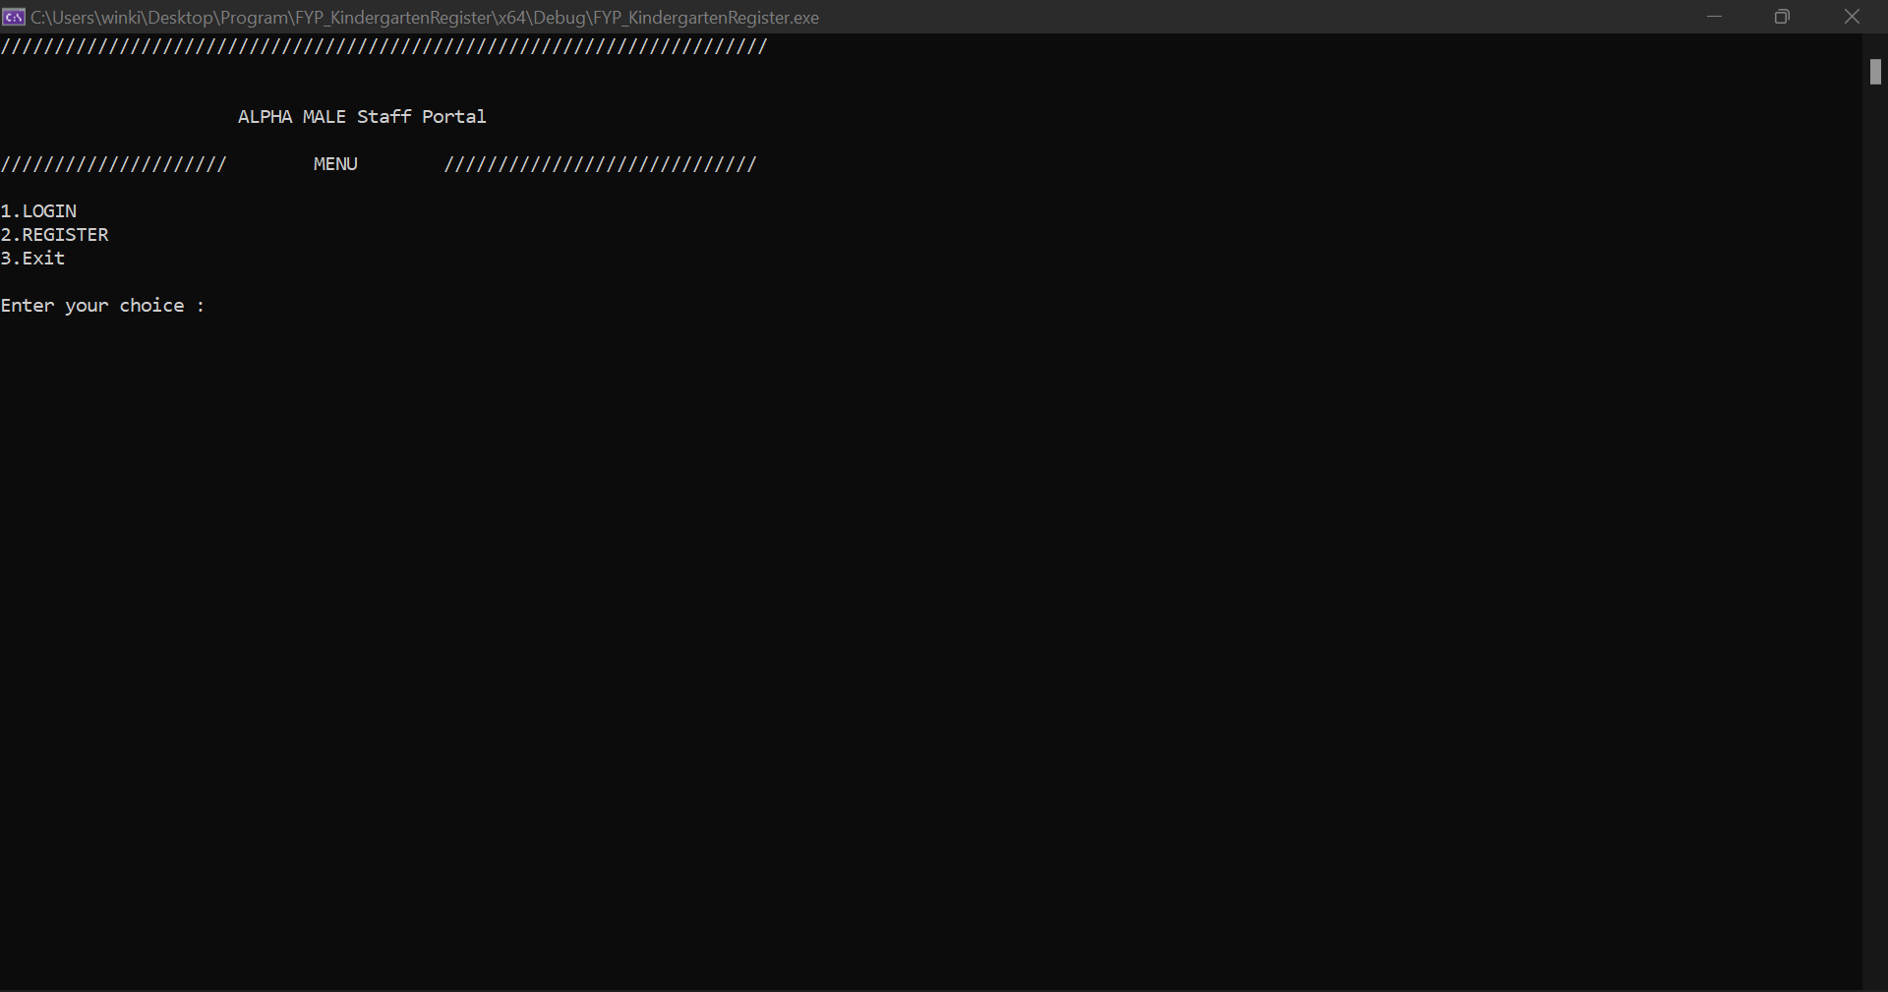

*(main menu of program)*

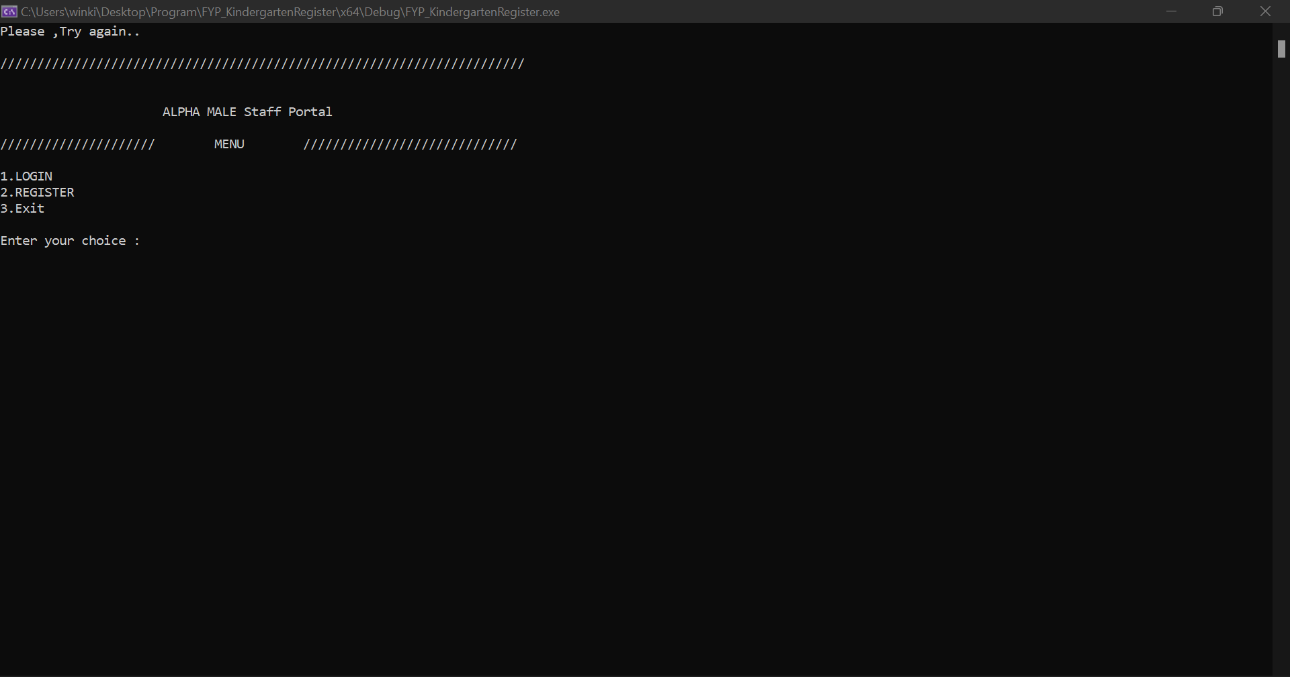

*(when a wrong option number is selected)*

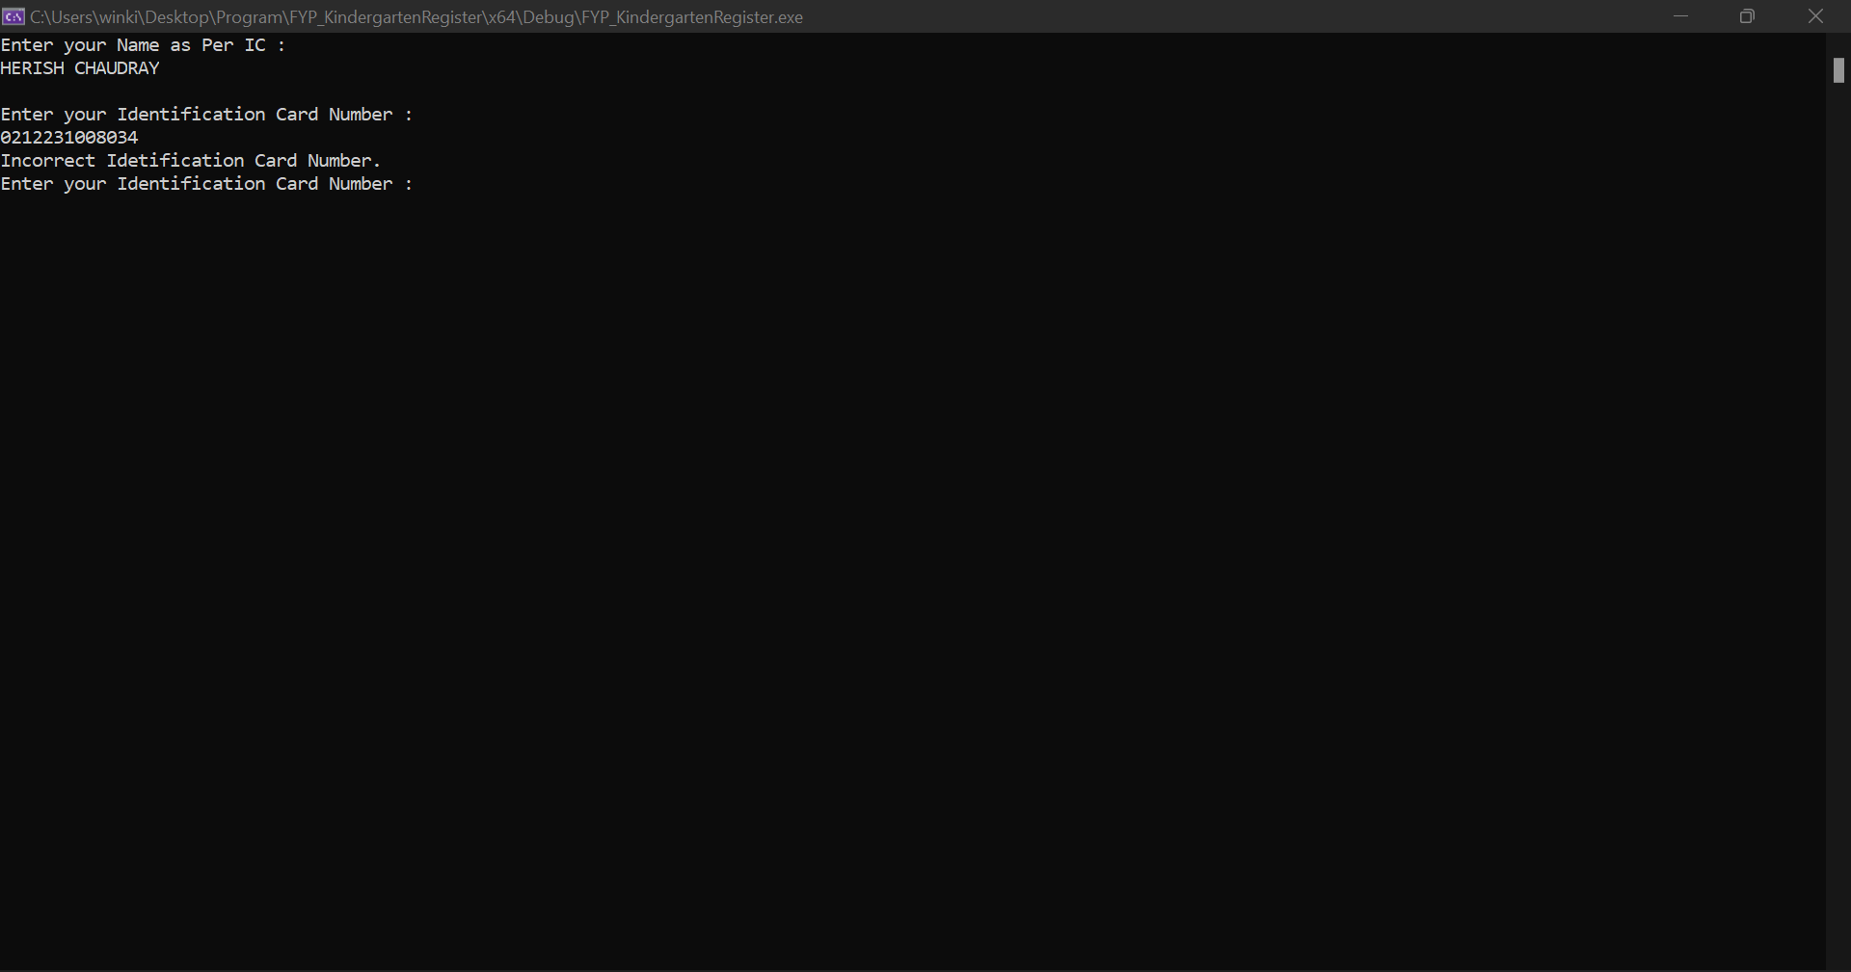

*(registering while wrong ic number is input)*

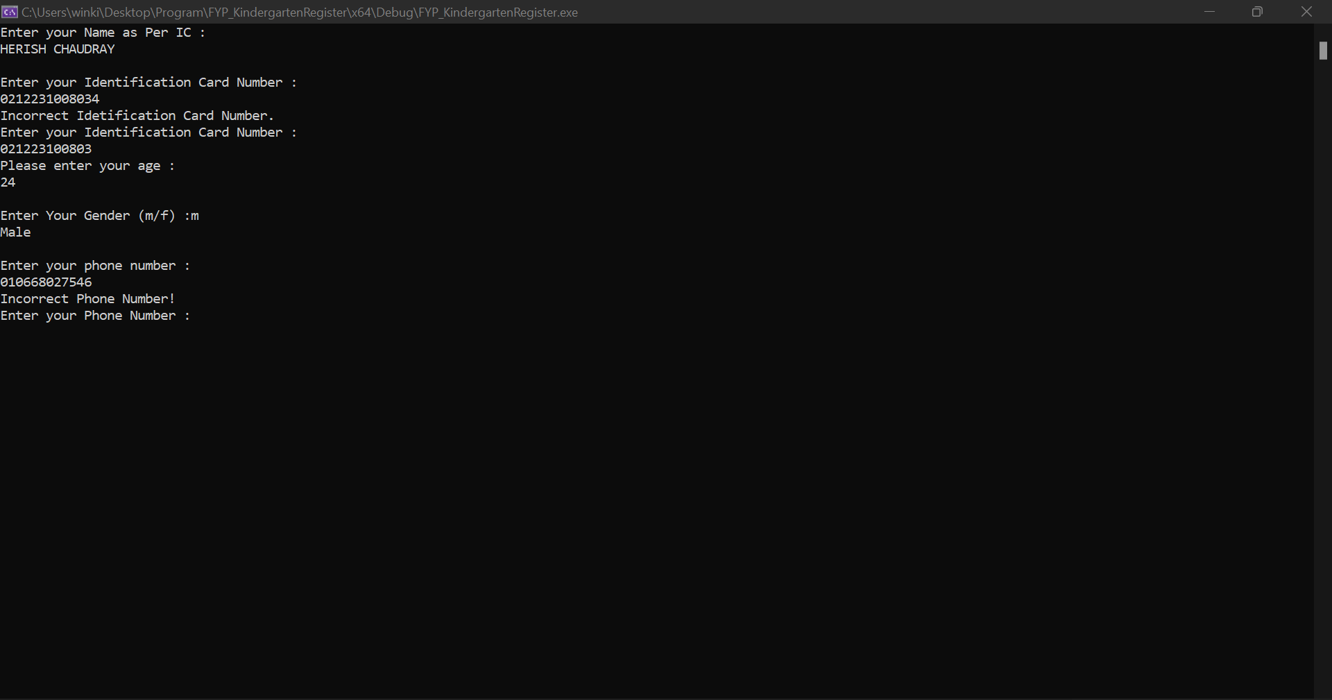

*(registering while wrong phone number is added)*

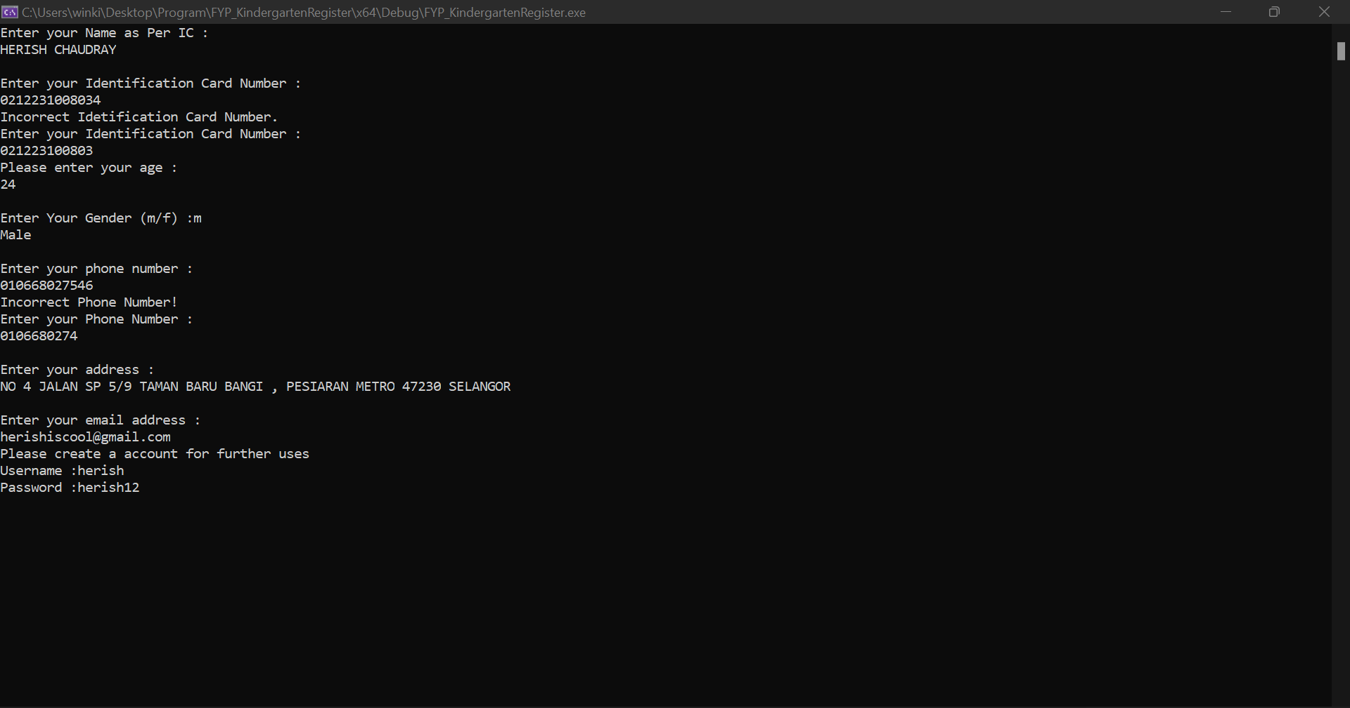

*(account registration)*

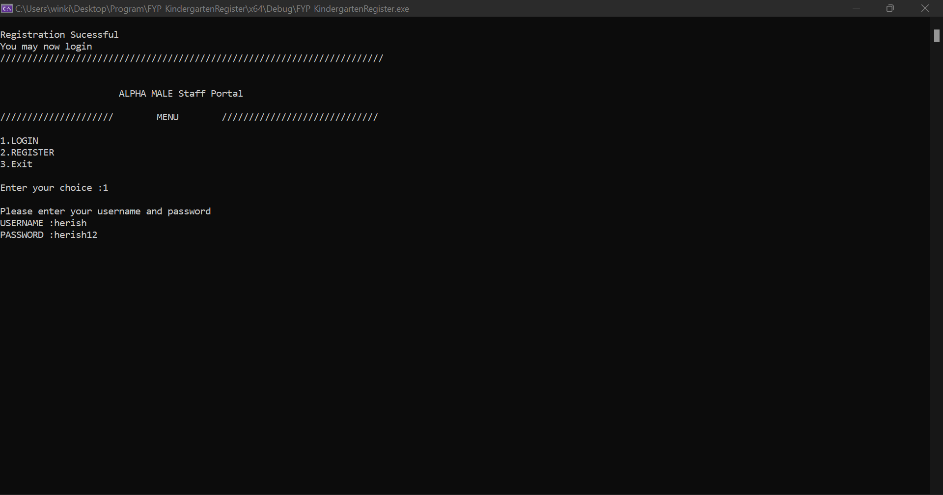

*(post registration)*

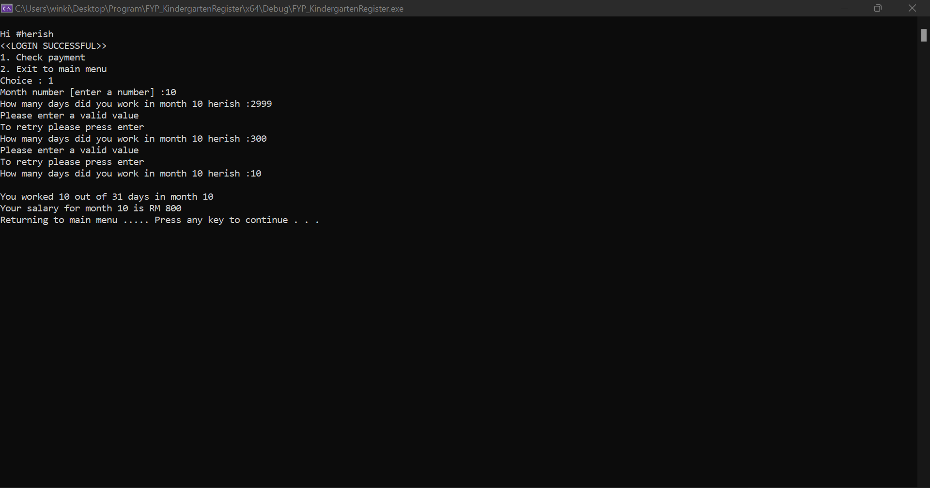

*(login with registered account and checking payment with extreme values)*

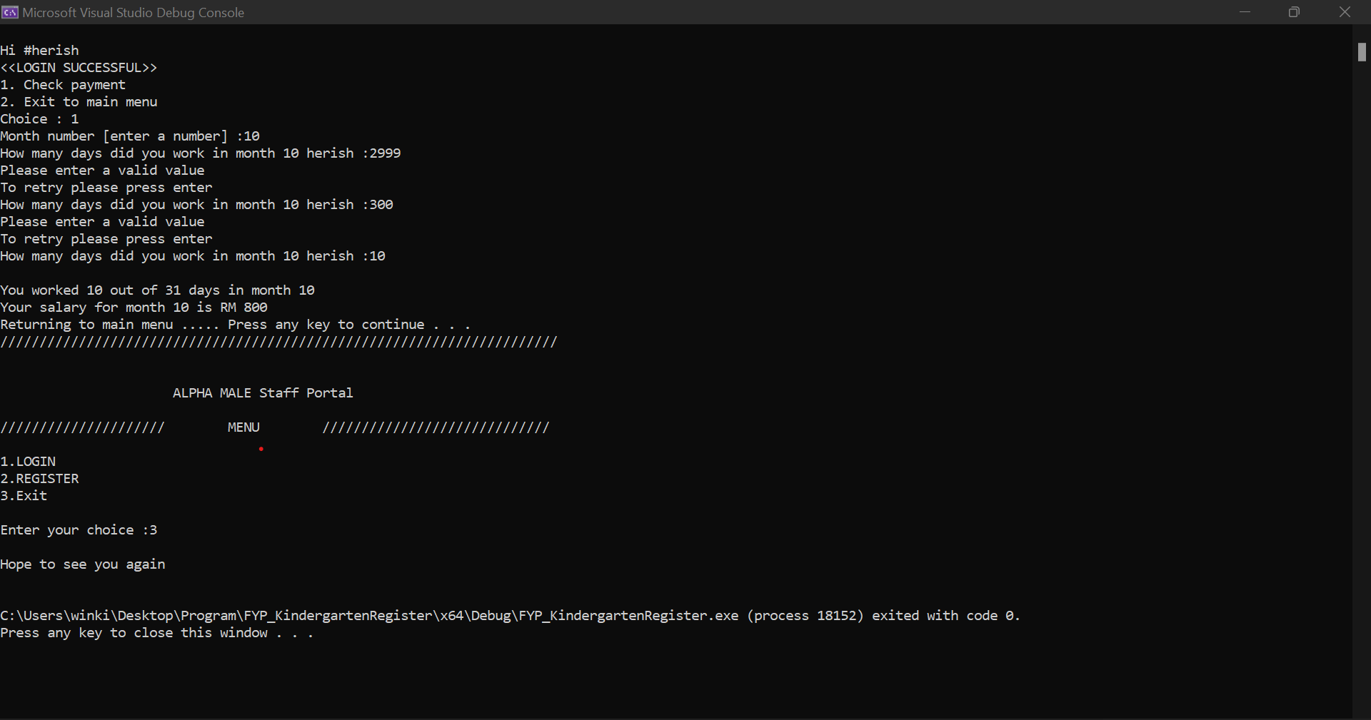

*(checking payment and exiting program)*