# Ringing the Bell

Tom King and Val Szigeti 7/5/2025

Last month, we went to New York City to watch our older son, Ryan, ring the bell at the stock exchange as the company he co-founded with his business partner Chris Britt 13 years ago went public.

Ryan’s Executive Assistant, Melissa Parker, made all the arrangements for us, including travel by private jet, hotel accommodations (right across from the NYC Public Library), private car with driver, access to the NASDAQ, dinner reservations and much more – we were pampered.



Julia King (David’s wife), Alana King (14), Tom, Jennifer King (Ryan’s wife), Melina King (11), Ryan, Val, David King

When you travel by private jet, you don’t have to get to the executive terminal hours ahead of time, you don’t have to go through security, the pilot loads your luggage, and when everyone’s onboard, you take off. Cabin pressure is such that your ears don’t pop, you travel at 45,000 – 50,000 feet, flying time is shorter, you can turn your chair 360 degrees, and there’s even a bed to sleep on. Your pre-ordered meal is served on white tablecloths… we decided we could get used to this.

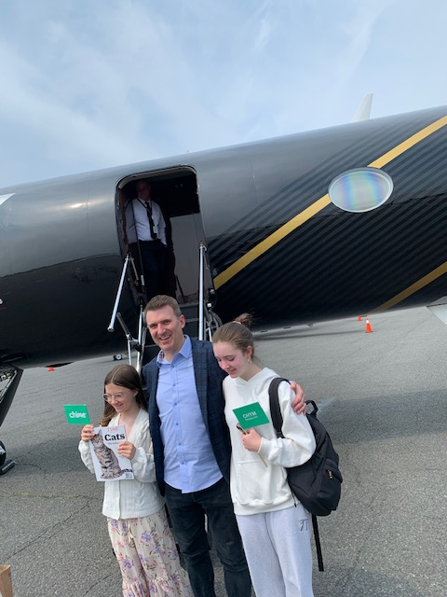

We arrived at Teeterboro Executive Airport on Tuesday and were taken by van to our hotel in mid-town Manhattan, right across from the NYC Public Library. Wednesday was a free day although we had to fill out some electronic forms to get passes into NASDAQ for the next day.

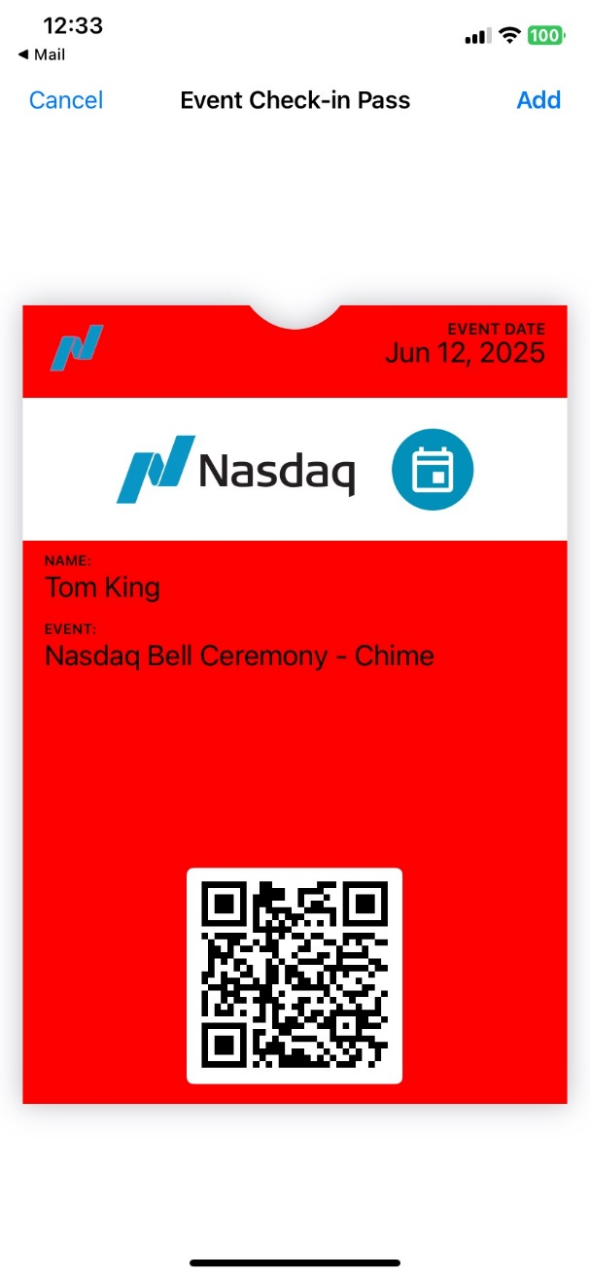

We had dinner with Val’s brother, Kal, and one of his sons; they came over from Long Island. Melissa made the reservations of course.

Thursday was the ringing of the bell as all the electronic display boards around Times Square were lit up with Chime ads. The event was broadcast from inside the NASDAQ stock exchange and live-streamed to the many gatherings of Chime employees around the country including San Francisco. Here’s a link to Ryan’s speech (we call it The King’s Speech 😉): <https://www.dropbox.com/scl/fi/fkbtvetxphdxwo3tzat9r/RyanAtNASDAQ250612.MOV?rlkey=vn6k5mbm2rzcis4anxa7t8cem&e=1&st=itsnd5t3&dl=0>

Big party on Thursday evening at Cipriani’s at 55 Wall Street, then back to San Francisco on Friday.