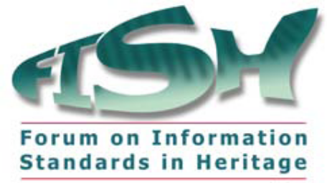


FISH-HEIRNET Spring Meeting – 8th June 2015

Location: English Heritage Office, 1 Waterhouse Square, 138-142 Holborn, London EC1N 2ST. Tel. 0207 973 3000. Belsay/Whitby Room
Time: 11.00 – 15:00 start. Working Lunch provided at 12.30.

AGENDA

1. Welcome and apologies

2. Minutes and Actions of the last meeting

3. Matters Arising

4. MIDAS Heritage – future direction

5. FISHTWG – update and the Thesaurus of Cultural Heritage

6. Websites – FISH, INSCRIPTION AND HERITAGEDATA.ORG

7. TACOS next steps for FISH

8. Data supply and reconciliation Project – Graham Tait

9. BIAB update

10. Reports from Contributing Organisations

11. Potential future agenda items

12. AOB

