MIDAS - A manual and data standard for monument inventories
Loose Leaf – January 1, 1998

The Royal Commission, in association with local government archaeologists, English Heritage, the National Trust and the British and Irish Archaeological Bibliography, has prepared this guide to "best practise in the compilation of monument inventories", intended, given the disassembled nature of the heritage sector in this country at present, to provide a "framework within which inventories should develop". This data standard is recommended for use by national organisations, local authorities and local groups - anyone who goes about the systematic collection of data on the monuments of England - in the interests of a more cohesive national data bank.

Product Details
- Loose Leaf: 133 pages
- Publisher: English Heritage (January 1, 1998)
- Language: English
- ISBN-10: 1873592337
- ISBN-13: 978-1873592335
- Product Dimensions: 11.4 x 8.1 x 0.4 inches
- Author: Ed Lee

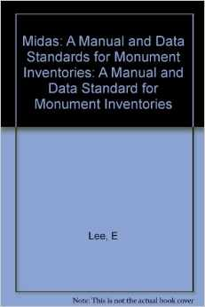

Amazon
http://www.amazon.com/MIDAS-manual-standard-monument-inventories/dp/1873592337

