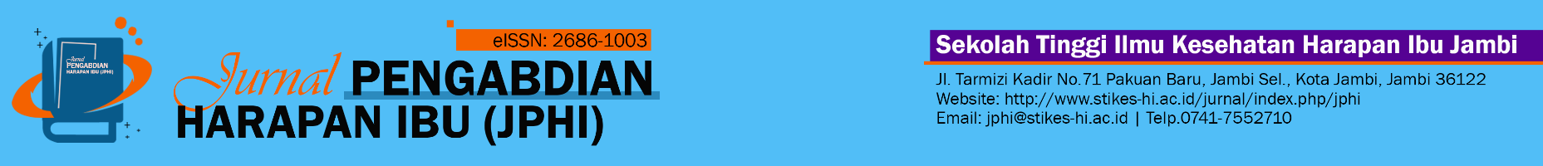
Jambi, 10 Juli 2026
Letter of Acceptance (LoA)

Dear author,

It's my pleasure to inform you that, after the peer review, your paper,
Title: | Pendampingan Ibu Balita melalui Penguatan Pengetahuan Imunisasi dan Pemberdayaan Kader Posyandu di Wilayah Kerja Puskesmas Limapuluh, Pekanbaru
Author(s): | Nurwijayanti ¹, Rifa Yanti²
Article ID: | 1252
has been ACCEPTED to be submitted in Jurnal Pengabdian Harapan Ibu (JPHI), e-ISSN: 2686-1003 and it will be available online at https://jurnal.stikes-hi.ac.id/index.php/jphi/index in Vol. 8 No.3 October 2026 .
Thank you very much for submitting your article to Jurnal Pengabdian Harapan Ibu (JPHI). I believe that our collaboration will help to accelerate global knowledge creation and sharing one step further.

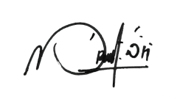
Best Regards

Ns. Marthalisa Wirahandayani, S.Kep., M.Kep
Journal editor

Sekolah Tinggi Ilmu Kesehatan Harapan Ibu Jambi
Jl. Tarmizi Kadir No.71 Pakuan Baru, Jambi Sel., Kota Jambi, Jambi 36122
Website: https://jurnal.stikes-hi.ac.id/index.php/jphi/index
Email: jphi@stikes-hi.ac.id
Telp.0741-7552710

