CONCERN CONSULT Ltd. (CCLtd)
Corporate Website Content Blueprint
1. About Us
CONCERN CONSULT Ltd. (CCLtd) is a legally registered Rwandan consultancy firm providing business advisory, technical consultancy, and training & development services.
We work across key sectors including business and entrepreneurship development, education and curriculum reform, and leadership and management systems. Our focus is on designing practical, context-driven solutions that respond to the real needs of individuals, organizations, and institutions.
At CCLtd, we specialize in developing custom models, systems, and capacity-building programs that enable our clients to become more effective, efficient, and impactful in achieving their goals. We partner with organizations of different sizes to deliver practical, innovative, and results-oriented solutions that drive growth and transformation.
Vision
To be a leading provider of technical consultancy, training & development, and advisory services that shape effective individuals and organizations.
Mission
To promote individual, organizational, and institutional growth through the delivery of high-quality, practical, and impactful consultancy and training services.
Core Objectives
- Design and deliver tailored training programs based on client needs.
- Promote entrepreneurship through practical, client-centered business advisory services.
- Develop systems and tools that strengthen professionalism, leadership, and organizational performance.
- Support institutions and individuals to achieve sustainable growth and improved effectiveness.
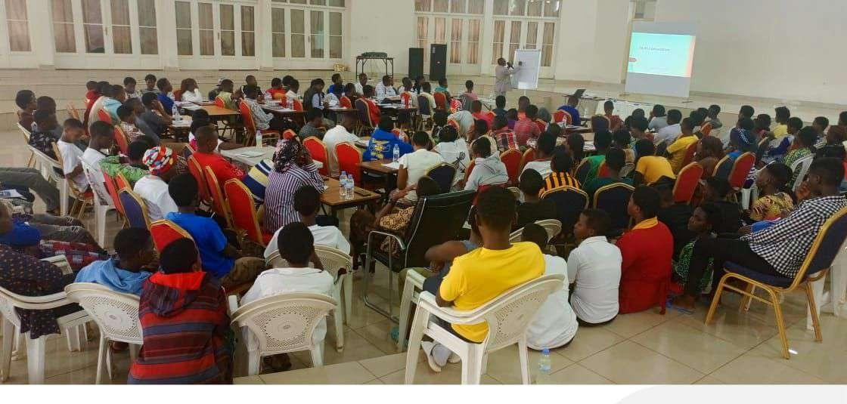
Figure 1: A cross-section of Rwandan professionals attending a masterclass on organizational performance and execution.
2. About the Founder
Rogers Patrick Kamugisha
Rogers Kamugisha Patrick is an education strategist, economist, and development practitioner with over 15 years of experience designing and scaling education, entrepreneurship, and business development solutions across East Africa. He is the Executive Director of Concern Consult Ltd., where he leads advisory work in education reform, entrepreneurship systems, and organizational development.
He is an internationally recognized education innovator and was a finalist for the Africa Education Medal, one of Africa’s most prestigious recognitions for impact in education. He is currently pursuing a PhD in Development Finance at Nelson Mandela University and holds an MBA (Marketing) and a Bachelor’s degree in Economics from Makerere University.
Rogers is a product strategist and instructional designer with deep expertise in entrepreneurship systems, curriculum development, and building scalable learning models that bridge education and real-world skills.
Key Achievements
- Finalist for the Africa Education Medal, recognizing outstanding contribution to education in Africa.
- Designed and supported entrepreneurship and skills-based education programs implemented across East Africa.
- Senior National Master Trainer in competency-based and skills-based learning systems.
- Led development of entrepreneurship curricula and education content used in schools and teacher training programs.
- Supported youth leadership and entrepreneurship development through mentoring and training programs.
3. Our Services
CONCERN CONSULT Ltd. is a leading provider of business advisory, technical consultancy, and training & development services in Rwanda, focused on bridging the gap between organizational strategy and real-world performance. We support businesses and institutions to improve effectiveness by strengthening systems, building capacity, and enabling practical execution of their goals.
I. Business Advisory Services
At CONCERN CONSULT Ltd., our Business Advisory Services are designed to strengthen all aspects of business performance—from financial management and marketing to operations, strategy, and growth planning. We support businesses to improve how they operate, how they reach customers, and how they scale sustainably. Our focus is on helping organizations move from ideas to execution, and from challenges to measurable performance.
Our advisory team brings together a mix of business coaches, mentors, and finance professionals, enabling us to provide practical, hands-on support tailored to businesses at different stages of growth. We work closely with entrepreneurs and organizations to identify strengths, address gaps, and design solutions that are aligned to their specific needs and context.
Our Advisory Focus Areas
- Marketing and market development
- Business management and operations
- Research and business insights
- Start-up development and growth support

Figure 2: Interactive business mentoring session focusing on startup management and operations strategies.
II. Technical Consultancy Services
CONCERN CONSULT Ltd. provides a comprehensive range of technical consultancy services across business, management, and education systems reform. We work with individuals, organizations, and institutions to translate strategy into effective implementation and measurable results. Our approach is highly practical and hands-on, ensuring that clients not only design strong plans but also successfully execute them in real-world contexts.
1. Project Management Consultancy
Successful project delivery requires strong systems, discipline, and effective leadership at both individual and organizational levels. We support clients to build these capabilities and ensure consistent delivery of results.
- Providing experienced project management expertise for short- and long-term assignments.
- Strengthening leadership, planning, and execution for successful project delivery and closure.
- Coaching project managers, teams, and leadership structures to improve performance.
- Supporting organizational change management processes to ensure effective adoption of new systems and practices.
We combine practical experience with structured methodologies to help organizations improve execution discipline and achieve sustainable project success.
2. Curriculum Reform & Education Systems Advisory
Across the Eastern and Southern Africa (ESA) region, many education systems continue to face challenges in translating curriculum reforms into improved learning outcomes, particularly in skills-based education. Effective curriculum reform requires alignment between curriculum content, teacher training, teaching methodologies, and assessment systems. While many educators understand the shift required, they often need structured support to implement it effectively.
CONCERN CONSULT Ltd. provides advisory and capacity-building services to educators and school leaders, university and training institution managers, and education policymakers and reform teams to strengthen the practical implementation of skills-based and competency-based learning systems to improve learner outcomes.
3. Additional Consultancy Areas
- Proposal development (RFPs and RFIs)
- Business process management and optimization
- Leadership and organizational development
- Business planning and enterprise development

Figure 3: Technical task team optimizing local business processes and developing execution plans.
III. Training & Development
CONCERN CONSULT Ltd. provides end-to-end training and learning solutions designed to align with your business strategy and strengthen human capital development in a structured and results-oriented way. Our focus is on designing, developing, and delivering tailored training programs that build practical skills, improve performance, and support organizational growth.
We work with organizations at any stage of their learning and development journey, offering a flexible approach that ensures value at every point of engagement.
Our Training & Development Approach
Our methodology is structured into key stages that ensure training is relevant, effective, and impactful.
Stage | Step | Strategic Focus
Stage 1 | Training Needs Analysis | Assessing organizational and team learning needs in relation to job roles and business objectives to target real performance gaps.
Stage 2 | Skills Audit & Assessment | Evaluating current capabilities across teams to isolate existing strengths, role-specific gaps, and clear operational baselines.
Stage 3 | Tailored Learning Program Design | Designing customized learning programs aligned with corporate goals that focus strictly on practical application.
Stage 4 | Training Delivery & Impact Assessment | Evaluating post-training outcomes to measure exactly what knowledge was gained and how it directly influences field performance.

Figure 4: A breakout team conducting a targeted skills assessment during a customized capacity-building workshop.
4. Partnerships & Collaboration
To expand our reach and strengthen impact, CONCERN CONSULT Ltd. actively seeks strategic partnerships with organizations, associations, and institutions across Rwanda. We believe that meaningful collaboration is essential to improving business performance, strengthening institutions, and delivering sustainable development outcomes for our clients. We welcome partnerships in areas of business advisory, education reform, training & development, and organizational capacity building.

Figure 5: A collaborative roundtable session exploring institutional partnerships and shared learning systems.
5. Contact Us
Our Address:
Centre Cesar, Avega, Kimironko Sector, Gasabo District, Kigali, Rwanda
Phone: +250 786 371 705
Email: kamugisharogers@gmail.com

