* ANDRIANTSILAVINA Tsiferana Heritsilavo 2632
* ANDRINIAINA Nirina Fifaliana 2774
* RAZANADRAKOTOMIARINJATO Mandrindra Andrianina Sendranotahina 2700
* ANDRIATOLOJANAHARY Maharo Mandampitiavana 2639
* RAMBOLAMANANA Fiderana Estella 2626

Loi uniforme

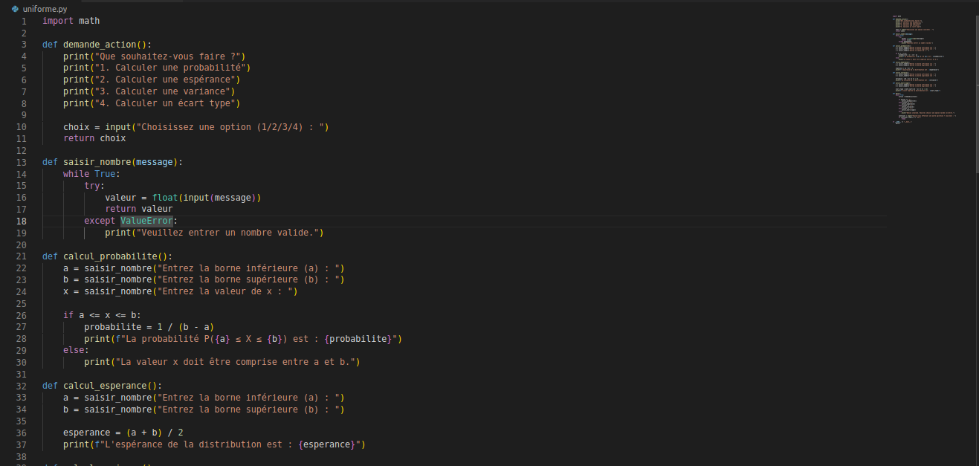

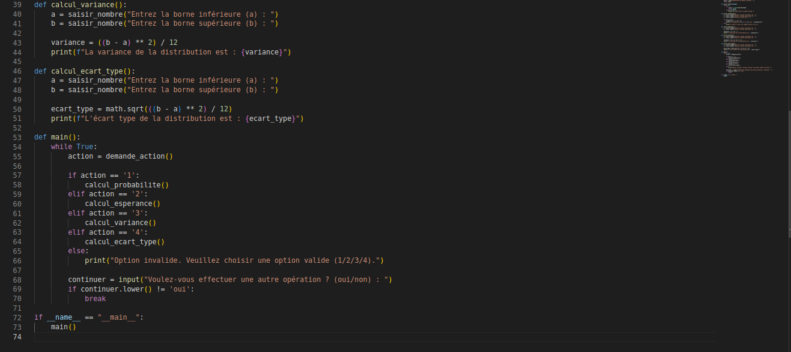

Loi Normale

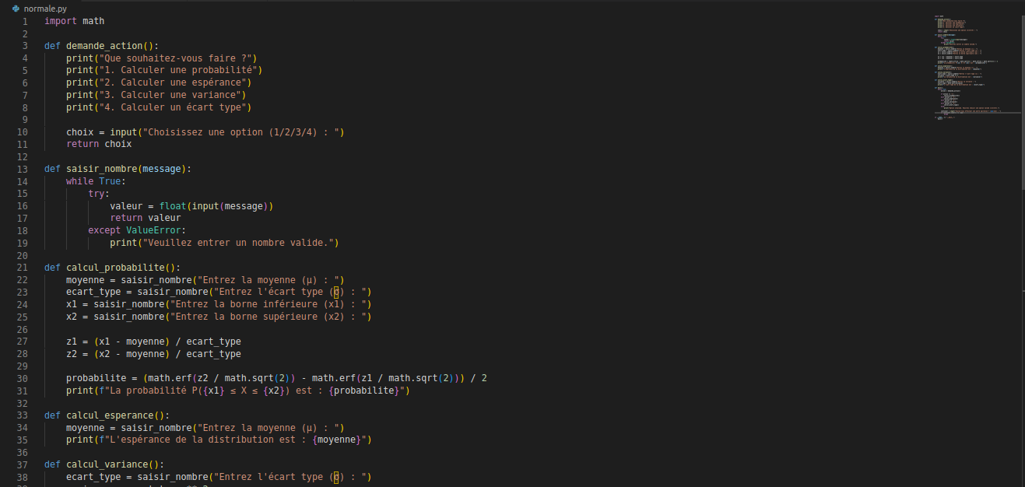

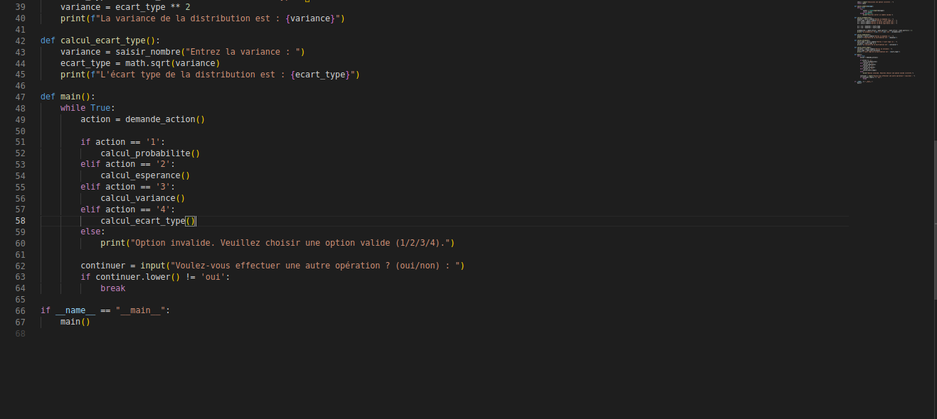

Loi de Pearson

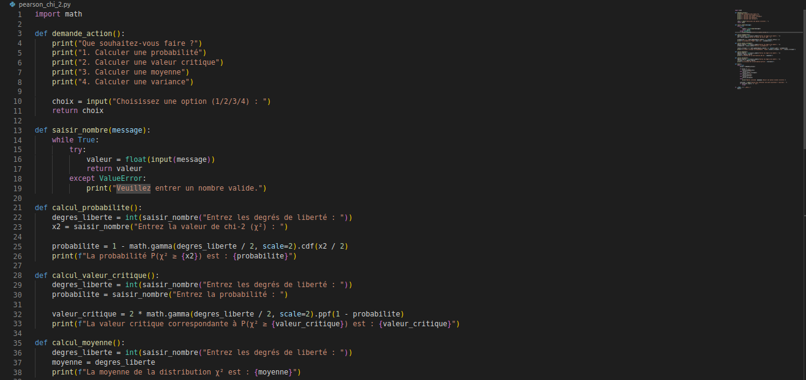

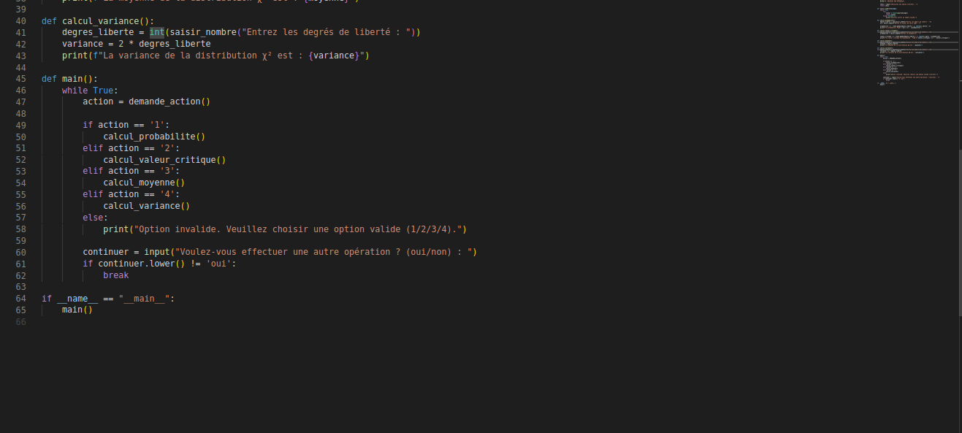

Loi de Fisher Snedcore

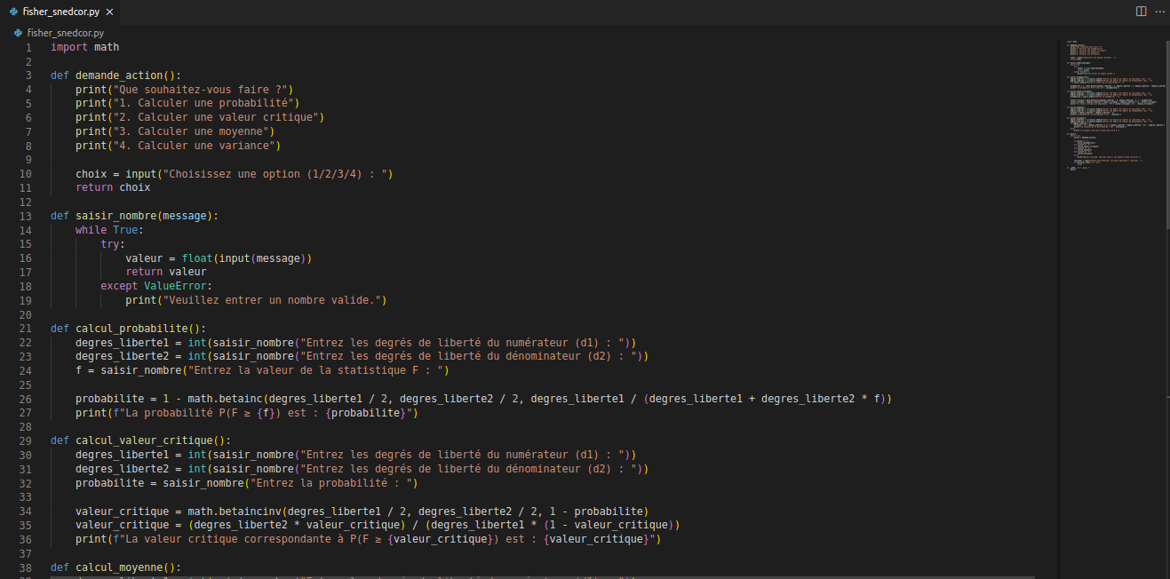

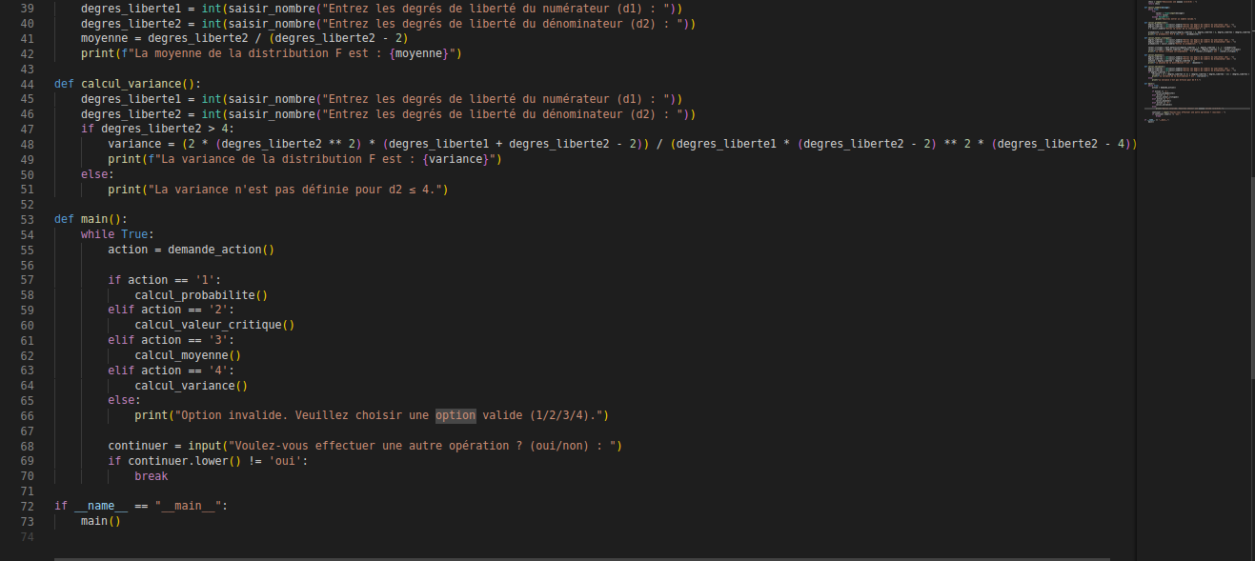

Loi de Student

