BUSINESS ANALYTICS CAPSTONE PROJECT
Power BI Business Analytics
Dashboard Development Report
Customer Purchasing Behaviour Analysis Using Microsoft Power BI

Prepared by
Mohamed Heriyanto Bin Jamal Mohamed
Market Analysis Track
Submitted in fulfilment of the Business Analytics Capstone Project
2026

Table of Contents
1. Introduction & Business Problem 3
2. Research Objectives 4
3. Dataset Overview 5
3.1 Customer Table 5
3.2 Purchase Table 5
4. Data Preparation 6
4.1 Customer Table Preparation 6
4.2 Purchase Table Preparation 6
4.3 Data Cleaning and Transformation Summary 7
5. Data Transformation & Data Model 8
6. DAX Measures & Calculated Columns 9
6.1 DAX Measures 9
6.2 Calculated Columns 9
7. Dashboard Development 10
7.1 Visual Selection Principles 10
8. Dashboard Analysis 11
8.1 Executive Dashboard 11
8.2 Customer Analysis 11
8.3 Product Analysis 12
8.4 Sales Trend 13
9. Business Recommendations 15
10. Challenges & Lessons Learned 16
11. Conclusion 17

1. Introduction & Business Problem
For this capstone project I set out to turn a raw set of customer and purchase records into a professional, interactive Power BI dashboard that management could actually use to make decisions. The company I analysed had customer and sales data sitting in disconnected tables, and while the data itself was complete, the insights inside it were difficult to see. Nobody could look at a spreadsheet of fifty thousand transactions and quickly answer a question like "which country is driving our revenue?" or "which age group should we be targeting?" That gap between having data and being able to use it was the core problem I designed my project around.
The business challenge, as I understood it, was that customer and sales data were available but insights were difficult to extract from raw tables. Management needed to know which customers, countries, products and months were driving performance, and there was no structured way to answer that quickly. I saw this as a clear opportunity for a business intelligence solution: Power BI could convert disconnected data into a structured, interactive view that decision-makers could explore themselves rather than waiting for a static report.
I decided the dashboard needed to deliver on four fronts. First, it had to turn raw customer and purchase data into interactive business insights. Second, it had to be built using proper Power BI practice — data modelling, DAX measures, calculated columns and well-chosen dashboard visuals, not just charts dropped onto a page. Third, its scope needed to cover customer demographics, product performance, sales trends and key customer segments, since those are the areas management cares about most. Finally, the outcome had to be actionable: I wanted the dashboard to support real recommendations on customer targeting, product focus and sales planning, not just describe the data.
Throughout the build I kept one design principle in mind: the dashboard is for management users, so it needed quick KPIs at the top of the page, more detailed analysis underneath, and slicers that let anyone filter the data interactively without needing to ask me for a new report every time a question changed. That principle shaped almost every decision I made from the data model through to the final page layout, and I refer back to it throughout this report.

2. Research Objectives
Before opening Power BI, I defined five research objectives to give the project a clear analytical direction. Everything I built afterwards — the data model, the measures, the individual dashboard pages — was designed to answer one or more of these objectives, and I use them later in this report to explain why each dashboard page exists.
- Analyse purchasing patterns by age, gender, country and income.
- Identify products with the highest sales revenue and purchase volume.
- Examine sales trends over time and identify peak purchasing periods.
- Evaluate customer segments that contribute the highest revenue and customer value.
- Provide business recommendations to improve sales, targeting and marketing strategy.
I used these five objectives as a checklist while designing the dashboard pages. The Customer Analysis page was built specifically to answer objectives one and four, the Product Analysis page answers objective two, and the Sales Trend page answers objective three. The final Business Recommendations section of both the dashboard and this report exists to satisfy objective five by translating the findings from the first four objectives into concrete management actions.

3. Dataset Overview
I worked with two source tables: a Customer table and a Purchase table. I imported both into Power BI Desktop using Get Data, and treated the Customer table as the descriptive, one-row-per-customer table and the Purchase table as the transactional fact table that everything else would be measured against.

3.1 Customer Table
The Customer table holds the demographic profile I used for segmentation throughout the dashboard. Its key fields are customer_id, gender, age, country and income. This is the table that lets me slice every revenue and order figure by "who" the customer is, which is central to objectives one and four.

3.2 Purchase Table
The Purchase table is the transactional record I used for product, order and sales analysis. I loaded fifty thousand purchase records into Power BI, with key fields including order_id, customer_id, product_name, price, quantity, discount, tax and order_date. Because this table is the fact table for sales performance, it powers almost every visual in the dashboard — revenue by month, orders by month, top products and the headline revenue KPIs all trace back to this single table.
Table | Row Level | Key Fields | Primary Use
Customer | One row per customer | customer_id, gender, age, country, income | Demographic segmentation and filtering
Purchase | One row per transaction (50,000 rows) | order_id, customer_id, product_name, price, quantity, discount, tax, order_date | Sales, revenue and trend analysis
Table 1: Overview of the two source tables used to build the data model.

4. Data Preparation
Once the two tables were loaded, I spent time in Power Query and in the data view checking and preparing the data before building anything visual. I did not want to build measures or charts on top of fields I hadn't verified, since errors at this stage tend to surface later as broken sorting or incorrect totals.

4.1 Customer Table Preparation
For the Customer table, I reviewed the existing fields — customer_id, gender, age, country and income — and then engineered two new fields that the raw data didn't provide on its own. I created an Age Group column so I could compare purchasing behaviour across meaningful age segments rather than every individual age value, and an Income Group column to classify customers into low, middle and high income bands. I also added sort columns alongside both of these so that the groups would appear in a logical order on charts and slicers instead of being sorted alphabetically.
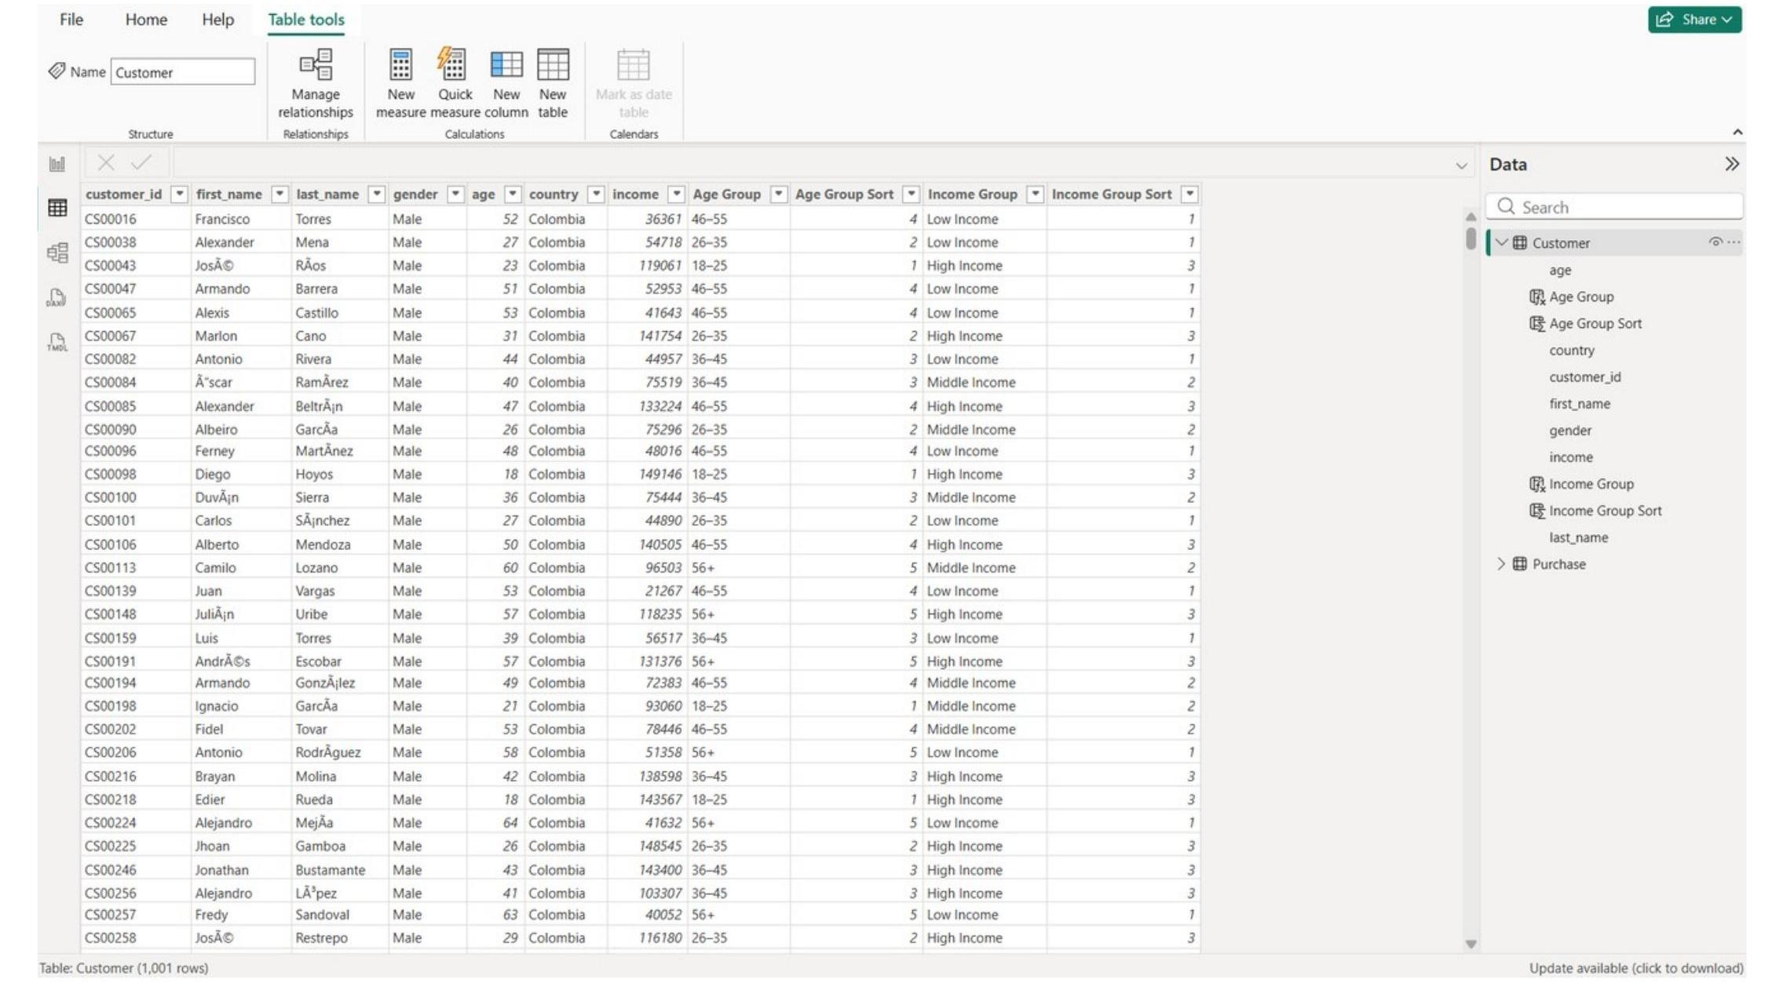
Figure 1: Customer table in Power BI, showing the Age Group, Age Group Sort, Income Group and Income Group Sort fields I created.

4.2 Purchase Table Preparation
For the Purchase table, my first step was simply confirming the scale of the data: fifty thousand purchase records, which is large enough that I had to be deliberate about performance and about getting data types right the first time. I reviewed the date, numeric and currency fields — price, quantity, discount, tax and shipping cost — to make sure they were typed correctly and would support accurate trend and revenue calculations. I then created Year, Month Name and Month Number fields from order_date so I could report on both a monthly and yearly basis.
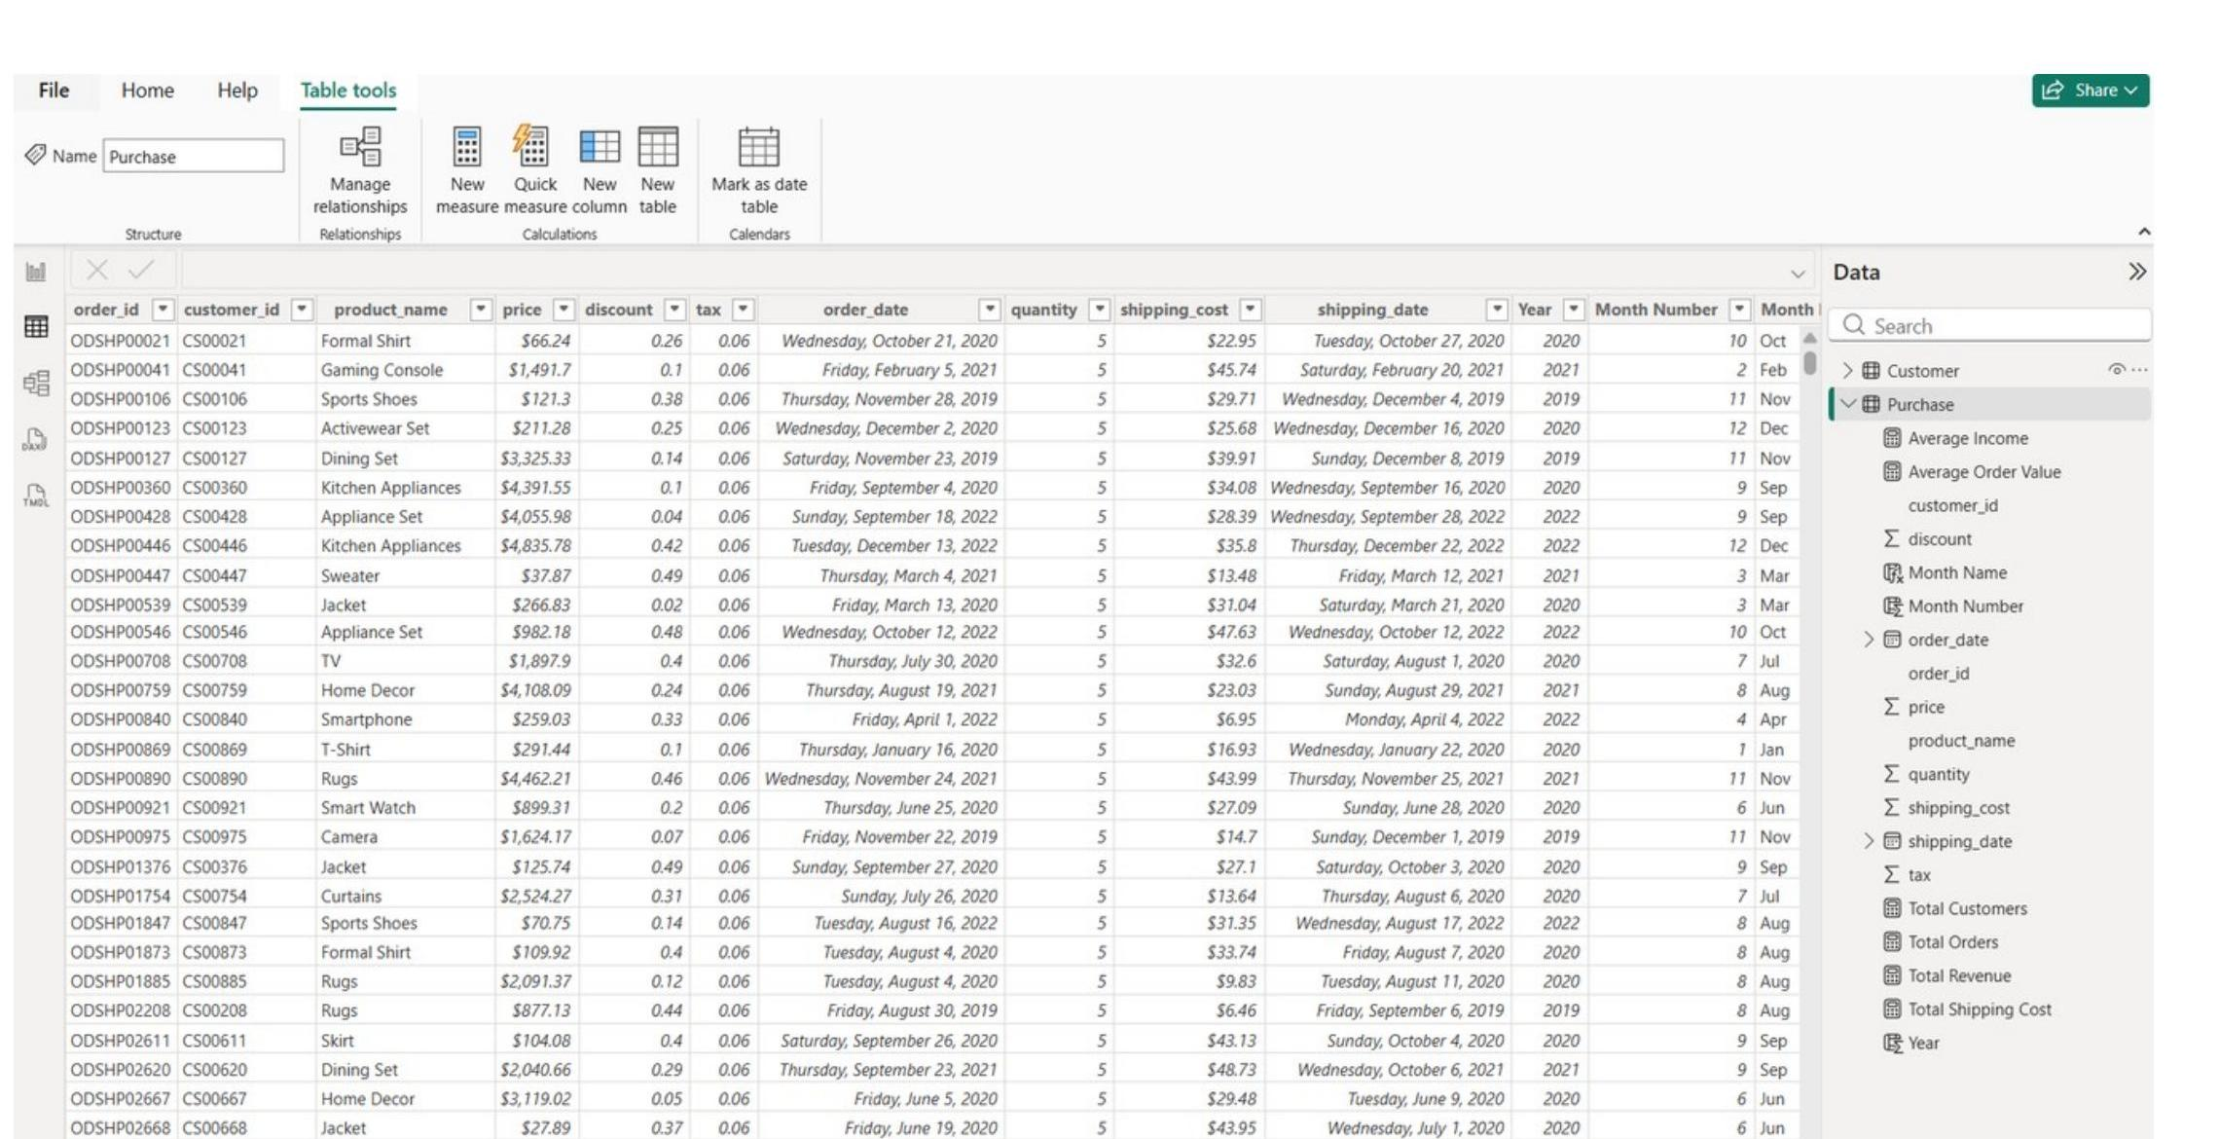
Figure 2: Purchase table in Power BI, showing the transaction fields and the Year, Month Name and Month Number fields I created.

4.3 Data Cleaning and Transformation Summary
Taken together, my data preparation work covered four areas that I treated as a checklist before moving into modelling:
- Data type validation: order_date and shipping_date set as Date fields; price, quantity, discount, tax and shipping cost checked and confirmed as numeric fields.
- Feature engineering: Age Group and Income Group created for customer segmentation; Year, Month Name and Month Number created for trend analysis.
- Data modelling: Customer and Purchase linked by customer_id in a one-to-many relationship to support demographic sales analysis.
- Dashboard validation: KPIs and charts tested against slicers, and Month Name sorted by Month Number so months display in calendar order rather than alphabetical order.
The key message I took into the next phase of the project was that the dashboard needed to be built from cleaned, transformed and modelled data, not from the raw tables alone. Skipping this stage would have meant carrying data type errors and unsorted categories straight into the visuals.

5. Data Transformation & Data Model
With both tables cleaned, I built the relationship that ties the whole model together. The Customer table contains one row per customer, while the Purchase table contains many purchase records per customer, so I connected them using a one-to-many relationship on customer_id: Customer[customer_id] 1 → * Purchase[customer_id]. This is the single relationship the entire dashboard depends on, because it allows customer demographics to filter purchase transactions correctly.
I chose this relationship structure deliberately rather than duplicating customer fields into the Purchase table. Keeping Customer and Purchase as separate, related tables meant every demographic revenue chart in the dashboard depends on this one clean relationship, and it meant slicers work correctly because filters flow from Customer through to Purchase whenever a user selects a country, gender or age group. A clean, single-direction relationship like this also reduces the risk of calculation and filtering errors compared with a model that has ambiguous or bidirectional relationships between the same two tables.
This step mattered more than it might sound, because every subsequent measure and chart in the project is only as reliable as the relationship underneath it. Once I confirmed the relationship was working correctly — by testing that selecting a country in a slicer correctly filtered the Purchase-side visuals — I moved on to building the DAX layer on top of this model.
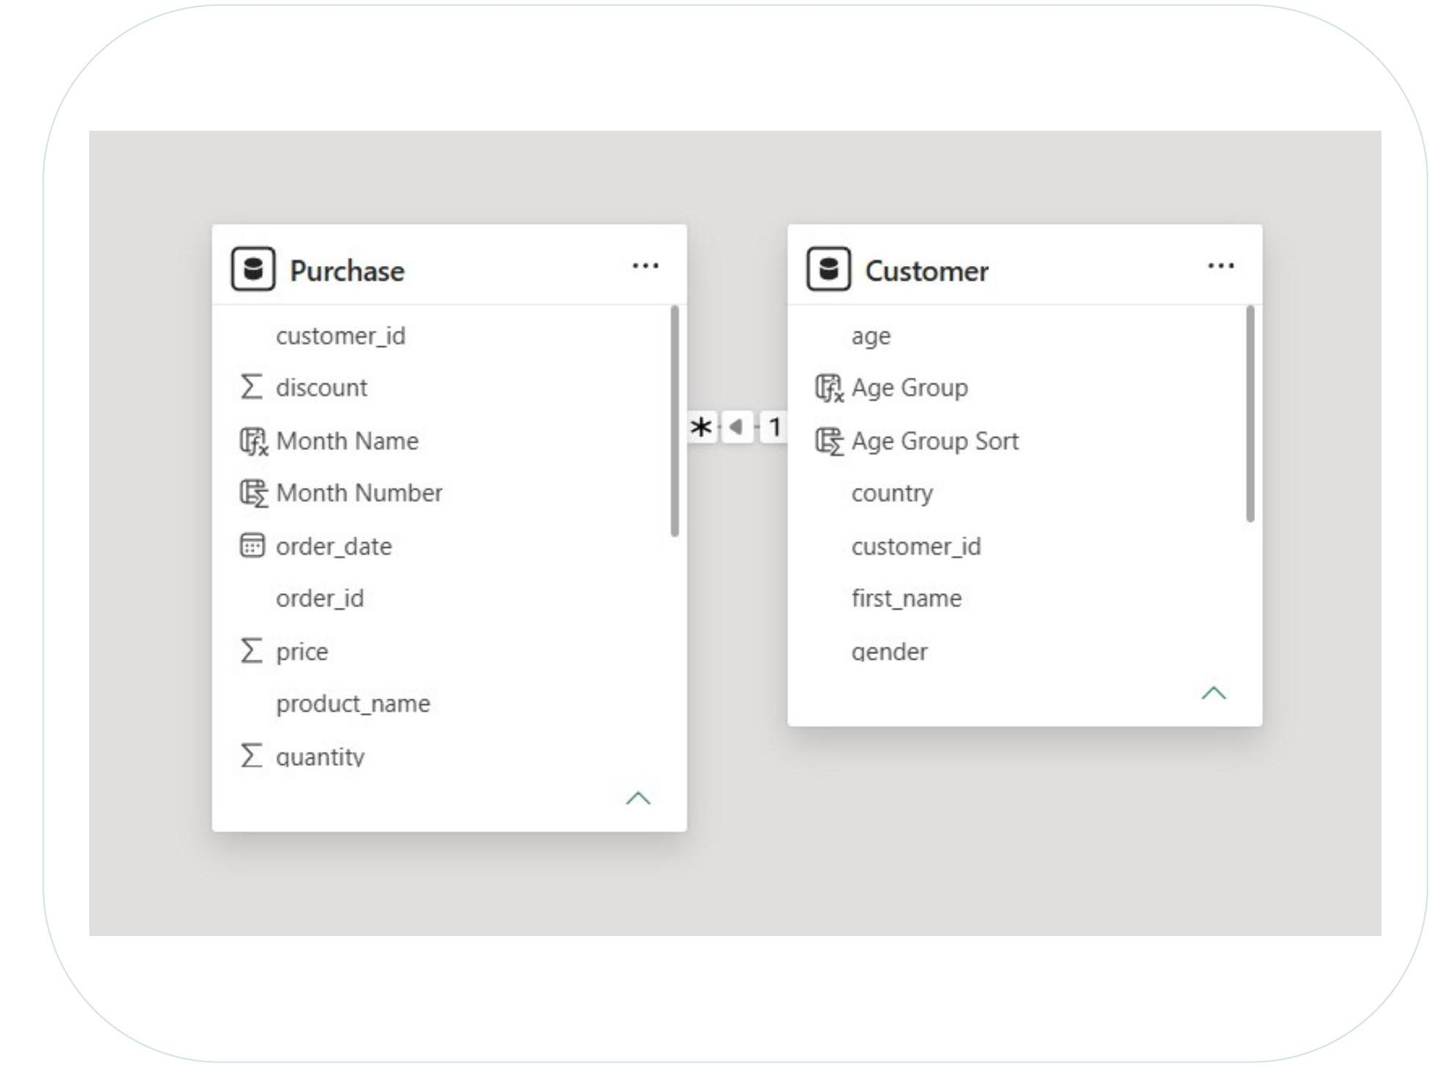
Figure 3: The Customer → Purchase relationship in Power BI's model view, joined on customer_id.

6. DAX Measures & Calculated Columns
With the model in place, I built the logic layer that powers every KPI card and chart in the dashboard. I split this work into two types of DAX: measures, which calculate dynamically based on whatever filters are applied, and calculated columns, which I used for grouping and sorting categorical fields.

6.1 DAX Measures
I created five core measures that are reused across the executive, product and trend pages of the dashboard:
- Total Revenue — the main performance metric used across the executive, product and trend pages.
- Total Orders — counts purchase activity and supports order trend analysis.
- Total Customers — measures the size of the customer base after any filters are applied.
- Average Order Value — shows average spending per order and supports customer value analysis.
- Total Shipping Cost — supports cost visibility and future profitability analysis.
I chose to build these as measures rather than as static calculated values for a specific reason: measures respond automatically to slicer selections, so the same Total Revenue measure recalculates whether a user has filtered to one country or to the whole dataset. This also avoids storing unnecessary calculated values on every row of the Purchase table, keeps the model lighter, and means I only had to define each metric once and could then reuse it across multiple visuals rather than rebuilding the logic per chart. This is standard practice in Power BI reporting, and it made the dashboard far more flexible than it would have been with hard-coded totals.

6.2 Calculated Columns
Alongside the measures, I created a set of calculated columns for fields that needed to be evaluated once per row and then used as chart categories or slicer fields:
- Age Group — groups customers into meaningful age segments for comparison.
- Age Group Sort — ensures age groups appear in logical order rather than alphabetically.
- Income Group — segments customers into low, middle and high income categories.
- Income Group Sort — ensures income groups appear ordered from low to high.
- Year, Month Name, Month Number — support time-based trend analysis and correct month ordering.
The distinction I applied here was straightforward: calculated columns make sense when a value is attached to each individual row, such as a customer's age group or a transaction's order month, because that value doesn't change based on filter context the way a measure's result does. Once created, I used these columns directly as chart categories and slicer fields throughout the dashboard, and the accompanying sort columns are what keep age groups, income groups and months displaying in a sensible order instead of Power BI's default alphabetical sort.

7. Dashboard Development
I approached the build as a six-step process, working through it roughly in order but returning to earlier steps whenever validation in a later step exposed something I needed to fix.
- Import data — I loaded the Customer and Purchase files into Power BI Desktop.
- Clean data — I checked data types, date columns, missing values and duplicates.
- Model data — I created the Customer → Purchase relationship using customer_id.
- Create logic — I built the DAX measures and calculated columns described in Section 6.
- Design dashboard — I built the pages, charts, slicers and applied consistent formatting.
- Validate output — I tested filters, verified KPIs and refined the visuals.

7.1 Visual Selection Principles
Rather than using as many chart types as possible, I selected each visual for a specific analytical purpose and tried to keep the chart choices consistent across similar questions:
- KPI cards — for a quick management summary of the headline numbers.
- Line charts — for trends over time, such as monthly revenue or orders.
- Bar charts (horizontal) — for ranking categories with longer text labels, such as countries or product names.
- Column charts (vertical) — for comparing a small number of discrete categories, such as age or income groups.
- Donut chart — for a simple proportion comparison, such as gender split.
- Slicers — for interactive, self-service filtering across the whole page.
My guiding rule was that the goal was never to showcase a variety of chart types, but to choose the visual that made the underlying business question as easy as possible to answer at a glance. I applied that rule consistently on the four dashboard pages I describe in the next section.

8. Dashboard Analysis
I organised the final dashboard into four pages, each built to answer a specific subset of my research objectives. I describe each page below in the same way I would walk a trainer or manager through it live: what the page shows, which chart types I used, and why.

8.1 Executive Dashboard
The Executive Dashboard is a one-page management summary of revenue, customers, orders and country performance, and it is the first page I designed because it sets the tone for how the rest of the dashboard should feel — quick to read, with detail available underneath for anyone who wants to dig further.
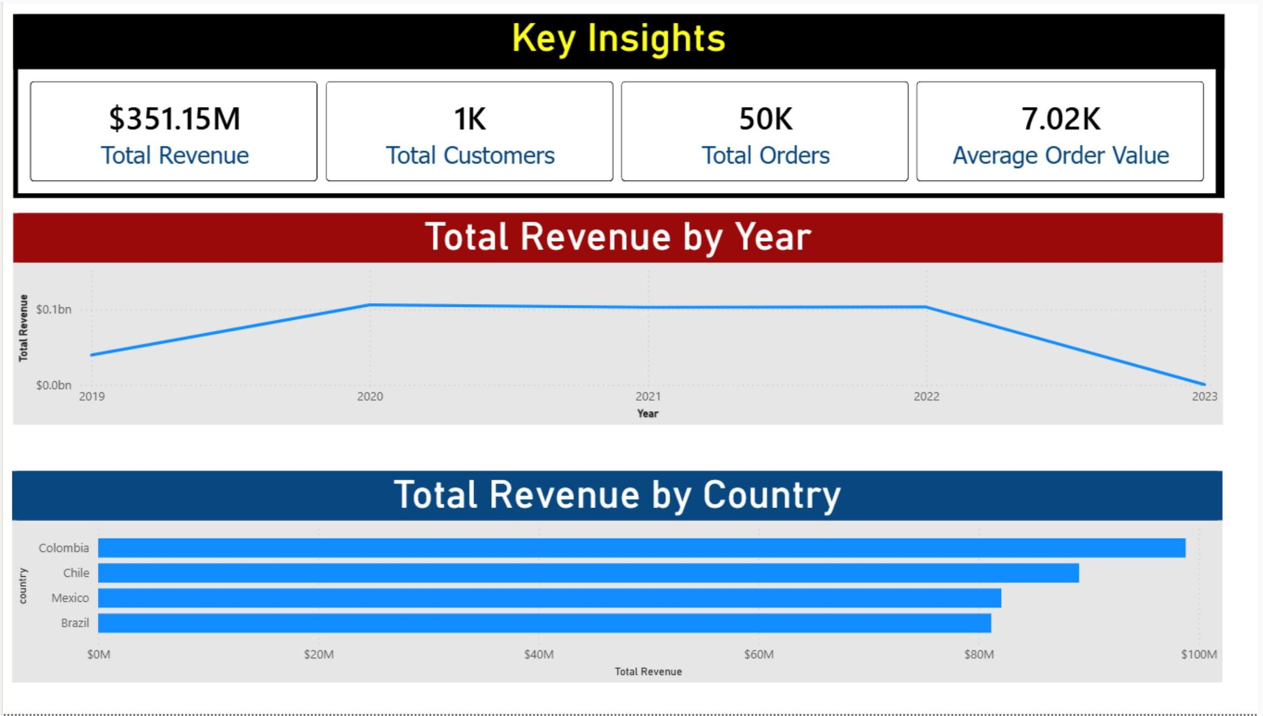
Figure 4: Executive Dashboard page — KPI cards, Total Revenue by Year and Total Revenue by Country.
KPI Cards: I placed Total Revenue, Total Customers, Total Orders and Average Order Value as cards across the top of the page because executives need the main business figures immediately, before reviewing any detailed chart. This gives anyone opening the dashboard a quick health check of overall business performance in the first few seconds.
Total Revenue by Year (Line Chart): I used a line chart here because line charts are best suited to showing change over time and making increases or decreases visible at a glance. This visual helps management see whether yearly revenue is growing, stable or declining, and supports trend monitoring and long-term planning.
Total Revenue by Country (Clustered Bar Chart): I chose a horizontal bar chart because country names are easier to read horizontally, and bars make ranking clear. This identifies which countries generate the strongest revenue contribution and supports country-level marketing and resource allocation decisions.

8.2 Customer Analysis
The Customer Analysis page was designed specifically to answer Objective 1 (purchasing patterns by demographics) and Objective 4 (identifying the highest-value customer segments).
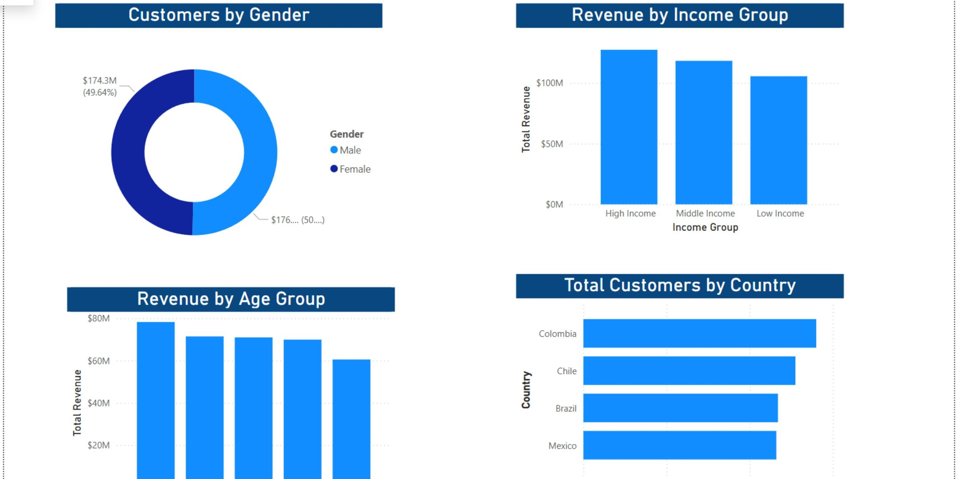
Figure 5: Customer Analysis page — Customers by Gender, Revenue by Income Group, Revenue by Age Group and Total Customers by Country.
Customers by Gender (Donut Chart): Gender has only a small number of categories, so a donut chart clearly shows the share of each group without needing axis labels.
Revenue by Income Group (Clustered Column Chart): A column chart clearly compares revenue generated by the Low, Middle and High income groups side by side. This chart supports premium targeting, loyalty strategy and segment-specific promotions.
Revenue by Age Group (Clustered Column Chart): Age groups are discrete categories that are easy to compare using vertical bars. This supports age-based marketing messages, product offers and customer retention campaigns.
Total Customers by Country (Clustered Bar Chart): As with revenue by country, I used horizontal bars because they handle country labels better and make it easy to rank countries by customer count, helping management decide where to focus marketing, service and expansion efforts.

8.3 Product Analysis
The Product Analysis page was built to answer Objective 2: identifying the products with the highest sales revenue and purchase volume.
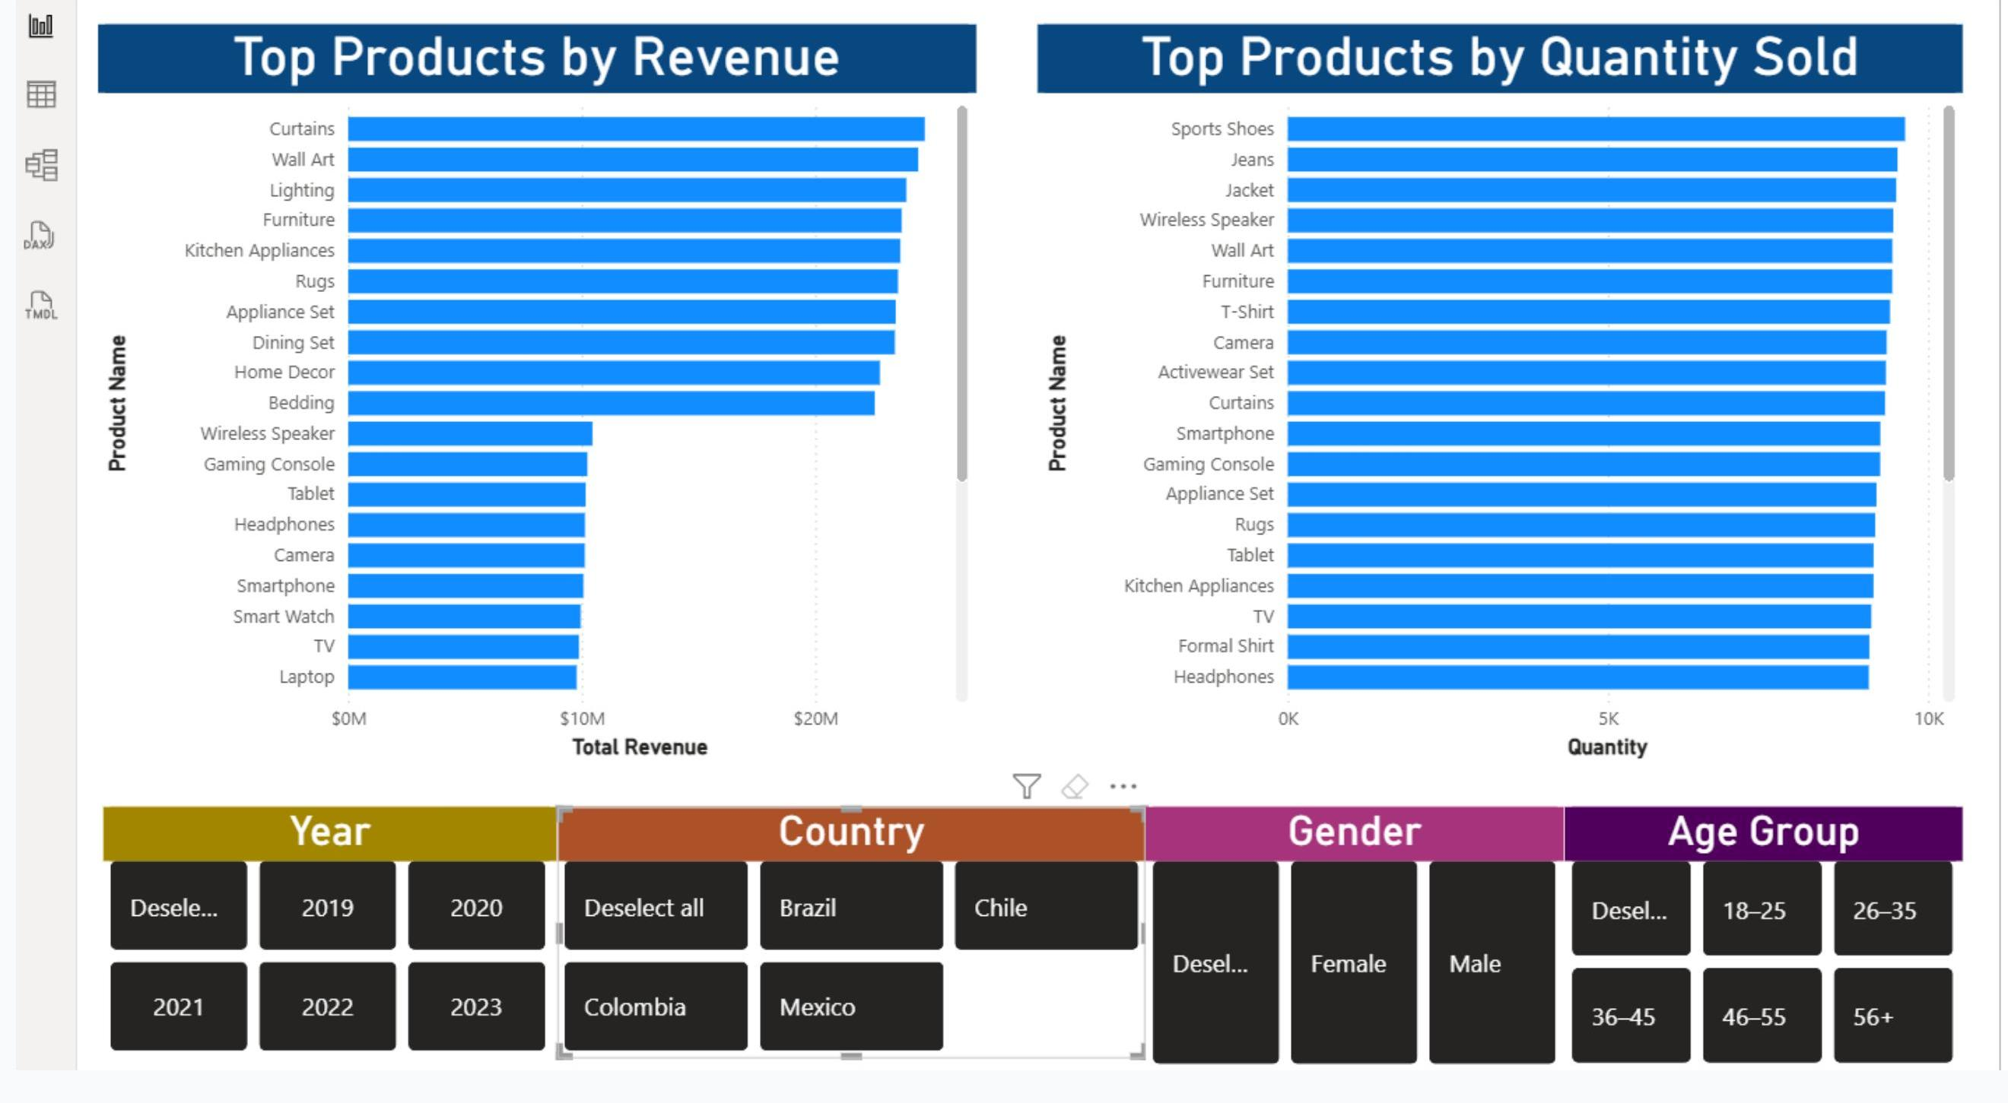
Figure 6: Product Analysis page — Top Products by Revenue and by Quantity Sold, with Year, Country, Gender and Age Group slicers.
Top Products by Revenue (Clustered Bar Chart): I used horizontal bars because product names are easier to read this way, and bars support ranking from highest to lowest revenue. This helps prioritise product promotion, inventory allocation and pricing strategy.
Top Products by Quantity Sold (Clustered Bar Chart): Quantity sold is a ranking metric like revenue, so I kept the same horizontal bar format for consistency, which clearly compares product demand and supports stock planning and demand forecasting.
Product Dashboard Slicers: I added Year, Country, Gender and Age Group slicers to this page so users can analyse product performance for a selected market, customer profile or time period without me having to build a separate static report for every possible question.

8.4 Sales Trend
The Sales Trend page was built to answer Objective 3: examining sales trends over time and identifying peak purchasing periods.
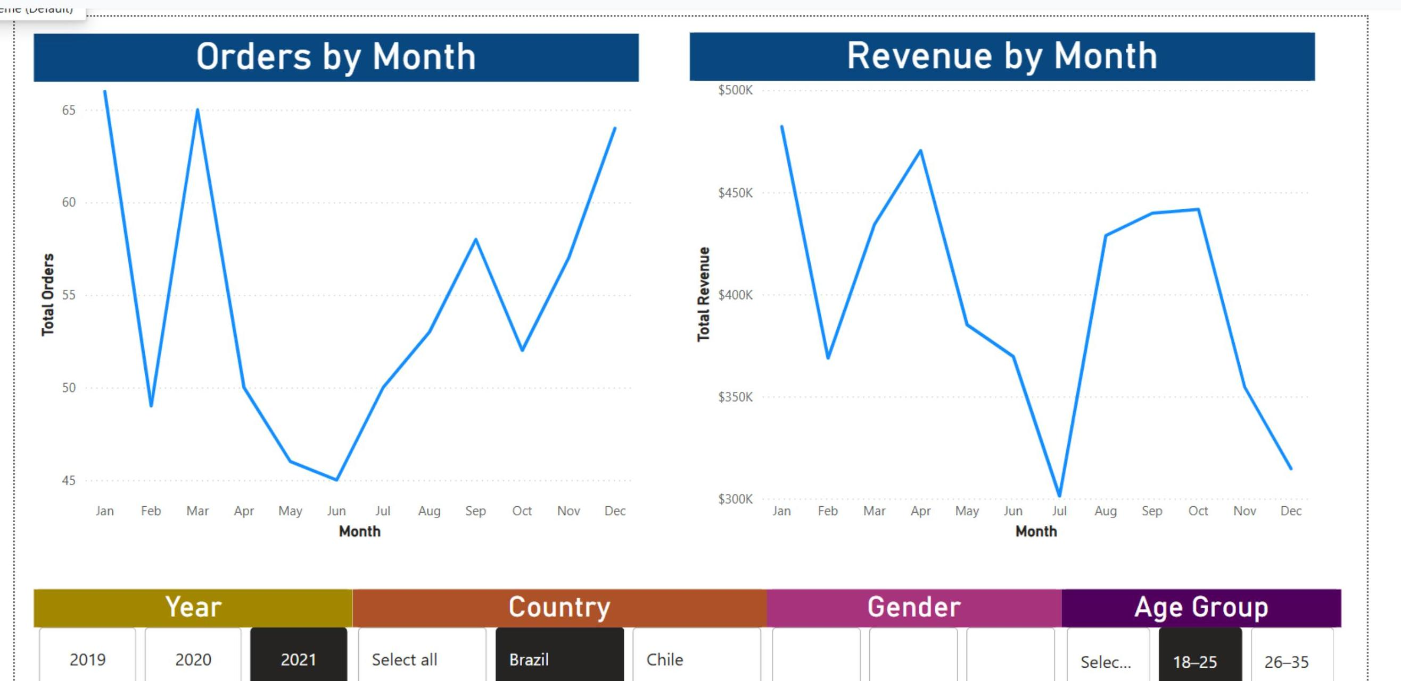
Figure 7: Sales Trend page — Orders by Month and Revenue by Month, with Year, Country, Gender and Age Group slicers.
Orders by Month (Line Chart): Order volume is time-based, and line charts are best for showing movement across months. This supports campaign scheduling, staffing and demand planning.
Revenue by Month (Line Chart): Monthly revenue is also a time-series metric, and a line chart reveals peaks, dips and seasonal patterns clearly. This supports forecasting, seasonal promotion planning and ongoing revenue monitoring.

9. Business Recommendations
The final purpose of the dashboard, and of this report, is to turn what I found into recommendations management can act on. I have grouped these by the evidence that supports each one.

9.1 Customer Targeting
Evidence: the High Income segment generates the highest revenue, and the age-group chart identifies a clearly strongest-performing age segment.
Recommendation: prioritise targeted campaigns, loyalty benefits and personalised offers for the highest-value income and age segments identified on the Customer Analysis page.

9.2 Product Strategy
Evidence: Curtains rank highest by total revenue, while Sports Shoes record the highest quantity sold. This tells me the product generating the most revenue is not necessarily the product purchased most frequently, which is one of the strongest findings in the whole dashboard because it compares product value against product demand.
Recommendation: manage products using two complementary strategies — protect stock availability and profit margins for high-revenue products such as Curtains, while using promotions, bundles and repeat-purchase campaigns to keep momentum behind high-volume products such as Sports Shoes.

9.3 Country Focus
Evidence: Colombia has both the highest total revenue and the largest customer base in the dashboard.
Recommendation: protect the company's position in Colombia through retention campaigns, while using targeted promotions to develop opportunities in Chile, Mexico and Brazil.

9.4 Sales Planning
Evidence: the monthly charts show noticeable changes in both orders and revenue throughout the year.
Recommendation: use these monthly patterns to plan inventory, staffing and promotional campaigns ahead of expected peak periods rather than reacting to them after the fact.

9.5 Dashboard Monitoring
Recommendation: management should review Total Revenue, Total Orders, Total Customers and Average Order Value on a regular basis, using the slicers to investigate performance by year, country, gender and age group whenever a metric moves unexpectedly.

10. Challenges & Lessons Learned
A few practical challenges came up while I was building this project, and working through them taught me more about Power BI than the parts that went smoothly.
Month ordering: Power BI sorts text fields alphabetically by default, which meant Month Name initially displayed as April, August, December and so on instead of a proper calendar sequence. I resolved this by creating a Month Number column and using "Sort by Column" to sort Month Name by Month Number, which is the same technique I applied to Age Group and Income Group once I noticed the same alphabetical-sorting problem there.
Choosing between bar and column charts: Early on I used vertical column charts for every category comparison, but country and product names are long enough that the labels overlapped or had to be rotated. Switching to horizontal bar charts for country and product comparisons, while keeping vertical columns for short category labels like age and income groups, made a real difference to readability.
Deciding between measures and calculated columns: It took me some trial and error to settle on a consistent rule for when to use a DAX measure versus a calculated column. I now use calculated columns only for values attached to each row that I need as a chart category or slicer field, such as Age Group, and measures for anything that needs to respond dynamically to whatever filters a user applies, such as Total Revenue.
Working with fifty thousand rows: The Purchase table's size meant I had to be more careful with data types and duplicate checks than I would be on a small sample, since a data type error or an unfiltered duplicate is easy to miss visually but affects every downstream KPI. Validating data types early, before building any measures, saved me from having to re-check every visual later on.
Keeping the model clean: I was tempted at one point to add extra fields directly into the Purchase table to avoid setting up the Customer relationship properly. Building the one-to-many relationship on customer_id instead, and relying on that single link for all filtering, kept the model simpler and made it much easier to trust that every visual was using consistent logic.

11. Conclusion
This project demonstrates how Power BI can transform raw customer and purchase data into a clear, interactive and business-focused analytics dashboard. Starting from two disconnected tables, I worked through data cleaning, feature engineering, relationship modelling, DAX measures and calculated columns, and finally through four purpose-built dashboard pages that each map back to one of my original research objectives.
What I take away from this project is that the value of a dashboard is not in the number of charts it contains, but in how deliberately each part of it was built. Every measure exists so it can be reused correctly across multiple visuals, every calculated column exists so a category displays and sorts sensibly, and every chart type was chosen because it answers its underlying business question more clearly than an alternative would have. The result is a dashboard that gives management a fast health check through the KPI cards, deeper analysis through the Customer, Product and Sales Trend pages, and enough interactivity through slicers that most follow-up questions can be answered without a new report being built.
I believe this report, together with the dashboard itself, gives a complete picture of both what I built and why I built it that way, and I am ready to walk through any section of it in more detail during my presentation.

