OPEN5GS
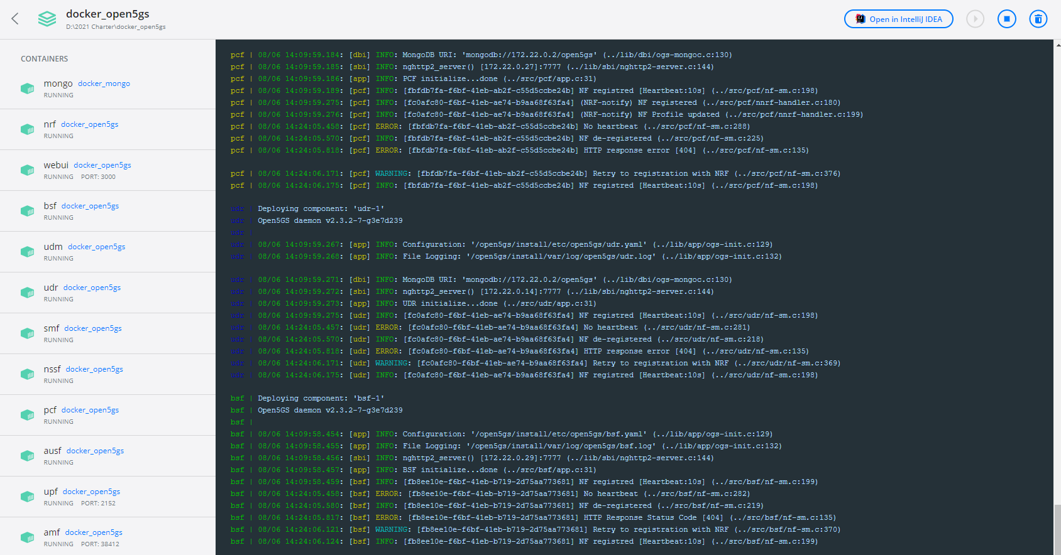
UERANSIM - container
RAN in separate docker-compose
Modified files for UERANSIM

