Problem 1: Lost Astronaut
Input N, K
astronauts[1..N] -> 1, 2, 3, ..., N
left -> N
elim -> 0
eliminationOrder <- empty list
While left > 1
elim -> (elim + K - 1) mod left
eliminated -> astronauts[elim]
“Move” eliminated to elimination order

If eliminated mod 2 = 0 then
K -> K + 2
else
K -> K - 1
end if
if K < 2 then
K -> 2
end if
remove astronauts[elim]
left -> left - 1
if elim = left then
elim -> 0
end if
end while
Output elimination order
output last astronaut
end last astronaut
Each round the program calculates elim = (elim+K-1) Mod left. This gives the index of the person who's the K-th one counted from the current starting position wrapping around the circle using the modulo operation if the count goes past the end of the array. That person, an astronaut is removed from the array and added to the elimination order. The variable left, which tracks how many astronauts are still in the circle is decreased by one. If the astronaut who just got eliminated was at the last position in the current array then elim is reset to 0. That’s because the next person in line now wraps back to the beginning of the array. Otherwise elim already points to the correct starting position since removing an element causes the rest of the array to shift left bringing the next person into place.
Before the next round begins the value of K is updated based on the number of the astronaut who was just eliminated. If that number was even K increases by 2. If the number was odd K decreases by 1. K can never go below 2 so if the decrease would make it less than 2 K is clamped back up, to 2. This continues until one astronaut remains in the array. Then the program prints the elimination order and the last remaining astronaut, who is sitting at index 0.

Problem 2: Alien In The Middle
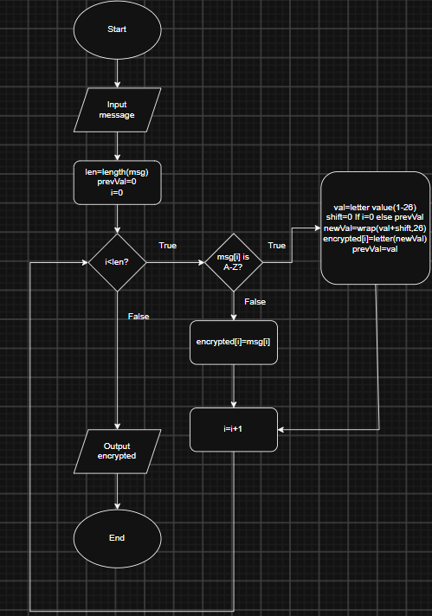

If the character is a letter the algorithm changes it into a number from 1 to 26. Then it adds a shift based on the number that the previous character had. For the first character there is no shift. For the next characters the number from the character before decides how much to shift. The new number is made to stay between 1 and 26 so that it stays inside the alphabet. Then it is changed back into a letter. Kept as part of the encrypted message. Any character that is not a letter stays the so spaces, punctuation or numbers are not changed at all.
The process keeps going until every character in the message is handled. Each encrypted letter depends on the one that came before. This way each letters encryption is connected to the one before it. This way of working makes a chain effect where each letters encryption is affected by the letters place in the alphabet. This makes the cipher more complicated than a substitution. When the whole message is encrypted, the algorithm shows the text. The flowchart shows clearly how the algorithm mixes steps with a connection, between parts. This gives an encryption method that's easy to understand but creates different results based on the message that is being encrypted.

