Targetscope Target Viewer
Predicate Specification Outline
v0.1 - January 30, 2014

Glossary

BED - Short for "Browser Extensible Display" that uses a tab-delimited text format that can span three or more columns, used to represent zero-indexed elements or areas of interest:

Column index | Name | Type | Nickname
1 | Chromosome | String | BED3, 4, 5, 6+
2 | Start index | Integer (i >= 0) | BED3, 4, 5, 6+
3 | Stop index | Integer (j > i) | BED3, 4, 5, 6+
4 | ID | String | BED4, 5, 6+
5 | Score | Float | BED5, 6+
6 | Strand | Character ("+" or "-") | BED6+
7+ | Metadata | String | Various

A BED record must minimally have three columns that define the genomic range of that record. Variants of BED with more than six columns exist. Records with more than six columns generally have display metadata associated with them, or represent specialized annotations.

BED records could be provided in any order. However, our analyses make use of BEDOPS tools, which require a lexicographical sorting on the chromosome column, followed by numerical sort on the start and stop indices. BEDOPS includes a command-line tool called sort-bed to apply this ordering on BED records.

Example of sorted BED6 data:

chr1 1000 2000 foo 0 +
chr17 100 200 bar 1 -
chr2 300 500 baz 3.14 -
chrX 100 400 bing 2 +

Where data are not available for the fourth through sixth columns, it is conventional to use a period as a placeholder.

BEDOPS - Toolkit for management of and applying set and statistical operations on BED files (https://github.com/bedops/bedops).

DHS peak - Genomic range that (for this purpose) is the source of a long-range interaction with a target gene. Contains (or overlaps) transcription factors of interest.

Gene - A set of genomic ranges that has some function for an organism and is copied from one generation to the next.

Gene annotation - A set of genomic ranges that usually specifies the coordinates of a gene's components (e.g., in eukaryotes like humans, exons and introns).

Gene promoter - A genomic range that contains a transcription start site element.

Genomic range - Minimally, a chromosome name and a start/stop coordinate pair. Analogous to a BED3 element.

Long-range interaction - A pair of genomic ranges that connect a target gene's promoter with an overlapping DHS.

Target gene - A set of genomic ranges (representing the gene's promoters) that is the starting point for analyses. Filters or predicates are applied on this initial input set, which expand the regions covered over the genome to search for TFs.

Transcription factor - A transcription factor ("TF") is a protein that binds to DNA and controls how other proteins get made (or, indirectly, how cell signaling occurs). For a given transcription factor's name, we provide a set of locations on the genome (one or more genomic ranges) where that transcription factor binds. Obtaining a set of transcription factor binding sites is the end goal of the target viewer component of Targetscope.

Data types - base and compound
Base types

1.1.1
Data - Score

Data | Integer, float, scientific notation

Score adds an integer or decimal numerical attribute to Element, Interaction or Set compound types.

1.1.2
Data - Name

Data | String

Name adds an identifying attribute to Element, Interaction or Set compound types.

1.1.3
Data - Strand

Data | Character (+/-/.)

Strand adds an orientation attribute to Element and Interaction compound types.

1.1.4
Data - Range

Data | BED3

Range consists of a chromosome name, start and stop index. The chromosome name follows UCSC convention and starts with the string "chr". The start and stop indices are integers greater than or equal to zero. The stop index must be greater than the start index.

1.1.5
Data - Metadata

Data | JSON-formatted string

The Metadata type adds a free-form, JSON-formatted descriptive attribute to Element, Interaction or Set compound types.

Compound types

1.2.1
Data - Element

Data | Range (optional: 1 or more Name;1 Score; 1 Strand, 1+ Metadata, 1+ Set)
Examples | Target gene promoter, gene annotation record, DHS peak, transcription factor hit

Operations can be applied on an Element or on a Set of Elements.

Example 1:

Here, we filter a set of transcription start sites for target gene RARA:

$ grep -w RARA tss.bed
chr17 38465445 38465446 RARA 41 +
chr17 38474532 38474533 RARA 90 +
chr17 38474536 38474537 RARA 15 +
chr17 38497639 38497640 RARA 1 +
chr17 38498614 38498615 RARA 20 +
chr17 38501492 38501493 RARA 150 +
chr17 38507638 38507639 RARA 3 +

Therefore, the set of RARA transcription start sites is on chromosome 17, with the Ranges of [38465445, 38465446), [38474532, 38474533) etc. The Name value is RARA. The Scores are varied. The Strand value of each is +. Each of these makes up an Element.

Example 2:

Here we show an example of some transcription factor binding sites, each an Element, also on chromosome 17:

$ unstarch chr19 fimo.combined.xfac.1e-5.parsed.starch | more
chr17 2 23 -V_NRSF_01 5.89317e-06 - TGCAGGAACAGGGTGAGAAGC
chr17 27 42 -V_OCT4_02 5.78775e-06 - ATTGTCATGCAATTA
chr17 125 141 -V_TAL1BETAE47_01 4.13235e-06 - CTGGACAGATGTTTGT
chr17 125 141 -V_TAL1BETAITF2_01 9.97644e-06 - CTGGACAGATGTTTGT
chr17 126 138 +V_RP58_01 5.58617e-06 + CAAACATCTGTC...

The fourth column of this file is the "TRANSFAC" name of the transcription factor (TRANSFAC is the name of a database of transcription factors — there are other databases; e.g., Jaspar and UniPROBE). Note here that the start character of the ID field matches the strand field on which the factor is located, and that the seventh column contains the reference sequence at that range.

1.2.2
Data - Interaction

Data | 2 Elements; 1 Score; 1 Name; 1 Strand; optional, 1 or more Metadata
Example | Long-range interaction

An interaction pair is a special Set that defines a connection between two Element values. For the Targetscope application specifically, this is a gene promoter Element and a distal DHS peak Element.

Operations can be applied on an interaction or on a grouping of interactions.

Example 1:

Here is an example of interactions centered around the gene RARA, in a BED format used for internal visualization. This is a special form of BED6, where the ID field contains a condensed form of the second pair of the interaction pairing, along with the interaction correlation score:

$ more interactions.bed
chr17 38498520 38498670 chr17:38107440-38107590,0.731035 3525 -
chr17 38498520 38498670 chr17:38174060-38174210,0.727828 3541 -
chr17 38498520 38498670 chr17:38184060-38184210,0.707405 3543 -
chr17 38498520 38498670 chr17:38221800-38221950,0.763215 3545 -
chr17 38498520 38498670 chr17:38222220-38222370,0.773827 3547 -
...

The first three columns represent the genomic Range of the gene promoter Element. The fourth column is a condensed string showing the DHS peak Element associated with that promoter, along with a correlation Score for that interaction. The fifth column, usually a score field in a BED file, is used here as a replacement Name for the pairing. The sixth column is the Strand of the promoter element.

To get a list of interactions associated with RARA promoters, we first filter on strand, and then use bedmap to map interactions to the RARA promoters:

$ awk '($6=="+")' interactions.bed > interactions_forward.bed
$ grep -w RARA tss.bed | bedmap --echo --echo-map - interactions_forward.bed
chr17 38465445 38465446 RARA 41 +|
chr17 38474532 38474533 RARA 90 +|
chr17 38474536 38474537 RARA 15 +|
chr17 38497639 38497640 RARA 1 +|
chr17 38498614 38498615 RARA 20 +|chr17 38498520 38498670 chr17:38512520-38512670,0.782996 3657 +;chr17 38498520 38498670 chr17:38514200-38514350,0.726464 3659 +;chr17 38498520 38498670 chr17:38603540-38603690,0.732044 3709 +;chr17 38498520 38498670 chr17:38698620-38698770,0.71501 3739 +;chr17 38498520 38498670 chr17:38713300-38713450,0.782635 3743 +;chr17 38498520 38498670 chr17:38714500-38714650,0.702538 3745 +
...

The RARA transcription start site (TSS) element on chr17 at range [38498614,38498615) has several interactions associated with it, on the basis of one or more bases of overlap between the TSS and the interaction's promoter component.

1.2.3
Data - Set

Data | 1 or more Name; 0+ Metadata, 0+ Elements, Interactions or Sets
Example | DHS peaks for a particular cell type or sequencing experiment, promoters, transcription factor binding sites, other sets

Examples of Sets include the "target gene" (a set of promoter Elements) or groups of multiple interactions for a given promoter Element.

A Set could also be made up of base types, like a set of unique Name values, etc.

Sets could go by other descriptive names. An Experiment is one type of a set, which contains a specific type of Element values. A set of Experiments can be grouped into another set called a Category. For instance, one Category of cell types might be called "ectoderm", which includes various cell line-specific Experiments with names like "BE2_C", "HMEC", "Hela", etc. In turn, each of those Experiments contains DHS peaks that are specific to that cell line.

A Category could group other categories. For example, a category called "karyotype" could contain three subcategories called "cancer", "normal" and "unassigned". Each of the three subcategories could contain cell-line specific Experiments that contain data for cancerous cell lines, normal cell lines, and cell lines unassigned to the cancerous or normal subsets.

Some operations can be applied on a Set, depending on what features the set offers or exposes.

1.2.4
Data - Array

Data | 1 or more Name; 0+ base types
Example | NA

Examples of Arrays are ordered lists of base types (Score, Name, Strand, Metadata).
Operations
Range operations

2.1.1
Operation - Adjust Element Range

Input | 1 or 2 integers for “left” and “right” ranges; Element Set
Output | Element Set
CLI example | bedops --range L:R --everything ElemSetA > ElemSetB

This operation shrinks or grows Elements by specified integer values.

Positive values expand elements; negative values shrink elements. Any Element with a processed Range with a length 0 or less is discarded.

If the values of L and R are equal and positive, the element grows symmetrically. If the values of L and R are equal and negative, the element shrinks symmetrically.

2.1.2
Operation - Adjust Interaction Range

Input | 1 or 2 integers for promoter range(s); 1 or 2 integers for DHS peak range(s); Interaction Set
Output | Interaction Set
CLI example | NA

This operation shrinks or grows either or both of the promoter and DHS components of specified Interactions by specified integer values.

Positive values for the promoter expand promoter elements; negative values shrink promoter elements. A positive left value expands the promoter on the left edge of its range; conversely, a negative left value shrinks the promoter on its left edge. The same applies for the right value, to the right edge of the element’s range.

Any promoter Element with a post-processed Range with a length 0 or less causes the entire Interaction to be discarded.

Similar rules are applied to the DHS peak component of the Interaction.

If the values of L and R are equal and positive, the promoter or peak component grows symmetrically. If the values of L and R are equal and negative, the promoter or peak component shrinks symmetrically.

The command-line equivalent would likely be a combination of two bedops --range operations on each component.

Filter operations

2.2.1
Operation – Filter Element by Score

Input | 1 Score; 1 Element Set; relational operator; 1 Boolean value
Output | Element Set
CLI example | awk ‘($5 > threshold)’ foo.bed > foo_thresholded.bed

This operation filters Elements with Score components by the specified numerical value and relational operator. A false Boolean value allows specifying the inverse of the operation.

After filtering, the output set should either be a proper subset of the input, the empty set, or the input itself.

2.2.2
Operation – Filter Element by Name

Input | 1 Name; 1 Element Set; 2 Boolean values
Output | Element Set
CLI example | awk '($4=="RARA")' foo.bed > foo_RARA.bed

This operation filters Elements with Name components by the specified string value. The first Boolean operator decides if the filtering is an exact or partial match on the input name string. A second, false Boolean value allows specifying the inverse of the operation.

After filtering, the output set should either be a proper subset of the input, the empty set, or the input itself.

2.2.3
Operation – Filter Element by Strand

Input | 1 Strand; 1 Element Set; 1 Boolean value
Output | Element Set
CLI example | awk ‘($6==”+”)’ foo.bed > foo_forward_stranded.bed

This operation filters Elements with Name components by the specified Strand value. A false Boolean value allows specifying the inverse of the result set (e.g., all elements but those which are forward-stranded).

After filtering, the output set should either be a proper subset of the input, the empty set, or the input itself.

2.2.4
Operation – Filter Element by Chromosome

Input | Element Set; string; Boolean
Output | Element Set
CLI example | bedextract chr17 foo.bed > foo_chr17.bed

This operation filters Elements with a Range component by the specified, exact chromosome string name. A false Boolean value allows specifying the inverse of the result set (all elements but those on the specified chromosome).

After filtering, the output set should either be a proper subset of the input, the empty set, or the input itself.

2.2.5
Operation – Filter Interaction by Component

Input | Interaction; integer (index)
Output | Element Set
CLI example | NA

This operation filters an Interaction to return either the first or second element set (promoter or DHS component).
Basic element set operations

2.3.1
Operation – Union Element Set

Input | 1 or more Element Sets
Output | Element Set
CLI example | bedops --everything foo1.bed foo2.bed ... > union.bed

This operation takes the union of Elements in a set, yielding one set made up of each of the input elements. Each Element in the output set preserves its basic Score, Name etc. attributes. The union of one input set is the set itself.

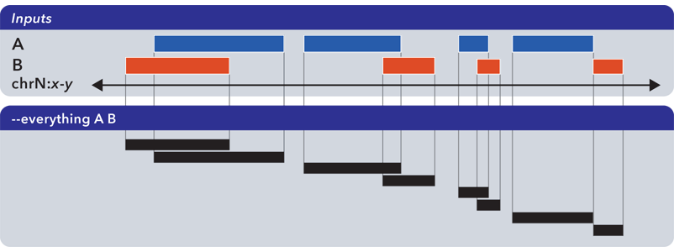

2.3.2
Operation – Merge Element Set

Input | 1 or more Element Sets
Output | Element Set
CLI example | bedops --merge foo1.bed foo2.bed ... > merge.bed

This operation takes the merge of Range of input Elements in a set, yielding one set made up of new Element values calculated from the ranges. Note: Because this result is calculated, each new Element in the output set loses any input attributes. The merge of one input set is the set of contiguous ranges of overlapping input elements.

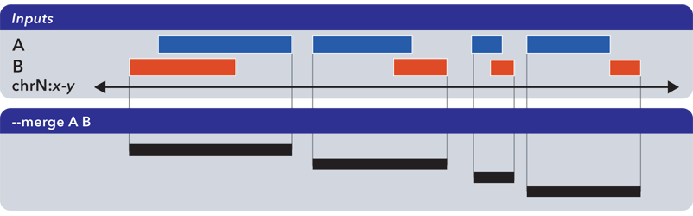

2.3.3
Operation – Inclusive Filter Element Set

Input | 2 or more Element Sets; integer (base) or float (percentage) overlap parameter
Output | Element Set
CLI example | bedops --element-of -1 foo.bed bar1.bed bar2.bed ... > inclusive_filter.bed

This filter creates a new set from elements in the first set, where range components of elements in the second (and subsequent) sets overlap the first set's elements by the specified integer or float value.

If that value is an integer, overlap is calculated as a measure of required overlap of bases in the elements' range components. If that value is a percentage, overlap is calculated as a required minimum fraction of overlap between ranges.

If there are more than two sets specified as input, the second and subsequent sets are first merged into an intermediate set. The first set is then filtered against this intermediate set using the specified overlap threshold.

Because the output set is made up of elements from the first set, those elements should preserve all additional attributes (Name, Score, etc.) where applicable.
The ordering of sets in this operation matters; e.g., compare these two inclusion operations, where the two sets are in different order:

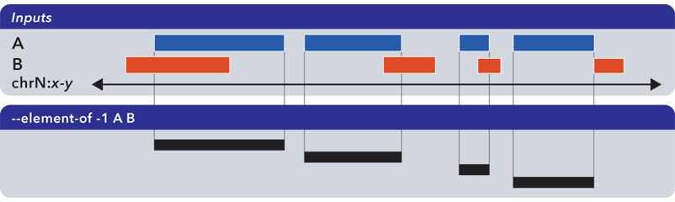

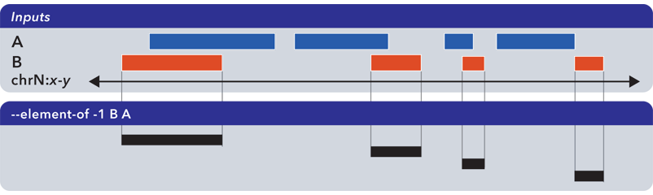

2.3.4
Operation – Exclusive Filter of Element Set

Input | 2 or more Element Sets; integer (base) or float (percentage) overlap parameter
Output | Element Set
CLI example | bedops --not-element-of -1 foo.bed bar1.bed bar2.bed ... > exclusive_filter.bed

This filter creates a new set from elements in the first set, where range components of elements in the second (and subsequent) sets do not overlap the first set's elements by the specified integer or float value.

If that value is an integer, overlap is calculated as a measure of required overlap of bases in the elements' range components. If that value is a percentage, overlap is calculated as a required minimum fraction of overlap between ranges.

If there are more than two sets specified as input, the second and subsequent sets are first merged into an intermediate set. The first set is then filtered against this intermediate set using the specified overlap threshold.

Because the output set is made up of elements from the first set, those elements should preserve all additional attributes (Name, Score, etc.) where applicable.

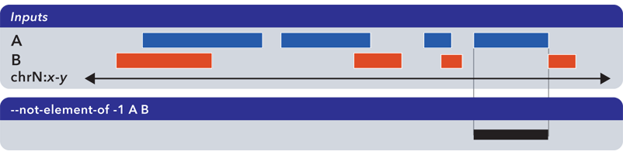

2.3.5
Operation – Complement of Element Set

Input | 1 or more Element Sets
Output | Element Set
CLI example | bedops --complement foo.bed bar.bed baz.bed ... > comp.bed

This filter creates a new set of elements from gaps between the contiguous ranges defined by one or more input sets.

The complement of one set excludes the start- and end-pieces of a chromosome. To include those ranges, one can calculate the difference operation between the input set and a "full chromosome" Element, taking the first and last elements of the result. Those two elements would be unioned with the complement of the input set to get the full extents set.

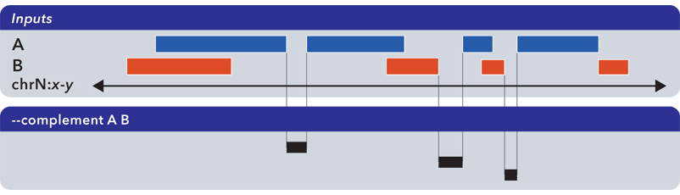

2.3.6
Operation – Difference of Element Set

Input | 2 or more Element Sets
Output | Element Set
CLI example | bedops --difference foo.bed bar1.bed bar2.bed ... > diff.bed

This filter creates a new set from ranges found in the first input set, excluding overlaps with ranges in the second and subsequent input sets.

Like the complement operation, this calculates new elements and so name and other attributes of elements in the first set are discarded.

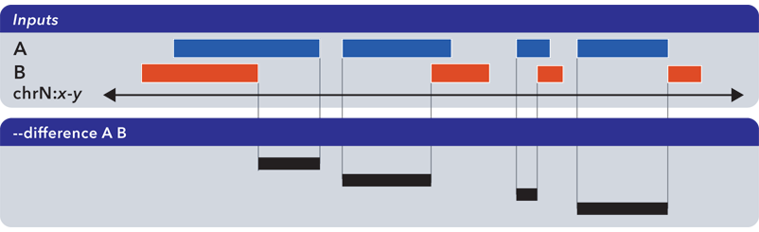

2.3.7
Operation – Symmetric difference of Element Sets

Input | 2 or more Element Sets
Output | Element Set
CLI example | bedops --symmdiff foo.bed bar.bed baz.bed ... > symmdiff.bed

This filter creates a new set from ranges found in the first input set, excluding overlaps with ranges in the second and subsequent input sets, unionized with ranges found in the second input set, excluding overlaps with ranges in all other input sets, etc.

Like the complement operation, this calculates new elements and so name and other attributes of elements in all sets are discarded.

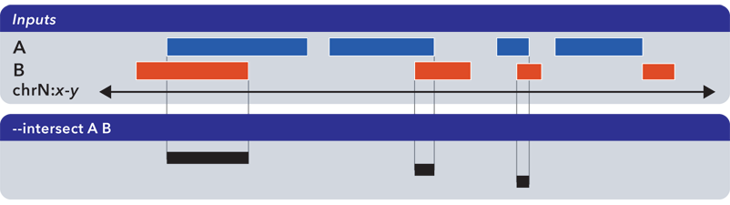

2.3.8
Operation – Partition of Element Sets

Input | 1 or more Element Sets
Output | Element Set
CLI example | bedops --partition foo.bed bar.bed baz.bed ... > parts.bed

This filter creates a new set from disjoint ranges computed from all input sets. A partition of one set alone will segment any overlapping elements within that set.

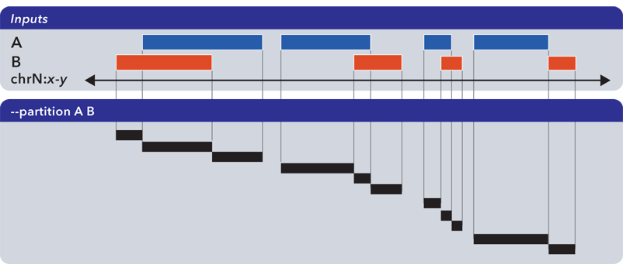
Basic interaction set operations

2.4.1
Operation – Union Interaction Set

Input | 1 or more Interaction Sets
Output | Interaction Set
CLI example | NA

This operation takes the union of Interactions in a set, yielding one set made up of each of the input interactions. Each Interaction in the output set preserves its attributes. The union of one interaction set is the set itself.

Map/Report operations

2.5.1
Operation – Map Element Set onto Element Set

Input | 1 or 2 Element Sets; overlap criteria (integer/bases or float/percentage); report operator(s)
Output | Element Sets
CLI example | bedmap --echo --echo-map --bp-ovr 1 ref.bed map.bed > ref_with_mapped_map.bed

This operation maps elements in one "map" set to elements in another "reference" set, if mapped elements meet the specified overlap criteria. For instance, take the following command:

$ bedmap --echo --echo-map --bp-ovr 1 ref.bed map.bed > ref_with_mapped_map.bed

This command associates elements in the file map.bed with each element in ref.bed, where each map element overlaps a reference element by one or more bases. The --echo-map operation reports all map elements that associate with a reference element.

The result of this most basic mapping example is a set of reference elements, where each reference element has another element set associated with it:

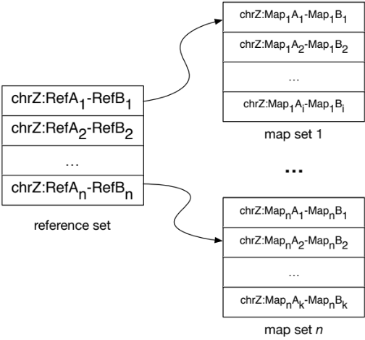

Some reference elements may associate with map sets with elements. Other reference elements may associate with an empty set, if the overlap criteria means that there are no overlapping (no mappable) elements.

In this example, we report the reference set elements along with all mapped elements. However, we may use operators to only report mapped elements:

$ bedmap --echo-map --bp-ovr 1 ref.bed map.bed | sort-bed - > mapped_map.bed

Alternative arguments to bedmap may summarize or "report" attributes about mapped elements. Discussion of these follow in Section 2.5.3.

Note that the default overlap criteria that is used by bedmap is one or more bases. The end user can customize this, but this default should be sufficient at this time.

2.5.2
Operation – Map Element Set onto Interaction Set

Input | 1 Element Set; 1 Interaction Set; index of desired interaction component to act as reference set; overlap criteria (integer/bases or float/percentage); report operator(s)
Output | Interaction Set
CLI example | NA

This is identical to mapping an element set against another element set, with the same default overlap criteria, except that we specify which of the two components of the interaction we would like to treat as the reference set to map our input element set against.

For instance, let's say we want a list of interactions, whose promoter components overlap with some genes of interest.

We start with an Interaction Set that pairs promoter components with DHS peak components. For the purposes of this example, the index of the promoter component in this set is "0" and the index of the DHS peak component is "1".

We also start with an element set of transcription start sites (TSSs) for target genes. These contain genomic Ranges and gene Names.

For this map operation, we specify an index of 0 to retrieve the set of interactions whose promoter components' ranges are overlapped by the TSS ranges.

2.5.3
Operation – Summary Report of Element Set Attributes

Input | 1 Element Set; summary operator
Output | Set, Array or base type
CLI example | bedmap --mean --bp-ovr 1 ref.bed map.bed > mean_map_signal_over_refs.bed

This operation summarizes attributes of an Element Set. This summary could be the result of a numerical calculation on Score data, or a listing of Name values.

Examples:

- For all the mappable elements that associate with a reference element, we may want a Set of names of those mapped elements, leaving out duplicates.
- For all the mappable elements that associate with a reference element, we want the arithmetic mean and variance of the signal or a Score value derived from mapped elements.

Operation | Argument | Description | Output
bases | - | Report the total number of bases in the Ranges in the input set | Score
bases-uniq | - | Report the unique (non-overlapping) number of bases in the Ranges in the input set | Score
count | - | Report the number of Elements in the input set | Score
cv | - | Report the coefficient of variation: the standard deviation of Score values in the input set, divided by their mean | Score
kth | i | Report the value at the kth fraction of Score values, where i = 0.5 reports the median (0 < i <= 1) | Score
mad | mult | Report the median absolute deviation of Score values, multiplied by mult | Score
max | - | Report highest Score in input set | Score
max-element | - | Report highest-scoring Element in input set (ties go to random element) | Set
mean | - | Report arithmetic mean of Score values in input set | Score
median | - | Report median Score value from input set | Score
min | - | Report lowest Score value from input set | Score
min-element | - | Report lowest-scoring Element in input set (ties go to random element) | Set
name | - | Report an ordered list of Names in the input set | Array
name-uniq | - | Report the unique Name values in the input set | Array
range | - | Report all Ranges of Elements in input set | Array
size | - | Report sizes of each Element in input set | Array
stdev | - | Report standard deviation of Scores in input set | Score
sum | - | Report sum of Scores in input set | Score
tmean | low, high | Report arithmetic mean, removing outliers as defined by the fractions low and high (0 <= low <= 1, 0 <= high <= 1, low + high <= 1) | Score
variance | - | Report variance of Scores in input set | Score

Example: Target gene to transcription factor binding sites
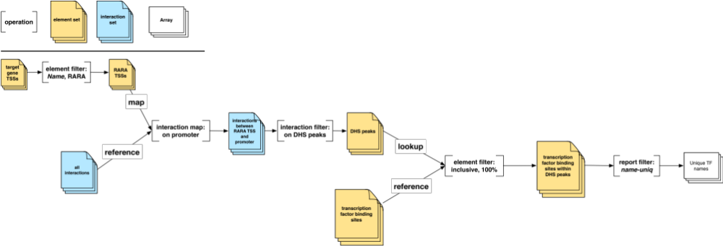

This figure describes a complete operation to retrieve the names of transcription factors which lie within DHS peaks, which are associated with interactions whose promoters overlap RARA transcription start sites.

Reading from left to right, we start with the Element Set of target gene transcription start sites (TSSs). We filter these on the name RARA to retrieve an element set of RARA-specific TSSs.

Next, we map this element set against the promoter elements of our Interaction Set of all interactions. This gives us all the RARA-specific interactions, which we filter to retrieve in element set of DHS peaks.

Subsequently, we apply an inclusive element filter against this set of DHS peaks and an element set of transcription factor binding sites. We apply overlap criteria of 100% to ensure that the transcription factor binding site lies entirely within the DHS peak.

Finally, we have an element set of transcription factor binding sites that lie within DHS peaks. We apply a report filter on the Name attribute, to retrieve a final result: an ordered list of unique transcription factor names.

