Herman Mann

Professor Alexander

CMSC 204

5 May 2021

Lab 10 – Chat Lab

**“Server and at least two clients are started.”**

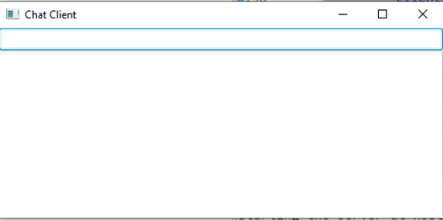

**“Two Clients Chatting.”**

GitHub Repository containing chat lab files.

