## **Document Repository Setup (Onedrive)**

The following steps will use Onedrive but keep in mind that Google Drive and Sharepoint are also options.

Sign in to Microsoft Onedrive using your Adobe Credentials.

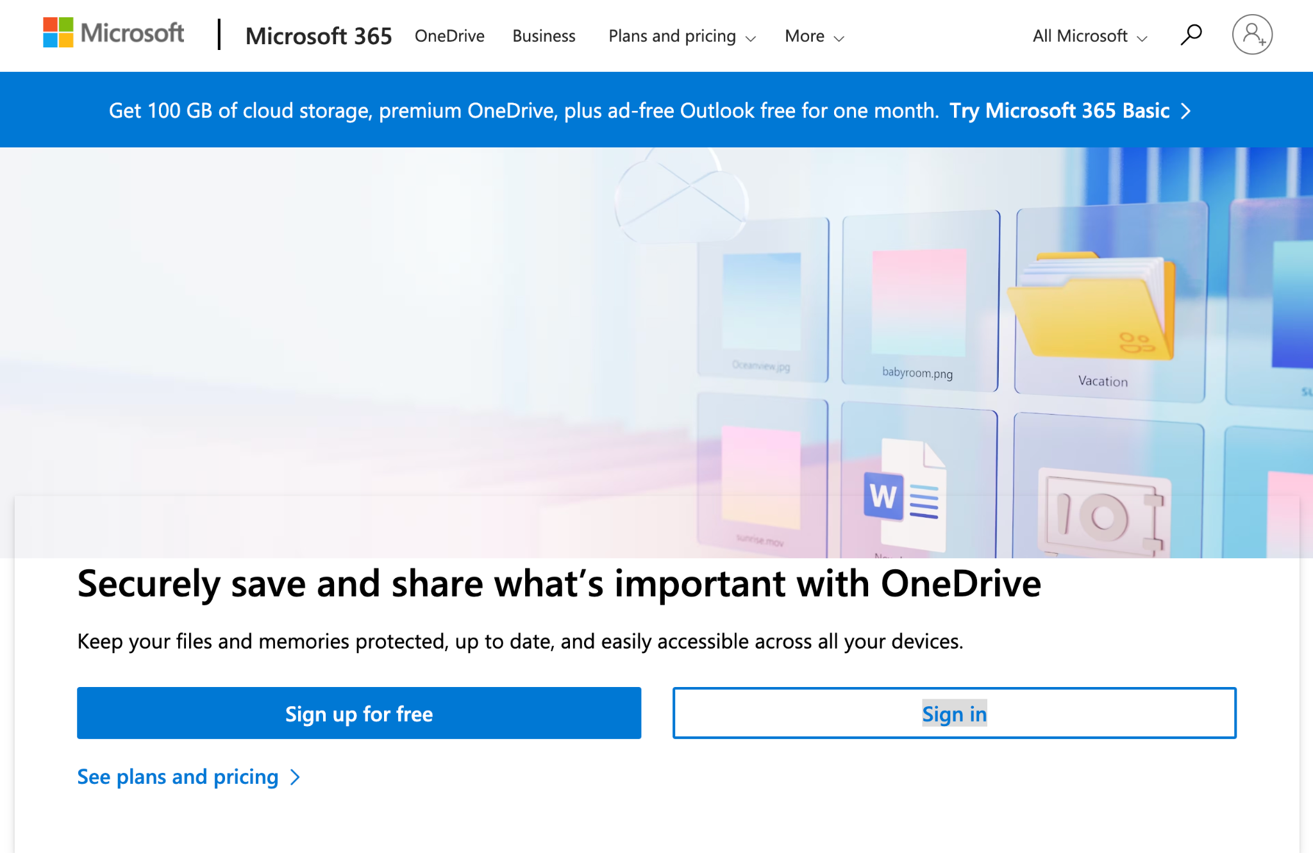

Click the Add new button and then select Folder to create a folder which will be used to hold your document based content. Pick a relevant and easy to remember name.

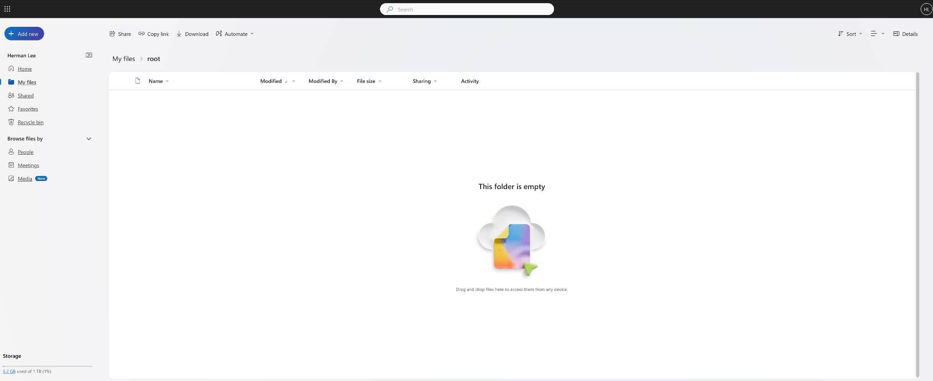

Add the starter content for your site by creating three separate Word documents.

1. index.docx
2. footer.docx
3. nav.docx

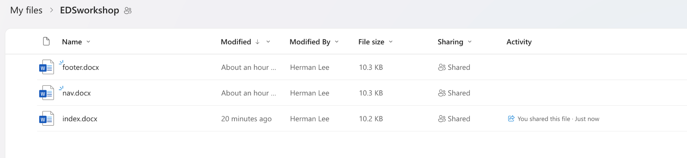

Open index.docx and add any text to the document. Hello World or Test Page will suffice.

Next you will share the folder with the Helix Bot. Doing so will allow the bot to access the folder and load it as pages of your site.

Click the Share button and share the folder with [helix@adobe.com](mailto:helix@adobe.com). (fundamental step)

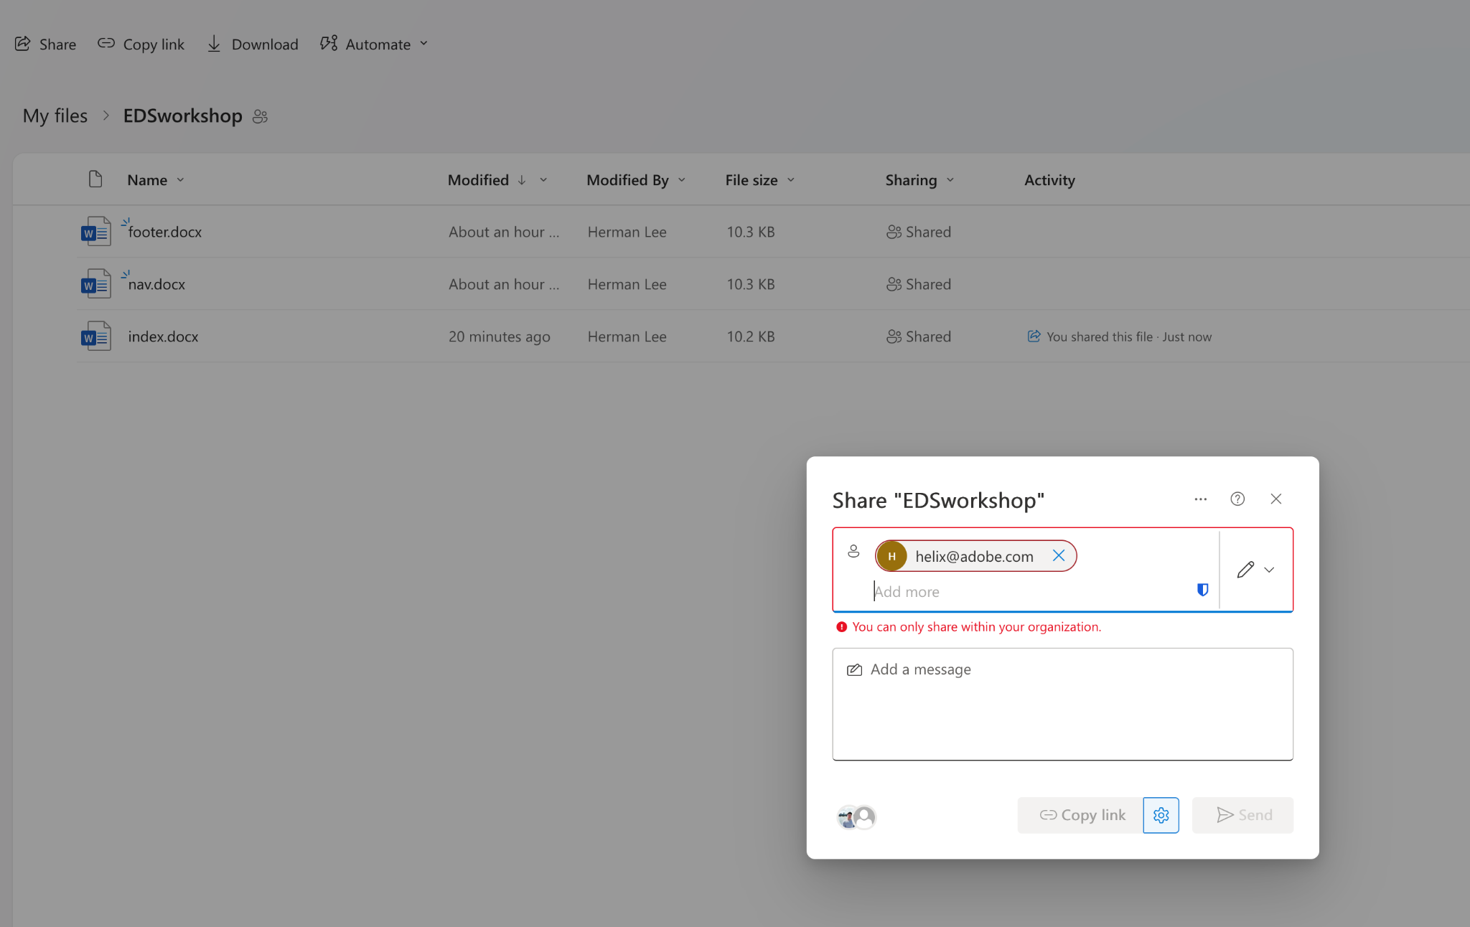

Finally, copy the link to the folder, making sure that nothing in the folder is selected. Select the Copy link button.

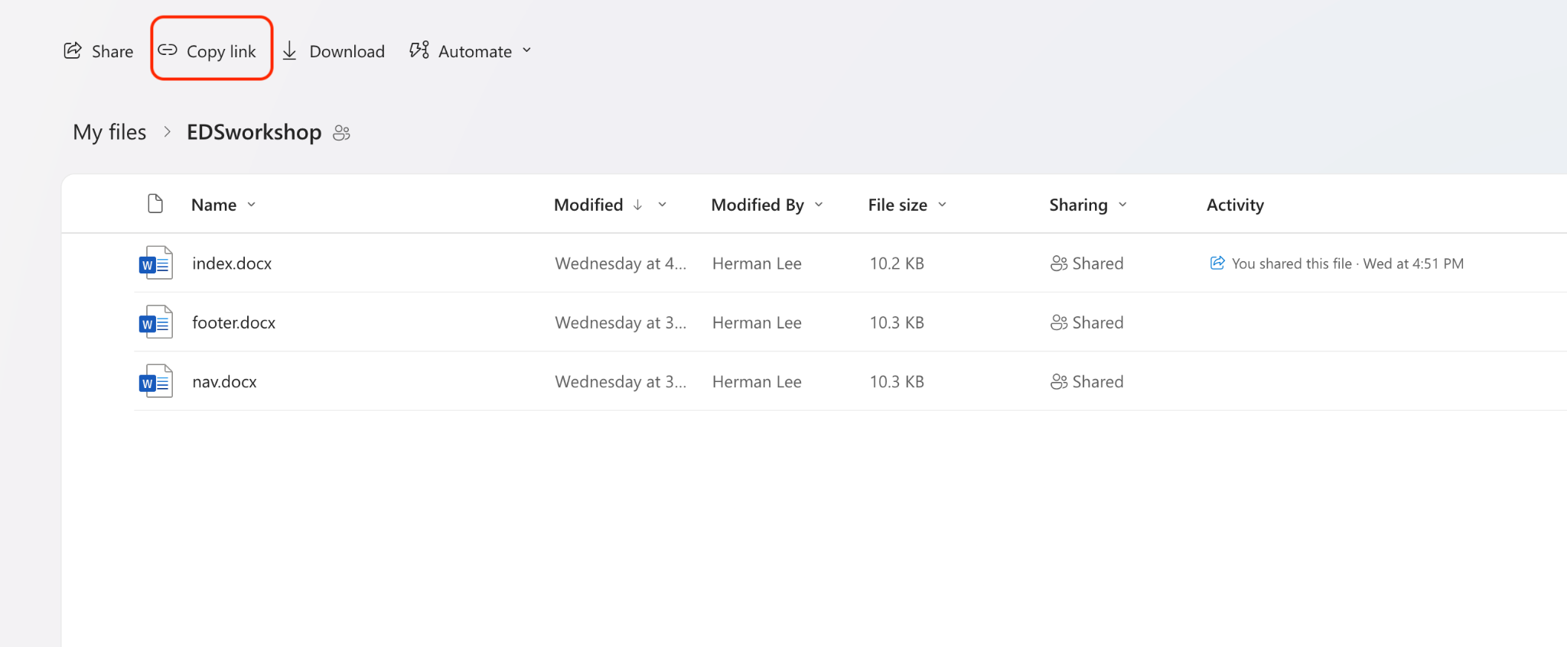

Click the Settings icon and select Only people with the existing access.

