Edge Delivery Services Workshop #2

## Scenario

You will be continue with the ensembledotcom codebase and ensemble folder (content source) from Workshop #1.

## Reminders

Use Google Chrome and the laptop that you configured the AEM CLI on.

# Prepare Sample Content

In this step you will upload the prepared files for use in the subsequent steps. You may skip steps in the tutorial where you will be asked to create files in your content source if the file already exists.

Delete index.docx, images folder and the drafts Folder in the “ensemble” folder in the Sharepoint [folder with your username](https://adobe.sharepoint.com/:f:/r/sites/AEMNAMExpertSCs/Shared%20Documents/Web%20Foundation%20Training?csf=1&web=1&e=Yg1gqb). Note, backup the files if you would like to keep them. They are being deleted because new sample content with the same file names will be used for this workshop.

Go to [Workshop 2 Content](https://adobe.sharepoint.com/:f:/r/sites/AEMNAMExpertSCs/Shared%20Documents/Web%20Foundation%20Training/hermanl/Workshop%202%20Content?csf=1&web=1&e=duXqaI) folder and upload all files to the “ensemble” folder in the [folder with your username](https://adobe.sharepoint.com/:f:/r/sites/AEMNAMExpertSCs/Shared%20Documents/Web%20Foundation%20Training?csf=1&web=1&e=Yg1gqb).

1. Index.docx
   1. This has placeholders to indicate where to add the Carousel Block and Carousel-gql Block.
2. services.xlsx
   1. This file is used as the data for the Carousel Block
3. aemHeadlessConfig.xlsx
   1. This file is used to prevent CORs issues and to tell the Carousel-gql Block which AEM Server to use.
4. email-forms.xlsx
   1. This is used to store the submitted form data. It was created with specific header, table and sheet names.
   2. For more info see: https://www.aem.live/docs/manual-forms-sheet-setup
5. drafts Folder
6. experiments Folder
7. images Folder
   1. Contains new images for the carousel

Preview and Publish the files. It is fine to select all the files, even the old ones.

## Prepare the Sample Code

In this step, you will add the Experimentation Plugin Code and updated script.js into your codebase.

In this step, you will add the Experimentation Plugin code and update the scripts.js file to enable the Experimentation Widget.

Download the plugin files at [Experimentation Plugin.zip](https://adobe.sharepoint.com/:u:/r/sites/AEMNAMExpertSCs/Shared%20Documents/Web%20Foundation%20Training/hermanl/Workshop%202%20Experimentation%20Plugin/Experimentation%20Plugin.zip?csf=1&web=1&e=GCKR1X). Unzip it.

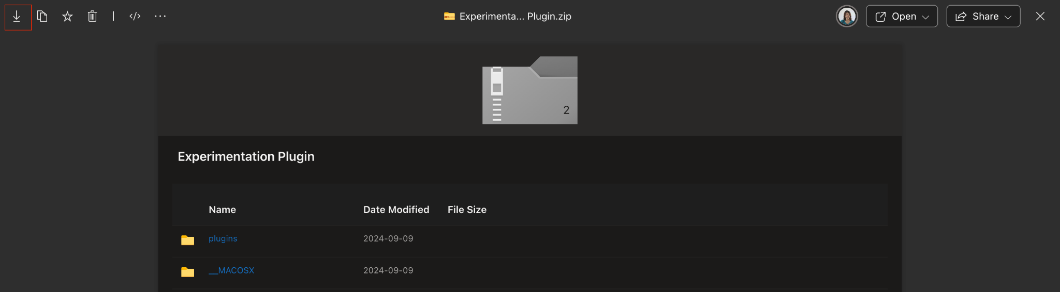

In Visual Studio Code, drag and drop the entire plugin folder into the Explorer.

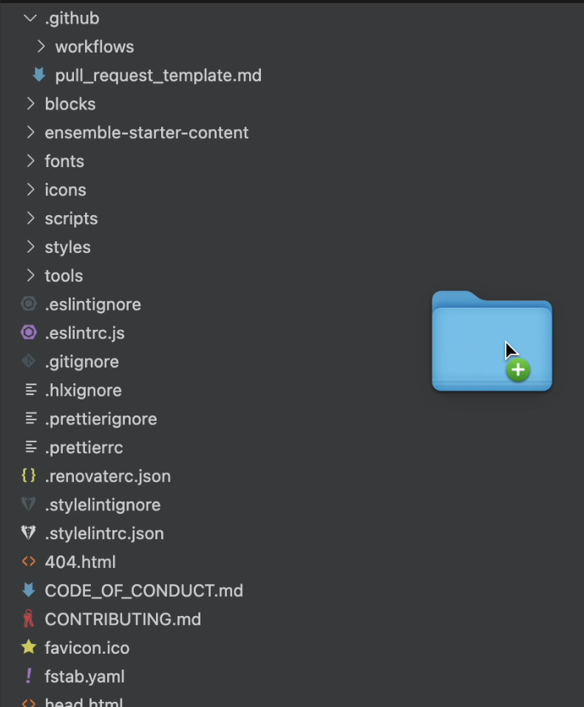

Select the Copy Folder option to copy the folder into your codebase. 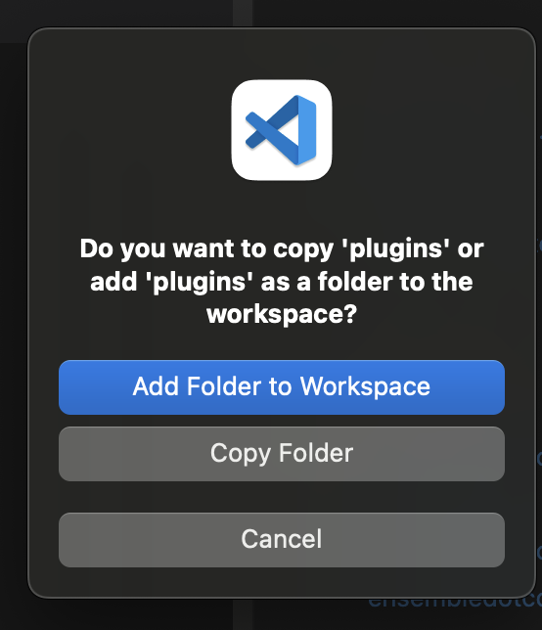

Confirm that the plugins folder is in the ensembledotcom area.

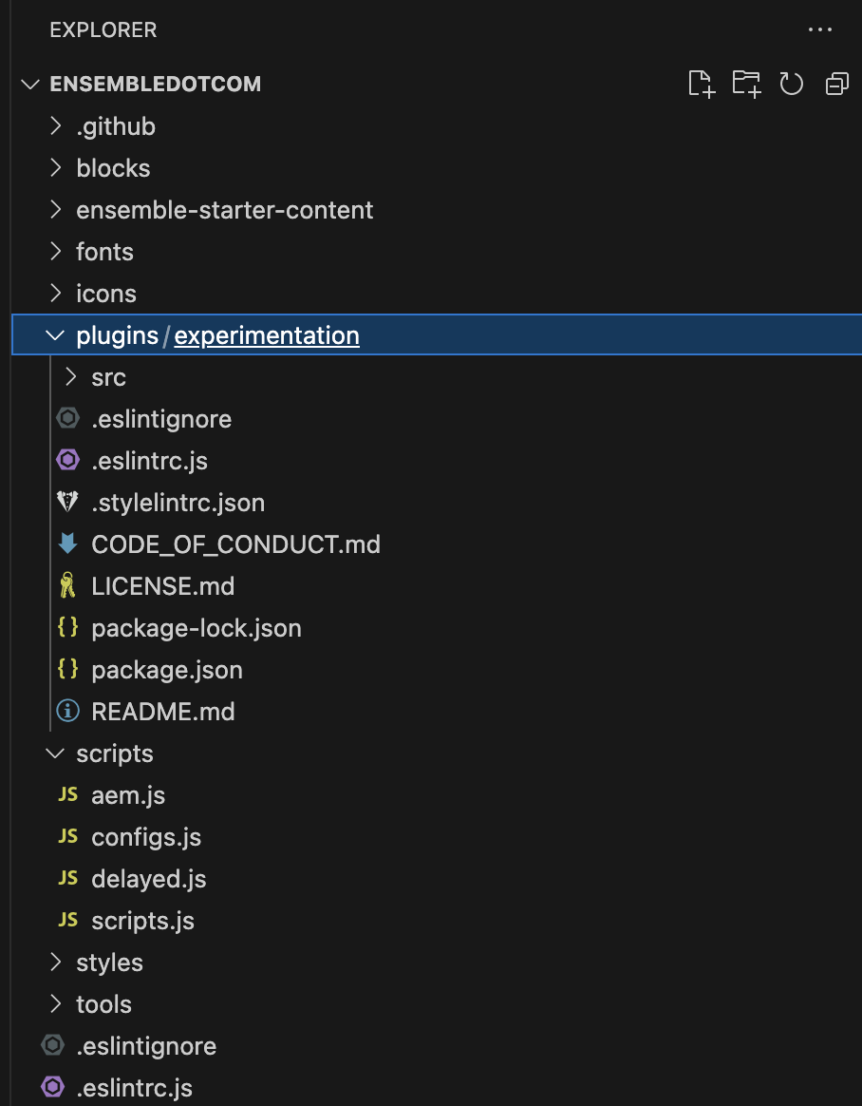

Next, go to <https://github.com/EnsembleSC/EnsembleDotComAfter/blob/main/scripts/scripts.js> and copy the code. There is a copy button in the Github UI for your convenience.

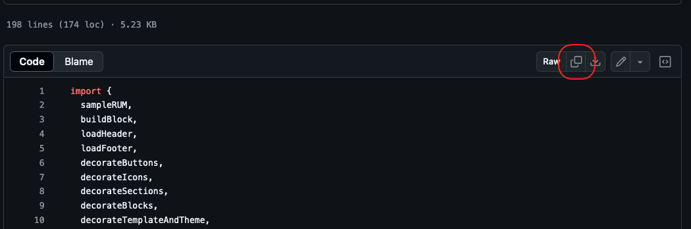

In Visual Studio Code, open the /scripts/scripts.js file and replace all contents with the code that you copied in the previous step. Save.

Next, go to <https://github.com/EnsembleSC/EnsembleDotComAfter/blob/main/scripts/configs.js> and copy the code. There is a copy button in the Github UI for your convenience.



In Visual Studio Code, create the /scripts/configs.js file and paste the code you copied in the previous step. Save.

In Visual Studio Code, commit the change to the Github repo. Select the Source Control button in the left rail.

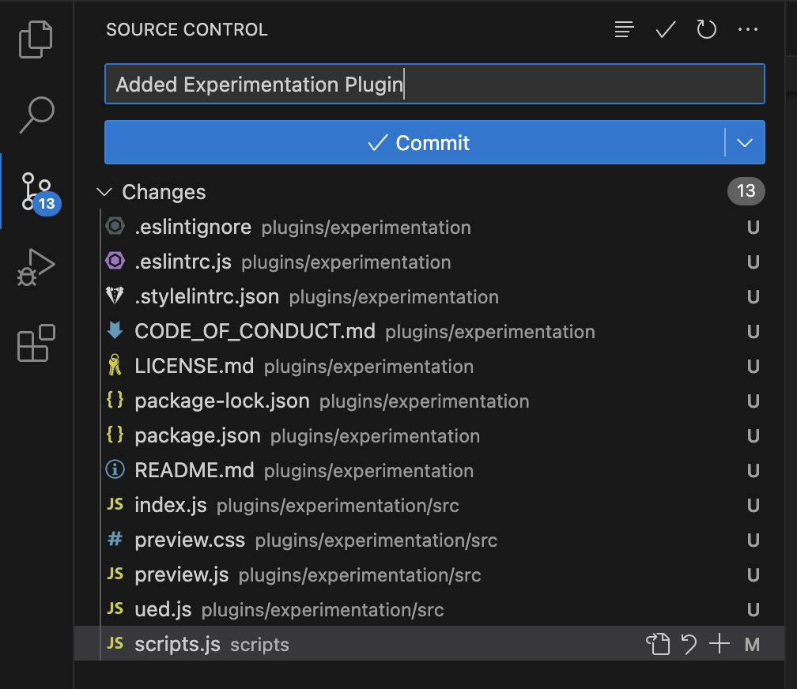

Enter a git commit message such as “Added Experimentation Plugin” into the field. (You cannot commit without providing a message)

Select the Commit button.

Select the Sync Changes button.

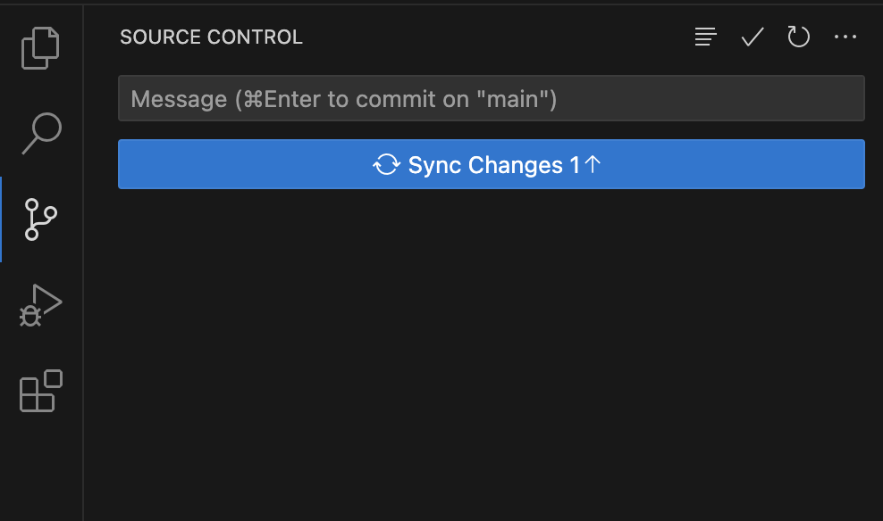

## 

[To Carousel Block Powered by a Spreadsheet](https://main--edsworkshop--hermanl.hlx.live/workshop2/carousel-spreadsheet)