# Carousel Block Powered by GraphQL and Content Fragment

Let’s add another Carousel Block to your codebase. This Carousel Block looks identical to the previous one but this one uses an API to retrieve data.

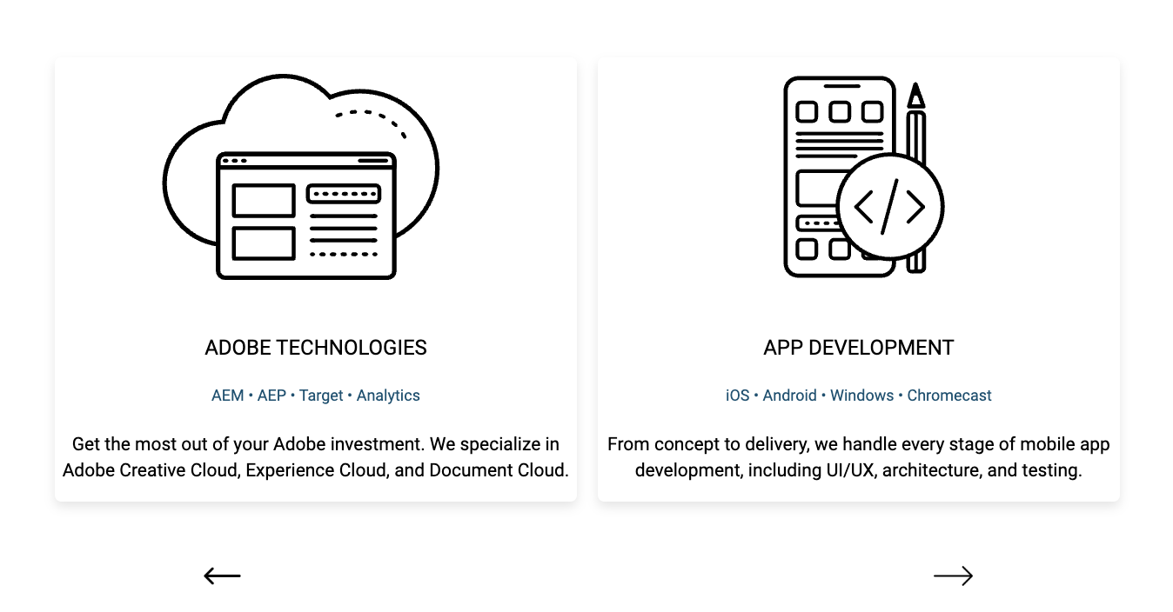

For the purposes of this workshop, endpoints with data have been created for you already.

## Author the Carousel Block

In this step, you will author the Carousel-gql Block in the /drafts Folder.

In Sharepoint, open your /drafts Folder of your site. Create a new Word Document named “carousel-gql.docx”. Open the document.

Create a table with 2 column and 2 rows.

Merge the 2 columns in row 1 into 1 cell.

In the top cell, enter Carousel-gql. This tells Edge Delivery Services which block to use.

In the bottom left cell, enter “Persisted Query” In the bottom right cell, enter “/**nameasc**”.

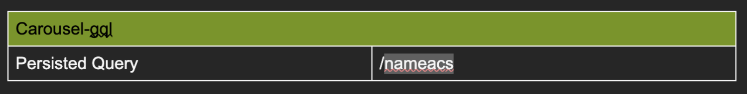

Duplicate the table. In the bottom left cell, enter “Persisted Query” In the bottom right cell, enter “/namedesc”.

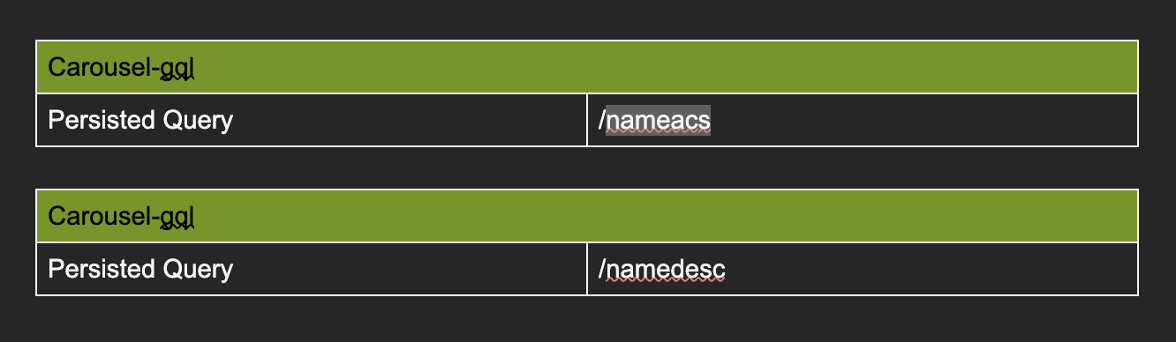

The URLs of the two endpoints are:

<https://publish-p131639-e1282833.adobeaemcloud.com/graphql/execute.json/EDS-Workshop/nameasc>

<https://publish-p131639-e1282833.adobeaemcloud.com/graphql/execute.json/EDS-Workshop/namedesc>

These endpoints are hosted on an AEM Sandbox environment that will hibernate if no one is using it. Therefore, these links may not always work.

Preview this file.

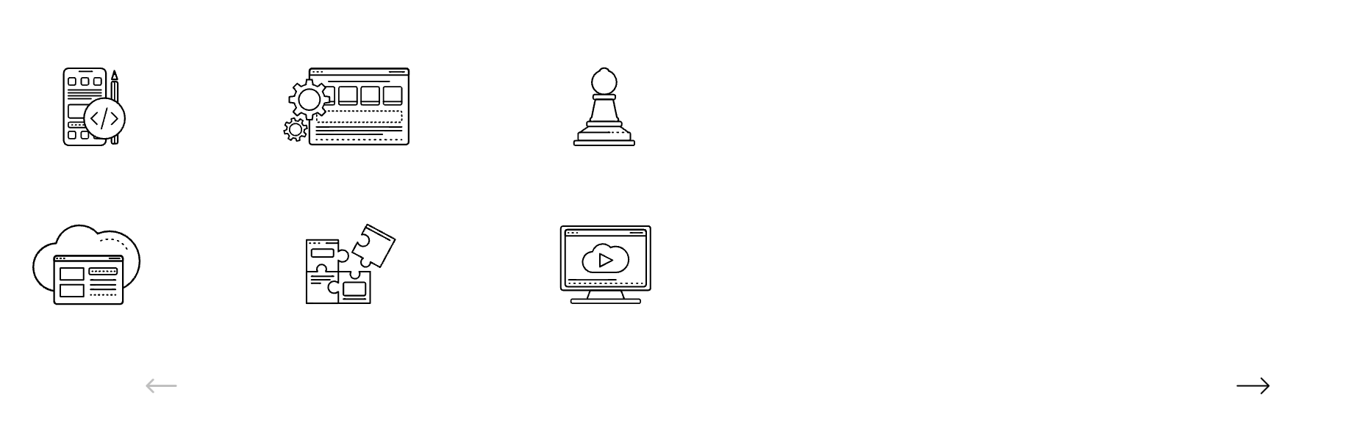

Don’t worry, it won’t look correct right now because there is no code for a Carousel-gql block.

## Harvest the Carousel-gql Code

In this step, you will harvest the code for the Carousel-gql Block from another project.

Open your ensembledotcom project in Visual Studio Code.

In the blocks folder, create a folder named carousel-gql. In the carousel Folder, create 2 new files; carousel-gql.css and carousel-gql.js.

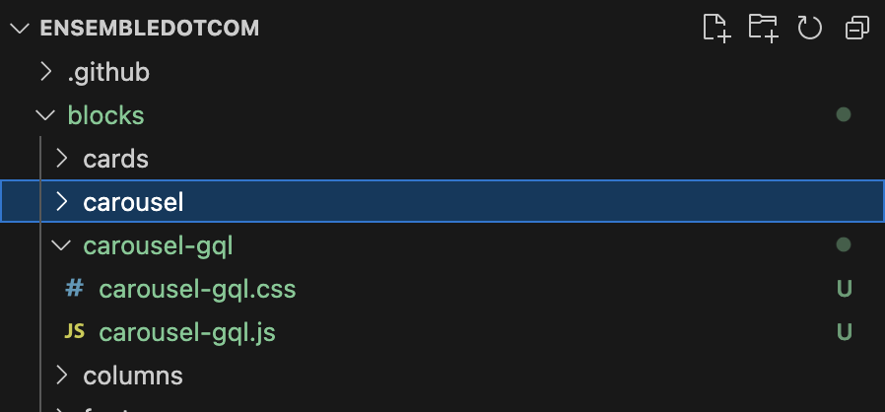

Go to <https://github.com/EnsembleSC/EnsembleDotComAfter/tree/main/blocks/carousel-gql>.

From Github, copy the contents of carousel-gql.css and carousel-gql.js into their respective copies in your ensembledotcom codebase.

There is a copy button in the Github UI for your convenience.

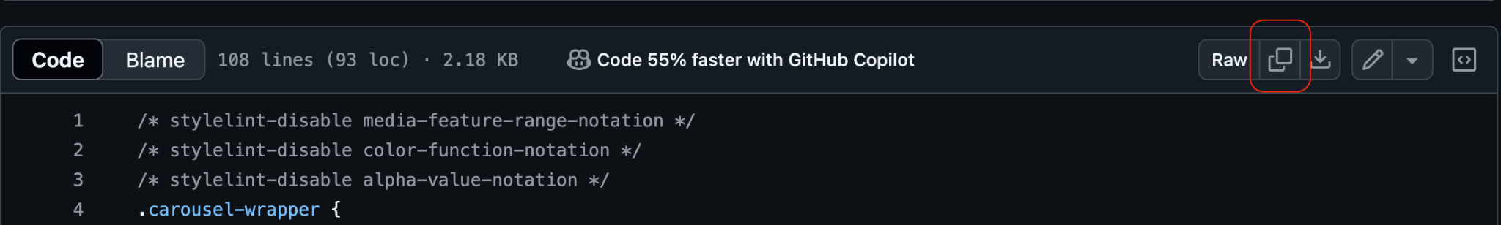

## Test the Carousel-gql Block Locally

In this step, you will validate that the Carouse-gql Block works locally.

Note, a fix to CORs issue has been added to the aemHeadlessConfig.xlsx file. Without this fix, you will encounter a CORs issue and the Carousel won’t load locally. This is because the GraphQL endpoint won’t let a page on localhost communicate with it. Keep CORs in mind when discussing local development with your customers.

Open your codebase in Visual Studio Code. Confirm that it is the right codebase by looking at the name in the center of the menu bar.



Bring up the terminal by selecting View from the menu then Terminal.

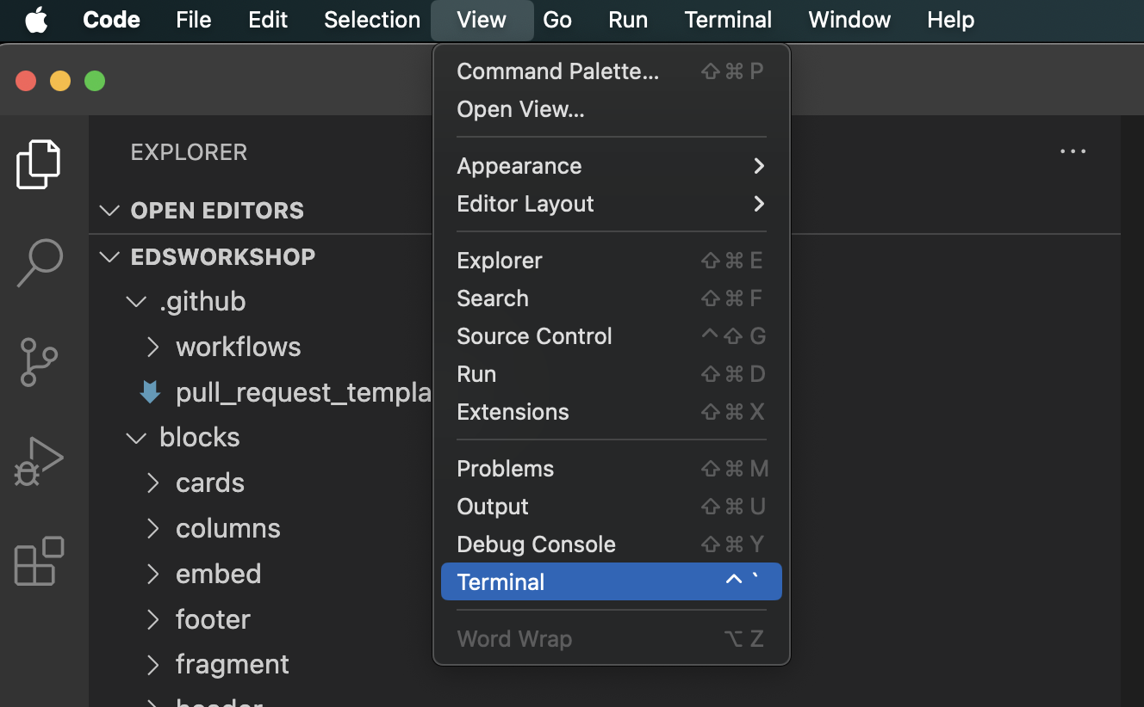

The Terminal panel should appear at the bottom of the window.

Type aem up into the terminal and press the ENTER key on your keyboard. This will turn on the tool.

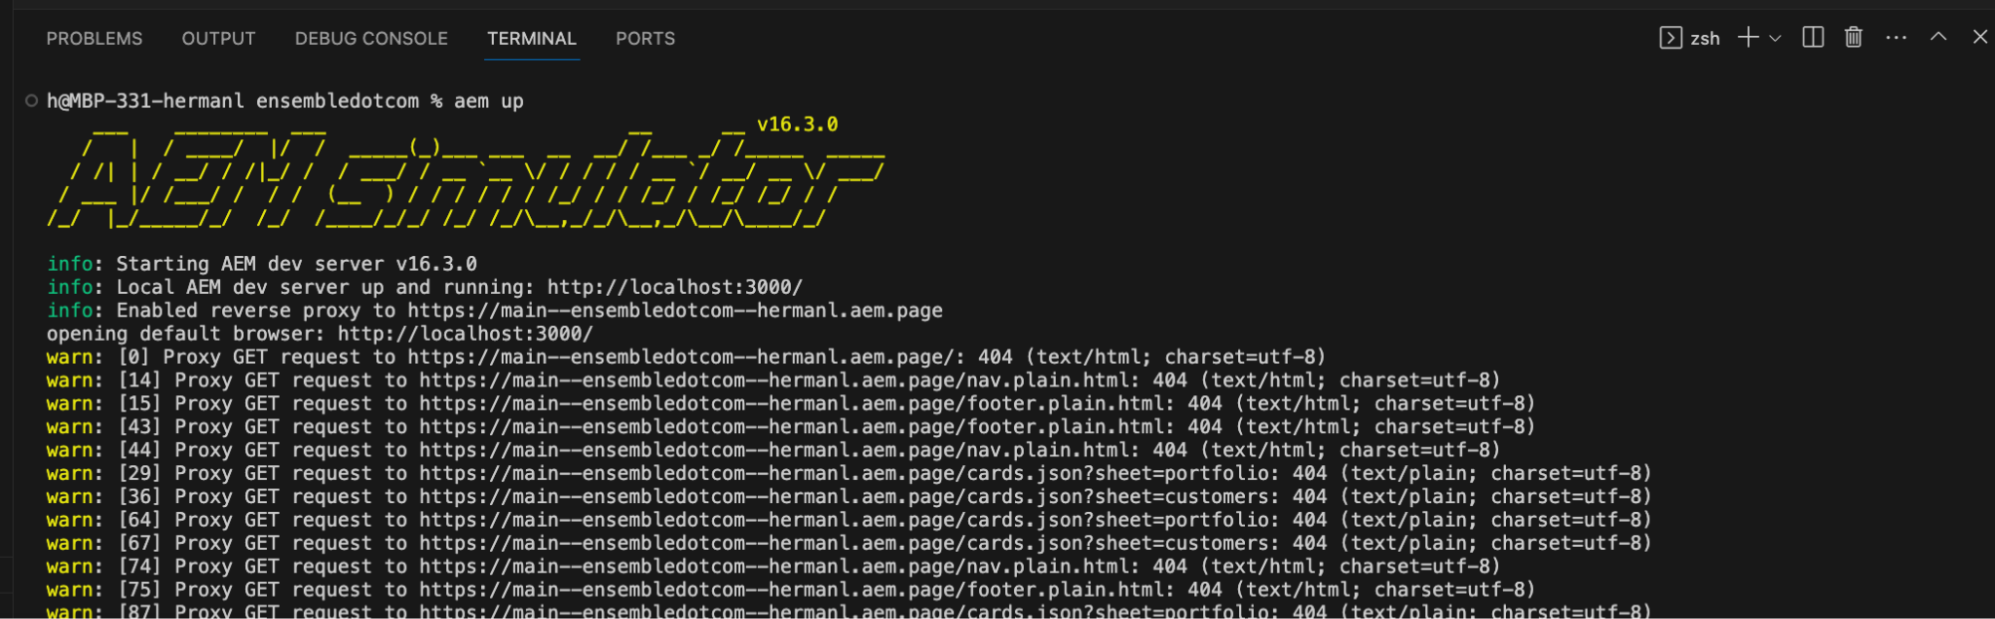

Open <http://localhost:3000/drafts/carousel-gql> in Google Chrome.

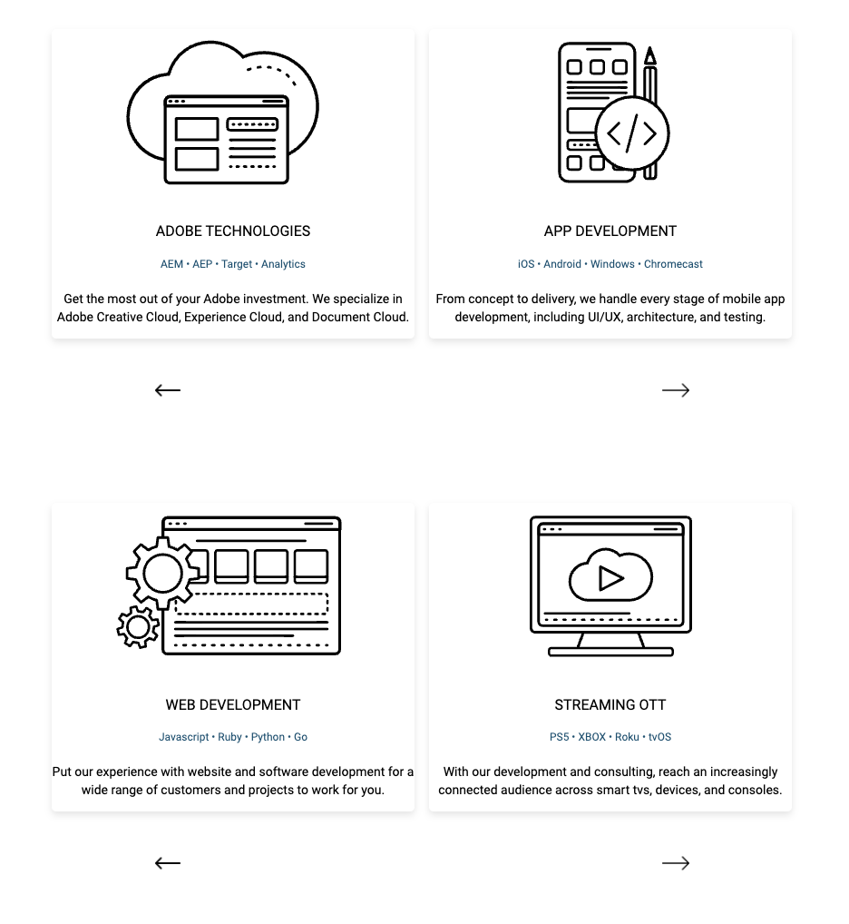

Do you see two Carousels?

## Commit

In this step, you will push the code into Github.

In Visual Studio Code, commit the change to the Github repo. Select the Source Control button in the left rail.

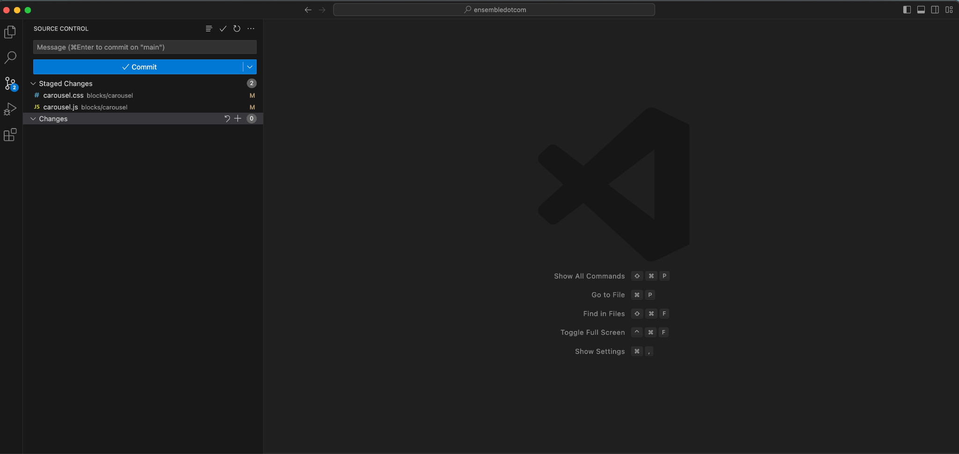

The next set of steps may differ depending on how your settings are.

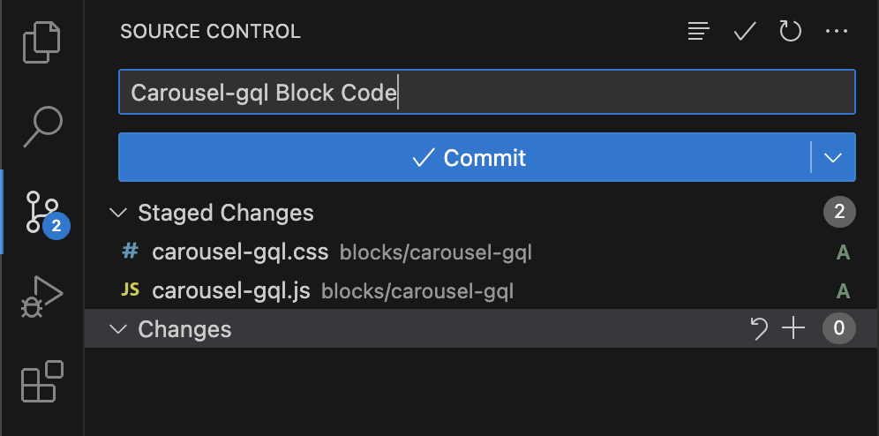

Enter a git commit message such as “Carousel-gql Block Code” into the field. (You cannot commit without providing a message)

Select the Commit button.

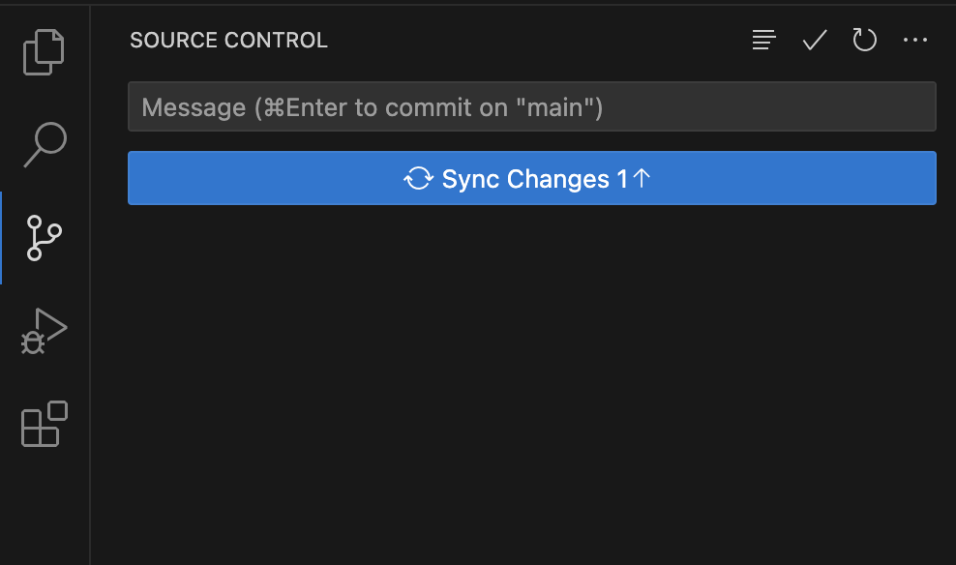

Select the Sync Changes button.

## Preview the Carousel Content

In this step, you will confirm that the code has made its way into the code repo.

Preview the /drafts/columns-gql.docx file. Validate that you see a working Carousel.

## Add the Carousel Content to index.docx

Now that the code works and the content is ready, you can add it to the index.docx.

Since the Carousel Content is already available in /drafts/columns-gql.docx, you can copy it from there into the index.docx. file. Note, this content can be added to any page.

Don’t forget to publish the new content.

## 

[To Experimentation](https://main--edsworkshop--hermanl.hlx.live/workshop2/experimentation)