# Carousel Blocks Powered by a Spreadsheet

Let’s add a Carousel Block to your site. This block renders structured data as cards in a carousel.

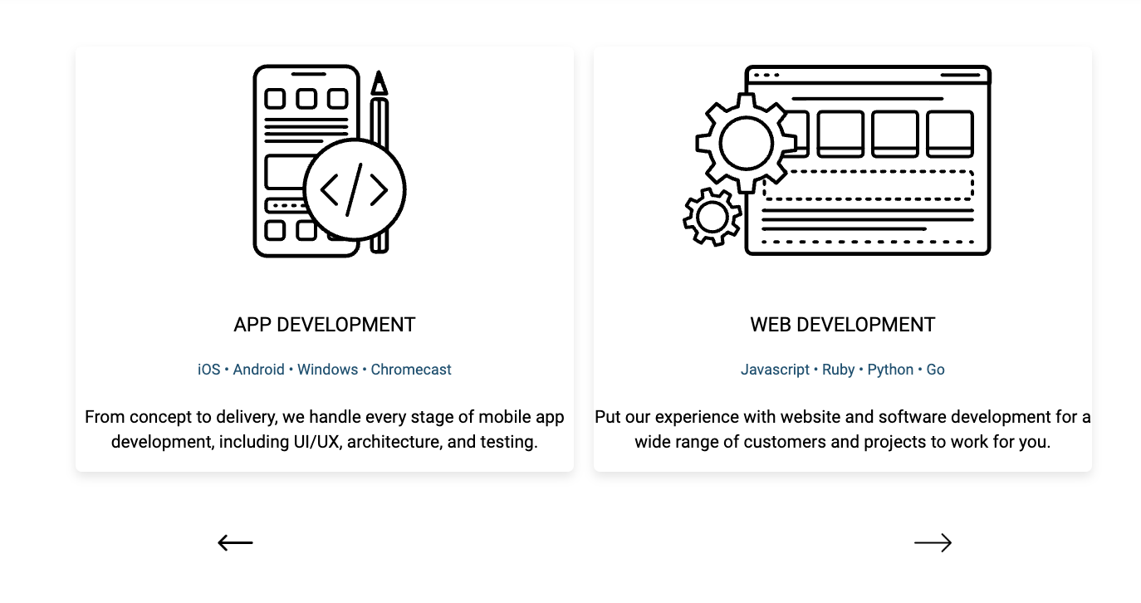

## Create the Spreadsheet

In this step, you will create the spreadsheet which Edge Delivery Services will convert into JSON.

In your ensemble folder, open the services.xlsx. Each row will be rendered as a card in the carousel.

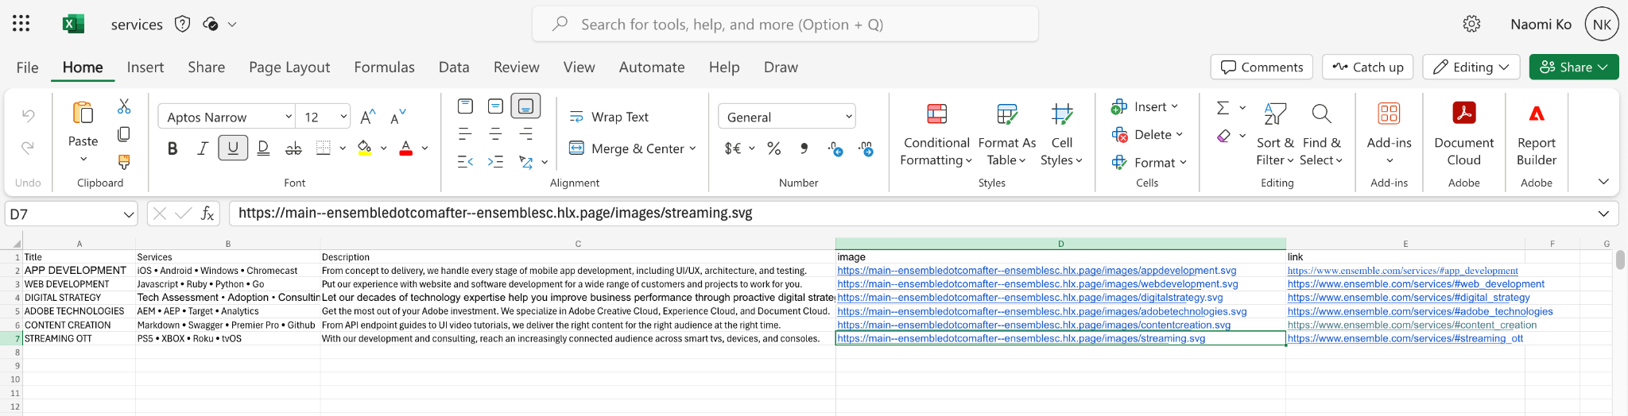

Preview it. The AEM Sidekick displays it as a table.

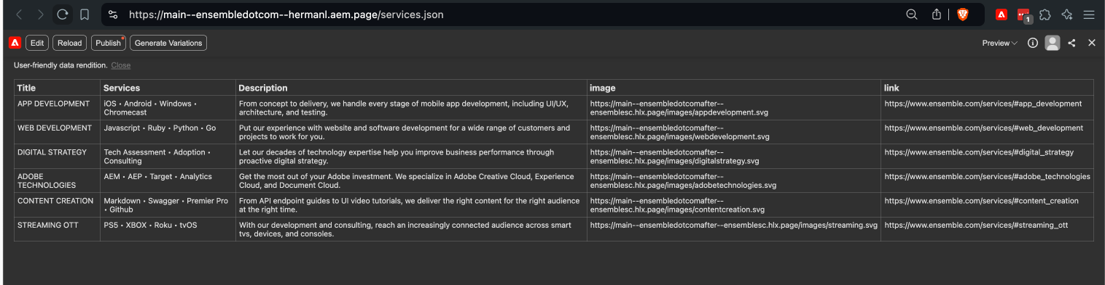

Close the AEM Sidekick and the browser will show vanilla JSON. Enable Pretty-Print to see formatted JSON.

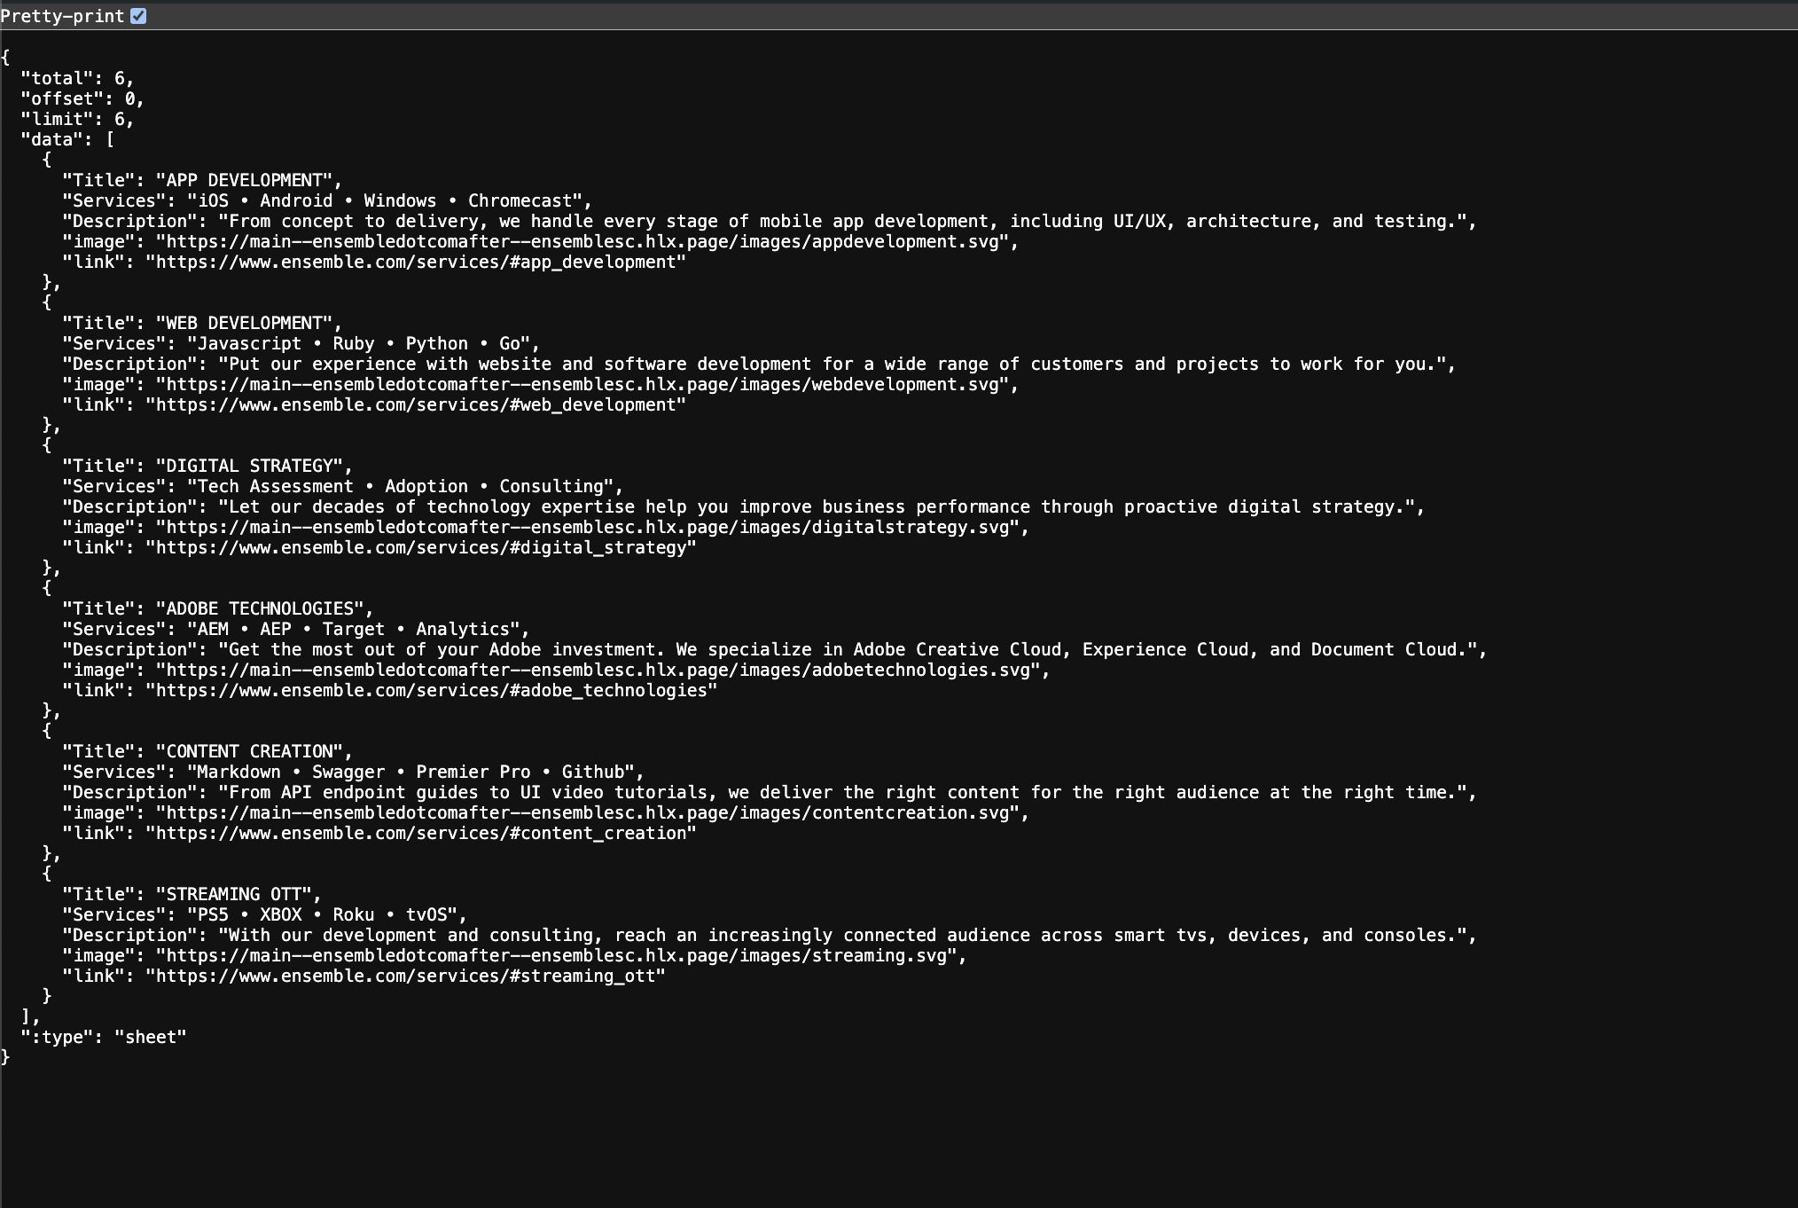

Note, the links to the images in the spreadsheet are not the links of the images in your content source. For the purposes of this workshop, the code has logic to piece together the links to your images using the provided URL. This was done so that you do not need to update the services.xlsx file.

## Author the Carousel Block

In this step, you will author the Carousel Block in the drafts Folder.

Open the drafts Folder. Create a new Word Document named “carousel.docx”. Open the document.

Create a table with 2 columns and 2 rows.

In the top cell, enter Carousel. This tells Edge Delivery Services which block to use.

In the bottom cell, enter a hyper link [https://main--ensembledotcom--GITHUBUSERNAME.AEM.page/services.json](https://main--ensembledotcom--githubusername.aem.page/services.json) wear GITHUBUSERNAME is your Github Username. Make sure this is actually a link and not just text.

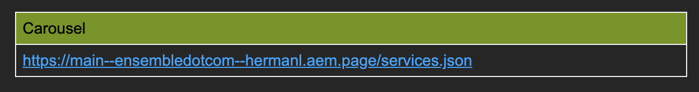

Preview this file.

Don’t worry, it won’t look correct like a carousel now because there is no code for a Carousel block. It will look like a link



## Harvest the Carousel Code

In this step, you will harvest the code for the Carousel Block from another project.

Open your ensembledotcom project in Visual Studio Code.

In the blocks folder, create a folder named carousel. In the carousel Folder, create 2 new files; carousel.css and carousel.js.

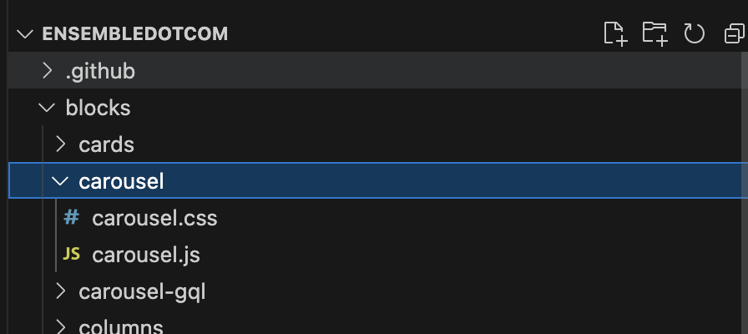

Go to <https://github.com/EnsembleSC/EnsembleDotComAfter/tree/main/blocks/carousel>.

From Github, copy the contents of carousel.css and carousel.js into their respective copies in your ensembledotcom codebase.

There is a copy button in the Github UI for your convenience.

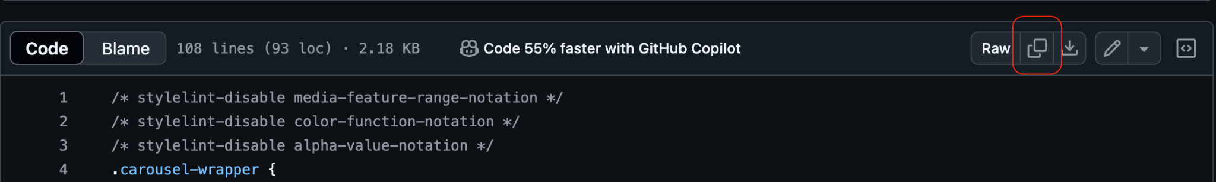

## Test the Carousel Block Locally

In this step, you will validate that the Carousel Block works locally.

Open your codebase in Visual Studio Code. Confirm that it is the right codebase by looking at the name in the center of the menu bar.



Bring up the terminal by selecting View from the menu then Terminal.

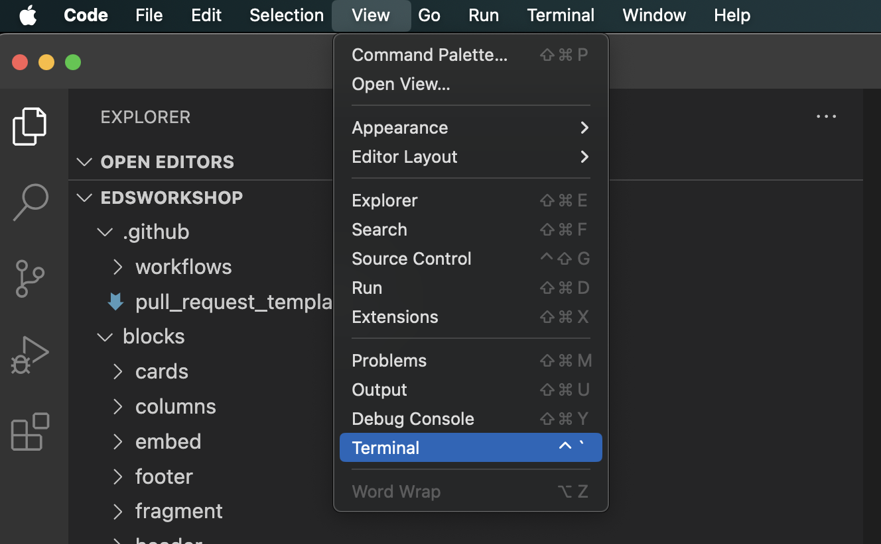

The Terminal panel should appear at the bottom of the window.

Type aem up into the terminal and press the ENTER key on your keyboard. This will turn on the tool.

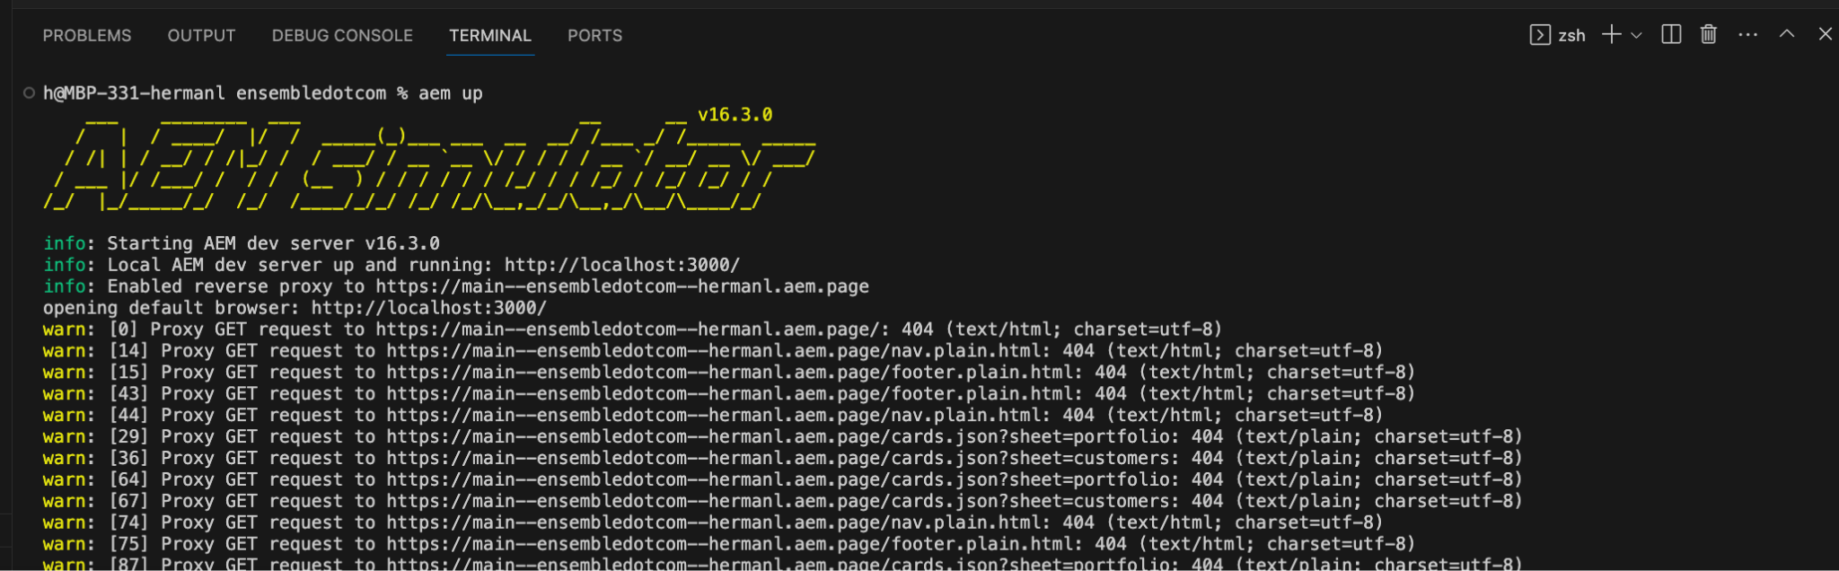

Open <http://localhost:3000/drafts/carousel> in Google Chrome. Confirm that it loads and has six different cards. The content should match what is in services.xlsx.

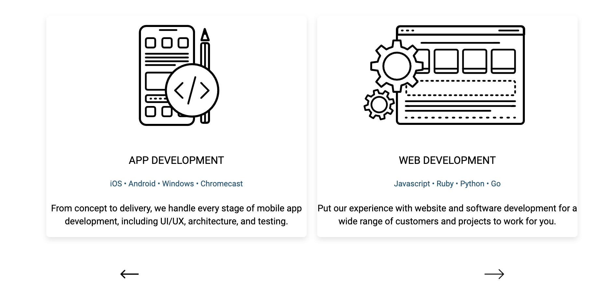

## Commit

In this step, you will push the code into Github.

In Visual Studio Code, commit the change to the Github repo. Select the Source Control button in the left rail.

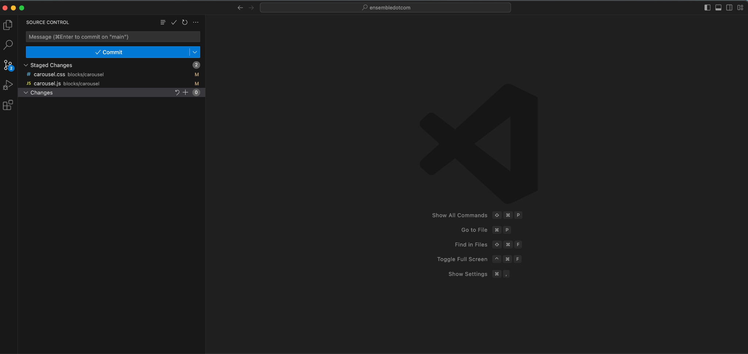

The next set of steps may differ depending on how your settings are.

Enter a git commit message such as “Carousel Block Code” into the field. (You cannot commit without providing a message)

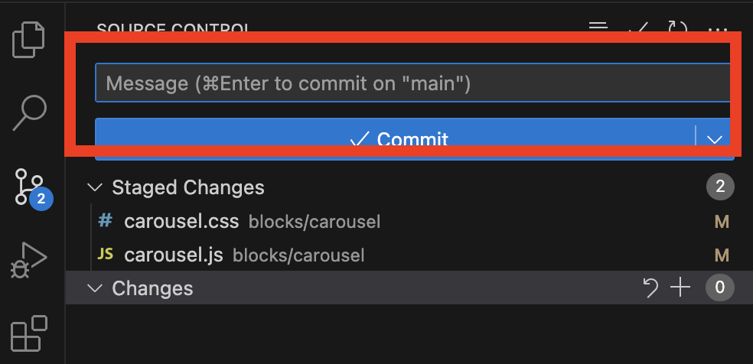

Select the Commit button.

Select the Sync Changes button.

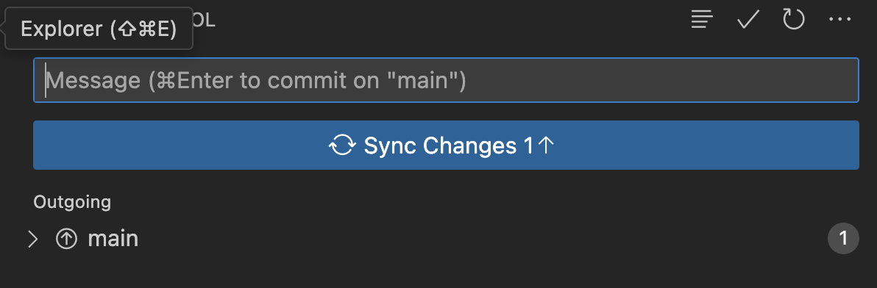

## Preview the Carousel Content

In this step, you will confirm that the code has made its way into the code repo.

Preview the /drafts/columns.docx file. Validate that you see a working Carousel.

## Add the Carousel Content to index.docx

Now that the code works and the content is ready, you can add it to the index.docx.

Since the Carousel Content is already available in /drafts/columns.docx, you can copy it from there into the index.docx. file. Note, this content can be added to any page.

Don’t forget to publish the new content.

[To Carousel Block Powered by GraphQL and AEM Content Fragments](https://main--edsworkshop--hermanl.hlx.live/workshop2/carousel-graphql)