# Experimentation

Edge Delivery Services has a built-in experimentation plugin which non-technical users can use to setup A/B test or Multivariate tests without the need to involve a developer. The setup only needs to be done once per site.

For more information, see <https://www.aem.live/docs/experimentation>.

## Create Your Challenger Page

In this step, you will make a folder to house your Challenger Page for your index page experiment.

Create a folder with a lowercase experiment ID challenger001 in your /experiments/ folder which is where all the pages for your challenger variants live. You can have multiple challenger page files in the same folder. The files will need to have different names.

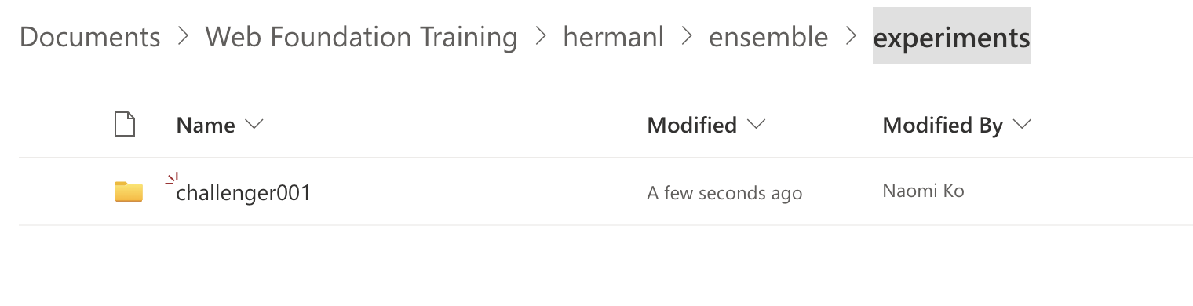

Once the folder has been created, put a copy of your index.docx into that folder.

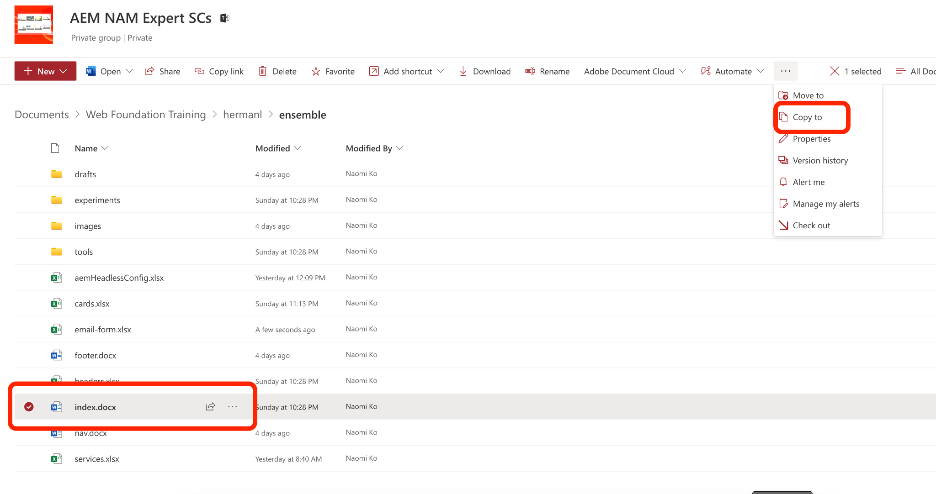

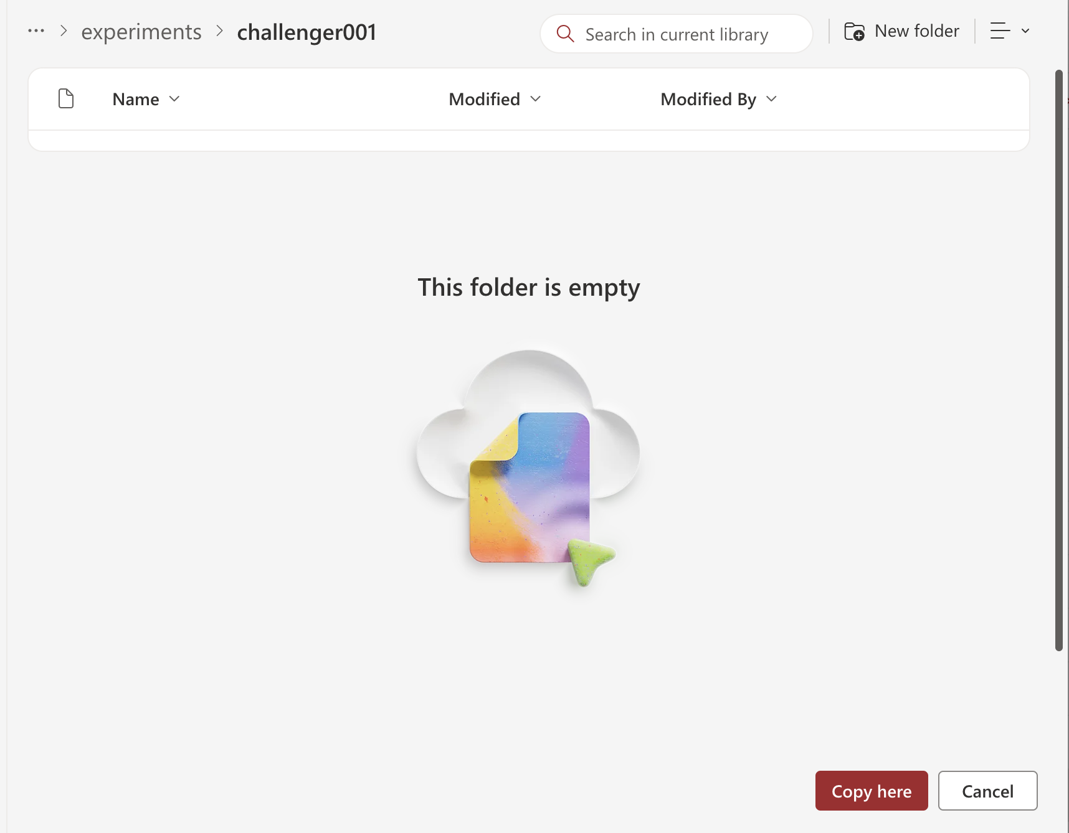

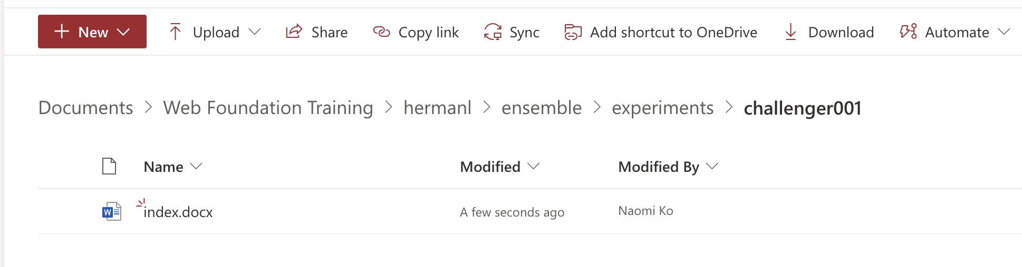

Update the new page with the changes that you would like to test as part of your experiment variant. You may change any part of the page.

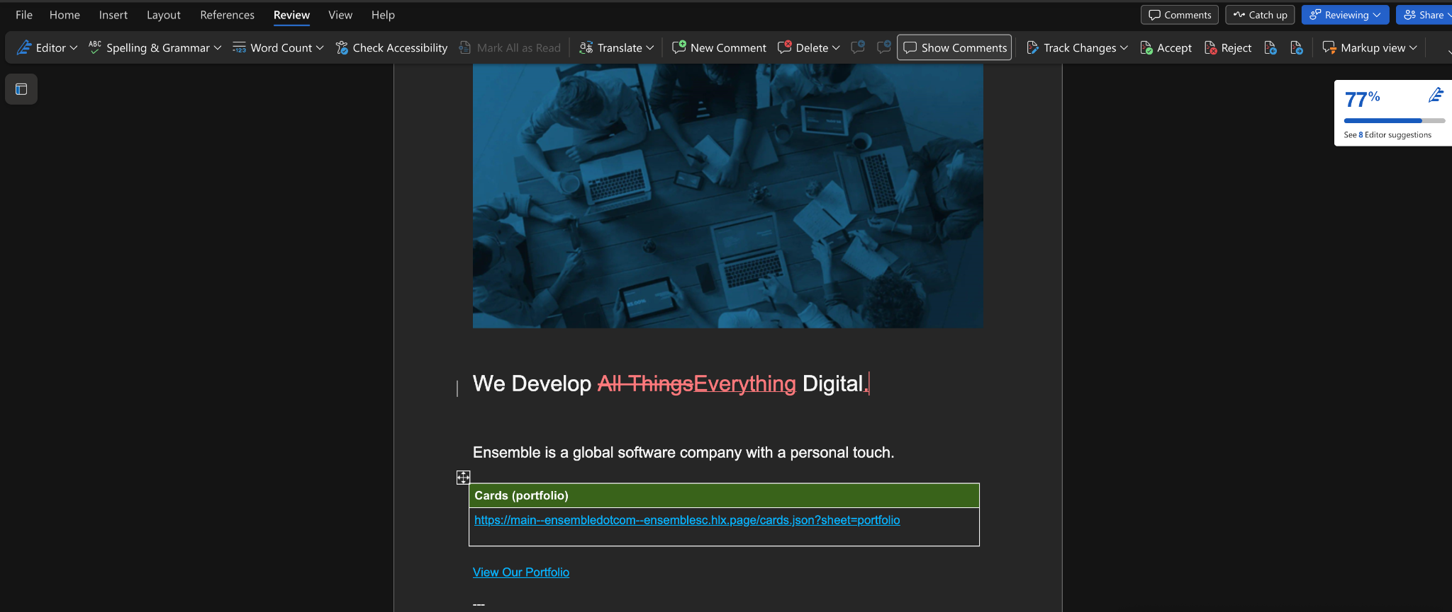

Preview and publish the challenger page using the AEM Sidekick and when you are done authoring the challenger page, the URL of the published challenger will be used in the next section. Copy the Publish URL (*.live).

## Set Up your Experiment

In this step, you will add metadata to the control page (index.docx) to tell Edge Delivery Services that the page is part of an experiment.

There are two metadata rows that need to be added for an experiment variant.

Experiment : containing your experiment ID

Experiment Variants: containing URLs for all the challengers of this page, separated by line breaks if you have more than one challenger

Open your index.docx that is in the ensemble folder. Make sure you are not opening the newly created index.docx page that is in the experiment folder.

Scroll down to the bottom of the file and find the Metadata Table.

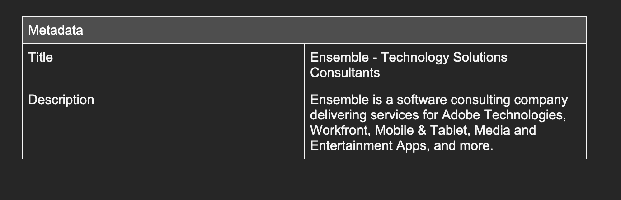

Add two rows to the bottom of the table. Add Experiment and Experiment Variants to the table. 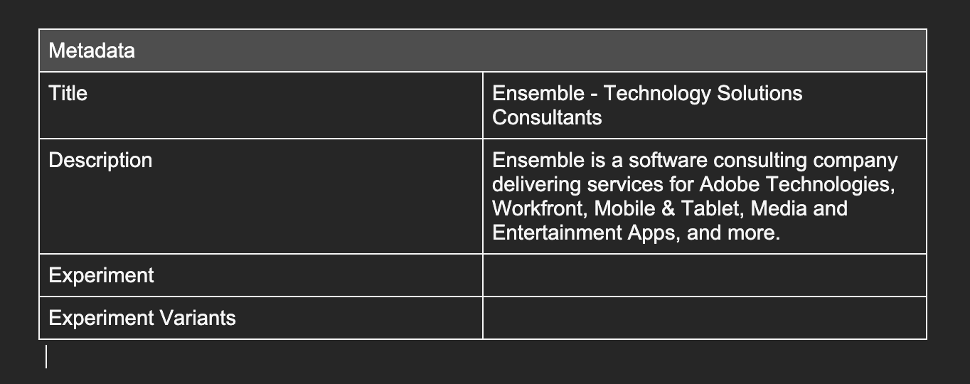

In the Experiment row, add challenger001.

In the Experiment Variants row, add the Publish link (*.live) of the challenger page. For example: <https://main--ensembledotcom--hermanl.aem.live/experiments/challenger001/>

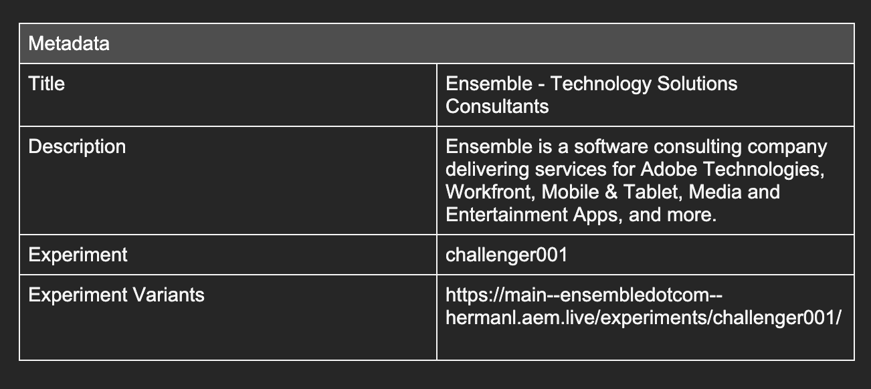

## Preview and Publish your Test

In this step, you will preview the page and then publish your page.

Preview the page. 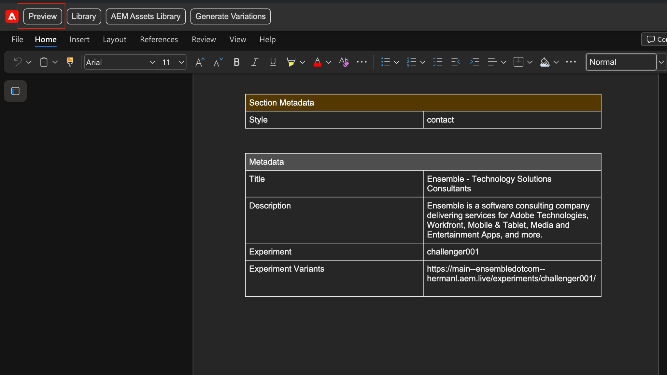

Publish the page.

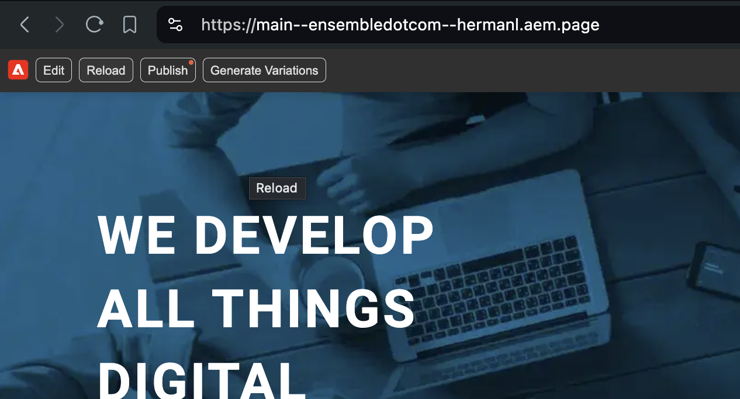

For an experiment variant the traffic split between all the variants (control + challengers) is automatically set to an even distribution. If you have one challenger, there will automatically be an even 50/50 split between control and the challenger. If you have 2 challengers, you will automatically see a third of the traffic allocated to control and each challenger and so on.

You can override the traffic split via metadata. For more information, see <https://github.com/adobe/aem-experience-decisioning/wiki/Experiments#authoring>

## Confirm that the Experiment is Running.

In this step, you will validate that the experiment is running.

Preview your index.docx file in the ensemble folder or open the Preview link of your site. Either method will open the homepage that the experiment is running on.

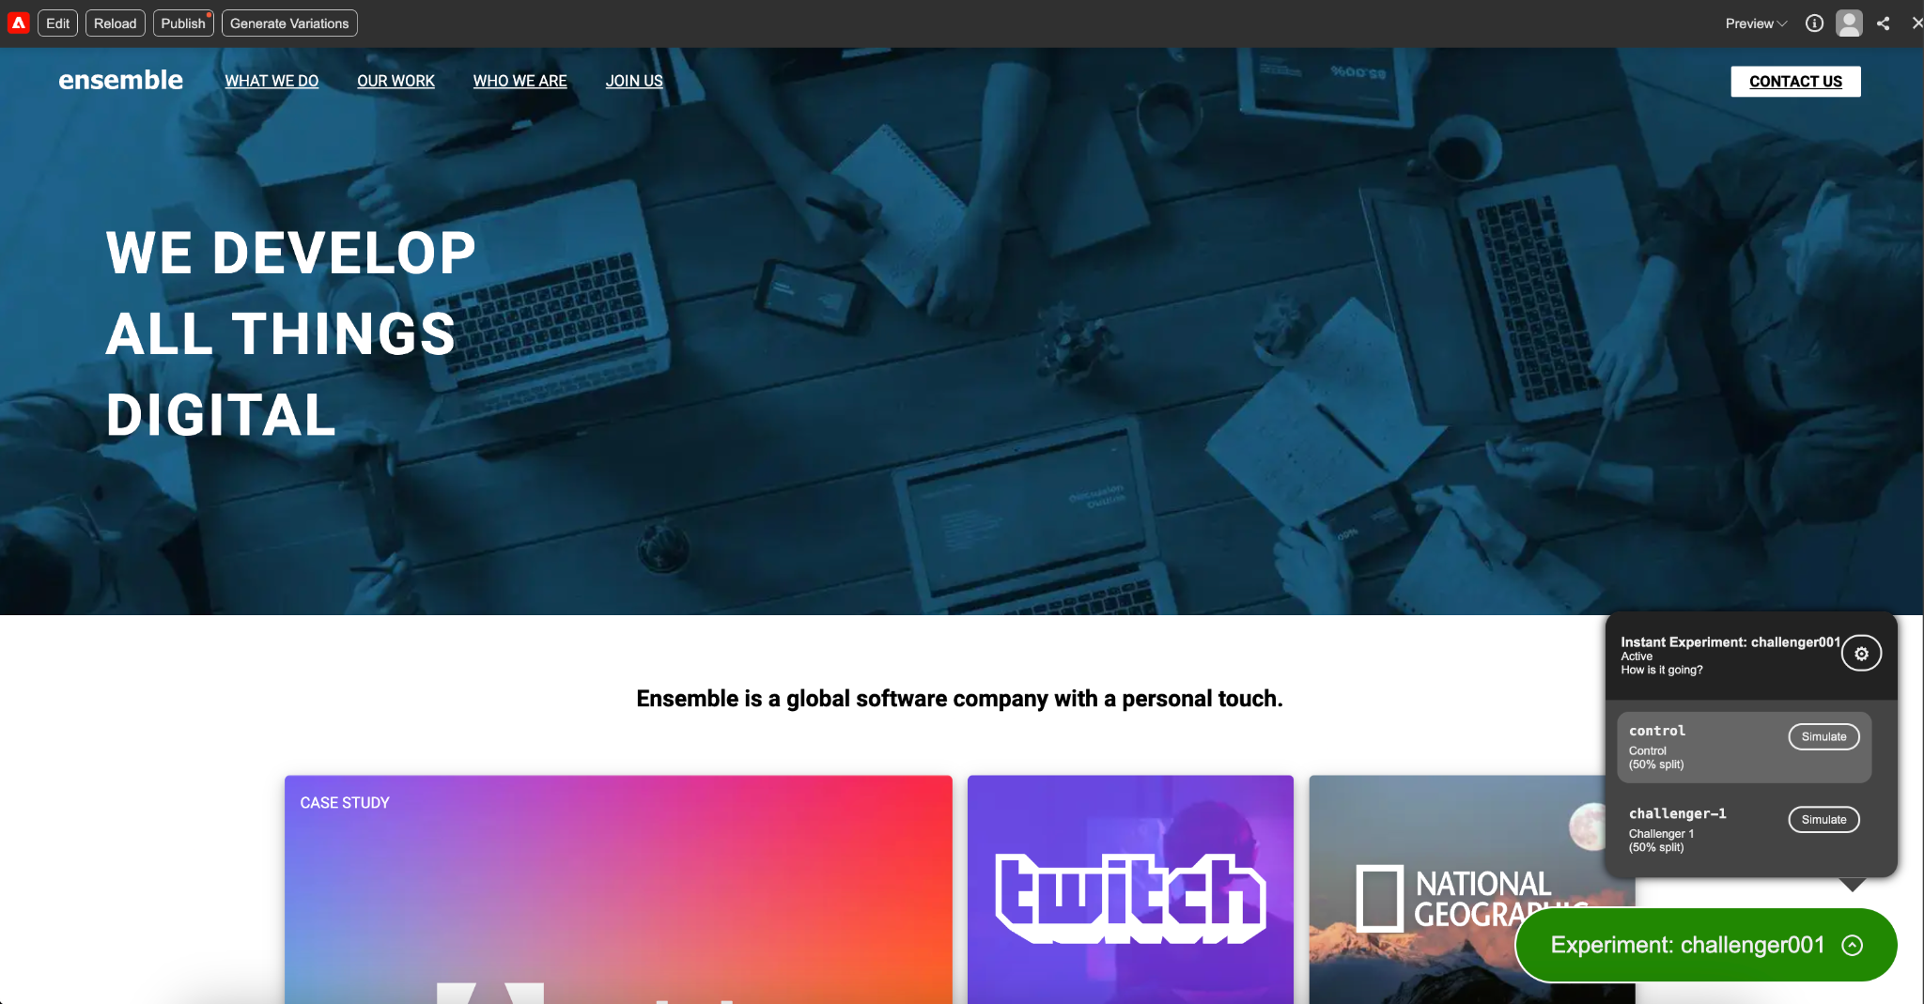

Validate that you can see the green bubble in the lower right hand corner.

Use it to switch/stimulate between the control content and the challenger content.

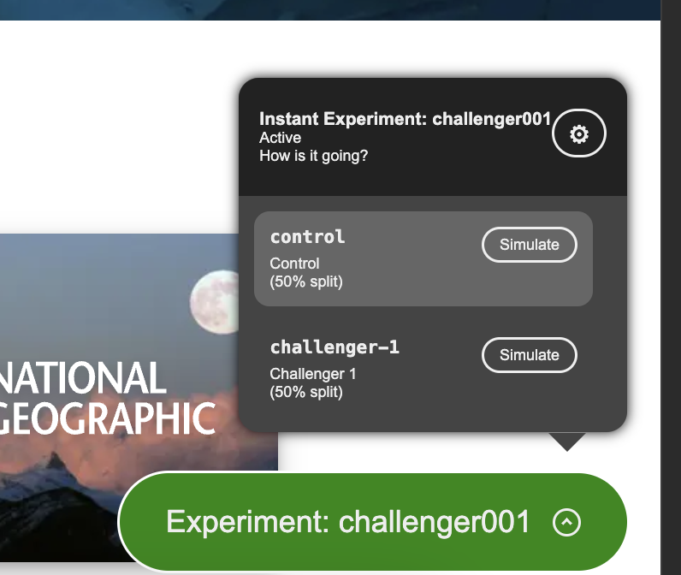

[To Forms](https://main--edsworkshop--hermanl.hlx.live/workshop2/forms)