ISS ChatBot User Guide

# 

# Getting Started

System Requirements

Power Supplier Recommender system supports the following Web Browsers:

* Internet Explorer 11
* Microsoft Edge 39 and above
* Firefox 53 and 52 ESR and above
* Google Chrome Version 59 and above
* Safari Version 10 and above

Quick Start

In order to run the system, you will need to subscribe to a slack account and to the mtech2019pt group.

# Launching the Application

Open your preferred browser and go to the URL “ [https://mtech2019pt.slack.com](https://mtech2019pt.slack.com/)”

Introduction

The landing page of the application is as shown below.

Step 1- click on + button beside the Apps.

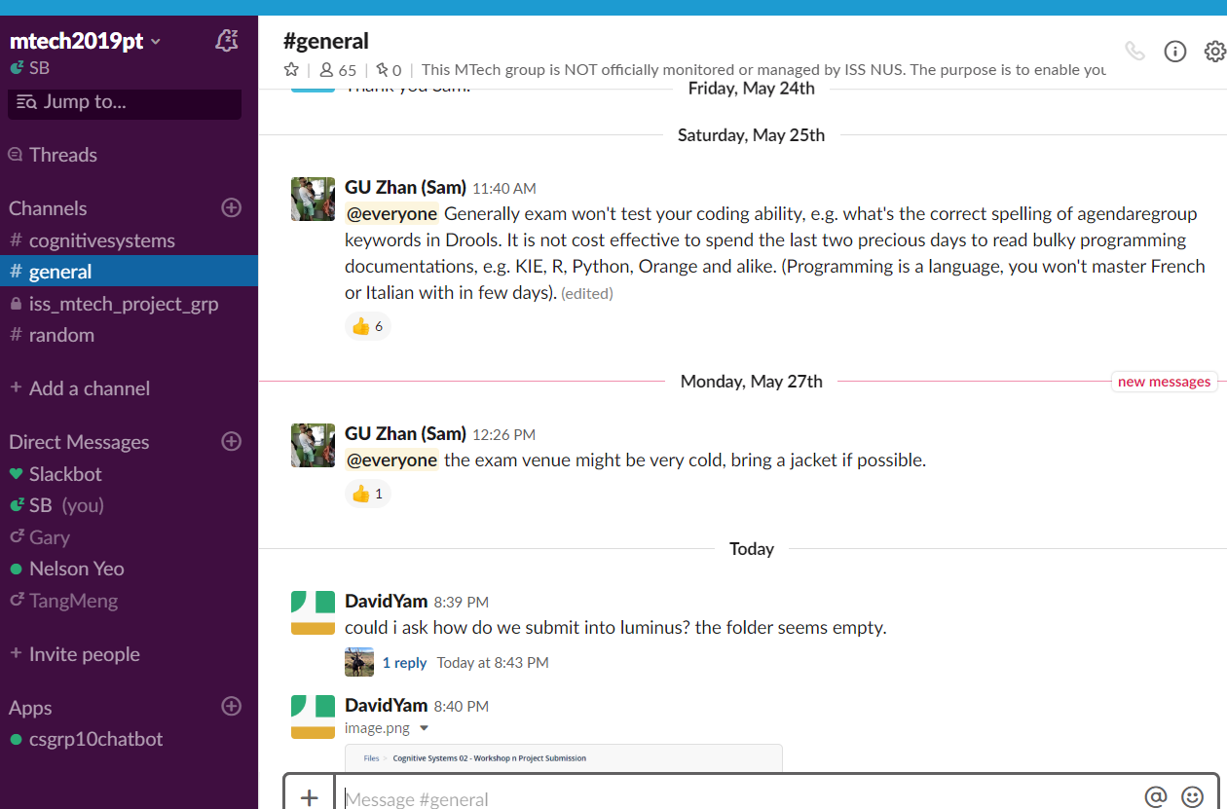

Step 1, click on the add button

Step 2: Search and select the csgrp10chatbot

Step 3: Double clikc on csgrp10chatbot and start chatting!

Sample questions and replies as follows:

1. cyber security courses?

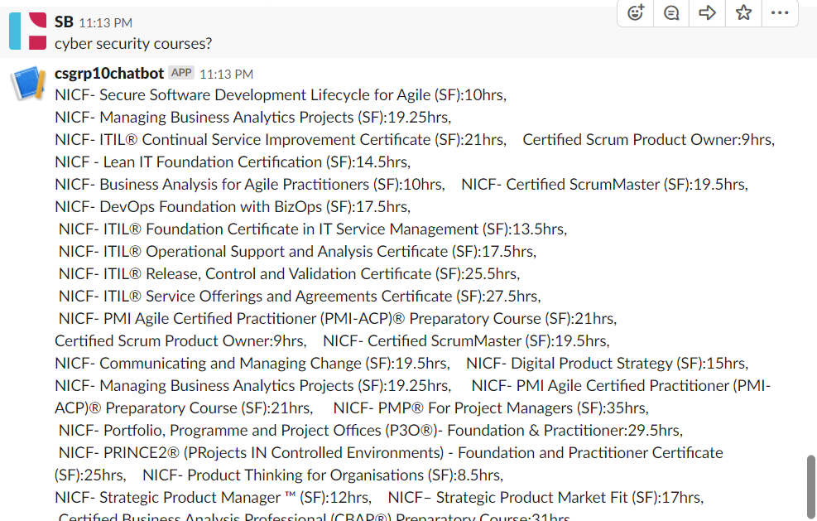

1. What is the price of strategic product manager course?

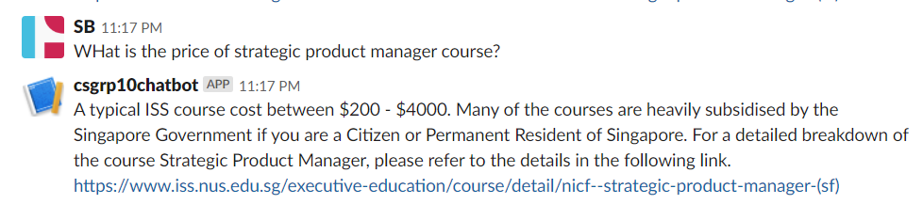

1. Is there sponsorship?

