1. **Ripple Carry adder:**

// Module 4-bit ripple carry adder.

module fulladdR(input wire [3:0] a, b, input wire cin, output wire [3:0] sum, output wire cout);

// Instantiate full adder modules here.

wire [2:0] c;

**fulladd u0 (a[0], b[0], cin, sum[0], c[0]);**

**fulladd u1 (a[1], b[1], c[0], sum[1], c[1]);**

**fulladd u2 (a[2], b[2], c[1], sum[2], c[2]);**

**fulladd u3 (a[3], b[3], c[2], sum[3], cout);**

endmodule

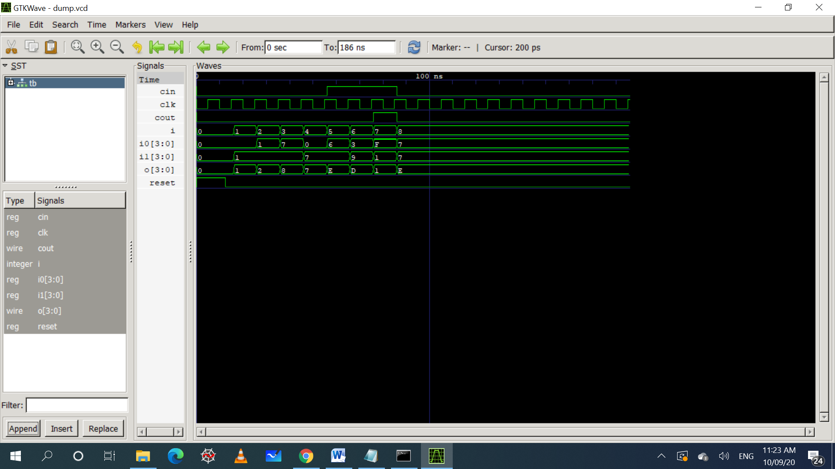

**2) Mux 4:1**

module mux4 (input wire [0:3] i, input wire j1, j0, output wire o);

wire t0, t1;

**mux2 mux2_0 (i[0], i[1], j1, t0);**

**mux2 mux2_1 (i[2], i[3], j1, t1);**

**mux2 mux2_2 (t0, t1, j0, o);**

endmodule

