Renter Sign-Up Function Specification

1. Revision History
Document scope: public self-registration for a renter account only. Landlord registration is intentionally excluded and will have its own FSD.
Version | Date | Author | Summary
1.0 | 2026-10-23 | AbangCebu AI Project Team | Initial renter-only sign-up FSD; based on supplied template and current application behavior.

2. Function Overview
This function lets a guest create a renter account from AbangCebu’s account-access dialog. The primary home-page flow opens the dialog from Sign in or the guest menu, then switches to Sign up. The same registration form is also available at /register.
Renter-specific data: full name, email address, password, and an optional Philippine mobile number. The selected role is renter. Email verification follows the configured Supabase Auth confirmation behavior.

3. User Story
As a guest looking for a rental in Cebu, I want to register as a renter with my email so that I can verify my account and continue to renter search features.
Use-case diagram: renter starts as a guest, chooses Sign Up, selects Renter, submits the account details, and verifies the email before continuing.
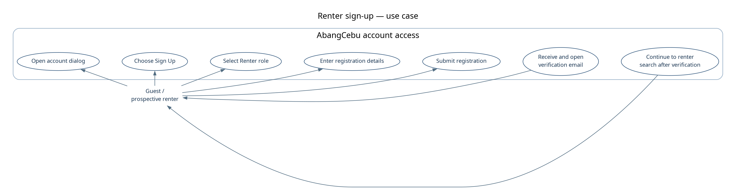
Figure 1. Renter sign-up use-case diagram.

4. Acceptance Criteria
The following criteria describe the current renter registration path and the observable behavior required at each stage. Known implementation gaps are listed separately in Section 11.
Acceptance criteria:
- A guest can open account access from the home-page Sign in control or guest menu and switch between Sign in and Sign Up without leaving the landing page.
- The registration form allows Renter to be selected and submits role="renter"; public registration does not allow an admin role.
- Full Name, Email Address, and Password are required. Phone number is optional.
- The phone input accepts no more than 11 characters in the current UI. Server validation rejects a supplied phone that is not a supported Philippine mobile format.
- The server normalizes email to lowercase and trims it; it validates the name, email, password, role, and optional phone before creating an account.
- Invalid browser/API input does not create an account. The user receives an error and can correct the form and retry.
- A successful request creates a Supabase Auth user and a renter profile through the database trigger, then the form displays the email-check success state.
- When email confirmation is enabled, opening the valid PKCE email link exchanges the code and redirects the renter to the safe /search route.
- The renter path does not collect landlord identity documents, property details, or listing data.

5. Preconditions
The user is not required to sign in before opening account access. A working application, registration API, Supabase Auth configuration, and access to the registration email inbox are required.
Renter scope assumes the user chooses Renter in the shared role selector. The renter form requires full name, email, and password; phone number is optional. Email delivery and confirmation depend on Supabase Auth configuration.

6. Function Flow
Normal flow:
Open account access → choose Sign Up → select Renter → enter details → submit → server validates → Supabase creates the auth account and database trigger creates the renter profile → success message asks the user to check email → user opens the PKCE link → callback redirects to /search. Invalid input returns to the form with an error.
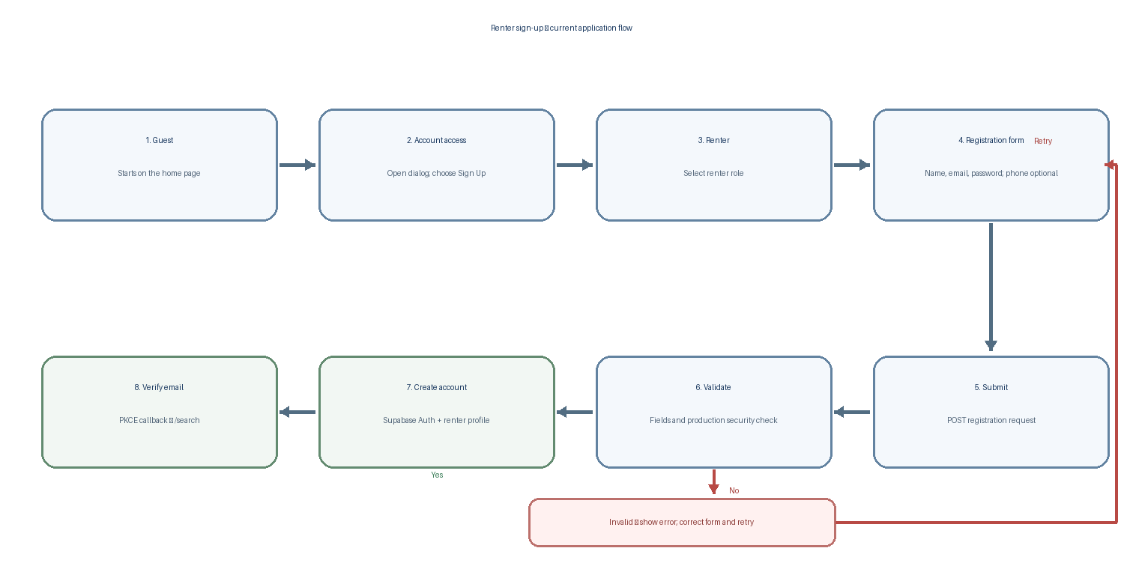
Figure 2. Current renter registration and email-verification flow.

7. Data Movement
Registration data travels from the renter form to the registration API, then to Supabase Auth and the profile trigger. The table records the inputs, outputs, and destination for each handoff.
Step | Input Data | Output Data | Source / Destination
1 | Guest opens account access and chooses Sign Up; selects Renter. | Registration form opens in Sign Up mode with renter role selected. | User → account dialog / RegisterForm
2 | Full name, email, password, optional phone number, role=renter. | Client-side form state; browser required/email checks; phone maxLength=11. | Renter → RegisterForm
3 | JSON: fullName, email, password, role, optional phoneNumber. | POST request to registration endpoint. | RegisterForm → POST /api/auth/register
4 | Untrusted request body. | Normalized payload or 400/422/403 error. API validates email, name, password, role, phone; production also requires Turnstile. | Route handler → validator / Turnstile
5 | Validated renter data and email callback URL. | Supabase Auth user and confirmation message when confirmation is required. | Route handler → Supabase Auth
6 | Auth user metadata: role, full_name, optional phone_number. | public.profiles row with user id, renter role, full name, optional accepted phone. | Supabase Auth → database trigger → public.profiles
7 | Registration success response. | Form displays “Check Your Email” and Return to Login; redirectUrl in response is not used by current form. | API → RegisterForm → renter
8 | Email PKCE code and next=/search. | Code exchange/session handling, then safe redirect to /search. | Email → browser → /auth/callback → /search
Passwords are submitted to Supabase Auth over the registration request and are not copied into the public profile. Email is retained by Supabase Auth; the profile trigger stores role, full name, and a valid optional phone number.

8. UI Mockups / Wireframes
The diagrams show the home-page account dialog and its renter sign-up state. The landing flow is a modal, not a separate renter-only modal. The /register page reuses the same role-aware form.
Low-fidelity wireframe — account dialog in Sign Up mode with Renter selected:
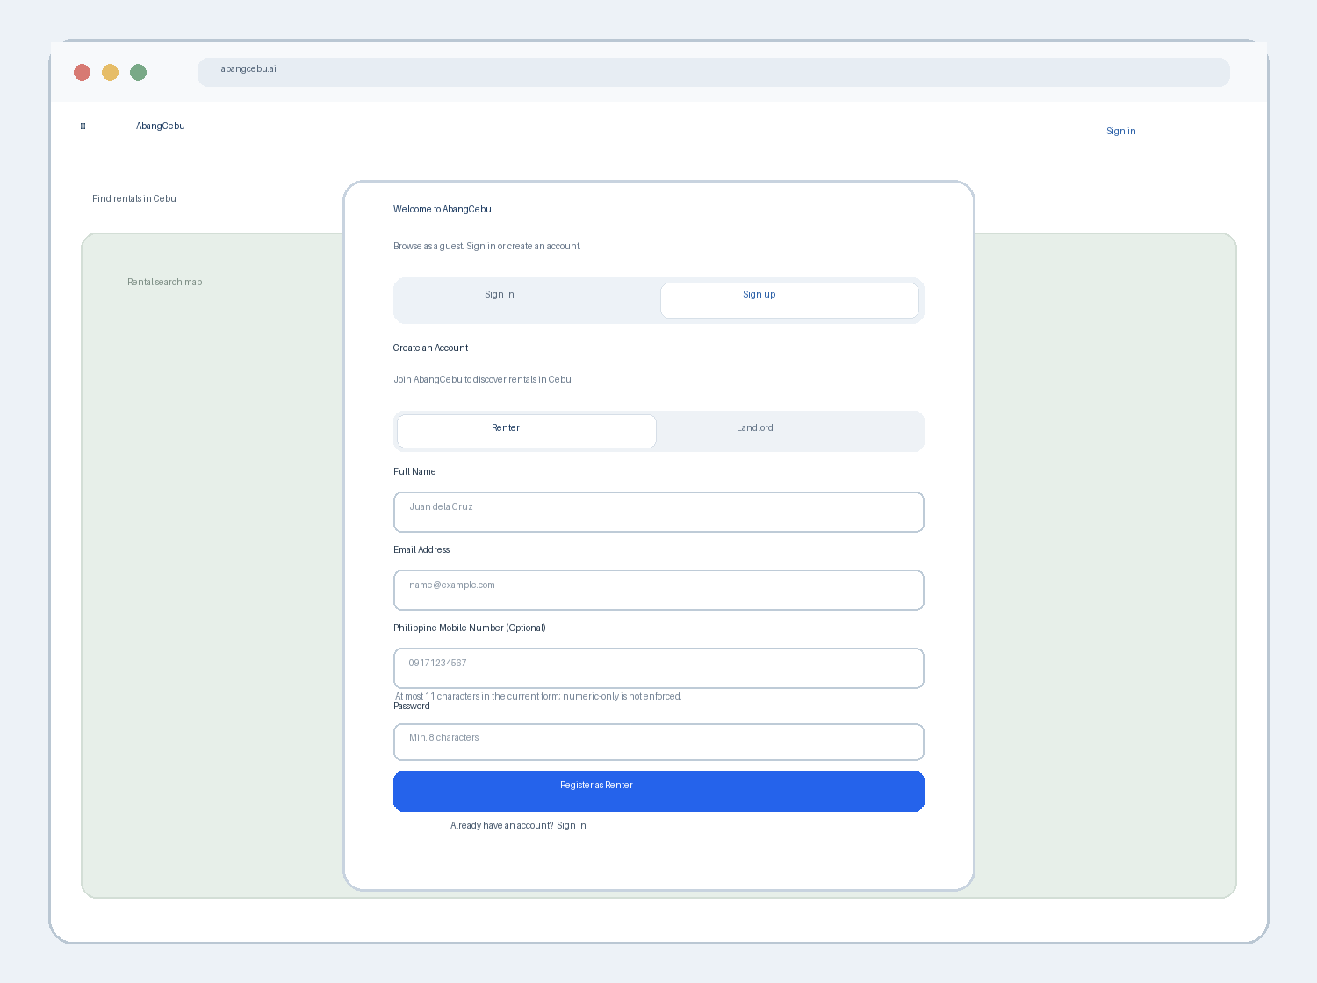
Figure 3. Low-fidelity renter sign-up dialog wireframe.
- The renter selects the Renter role before submitting the shared registration form.
- Required fields: Full Name, Email Address, and Password. Philippine Mobile Number is optional.
- The phone input currently limits entry to 11 characters and suggests a numeric keyboard. It does not enforce digits-only input.

9. Error Handling
Validation may occur in the browser, API, Supabase Auth, or the PKCE callback. The current form presents API registration errors in a form-level alert rather than attaching returned field details to each input.
Error Condition | Message / System Behavior | Action / Recovery
Required field empty | Browser blocks submission for required fields. | Complete Full Name, Email Address, and Password.
Email has invalid browser format | Browser reports that a valid email is required. | Correct the email address.
Server validation fails (name, email, role, password, phone) | 422; current form shows a general registration error, not per-field detail. | Correct the submitted details and retry.
Phone provided but unsupported | 422 validation error; phone remains optional. | Use a valid Philippine mobile number or leave the optional field blank.
Email already registered | API returns mapped 409 account-exists response. | Switch to Sign In or use password recovery.
Production Turnstile token absent/invalid | 403 security-verification error. Current form sends no Turnstile token. | Current production flow is blocked until a widget/token handoff is implemented.
Network/API request fails | Form displays “Network error. Please try again later.” | Retry when connectivity is restored.
Supabase or server fails | Sanitized registration error; server failure may return 500. | Retry later; do not expose upstream diagnostics.
Email callback code missing, expired, or invalid | Callback redirects to login with an auth-link error query. | Start sign-in or request a new registration confirmation link if available.

10. Dependencies
The renter sign-up function depends on the following application and external services:
No landlord onboarding or KYC process is part of this renter-specific function.
- Home page and guest account drawer; account-access modal and Sign In / Sign Up mode switch.
- RegisterForm and shared renter/landlord role selector; /register route uses the same form.
- POST /api/auth/register; validateRegistration and Philippine mobile normalization.
- Supabase Auth signUp and configured email-confirmation delivery.
- Database trigger public.finder_new_user() and public.profiles table.
- GET /auth/callback for PKCE exchange and safe post-verification routing.
- Production Cloudflare Turnstile verification and TURNSTILE_SECRET_KEY; the registration UI currently does not supply a token.

11. Non-Functional Notes
Security, accessibility, and reliability requirements apply at both the browser and server boundary. Server validation remains authoritative; client constraints are not a security control.
Known implementation gaps and compatibility notes:
- Production Turnstile mismatch: /api/auth/register requires a valid token in production, but RegisterForm does not render a Turnstile widget or include turnstileToken in its request. Production renter registration therefore receives 403 until this is resolved.
- Phone format mismatch: the form caps input at 11 characters, while the server also accepts +639 and 639-prefixed numbers. The current UI cannot enter those longer formats; type="tel" and inputMode="numeric" do not enforce digits-only content.
- Password guidance mismatch: the visible placeholder says “Min. 8 characters”; server also requires 8–72 characters and at least 3 of uppercase, lowercase, number, and symbol. The strength meter is informational and does not exactly encode the server rule.
- Field error visibility: the API returns field details, but the form displays only the top-level message. Users may need to infer which value to correct.
- Success routing: the API returns a verification redirectUrl, but the form displays the success message in place and does not navigate to that URL. The email callback itself is configured with next=/search.
- The registration API returns a specific already-registered email response (409); do not describe this as an anti-enumeration response.
- Security: enforce the renter/landlord allow-list and all field constraints on the server; never trust client-only validation. Admin is not a public self-registration role.
- Credential handling: send the password only to the authentication endpoint/provider; do not store it in public.profiles or expose it in logs or error messages.
- Privacy: the profile row stores the user id, role, full name, and optional phone. The account email belongs to Supabase Auth.
- Accessibility: keep visible labels, native input types, required attributes, clear error/success status, and keyboard-operable controls.
- Resilience: network and provider errors must leave entered fields available for retry and show sanitized recovery guidance.

