Pynx test: 26.02.2020 – Jaianth Vijayakumar

All the tests are carried out keeping the detector distance at 61e-3 m, pixel size 11.6 e-6 m, size of the frame = 400 * 400 pixels, algorithm : DM ** 500, probe=1, beam diameter: 61 nm. Output files are located in “/home/experiences/hermes/com-hermes/Desktop/test-pynx/pynx/ptycho/scripts/ResultsScan0000” as of 26.02.2020

Test run 1 : keep parameters same and repeat reconstruction

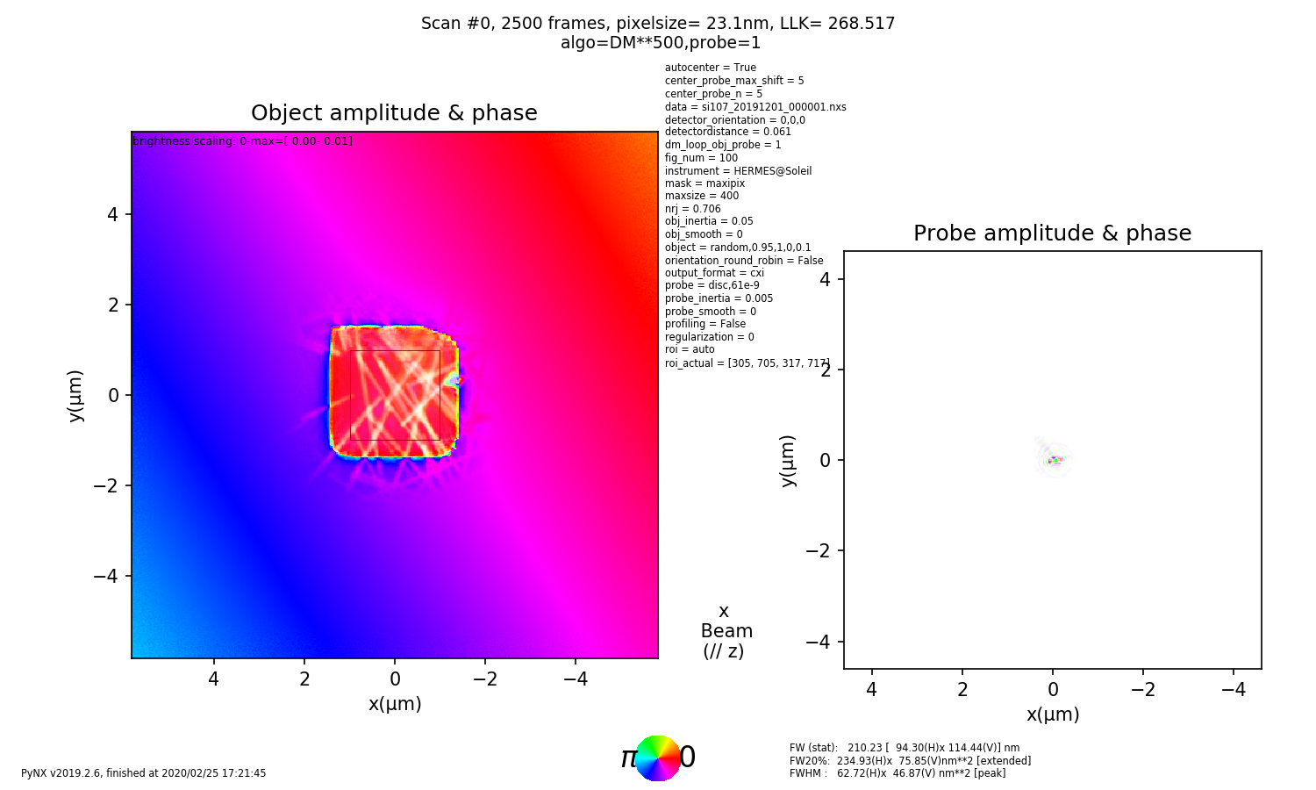
Run 112.
LLK value – 268.5

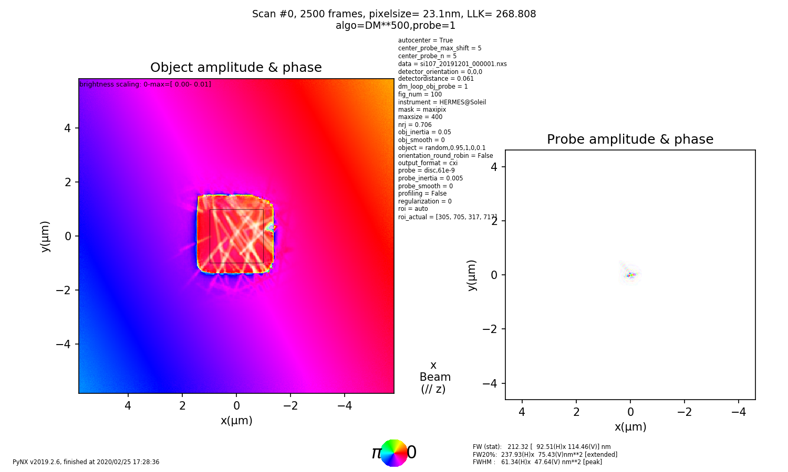
Run113.
LLK value – 268.8

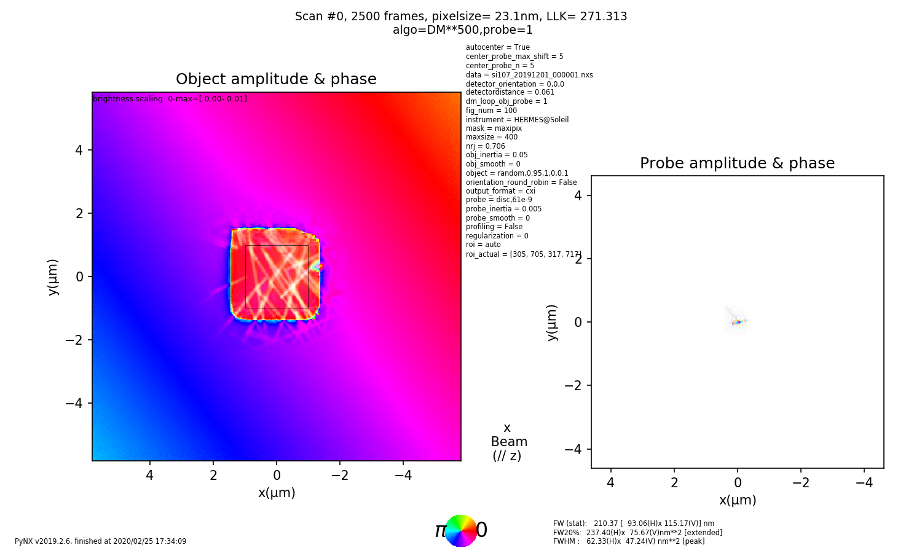
Run 114.
LLK value – 271.3

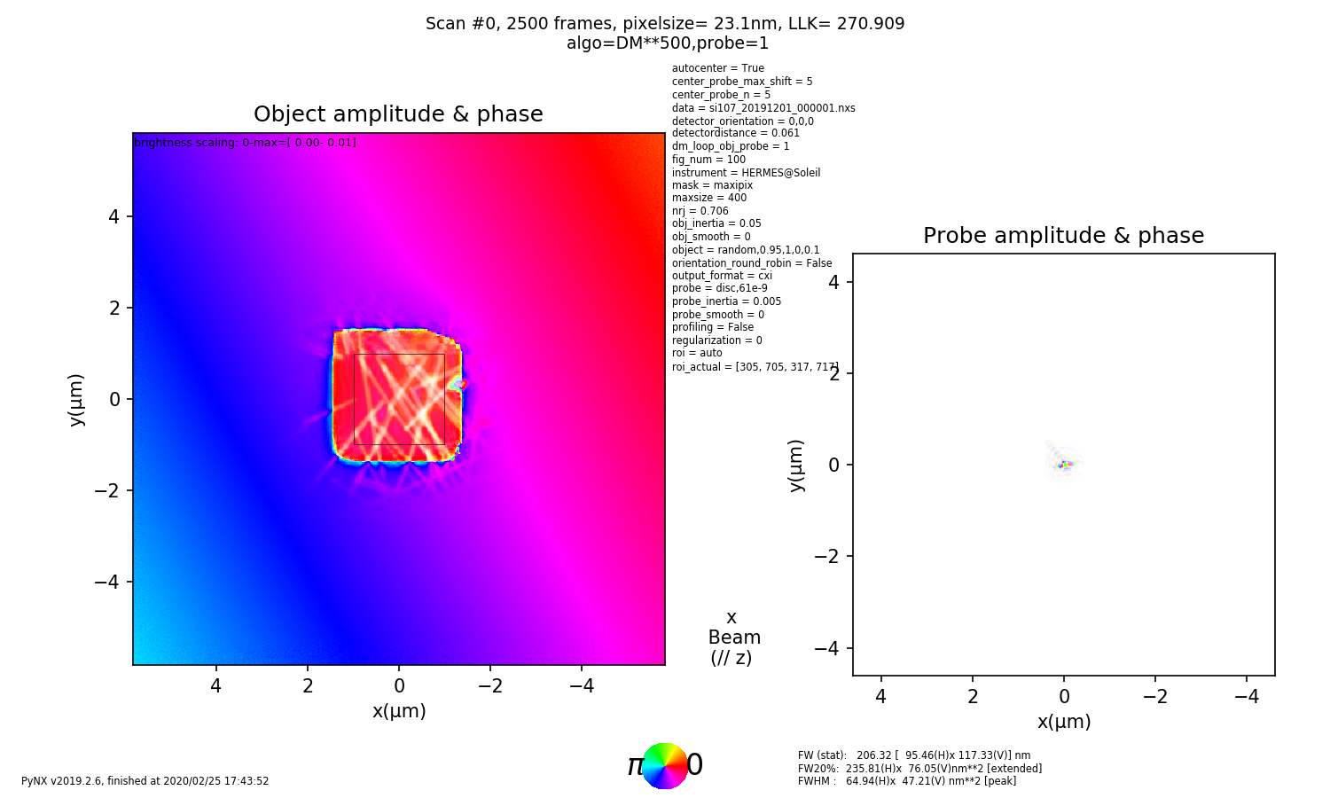
Run 115.
LLK value – 270.9

Intensity chang with runs

Image no. Intensity of back ground Intensity on the rod Ratio (rod/background)

112 (LLK-268.5) 116.2 155.02 1.33
113 (LLK-268.8) 116.9 153.6 1.31
114 (LLK-271.3) 115.1 153.2 1.33
115 (LLK-270.9) 116.5 153.2 1.31

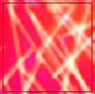

Conclusion: The intensity between background and the structure is almost same (change ~ 1%), therefore background can be subtracted for XMCD image analysis, an error bar of 1% should be mentioned in the report/manuscript.

Test run 2: Find which coordinate system works better

1. Assigning X and Y with input step size

a. X= moving Y = constant (Run : No.111) b. X= constant first Y = moving (Run. No 110)

eg. (0,0), (1,0) (2,0)…..(0,1),(1,1),(2,1)…. eg. (0,0), (0,1) (0,1)…..(1,0),(1,1),(1,2)….

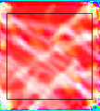
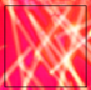

2. Using coordinates given 3. Using Interferometer coordinates (Run No. 118)
with 50 by 50 array (Run No. 117) hdf tree - entry1/instrument/counter0/sample_x/data
hdf tree - entry1/counter0/sample_x

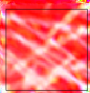
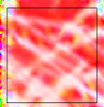

4. Exchanging X and Y
a. Using coordinates given b. Using Interferometer coordinates( Run No. 119)
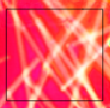
with 50 by 50 array (Run No. 120)
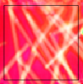

Coordinate type LLK value

1. Input stepsize X constant,Y moving (Run 110) 273.4

2. Input stepsize X moving, Y constant (Run 111) 465.8

3. Using coordinates 50 x 50 array (Run No. 117) 461.1
(x and y same as hdf file)

4. Using coordinates 50 x 50 array (Run No. 120) 268.7
(x and y interchanged)

5. Using Interferometer coodinates(Run No. 118) 528.8
(x and y same as hdf file)

6. Using Interferometer coodinates(Run No. 119) 272.9
(x and y interchanged)

Conclusion: To have better quality image LLK has to be the lowest! Any coordinate type 1,4,6 can be used in the pre processing, based on TTK value no. 4 can be a good choice.

Test 3: Orientation of the image (diffraction pattern)

1. Without flipping up down 2. Without flipping up down
– rotate 270 degrees (Run: 121) – rotate 180 degrees (Run: 122)
- LLK = 275.3 - LLK = 270.4
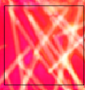
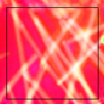

3. Without flipping up down 4. Without flipping up down
– rotate 90 degrees (Run: 123) – rotate 0 degrees (Run: 124)
- LLK = 268.1 - LLK = 268.6

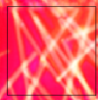
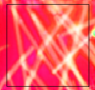

Conclusion: Rotating the images made no significant changes in the LLK value. The coordinate system and other physical parameters such as detector distance/ pixel size etc have some clear changes on the images and on the LLK value. In the preprocessing code we can still flipud and rotate 270 degrees to be consistent with the detector orientation.

Test 4: Effect on Detector distance

D = 68 e-3 m (Run 185) D = 70 e-3 m (Run 186)
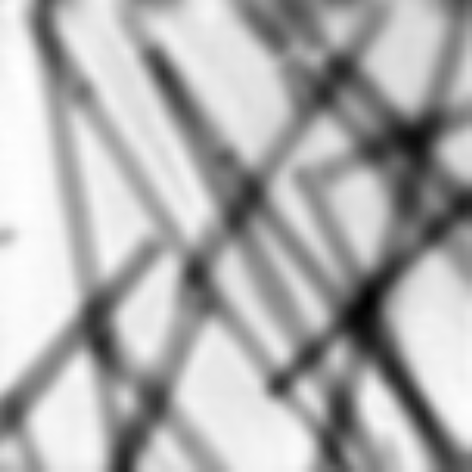
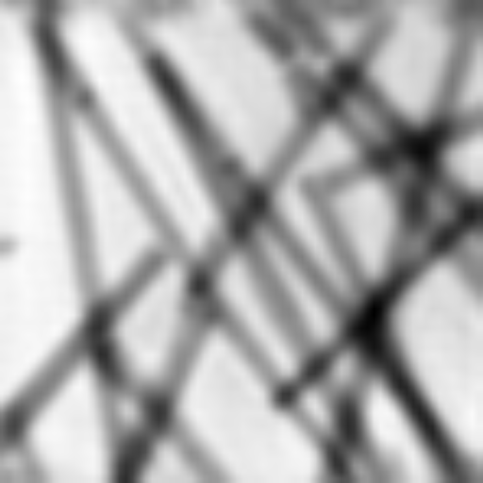
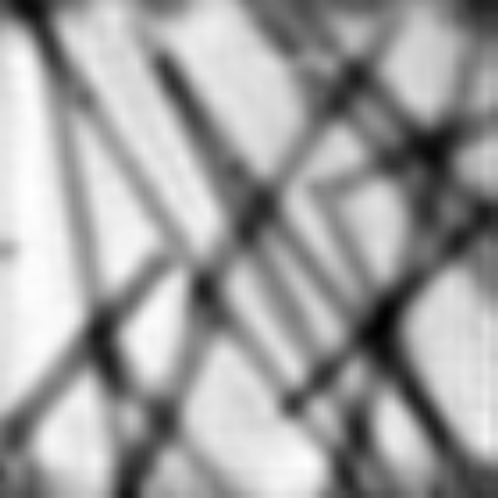

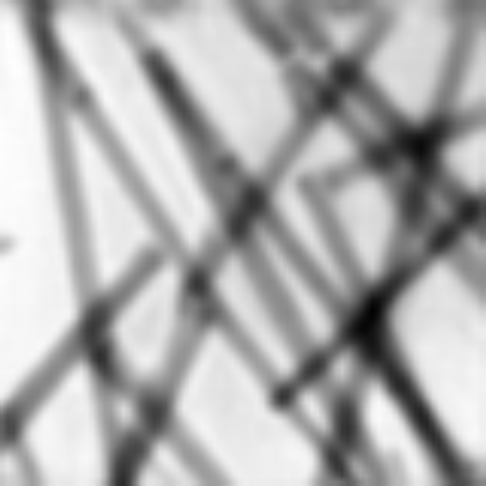
D = 75 e-3 m (Run 187) D = 65 e-3 m (Run 188)

D = 63 e-3 m (Run 189) AP,ML,DM (Run 188)
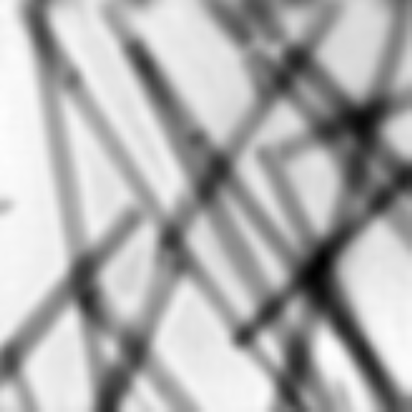
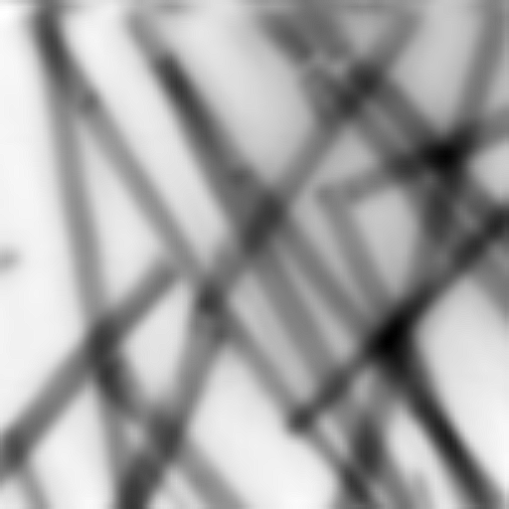

Test 4: Different Algorithms

1. DM**500 (Run:212) 2. DM**1000 (Run:213)

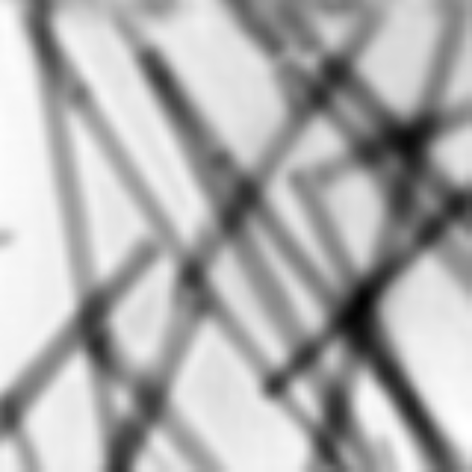
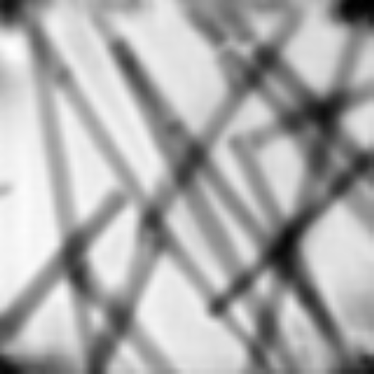

3. DM**2000 (Run:214) 4. DM**3000 (Run:215)

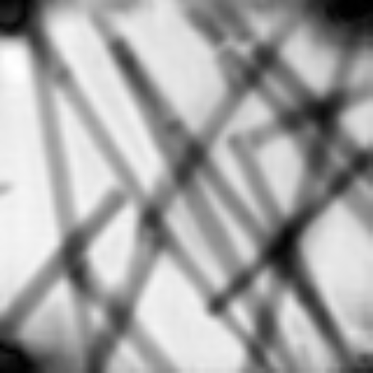
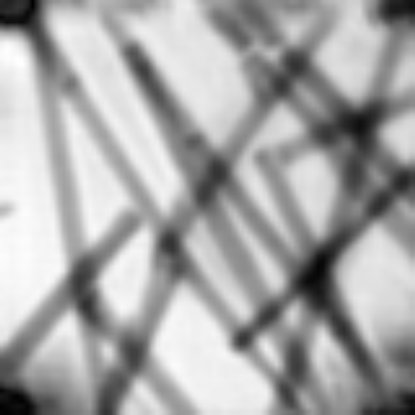

3. DM**4000 (Run:216) 4. DM**5000 (Run:217)
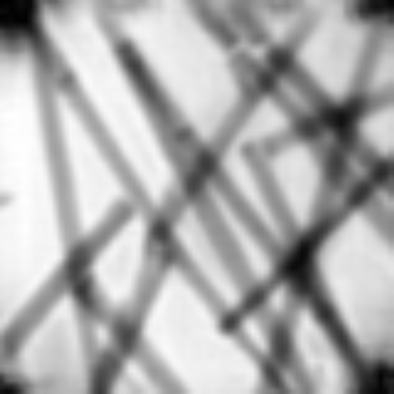
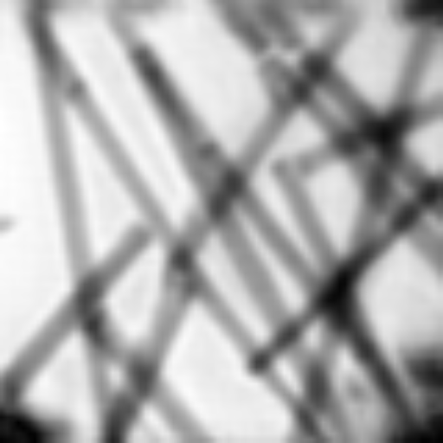

Conclusion: Increasing the number of iterations in the differential mapping algorithm do not improve the image quality.

1. AP**500 (Run:218) 2. AP**1000 (Run:219)
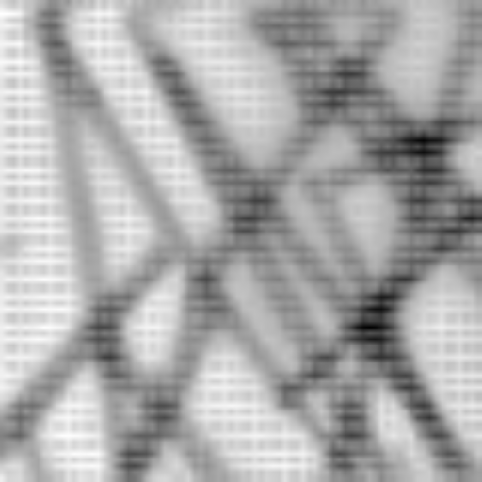
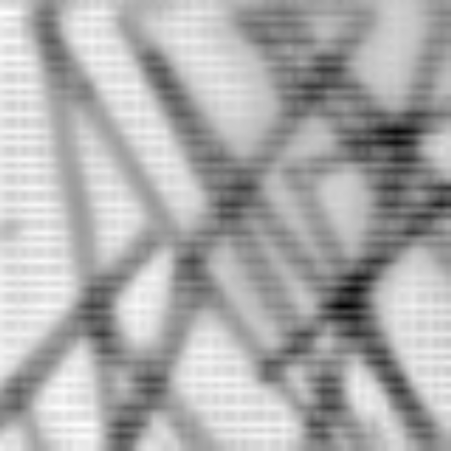

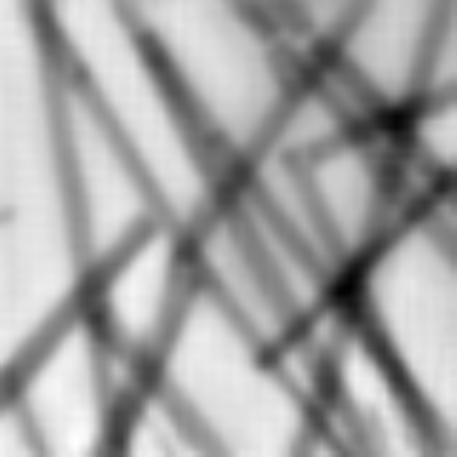
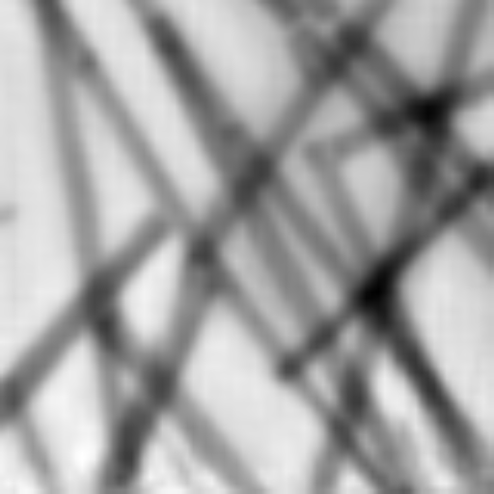
1. AP**2000(Run:220) 2. AP**3000 (Run: 221)

1. AP**4000(Run:222) 2. AP**5000 (Run: 223)
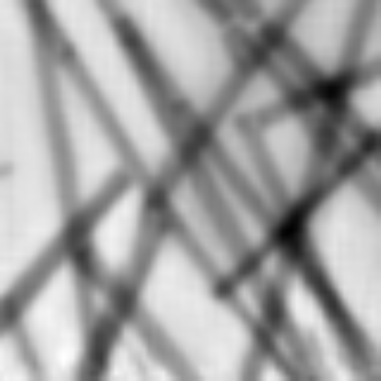
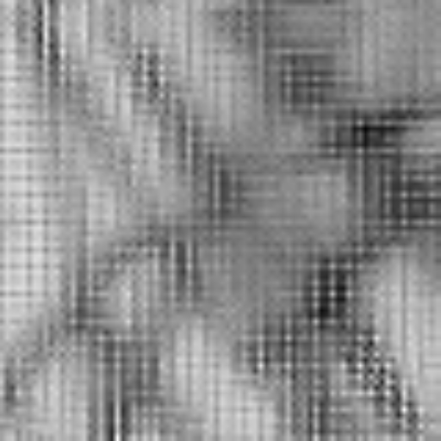

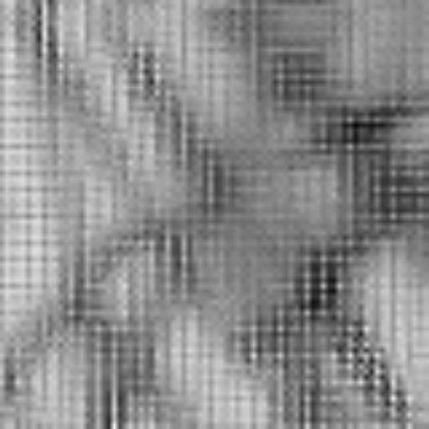
1. ML**500(Run:224) 2. ML**2 `000 (Run: 223)

1. AP**100DM**500 (RUN: 229) 2. AP**500DM**1000(Run: 230)
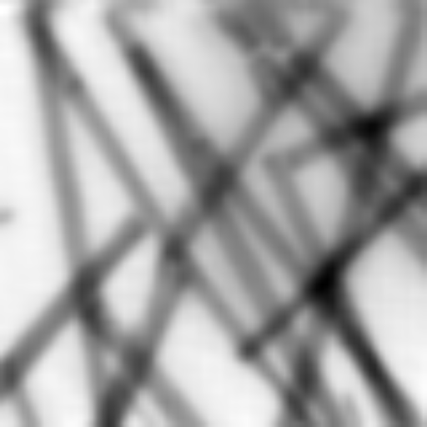
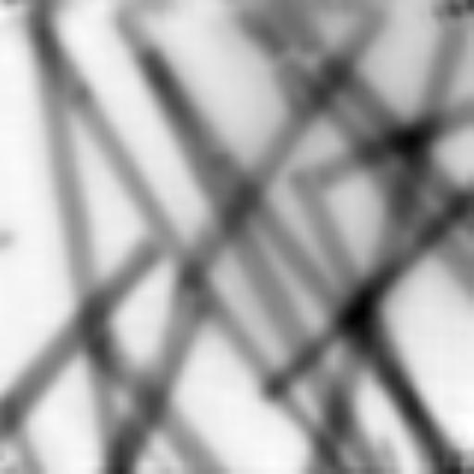

1. AP**2000DM**3000 (RUN: ) 2. AP**500DM**1000(Run: 230)

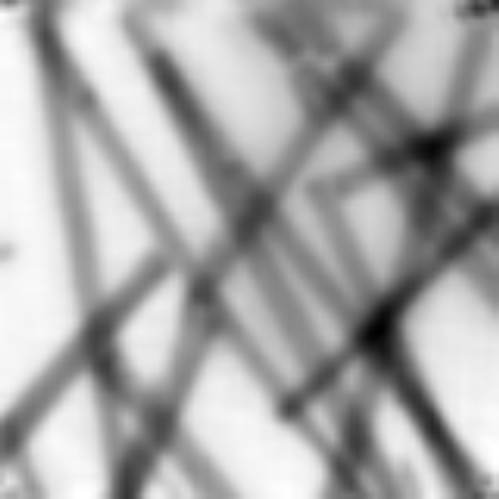

Conclusion: Regardless of which algorithm used or for how many iterations the image is not getting sharper.

Test 5: Verborse
Verbose = 1 Verbose = Algorithm = 500
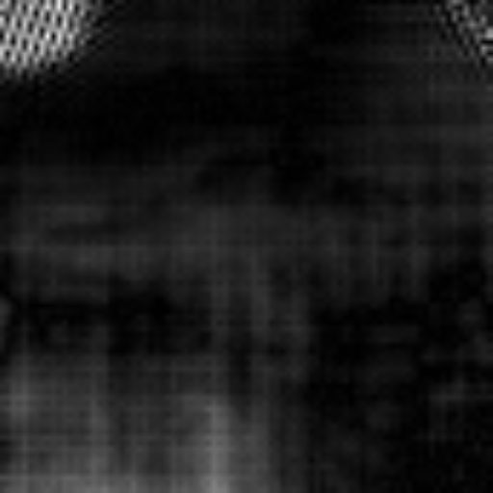
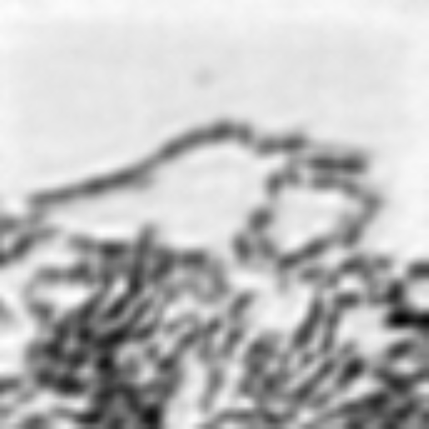

Verbose = 0

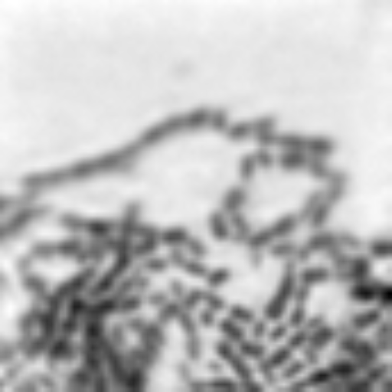
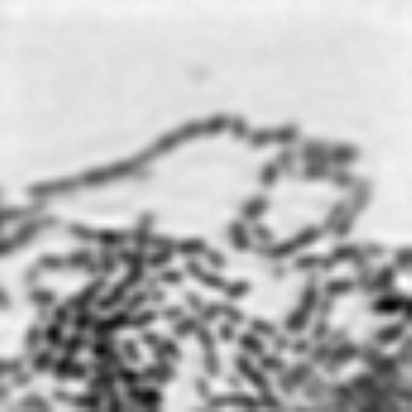
DM**500 probe =1, object =1 AP**100DM**500 probe =1

AP**100DM**500 (without probe = 1 and object =1)

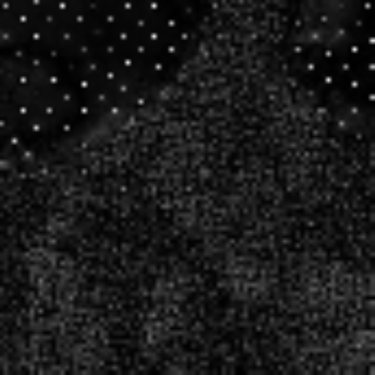

Conclusion: Keep Verbrose = 0, object =1 is not needed in the algorithm as it keeps changing the image. However probe =1 is mandatory in the algorithm. Shaper images can be obtained.

Test 6: Which algorithm works better

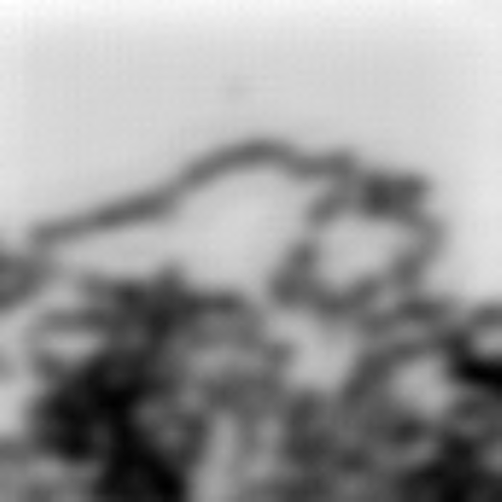
1. ML**100AP**100DM**800, probe=1

2. ML**100,DM**500, probe=1

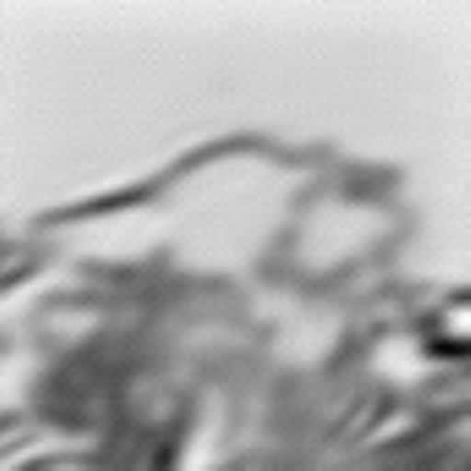

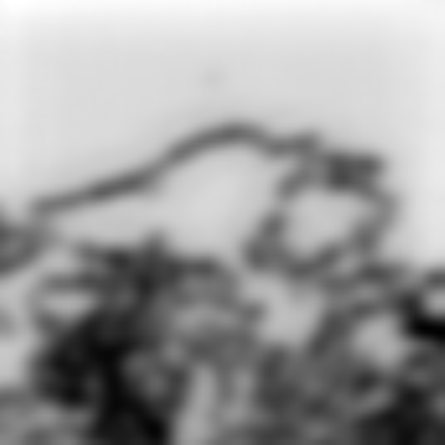
3. AP**100,DM**500, probe=1

DM can be run in the last, then sharpness is better

Nanorods
DM**500, probe =1 (Run 0288)

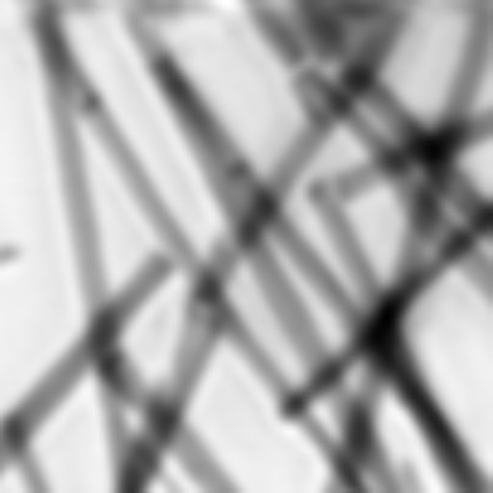

DM**1000, probe =1 (Run 0289)

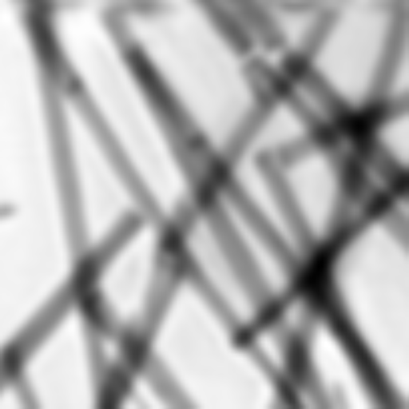

DM**1000, probe =1 (Run 0290)
'dm_loop_obj_probe':3,

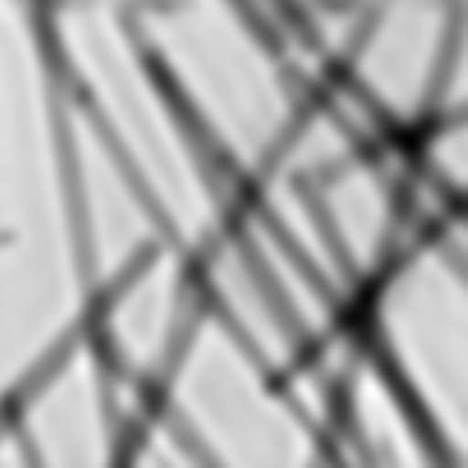

AP**100,DM**500, probe =1 (Run 0291)
'dm_loop_obj_probe':3,

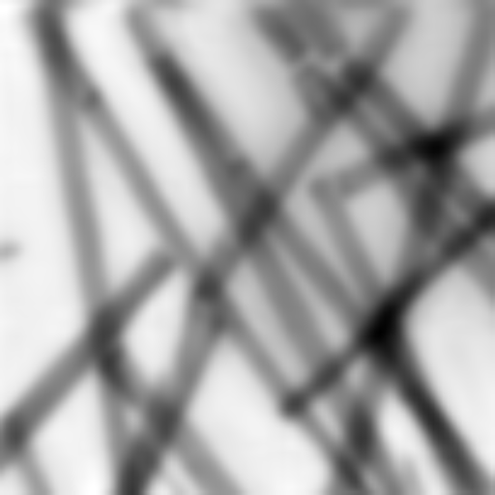

ML**100AP**500,DM**500, probe =1 (Run 0294)
'dm_loop_obj_probe':3,

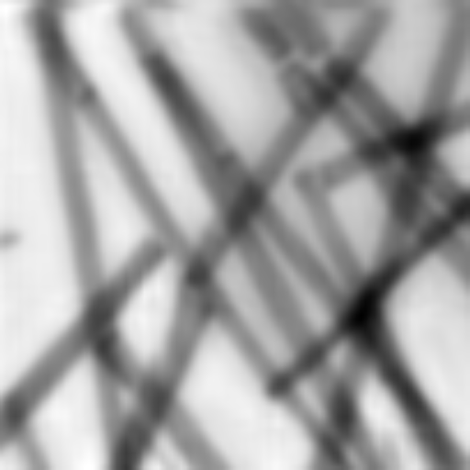

'(AP**200*DM**200)**5,nbprobe=3,background=1,probe=1'

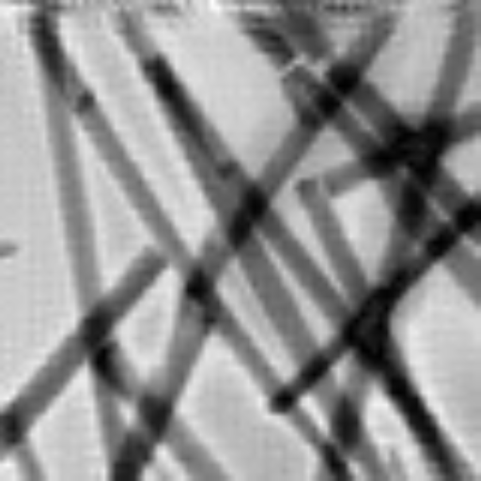

'(ML**200*AP**200*DM**200)**10,nbprobe=3,background=1,probe=1'
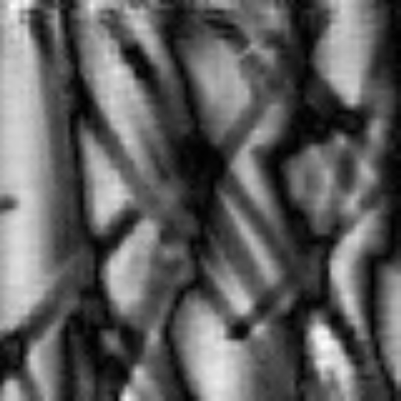

'(AP**200*DM**200)**10,nbprobe=3,background=1,probe=1'
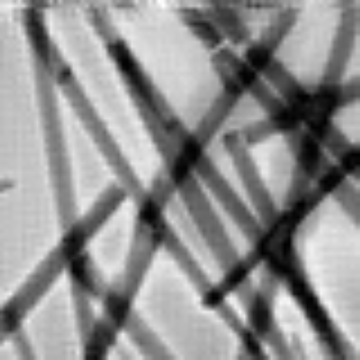

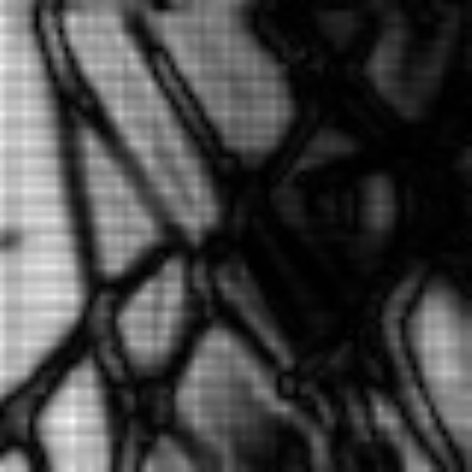
'(AP**200*DM**200)**10,background=1,probe=1'

'(AP**200*DM**200)**10,nbprobe=3,probe=1'

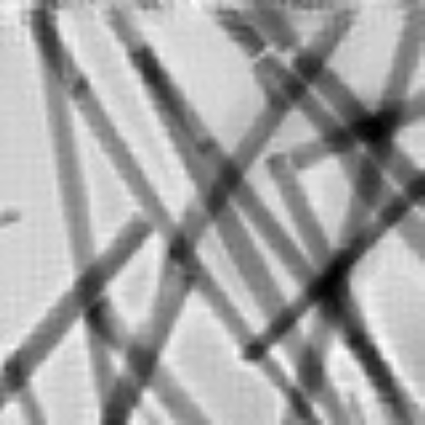

'(AP**200*DM**200)**10,nbprobe=3,probe=1, object =1'
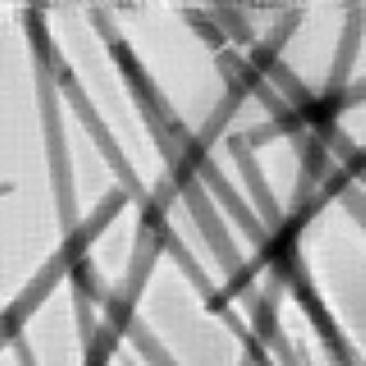

'(AP**200*DM**200)**5,nbprobe=3,probe=1, object =1' MAXSIZE : 512
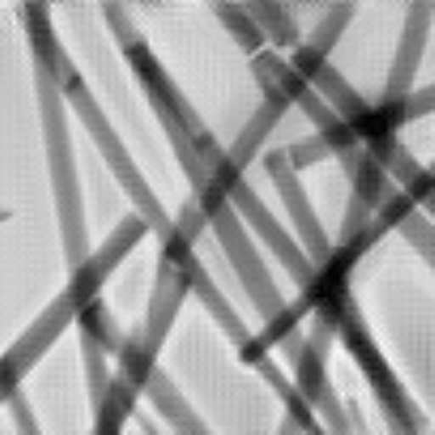

'(AP**200*DM**200)**10,nbprobe=3,probe=1, object =1' MAXSIZE : 512

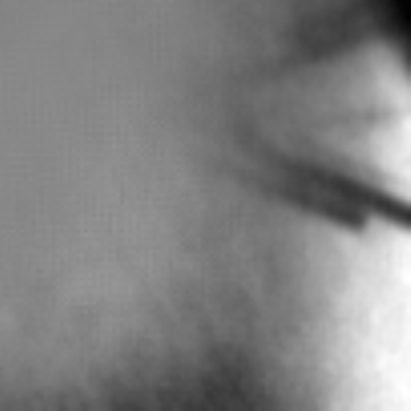

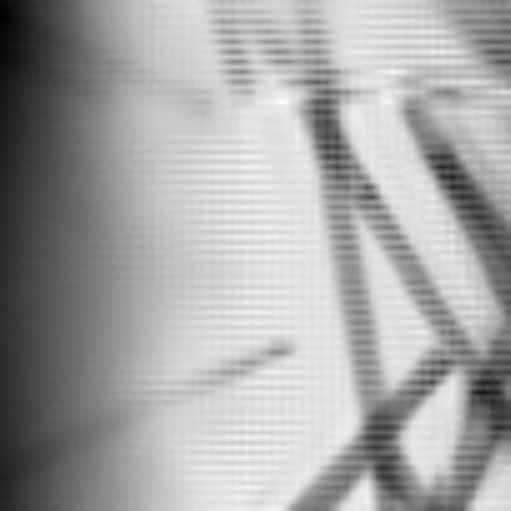
'(AP**200*DM**200)**5,nbprobe=4,probe=1, object =1' MAXSIZE : 512

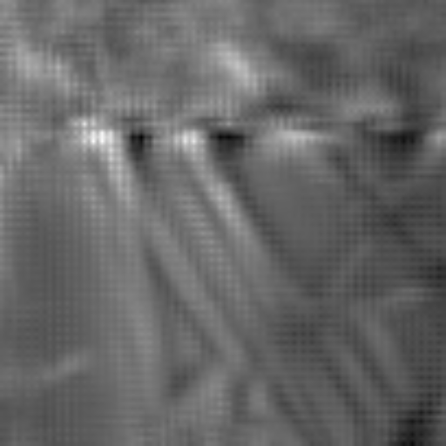
'(AP**200*DM**200)**2,nbprobe=4,probe=1, object =1' MAXSIZE : 512, obj_initertia=0.01

'ML**50,(AP**200*DM**200)**2,nbprobe=4,probe=1, object =1' MAXSIZE : 512, obj_initertia=0.01
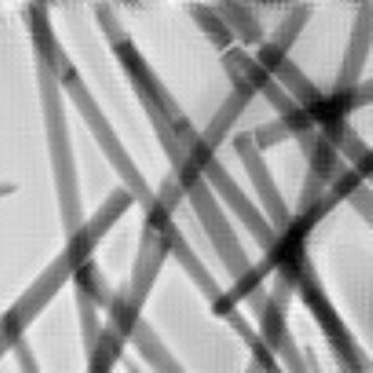

'ML**50,(AP**200*DM**200)**2,nbprobe=4,probe=1, object =1' MAXSIZE : 512, obj_initertia=0.01, background=1

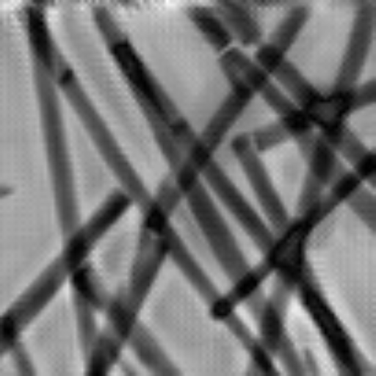
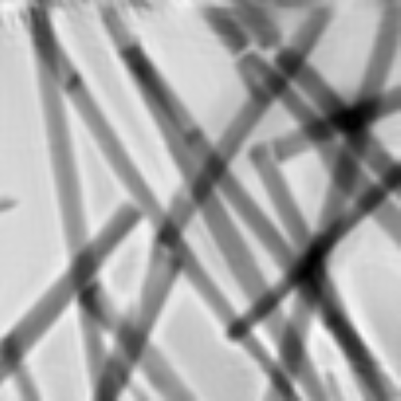

'ML**50,(AP**200*DM**200)**2,nbprobe=4,probe=1, object =1' MAXSIZE : 512, obj_initertia=0.01, obj_smooth=1.5

'ML**50,(AP**20*DM**20)**2, dm**100,nbprobe=4,probe=1, object =1' MAXSIZE : 512, obj_initertia=0.01,



'ML**50,(AP**20*DM**20)**2, ,nbprobe=4,probe=1, object =1, dm**500' MAXSIZE : 512,
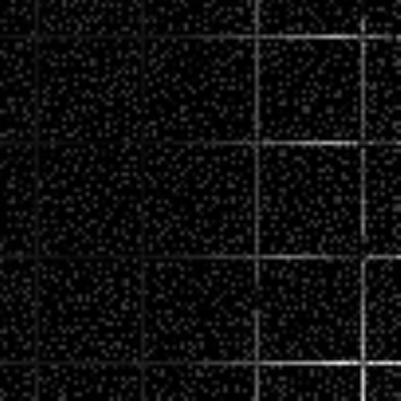
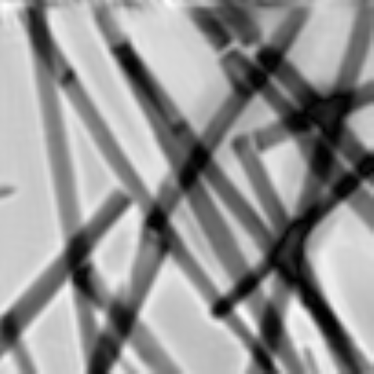

Verbose 10: AP**1000,DM**1000

Pynx new version Pynx old version
AP**500,DM**500
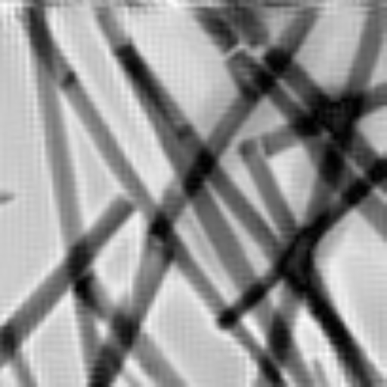
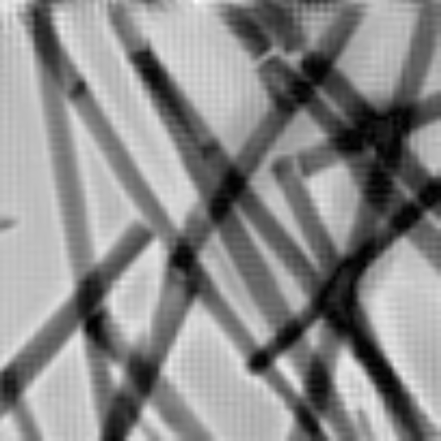
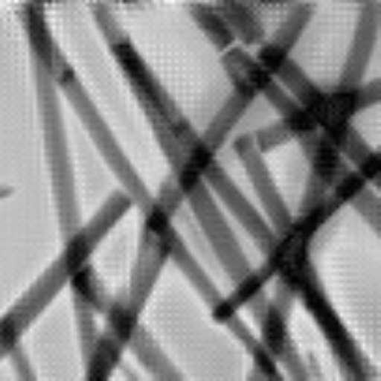

VERbOS 10 Verbose 0

752 s 750 s

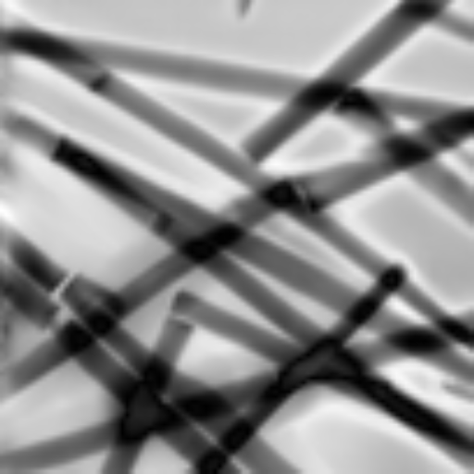
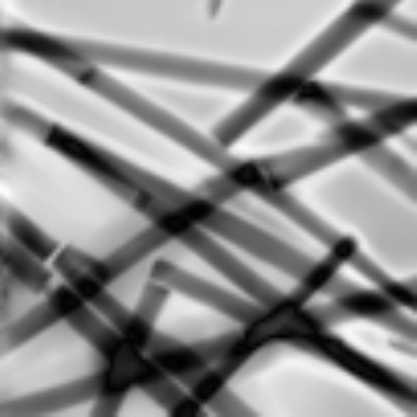
Without mask With mask

Does not help much

With background = 0 – not over saturating in some regions
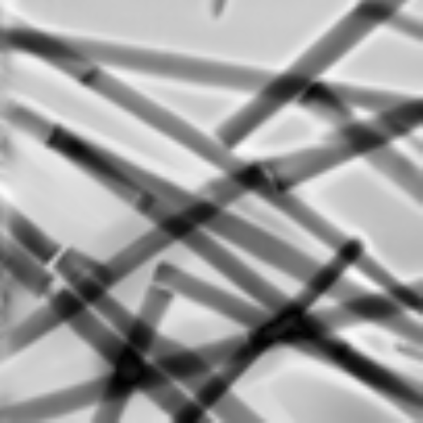

With verbose = 0 - Not much changes now verbose has direct relation with mask that is added


