User manual: Pre-process + pynx reconstruction by Bash file

The bash file to run the pre-processing and pynx is located in “/home/experiences/hermes/com-hermes/pynx_HERMES/pynx_v1/Pre_Processing”.

1. Open Terminal
2. Type cd /home/experiences/hermes/com-hermes/pynx_HERMES/pynx_v1/Pre_Processing
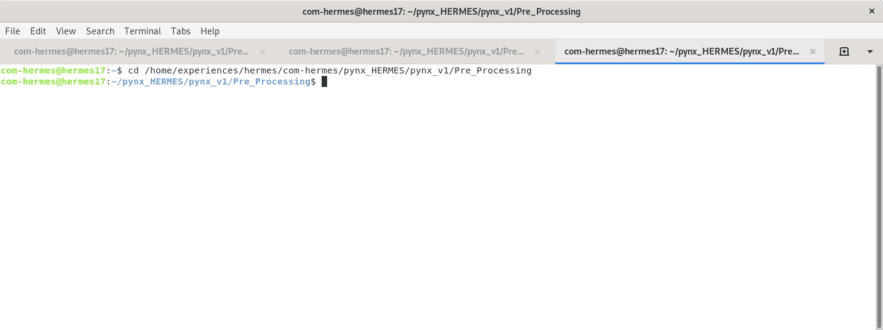

3. Type gedit bash_filie_preprocessing.sh to open a text editor. Else if you are a geek use nano bash_filie_preprocessing.sh
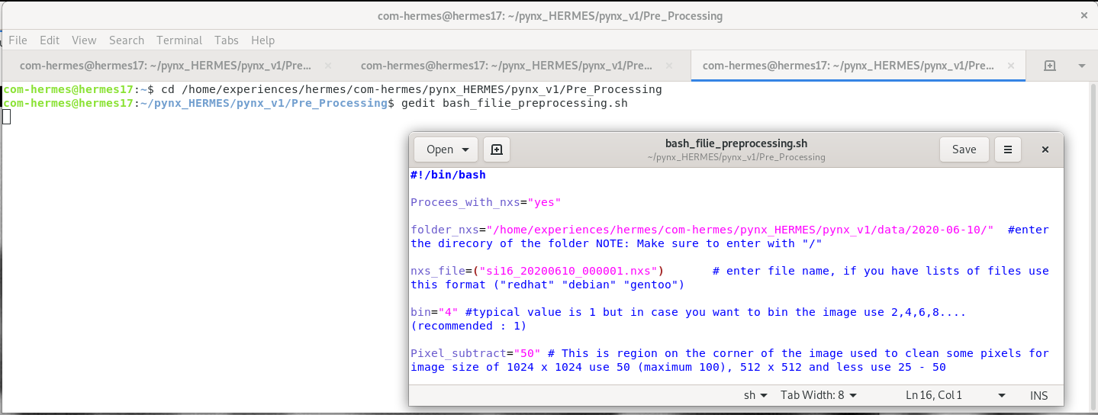

4. In the bash file, make sure you do not leave unnecessary space unless specified, just replace the names and maintain the format used before. Such mistakes can lead to some errors, during which check if all the syntaxes are correct.
(a) To Pre-process using a single nxs file, following values should be given:

a.1. Process_with_nxs=”yes”
a.2. folder_nxs=”/.../.../”- make sure to end with forward slash
a.3. nxs_file=(“….”)
a.4. bin=” ”
a.5. Pixel_subtract=” “
a.6. step_size=” “
a.7. different_files=”no”
a.8. Ignore folder_nxs_dark, nxs_dark_name, folder_STXM, STXM_file
a.9. Process_whole_folder=”no”
a.10. Ignore Enter_folder_process
a.11. reconstruct_after_pre_process=”yes” (else put “no”)
a.12. algorithm=”AP**1000,DM**100,nbprobe=3,probe=1,obj_smooth=0.3,background=1”
a.13. Save the file
a.14. Go to the terminal and type ./bash_filie_preprocessing.sh press enter, the pre-process and reconstruction will begin.

(b) To Pre-process different files, following values should be given:

b.1. Process_with_nxs=”no”
b.2. folder_nxs=”/.../.../”- make sure to end with forward slash
b.3. nxs_file=(“….”)
b.4. bin=” ”
b.5. Pixel_subtract=” “
b.6. step_size=” “
b.7. different_files=”yes”
b.8. folder_nxs_dark=”...”
b.9. nxs_dark_name =“...”
b.10. folder_STXM=”...”
b.11.STXM_file=”...”
b.12. Process_whole_folder=”no”
b.13. Ignore Enter_folder_process
b.14. reconstruct_after_pre_process=”yes” (else put “no”)
b.15. algorithm=”AP**1000,DM**100,nbprobe=3,probe=1,obj_smooth=0.3,background=1”
b.16. Save the file
b.17. Go to the terminal and type ./bash_filie_preprocessing.sh press enter, the pre-process and reconstruction will begin.

(c) To Pre-process an entire folder with nxs, nxs dark and STXM file, following values should be ginven:

c.1. Process_with_nxs=”no”
c.2. Ignore folder_nxs, nxs_file
c.3. bin=” ”
c.4. Pixel_subtract=” “
c.5. step_size=” “
c.6. different_files=”no”
c.7. Ignore folder_nxs_dark, nxs_dark_name, folder_STXM, STXM_file,
c.8. Process_whole_folder=”yes”
c.9. Enter_folder_process=”….”
c.10. reconstruct_after_pre_process=”yes” (else put “no”)
c.11. algorithm=”AP**1000,DM**100,nbprobe=3,probe=1,obj_smooth=0.3,background=1”
c.12. Save the file
c.13. Go to the terminal and type ./bash_filie_preprocessing.sh press enter, the pre-process and reconstruction will begin.

