ADA mini hw9 B08902065 資工二 洪易

1.

We can observe that in G, there must exist a node b in SCC(B) and an edge from A to b. Take the two example graphs in the bottom for example. We can see that in graph(G), there is an edge from A to b. While doing DFS, it’s obvious that it must go through b to reach A, as A can’t reach any of SCC(B). Therefore, A finish earlier than SCC(B).

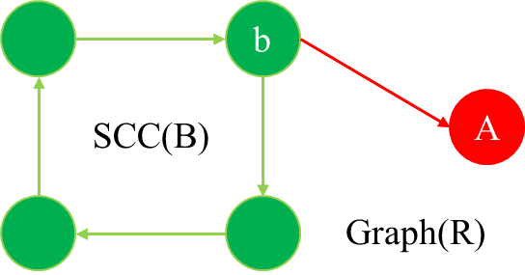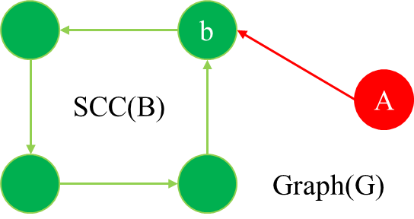

2.

Without loss of generality, we can choose two vertex A, B in graph(R), which A finish earlier than B in DFS in graph(R). In other words, we can see that there must exist only edges from B to A but not in the reverse direction. Therefore, in graph(G), there only exist edges from A to B. Consider two cases, if B can reach A in graph(G), then they must be in the same SCC. Else, B can’t reach A as it finishs later in DFS in graph(R).