Assignment 1
Mandeep Singh and Sidharth Sharma
(2014145) (2014163)
Autonomous Driving

- rosrecap.py reads the bagfile of any frequency, and implemets a kalman filter of 20Hz.
For eg.: If GPS readings are recieved at frequency of 3 Hz, the kalman filter will estimate the vehicle position and will output the following:
- New State (if it comes)
- New Covariance Matrix
- Updated State
- Updated Covariance Matrix
- With every estimated value it will output the following:
- Estimated State
- Estimated Covariance Matrix

- Sensor Noise Covariance Matrix : [ 0.05, 0; 0, 0.05] (Assumed)
- H = I (Assumed)
- F -> Prediction Matrix : [1 ,delta_t; 0 1]

- Plotting the GPS coordinates from our bag file and the one we estimate using KF

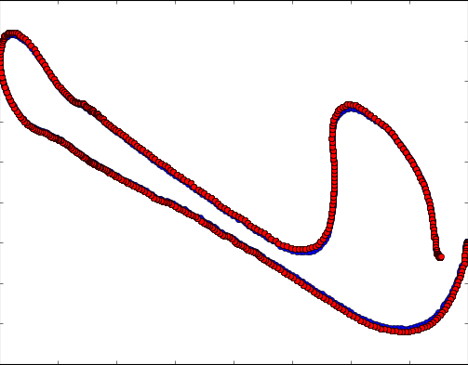
The Actual data from our bag file is represented in red circles.
Beneath which is our estimated data represented in blue squares

After this we ran our code on bag files of varying frequencies.
In all the cases our filter worked correctly

Example: Using it on 16Hz
