**Polytechnic University of the Philippines**

**Sta. Mesa Manila**

**College of Computer and Information Sciences**

**Jubecer Client and Security Guards Management System**

A Project Paper Proposal

Presented to

The Faculty of the College of Computer and Information Sciences of

Polytechnic University of the Philippines

In Partial Fulfillment

of the Requirements for the Degree of

Bachelor of Science in Information Technology

Albino, Chris Jericho

Geraldez, Earl Dixon M.

Lacsina, Luigi

Macandog, Evander Louis

Mandap, Abel Jr.

Maskarino, Ernest John

Page

**Title Page**……………………………………… …….i

**Table of Contents**……………………………… ………………………………………...ii

**1.0 Project Definition**………………… ………………………………………………….1

1.1 Introduction…………………… …………………….1

1.2 Business Case…………………………… ………………2

1.2.1 Background of the Organization ……………………………….…...2

1.2.2 Project Overview …………………….……………………………..3

1.2.3 Project Constraints …………..…………………………..………….4

1.2.4 Project Assumptions ……………………………………..………….5

1.3 Scope and Limitation ………… …………….5

1.4 Methods Used in the study ………………………………………………

**2.0 Functional Specification Report** ………………… …………….6

2.1 Data Requirements ………..…………………………… …………………….6

2.1.1 Forms……………………………………..………...……………….7

2.1.1.1 List of Forms…………………………..……………….….7

2.1.1.2 Sample Forms………………………….....…………….…7

2.1.2 Reports………………..………………………………….………...17

1.2.4 List of Reports………………………..………….…………17

1.2.4 Sample Reports……….………………………....…………17

2.2 Policies and Procedures………………………………..…………….………20

2.2.1 Procedures……………………………………………….…………20

2.2.1.1Context Diagram………………………………..………...20

2.2.2.2 Level 1 DFD…………………………………...………...21

2.2.2 Policies……………………………………..………………….…...26

2.2.2.1 Business Requirement…………………...……..………..26

2.2.2.2 Business Policies……………………………….………...29

2.3 Problem Analysis…………………………………….………………………33

2.3.1 Fishbone ……………………………………………….....………..33

2.3.2 Conclusion …………………………………...…………..……..…34

2.3.3 Recommendation……………………………………..……………35

**3.0 Proposed System Definition**……………………………………………………......36

3.1 Functional Specifications………………………………………..…………...36

3.1.1 System Boundaries……………………………………..…….……36

3.1.1.1 System Use Case Diagram……………………..………..36

3.1.1.2 Detailed Use Case Diagram……………………..………37

3.1.2 Sytem Flow……………………………………………..………….39

3.1.2.1 <Per Module>..………………………………..…………40

3.2 Technical Specifications………………………………..……………………54

3.2.1 Domain Object Modelling……………………………..………..…54

3.2.1.1 Final Class Diagram ………………………………..…..54

3.2.2 Database Design……………………………………..…………….55

3.2.2.1 Database Schema……………………………..………….55

3.2.2.2 Database Dictionary…………………………..………….56

**CHAPTER 1: PROJECT DEFINITION**

**1. Introduction**

Companies use information as a weapon in the battle to increase

productivity, deliver quality products and services, maintain customer loyalty, and

make decisions. Information technology can mean the difference between

success and failure. An Online Management System is both creative and technical

advantageous aspects in the world of internet, including the design, advertising,

sales and development. It is now being used by many companies, including those

companies which competing in the world of business

Jubecer Security Service, Inc. is an organization, which provides armed

security services and expertise to private and public clients. They deploy trustworthy and well trained securities to protect establishments. They provide high quality security service to clients. They also employ security and lady guards and train them to be fit to line of work.

The company is used to have a process of manual transactions on their business. However, more and more problems arise, especially when they have a different client on different locations far from their office. Processing and transferring of records and other business related data from their clients to their office takes more time and effort and prone to data loss making the transaction more difficult.

In relation to this, the researchers will develop an Online Management System for a hassle-free transaction not only for the Clients but also for the company employees as well. This will provide modules for transaction processes, maintenance, reports generation and a mobile application. The main purpose of this system is to resolve the problems encountered by the Jubecer Security Service, Inc. on their business process.

**1.2. BUSINESS CASE**

**1.2.1 BACKGROUND OF THE ORGANIZATION**

Jubecer Security Service, Inc. is an organization, which provides armed

security services and expertise to private and public clients located at Unit 6.G/F.

Corner Complex Bldg. #12 New York St. Brgy. Immaculate Conception, Cubao,

Quezon City. They deploy trustworthy and well trained securities to protect

establishments. They provide high quality security service to clients. They also

employ security and lady guards and train them to be fit to line of work. The primary goal of the company is to maintain the good relationship to the clients by providing a quality services. The company is constantly changing that’s why providing an excellence services and strong partnership with customers are the satisfactory of company’s image.

JUBECER SECURITY SERVICES, INC. Is a duly organized and registered

by virtue of the Laws of the Republic of the Philippines with Securities and

Exchange Commission Registration Number CS20160595 and licensed with the

Philippine National Police – Supervisory Office for Security and Investigation

Agencies(PNP-SOSIA) under PAS-T-00121-2016 as a private Security Agency

authorized to operate nationwide, and Member of Philippine Association of

Detective and Protective Agency Operators(PADPAO).

**1.2.2 PROJECT OVERVIEW**

The project will be focusing on making a computerize way on how Jubecer Security Service Inc., will manage their entire business transactions. The said project will be an web-based management system. It is an online management system with different modules designed to help the agency easily manage their works at least cost and efforts. This will provide modules for transaction processes, maintenance and reports generation. For transaction module, it will cover the service inquiry by the Clients, and other transactions like Security Guards swapping and replacements request, additional gun request, ammunition request and payment, for the Security Guards, it will provide an online application, leave request, and swapping request. For security purposes, the system will have three (3) level of access. This will be the Administrator/s, Employees and Customers. For maintenance module, only Administrator has the authority to configure the site, add/update/delete data, block suspicious Clients, view contracts and generate reports. This security together with the log-in module will limit the access of non-administrator, thus protecting the important data from hackers. For account protection of the registered users, passwords will be encrypted upon saving into database. In case the members forgot their password, the system will provide a link to reset the password which will be sent only to the member’s email. For Guests, they can easily inquire services through the landing page which provide the basic information and background of the company as well as the service they offered.

Aside from those modules stated above, the system will also provide a mobile application. The main purpose of this module is to make the viewing easily for Clients and Security Guards. Viewing of their profile, status, and other business related data can be done through this mobile application. This will also offer an easy-browsing of services offered by the company and attendance of Security Guards can be easily tracked and monitored.

**1.2.3 PROJECT CONSTRAINTS**

The Project Team identified several constraints which will impact and limit the design of the tool. To date, the following constraints have been identified:

* Time and Schedule - The project have a specific deadline to attend any unexpected delays or event may affect the time table of the group to finish the said project. The scope may also change when the time is no longer in favor on the development time. There are also some other subjects to attend to. Some team members of the project do not have the same schedule with the other team members.
* Resources limitation - Not all of the team’s members have their own laptop or pc to work on. Budget is limited which also limit the resources and visit to client for consultation. There are other miscellaneous expenses for the project too.
* Project Scope - the most crucial constraint because every changes in the scope may change the whole cycle of the project.

**1.2.4 PROJECT ASSUMPTIONS**

The following assumptions were made in preparing the project plan. These

are the factors that believed to be true, although this factors are not confirmed to

be true.

* The client will actively participate in the project
* Project Management ensures that project team members are available as needed to complete project tasks and objectives.
* Project should be ready and finished by March 2017.
* There are adequate allotment of resources for the project.

**1.3 Scope and Limitation**

The project is focused primarily on the managing of client information and guard information. However, billing and collection, and guard deployment is also included in the system. The project also provides a website that adds up for the online exposure of Jubecer Security Services Inc., and a mobile application for Clients, and Security Guards for easy access on their account.

The system have three levels of access such as Administrator, Security Guard/Client, and Customer. The administrator manages essential information of transactions to clients such as contract details, guard details, gun details, receipt, statement of account, and managing transactions to security guards such as confirmation of employment, leave confirmation, swap confirmation, resignation confirmation, guards’ list, and generating reports.

As for the Security Guards/Clients, they can view and manage their requests. The clients can send requests like service request, guard replacement request, additional gun request, additional guard request, and the client’s payment. The security guards can send incident reports, attendance record, requests such as leave request, swap request, and resignation request. Clients and Security Guards have their own accounts which is useful for managing transactions and their information. Unlike the Clients and Security Guards, the Customer can only browse the website and see information about the agency. He has no power to hold transactions if he doesn’t have an account. The administrator will make an account for the customer if he sends a service request, thus making the customer a client.

In terms of deployment, the clients may choose their preferred guards and if the preferred guard is fine with the client, the guard will be successfully deployed. In terms of payment, the administrator sends a statement of account to the client and he, himself, will go to the client to collect the payment.

The system and mobile application is dependent on the internet. Since it is web-based, internet connectivity is a requirement. One of the limitations of the system is the inability of the server in times of downtime due to technical problem in hardware, software or internet connectivity related problems. The mobile application requires to be run on a device that supports mobile applications, so not having a smartphone is also a limitation. The developed system follows the ISO 9126 series evaluation form to ensure that the system is in good quality.

ISO 9126 Software Evaluation Form

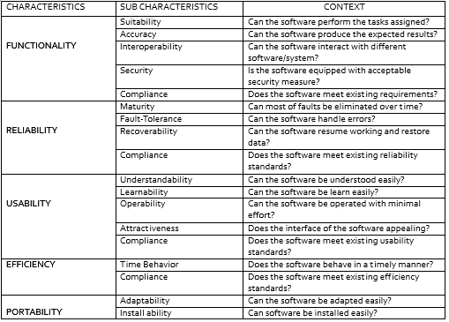

This table shows that the system complies with the standard.

**1.4 Methods used in the study**

In this study, the project team decided to employ the iterative waterfall

model of software development life cycle. The team started with a simple implementation of a small set of the software requirements and iteratively enhances the evolving versions until the complete system is implemented and ready to be deployed. The development begins by specifying and implementing just part of the software, which is then reviewed in order to identify further requirements. This process is then repeated, producing a new version of the software at the end of each iteration of the model.

**CHAPTER 2**

**Functional Specification Report**

**2.1 Data Requirements**

**2.1.1 Forms**

|  |  |  |
| --- | --- | --- |
| **No.** | **Form** | **Description** |
| 1 | Employment Application Form | This form is needed by the security guards whenever they need to apply on the agency. It includes the requirements needed by the agency, clearances, license, and personal information of the applicant, including their educational background, employment record, military service information and other related information. |
| 2 | Contract Form | It contains the terms and conditions between the client and the agency. |
| 3 | Application for Leave | This is the form needed by the Security Guards when they have to request leave. |

**2.1.1.1 List of Forms**

**2.1.1.2 Sample Forms**

1.) Employment Application Form

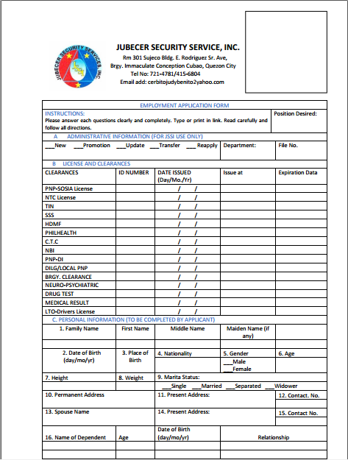

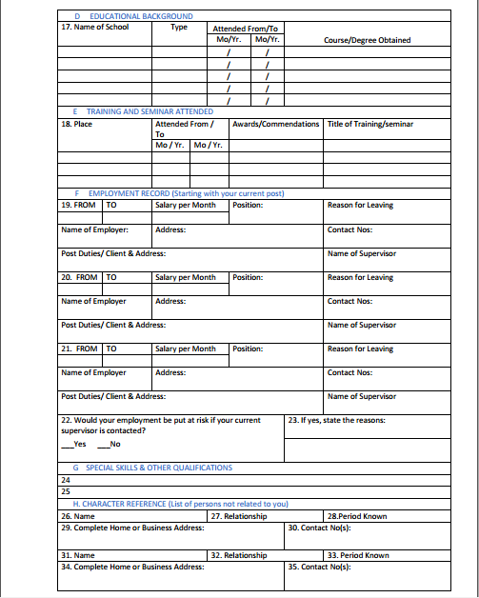

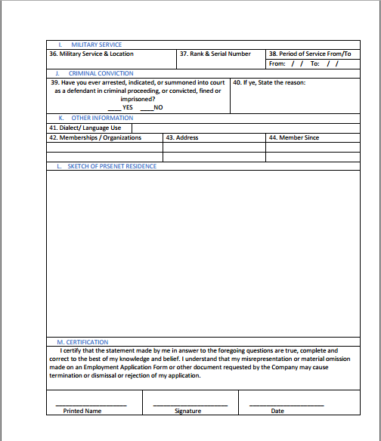

2.) Contract Form

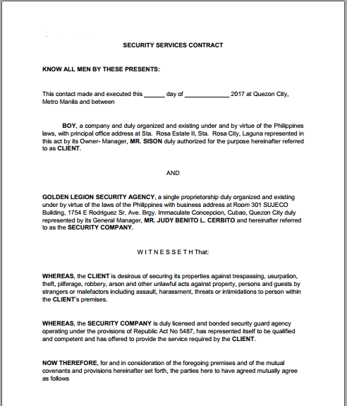

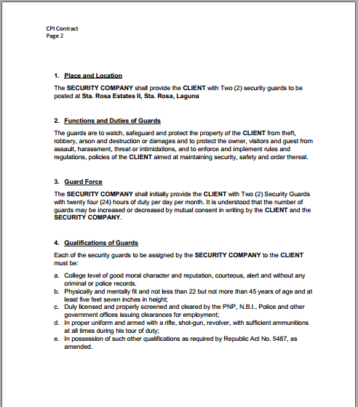

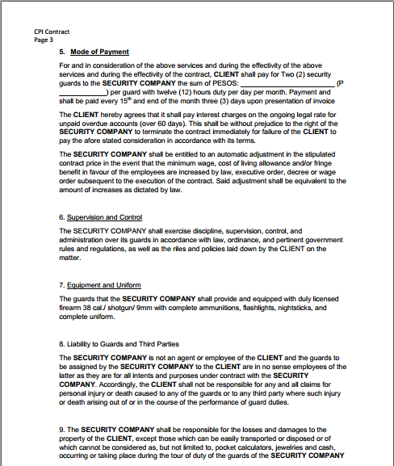

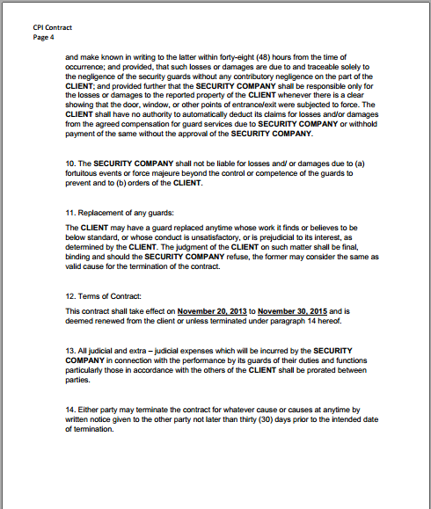

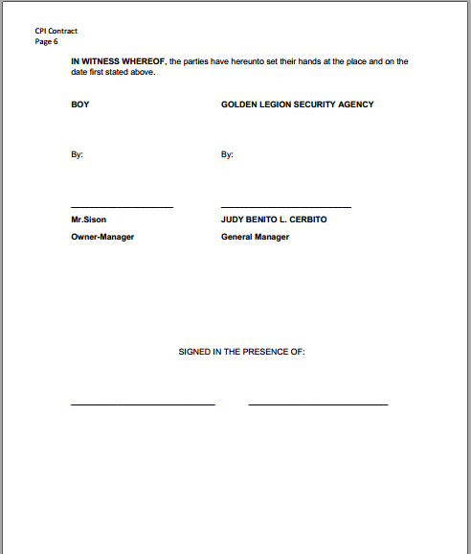

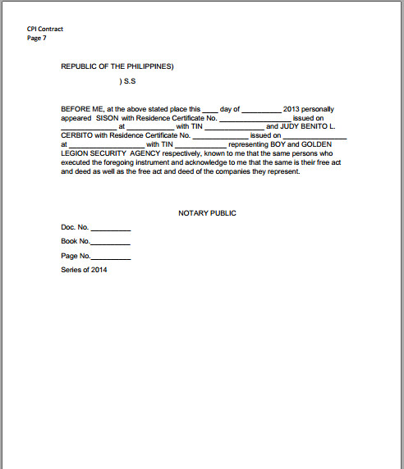

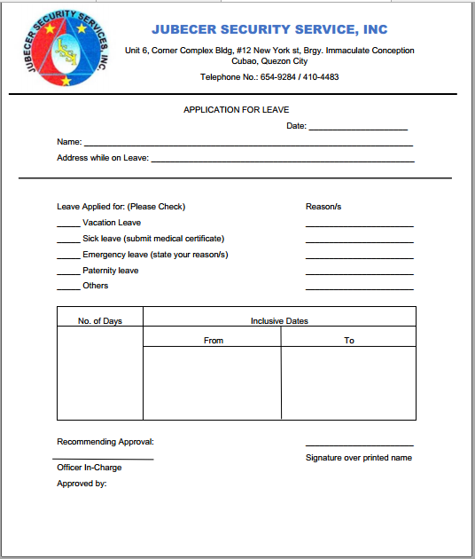3.) Application for Leave

**2.1.2 Reports**

**2.1.2.1 List of Reports**

1. Disposition report - it contains the information about the guards dispose in the respective client.
2. List of officers and their respective designation - it contains the details about list of officers and the location where they are deployed.
3. Gains and Losses -it contains the information regarding the number of newly employed
4. Guard Daily Time Record – contains the weekly attendance of security guards at their respective posts.
5. Incident Report – contains the records of incidents during the time of guard’s duty.
6. Client Payment Report – contains the payment history of the Client.

**2.1.2.2 Sample Reports**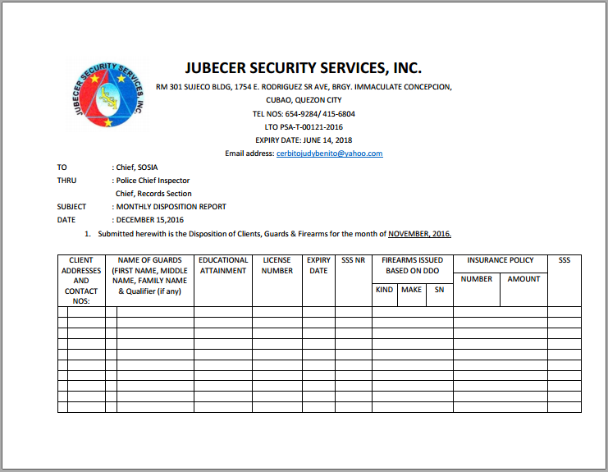

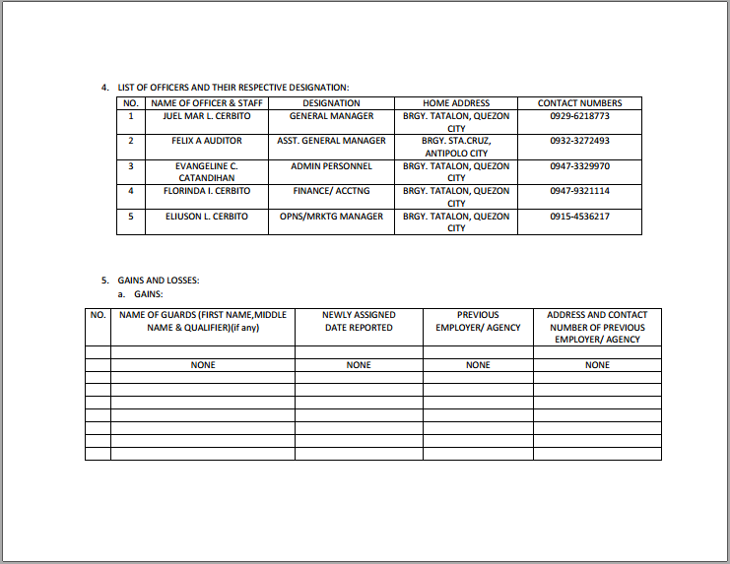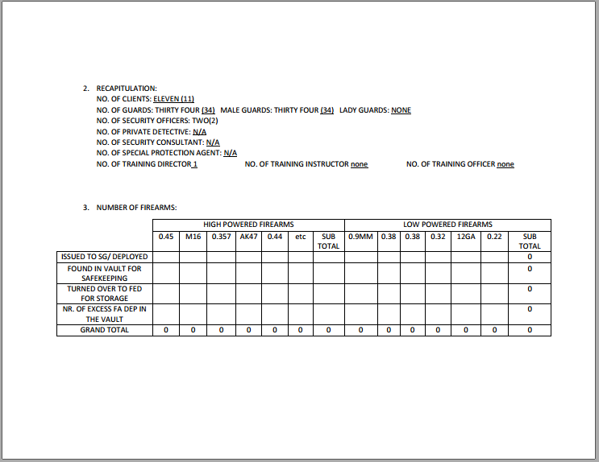

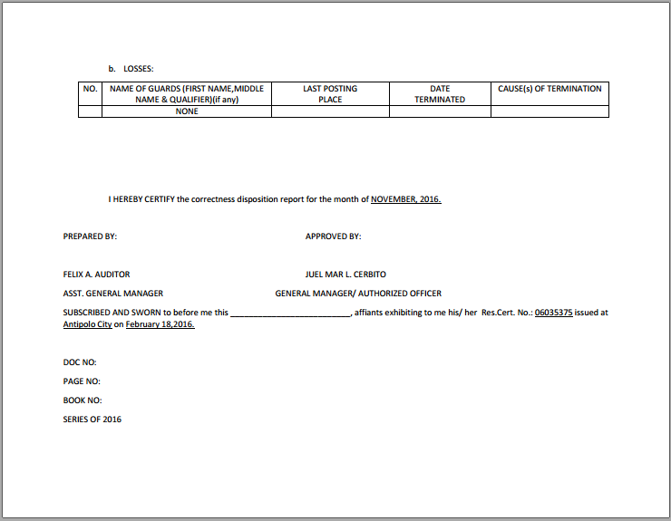

**2.2 Policies and Procedures**

**2.2.1 Procedures**

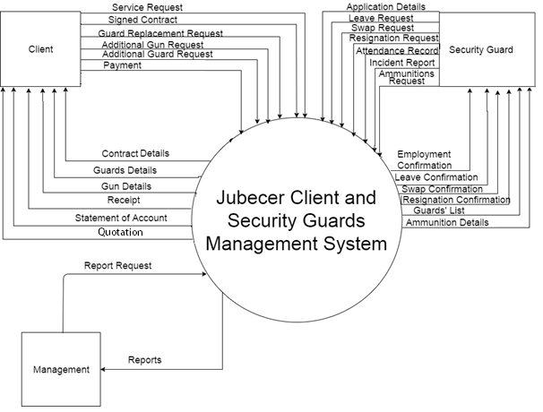**2.2.1.1 Context Diagram**

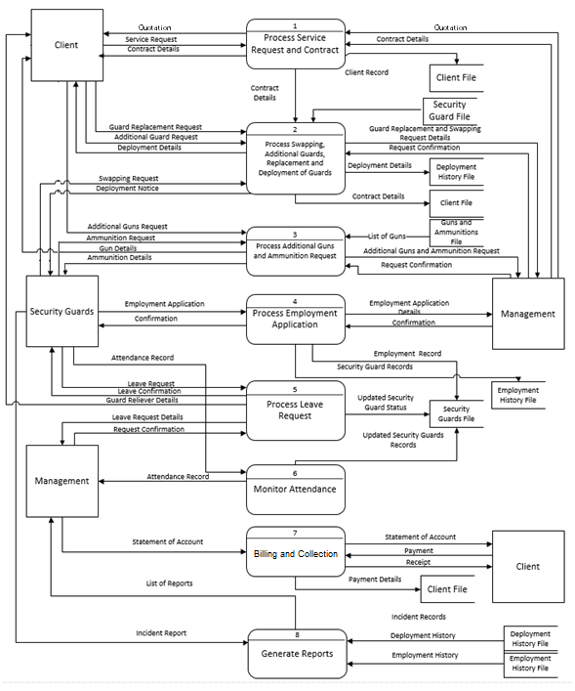**2.2.1.2 Level 1 DFD**

1. Client Registration/Processing of Contracts

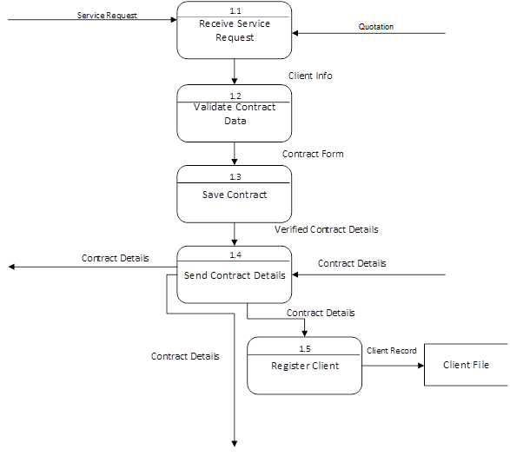

1. Deployment of Security Guards



1. 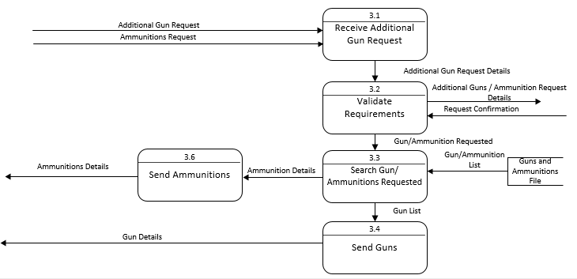Ammunition Request
2. 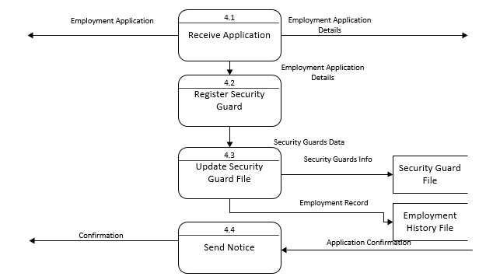Process Employment Application
3. 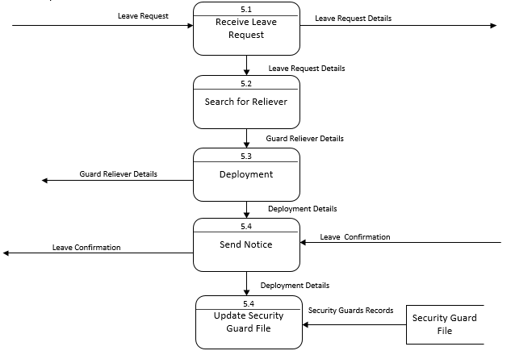Leave Request

7. Billing and Collection

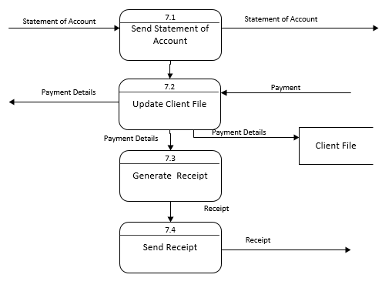

**2.2.2 Policies**

**2.2.2.1 Business Requirements**

|  |  |
| --- | --- |
| **Business Requirement ID** | **Description** |
| BR-001 | The applicant shall submit the  following requirements to the agency:  PNP SOSIA License, NTC License, TIN,SSS, PHILHEALTH,C.T.C., NBI, PNP-DI, DILG/Local PNP, Brgy. Clearance, Drug Test, Medical Result, LTO Driver’s License |
| BR-002 | The applicant should fill up the  application form provided by the  agency. |
| BR-003 | Pre-qualified applicants are called to  report to the agency’s office for further  assessment and to undergo other  related interviews based on the result  of his written examination, oral  interview, recital of 11 General Orders,  Professional Code of Ethics and  Conduct, and other related questions. |
| BR-004 | Prior to deployment/posting of the  newly hired employees, in the absence  of the HRD Manager, the Personnel  Assistant conduct a briefing and  orients the candidates on the  company profile and organizational |

|  |  |
| --- | --- |
|  | chart, employment status , salaries,  and wages, employee’s welfare,  benefits, health and safety, personnel  security concerns, company policies  and regulations, recruitment,  deployment and termination of  employees, leave benefits, violations  and corresponding penalties,  recognition/awards, conforme/signing,  signifying that she/he fully understood  the aforementioned, and hired  candidate is officially introduced to all  department heads/officers of the  company. |
| BR-005 | Operation Department to conduct  briefings/orientation as to the basic  information concerning the  destination/detachment of the guard,  an introduction of his superior officers,  and the Standard Operating  Procedures (SOP’s) in a specific post  or place of assignment. |
| BR-006 | Guards should be in proper PNP SOA  uniform, complete paraphernalia, and  company patches for they will be  monitored by the operation department  during deployment. |
| BR-007 | Security guards must have a copy of  his duly approved Duty Detail Order  (DDO) to be presented to his superior  officer and the client as well. |
| BR-008 | Security guards in his duty must be in  SG prescribed uniform and shall carry  the issued firearm only when there are  in actual performance of guard duty  within the compound of the  establishment or property of their client  in the place and time specified in the  Duty Detail Order. |

**2.2.2.2 Business Polices**

|  |  |
| --- | --- |
| **Business Policy ID** | **Description** |
| BP-001 | To become security personnel, the  applicant should pass the preliminary  interview, examinations, and  assessment of technical abilities. |
| BP-002 | Preliminary interview must be  conducted by the Psychometrician or  Personnel Assistant. This is to double  check the information written in the  resume as well as assess the  personality of the applicant. |
| BP-003 | All judicial and extra – judicial  expenses which will incurred by the  security company in connection with  the performance by its guards of their  duties and functions particularly those  in accordance with the orders of the  client shall be prorated between  parties. |
| BP-004 | The security company shall not be  liable for losses and/or damages due  to (a) fortuitous events or force  majeure beyond the control or  competence of the guards to prevent  and to (b) orders of the client. |
| BP-005 | The security company shall be  responsible for the losses and  damages to the property of the client,  except those which can be easily  transported or disposed or of which  cannot be considered as, but not  limited to, pocket calculators, jewelries,  and cash, occurring or taking place  during the tour of duty of the guards of  the security company and make known  in writing to the latter within forty-eight  (48) hours from the time of occurrence,  and provided, that such losses or  damages are due to and traceable solely to the negligence of the security  guards without any contributory  negligence on the part of the client;  and provided further that the security  agency shall be responsible only for  the losses or damages to the reported  property of the client whenever there is  a clear showing that the door, window,  or other points of entrance/exit were  subjected to force. |

|  |  |
| --- | --- |
| BP-006 | The client shall have no authority to  automatically deduct its claims for  losses and/or damages from the  agreed compensation for guard  services due to Security Company or  withhold payment of the same without  the approval of the security company. |
| BP-007 | Duty Detail Order is not an authority for  security guards to carry their issued  firearm outside the premises of the  specified post/station nor shall the  firearm described herein leave the  client post/station. |
| BP-008 | The guards are to watch, safeguard  and protect the property of the client  from theft, robbery, arson, and  destruction or damages and to protect  the owner, visitors and guests from  assault, harassment, threat or  intimidation, and to enforce and  implement rules and regulations,  policies of the client aimed at  maintaining security, safety, and order  thereat. |
| BP-009 | Clients can avail the agency’s  services with a contract form. Clients  have to approach the agency in  personal to do the transactions and  other business processes related to  the service. The management of the  client and the management of the  agency must talk to each other, in  order to settle the agreed contract. |

**2.3 Problem Analysis**

**2.3.1 Fishbone**

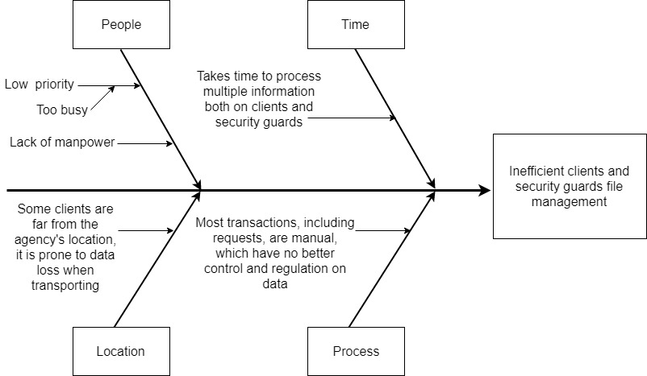

**2.3.3 Problems and Requirements**

|  |  |  |
| --- | --- | --- |
| No. | Problem | Requirement |
| 1 | Divided attention given to file management | Capability of committing on handling files |
| 2 | No control and regulation of data with manual forms | Capability to control and regulate data |
| 3 | Agency lacks on manpower on handling bulk information | Functionality to handle bulk information |
| 4 | Time and effort is required for managing files/information | Efficient on managing files |

**2.3.3 Conclusion**

The problems stated on the fishbone diagram are the main cause for the inefficient clients and security guards file management which is the main problem encountered by the agency on their entire business process using the manual transactions. Using manual methods of sending and receiving their clients and employee records makes the process time consuming and requires more effort. The data also are not secured and more prone to damage and loss. The manual process also requires lots of forms to be kept and requires more effort to handle and maintain. The unsystematised workflow of their business process causes the entire transaction to run slow and unorganized. Difficulty in processing client’s, security guards’, and security officer’s data lead to wasting time which means less revenue for the agency. Based on those problems and other data gathered, the proponents conclude that the Jubecer Security Service, Inc is in need of an online system and have come up with the appropriate solution. The proponents have devised a system that will streamline the procedure of processing the business transactions with an online management information system.

**2.3.3 Recommendations**

Jubecer Security Services, Inc manual transactions processing is outdated, worn down, and cannot be expected to be applied to the increasing demand for a higher and much better services. Based on the stated conclusion the proponents recommend to develop a web-based management system to resolve the problem encounter by the agency about difficulty in managing and processing their business data and records. The proponents recommend the system to have modules that will cover the transaction processes like service inquiry and request by the Clients, additional gun request, guard replacement request, employment application of Security Guards, leave request, swapping request and attendance monitoring. The said system should also have Maintenance module and a mobile application for Clients and Security Guards to view their profile, service offered and other business related data.

**CHAPTER 3: PROPOSED SYSTEM DEFINITION**  
 **3.1 Requirements-Features Matrix**

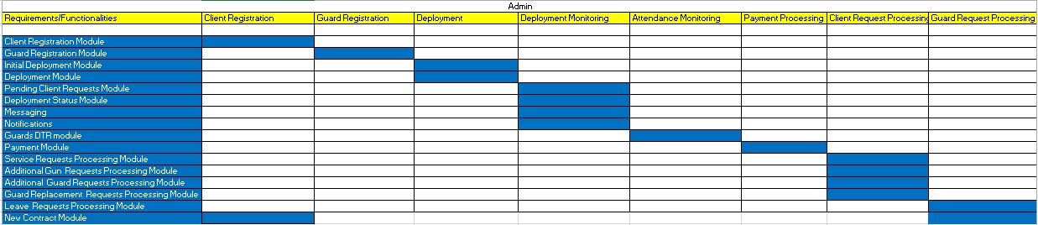

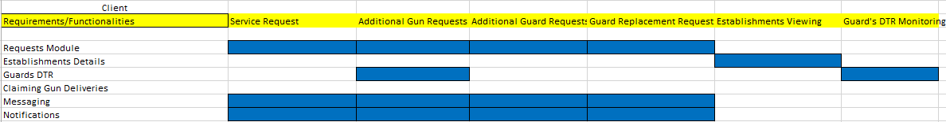

**3.2 Functional Specification**

**3.2.1 System Boundaries**

**3.2.2 System Use Case Diagram**

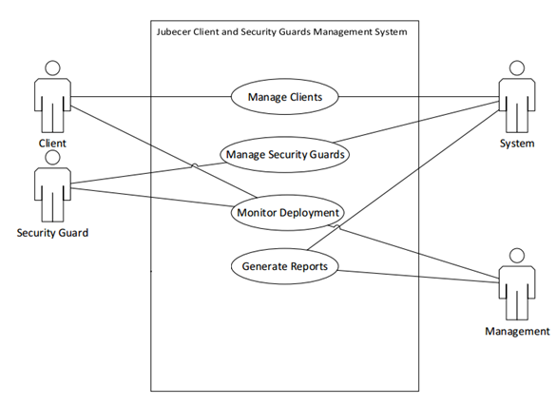

**3.2.3 Detailed per Use Case**

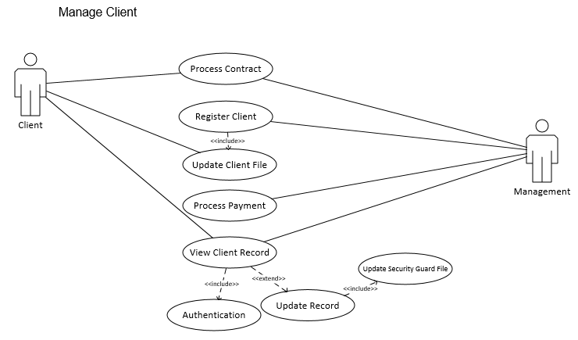

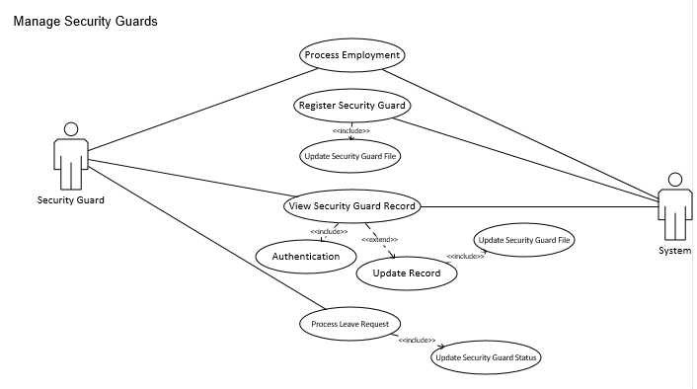

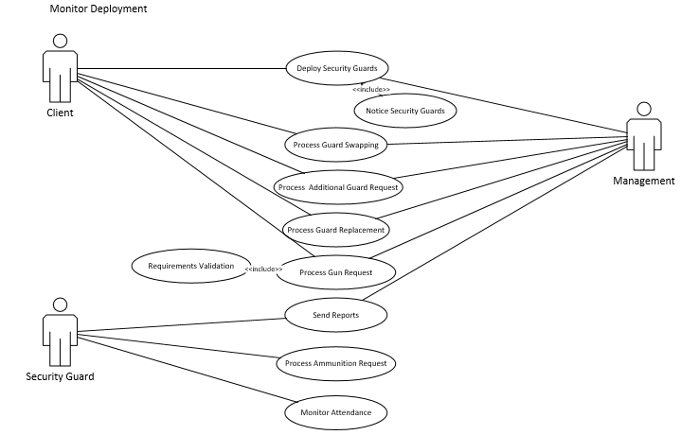

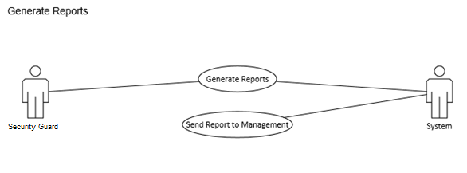

**3.3.4 Use Case Description**

|  |  |
| --- | --- |
| **Use Case Name** | Manage Client |
| **Actors** | Client, Management |
| **Purpose** | This use case describes how the management uses the system to manage the client. |
| **Brief Description** | Client and management agrees to contract. Client is registered by the management. Management process client’s payment. Client record/file is updated. |
| **Pre-Condition/s** | Client wants service from management. |
| **Post-Condition/s** | Contract is processed.  Client is registered.  Client records/files are updated.  Payment is processed. |

|  |  |
| --- | --- |
| **Basic Flow** | |
| **Actor Action** | **System Response** |
| 1. Client wants a service from the management. | Prompts a contract. |
| 3. Client agrees to contract terms. | Contract between management and client is created. |
| Client shares his necessary information.  4. | Information of client is recorded. |
| 5. Client sends payment for service. | 6. Payment details are recorded.  7. |
| **Alternate Flow** |  |
| Item #3. Client doesn’t agree to the terms, then contract isn’t signed.  3.a.  3.b. |  |
| Item #5 Client didn’t pay the service, then it could possibly be a termination of contract. |  |

|  |  |
| --- | --- |
| **Use Case Name** | Manage Security Guards |
| **Actors** | Security Guard, System |
| **Purpose** | This use case describes how the management uses the system to manage security guards. |
| **Brief Description** | Security guards send application form. The system processes the application forms. System registers the security guard. Record for the security guard is created. Security guard submits a request. System confirms the request. |
| **Pre-Condition/s** | The security guard submits a request. |
| **Post-Condition/s** | Employment of security guard is processed.  The management have registered an account for a security guard.  Security guard’s requests are processed. |

|  |  |
| --- | --- |
| **Basic Flow** | |
| **Actor Action** | **System Response** |
| The use case begins when the security guard submits an application form for employment. | 2. Accepts security guard application. |
|  | The management registers the security guard. |
|  | Security guard file updated with the registration of new guard. |
| Security guard views his record.  4. | Displays security guard record. |
| Security guard submits a request. | Request sent to management waiting for confirmation.  7. |
|  | 9. Request is accepted. |
|  | Security guard status is updated. |
| **Alternate Flow** |  |
|  | Item #2 The security guard isn’t qualified, then he isn’t hired. |
|  | Item #9 The request is denied. |

|  |  |
| --- | --- |
| **Use Case Name** | Monitor Deployment |
| **Actors** | Client, Management, Security Guard |
| **Purpose** | This use case describes how the management uses the system to monitor deployment of security guards to clients. |
| **Brief Description** | Security guards are deployed to the client. Security guards are notified and accepts the deployment. Client submits request to the management. The management confirms the requests. Security guard sends reports to the management. Security guard process ammunition request for the client. Security guards monitors attendance. |
| **Pre-Condition/s** | There are a number of security guards on the guard pool. |
| **Post-Condition/s** | Security guards are deployed.  Client requests pertaining guards are processed by the management.  Security guard sends report to the management.  Security guard processes ammunition for the client.  Security guard monitors guard’s attendance. |

|  |  |
| --- | --- |
| **Basic Flow** | |
| **Actor Action** | **System Response** |
| 1. Security guards are deployed to the client. | Client and security guard records are updated. |
| Client sends request pertaining to guards. | Request send to management waiting for confirmation. |
| 4. | 4. Confirms the request. |
| 5. Guards make and send reports to the management. | 6.  7. |
| 8. Guards make ammunition request. | 9. Approves the request. |
| Guards monitor attendance. | Record the attendance. |
| **Alternate Flow** |  |
| Item #1. Security guards aren’t deployed, then they are still available for deployment.  3.a.  3.b. | Item #4. Request denied. |
|  | Item #9 Request denied.  6.a |

|  |  |
| --- | --- |
| **Use Case Name** | Generate Reports |
| **Actors** | Security Guard, System |
| **Purpose** | This use case describes how the security guards send reports to the management. |
| **Brief Description** | Security guard generate report. The security guard sends the report to the system. The system sends the report to the management. |
| **Pre-Condition/s** | There is a report to be generated by the security guard. |
| **Post-Condition/s** | The security guard sends the report to the system.  The system sends the report to the management. |

|  |  |
| --- | --- |
| **Basic Flow** | |
| **Actor Action** | **System Response** |
| 1. The security guard generates the report. |  |
| 2. The security guard sends the report to the system. | 3. Receives the report. |
| 4. | 4. System sends the report to the management. |
| **Alternate Flow** |  |
| Item #1. There is no report generated by the security guard.  3.a.  3.b. | Item #3. Report isn’t received by the system. |

**3.3 Technical Specification**

**3.3.1. Class Diagram**

**3.3.1.1 List of Classes**

**C:\Users\earldixon\Downloads\Class Diagram.png**

**3.3.1.2 Class Diagrams (per Use Case by System)**

**3.3.2. Activity Diagram**

**3.3.3. Database Design**

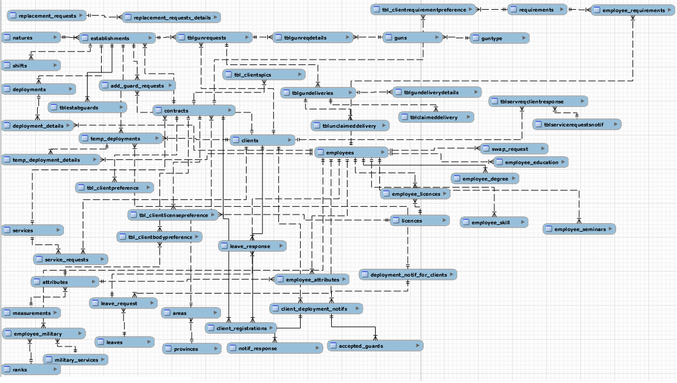**3.2.2.1 Database Schema**

**3.2.2.2 Database Dictionary**

|  |  |  |  |  |
| --- | --- | --- | --- | --- |
| attributes | | | | |
| Field Name | Description | Type | Length | Sample |
| Id | attributes ID | INT | 11 | 1 |
| Name | attributes name | VARCHAR | 200 | Arm span |
| Status | attributes status | VARCHAR | 45 | active |
| created_at | date created | TIMESTAMP |  | 4/2/2016 |
| updated_at | date updated | TIMESTAMP |  | 4/9/2016 |
| Measurements | measurement ID | VARCHAR | 200 |  |
|  |  |  |  |  |
| measurements | | | | |
| Field Name | Description | Type | Length | Sample |
| Id | measurement ID | INT | 11 | 1 |
| Name | measurement name | VARCHAR | 200 | feet (ft) |
| Status | measurement status | VARCHAR | 45 | active |
| created_at | date created | TIMESTAMP |  | 4/2/2016 |
| updated_at | date updated | TIMESTAMP |  | 4/9/2016 |
|  |  |  |  |  |
| provinces | | | | |
| Field Name | Description | Type | Length | Sample |
| Id | province ID | INT | 11 | 1 |
| Name | province name | VARCHAR | 200 | Rizal |
| Status | province status | VARCHAR | 45 | active |
| created_at | date created | TIMESTAMP |  | 4/2/2016 |
| updated_at | date updated | TIMESTAMP |  | 4/9/2016 |
|  |  |  |  |  |
| areas | | | | |
| Field Name | Description | Type | Length | Sample |
| Id | area ID | INT | 11 | 1 |
| Name | area name | VARCHAR | 200 | NCR |
| Status | area status | VARCHAR |  | active |
| created_at | date created | TIMESTAMP |  | 4/2/2016 |
| updated_at | date updated | TIMESTAMP |  | 4/9/2016 |
| provinces_id | province ID | VARCHAR | 200 | RZL001A |
|  |  |  |  |  |
| employee_attributes | | | | |
| Field Name | Description | Type | Length | Sample |
| Id | Employee Attributes ID | INT | 11 | 1 |
| employees_id | Employee ID | VARCHAR | 45 | EMP001A |
| attributes_id | attributes_id | VARCHAR | 11 | 1 |
| Size | Size | DECIMAL |  | 3.5 ft |
| created_at | date created | TIMESTAMP |  | 4/2/2016 |
| updated_at | date updated | TIMESTAMP |  | 4/9/2016 |
|  |  |  |  |  |
| clients | | | | |
| Field Name | Description | Type | Length | Sample |
| Id | Client ID | VARCHAR | 45 | MCDO001A |
| Name | Client name | DECIMAL |  | Macdonalds |
| Areas | Area of Client | INT | 11 | 1 |
| created_at | date created | TIMESTAMP |  | 4/2/2016 |
| updated_at | date updated | TIMESTAMP |  | 4/9/2016 |
|  |  |  |  |  |
| user | | | | |
| Field Name | Description | Type | Length | Sample |
| Id | Admin ID | VARCHAR | 45 | ENST001A |
| Username | Admin username | VARCHAR | 45 | bimbi |
| Password | Admin password | VARCHAR | 45 | bimbi001 |
| Status | Client status | VARCHAR | 45 | active |
| Usertype | Type of User | VARCHAR | 45 | administrator |
| created_at | date created | TIMESTAMP |  | 4/2/2016 |
| updated_at | date updated | TIMESTAMP |  | 4/9/2016 |
|  |  |  |  |  |
| ammo_request | | | | |
| Field Name | Description | Type | Length | Sample |
| ID | Ammunition Request ID | INT | 11 | 1 |
| clients_id | Client ID | VARCHAR | 45 | MCDO001A |
| Status | status | VARCHAR | 45 | active |
| Read |  | TINYINT | 1 |  |
| created_at | date created | TIMESTAMP |  | 4/2/2016 |
| updated_at | date updated | TIMESTAMP |  | 4/9/2016 |
|  |  |  |  |  |
| contract | | | | |
| Field Name | Description | Type | Length | Sample |
| id | CONTRACT ID | VARCHAR | 45 | CONTRCT001A |
| client_id | Client ID | VARCHAR | 45 | MCDO001A |
| services_id | Services ID | INT | 11 | 1 |
| address | Client Address | TEXT |  | 4/2/2016 |
| area_id | Area ID | INT | 11 | 4/9/2016 |
| guard_count | no. of guards to be Deployed | INT | 11 | 10 |
| status | contact status | VARCHAR | 45 | active |
| year_span | year span | TINYINT | 4 | 5 |
| date_start | date started | DATE | 6 | 4/2/2016 |
| created_at | date created | TIMESTAMP |  | 4/2/2016 |
| updated_at | date updated | TIMESTAMP |  | 4/9/2016 |
|  |  |  |  |  |
| contract_deployments | | | | |
| Field Name | Description | Type | Length | Sample |
| id | Contract Deployment ID | INT | 11 | 1 |
| contract_id | CONTRACT ID | VARCHAR | 45 | CONTRCT001A |
| employees_id | Employee ID | VARCHAR | 45 | EMP001A |
| Roles_id | Role ID | INT | 11 | 1 |
| status | contact status | VARCHAR | 45 | active |
| created_at | date created | TIMESTAMP |  | 4/2/2016 |
| updated_at | date updated | TIMESTAMP |  | 4/9/2016 |
|  |  |  |  |  |
| employee_licences | | | | |
| Field Name | Description | Type | Length | Sample |
| id | Employee License ID | INT | 11 | 1 |
| employees_id | Employee ID | VARCHAR | 45 | EMP001A |
| licences-ID | License ID | INT | 11 | 1 |
| created_at | date created | TIMESTAMP |  | 4/2/2016 |
| updated_at | date updated | TIMESTAMP |  | 4/9/2016 |
|  |  |  |  |  |
| employees | | | | |
| Field Name | Description | Type | Length | Sample |
| id | Employee ID | VARCHAR | 45 | EMP001A |
| status | Employee status | VARCHAR | 45 | active |
| first_name | First Name | VARCHAR | 45 | Abel |
| middle_name | Middle Name | VARCHAR | 45 | Albino |
| last_name | Last Name | VARCHAR | 45 | Macandog |
| birth_date | Date of Birth | DATE | 6 | 4/9/1687 |
| address | Employee Address | TEXT |  | 82 Saint Joseph St, Binagonan, Rizal |
| areas_id | Area | INT | 11 | 1 |
| deployed | if Deployed | TINYINT | 1 | YES |
| created_at | date created | TIMESTAMP |  | 4/2/2016 |
| updated_at | date updated | TIMESTAMP |  | 4/9/2016 |
|  |  |  |  |  |
| employee_requirements | | | | |
| Field Name | Description | Type | Length | Sample |
| id | Employee Requirement ID | INT | 11 | 1 |
| employees_id | Employee ID | VARCHAR | 45 | EMP001A |
| requirements_id | Requirements ID | INT | 11 | 1 |
| created_at | date created | TIMESTAMP |  | 4/2/2016 |
| updated_at | date updated | TIMESTAMP |  |  |
|  |  |  |  |  |
| gun_requests | | | | |
| Field Name | Description | Type | Length | Sample |
| id | Gun Request ID | INT | 11 | 1 |
| clients_id | Client ID | VARCHAR | 45 | MCDO001A |
| guns_id | Gun ID | INT | 11 | 1 |
| status | status | VARCHAR | 45 | active |
| read |  | TINYINT | 1 |  |
| created_at | date created | TIMESTAMP |  | 4/2/2016 |
| updated_at | date updated | TIMESTAMP |  | 4/9/2016 |
|  |  |  |  |  |
| guns | | | | |
| Field Name | Description | Type | Length | Sample |
| id | Gun ID | INT | 11 | 1 |
| name | Gun Name | VARCHAR | 200 | M1903 Springfield |
| guntype | Gun Type | VARCHAR | 200 | Rifle |
| status | Gun Status | VARCHAR | 45 | active |
| created_at | date created | TIMESTAMP |  | 4/2/2016 |
| updated_at | date updated | TIMESTAMP |  | 4/9/2016 |
|  |  |  |  |  |
| leave_request | | | | |
| Field Name | Description | Type | Length | Sample |
| id | Leave Request ID | INT | 11 | 1 |
| employee_id | Employee ID | VARCHAR | 45 | EMP001A |
| leaves_id | Leave ID | INT | 11 | 1 |
| start_date | Date Start | DATE | 6 | 4/2/2016 |
| end_date | Date End | DATE | 6 | 4/9/2016 |
| reason | Reason for Leaving | TEXT |  | Wedding Anniversary |
| status | Leave Status | VARCHAR | 45 | active |
| read |  | BOOLEAN |  |  |
| created_at | date created | TIMESTAMP |  | 4/2/2016 |
| updated_at | date updated | TIMESTAMP |  | 4/9/2016 |
|  |  |  |  |  |
| leave | | | | |
| Field Name | Description | Type | Length | Sample |
| id | Leave ID | INT | 11 | 1 |
| name | Leave Description | VARCHAR | 45 | MATERNAL LEAVE |
| days |  | INT | 11 | 10 |
| notification |  | INT | 11 | 3 |
| status | Leave Status | VARCHAR | 45 | active |
| created_at | date created | TIMESTAMP |  | 4/2/2016 |
| updated_at | date updated | TIMESTAMP |  | 4/9/2016 |
|  |  |  |  |  |
| licences | | | | |
| Field Name | Description | Type | Length | Sample |
| id | Licence ID | INT | 11 | 1 |
| name | License Description | VARCHAR | 200 | SOSIA License |
| status | Licence Status | VARCHAR | 45 | active |
| created_at | date created | TIMESTAMP |  | 4/2/2016 |
| updated_at | date updated | TIMESTAMP |  | 4/9/2016 |
|  |  |  |  |  |
| military_services | | | | |
| Field Name | Description | Type | Length | Sample |
| id | Military Service ID | INT | 11 | 1 |
| name | Military Service Name | VARCHAR | 200 | CAT |
| status | Military Service Status | VARCHAR | 45 | active |
| created_at | date created | TIMESTAMP |  | 4/2/2016 |
| updated_at | date updated | TIMESTAMP |  | 4/9/2016 |
|  |  |  |  |  |
| natures | | | | |
| Field Name | Description | Type | Length | Sample |
| id | Business Nature | INT | 11 | 1 |
| name | Business Nature ID | VARCHAR | 200 | PUBLIC SCHOOL |
| price |  | DECIMAL | 10.0 |  |
| status | Business Nature Status | VARCHAR | 45 | active |
| created_at | date created | TIMESTAMP |  | 4/2/2016 |
| updated_at | date updated | TIMESTAMP |  | 4/9/2016 |
|  |  |  |  |  |
| ranks | | | | |
| Field Name | Description | Type | Length | Sample |
| id | Rank ID | INT | 11 | 1 |
| name | Rank Name | VARCHAR | 200 | LIASON OFFICER |
| mname | Military Service ID | VARCHAR | 200 | MILTSERV001A |
| status | Business Nature Status | VARCHAR | 45 | active |
| created_at | date created | TIMESTAMP |  | 4/2/2016 |
| updated_at | date updated | TIMESTAMP |  | 4/9/2016 |
|  |  |  |  |  |
| renewal_requests | | | | |
| Field Name | Description | Type | Length | Sample |
| id | Renewal Request ID | INT | 11 | 1 |
| clients_id | Client ID | VARCHAR | 45 | MCDO001A |
| status | status | VARCHAR | 45 | active |
| read |  | VARCHAR |  |  |
| created_at | date created | TIMESTAMP |  | 4/2/2016 |
| updated_at | date updated | TIMESTAMP |  | 4/9/2016 |
|  |  |  |  |  |
| replacement_requests | | | | |
| Field Name | Description | Type | Length | Sample |
| id | Replacement ID | INT | 11 | 1 |
| clients_id | Client ID | VARCHAR | 45 | MCDO001A |
| contract_id | CONTRACT ID | VARCHAR | 45 | CONTRCT001A |
| employee_id | Employee ID | VARCHAR | 45 | EMP001A |
| reason | Reason for Replacement | TEXT |  | Poor performance |
| status | Leave Status | VARCHAR | 45 | active |
| read |  | BOOLEAN |  |  |
| created_at | date created | TIMESTAMP |  | 4/2/2016 |
| updated_at | date updated | TIMESTAMP |  | 4/9/2016 |
|  |  |  |  |  |
| roles | | | | |
| Field Name | Description | Type | Length | Sample |
| id | Role ID | INT | 11 | 1 |
| name | Role Name | VARCHAR | 45 |  |
| description | Role Description | VARCHAR | 45 | MILTSERV001A |
| status | Role Status | VARCHAR | 45 | active |
| created_at | date created | TIMESTAMP |  | 4/2/2016 |
| updated_at | date updated | TIMESTAMP |  | 4/9/2016 |
|  |  |  |  |  |
| services_request | | | | |
| Field Name | Description | Type | Length | Sample |
| id | Role ID | INT | 11 | 1 |
| clients_id | Client ID | VARCHAR | 45 | MCDO001A |
| services_id | Services ID | INT | 11 | SERV001A |
| natures_id | Business Nature | INT | 11 | SCHL001A |
| address | Client Address | VARCHAR | 45 | 82 Saint Joseph Street, Binangonan, Rizal |
| area_id | Area ID | INT | 11 | NCR001A |
| guard_count | Number of Guards | INT | 11 | 10 |
| date_start | Date Started | DATE |  | 4/2/2016 |
| status | Request Status | VARCHAR | 45 | active |
| read |  | TINYINT | 1 |  |
| created_at | date created | TIMESTAMP |  | 4/2/2016 |
| updated_at | date updated | TIMESTAMP |  | 4/9/2016 |
|  |  |  |  |  |
| services | | | | |
| Field Name | Description | Type | Length | Sample |
| id | Service ID | INT | 11 | 1 |
| name | Service Name | VARCHAR | 200 | Patrol Service |
| description | Service Description | VARCHAR | 45 | Patrol Service |
| status | Service Status | VARCHAR | 45 | active |
| created_at | date created | TIMESTAMP |  | 4/2/2016 |
| updated_at | date updated | TIMESTAMP |  | 4/9/2016 |
|  |  |  |  |  |
| swap_requests | | | | |
| Field Name | Description | Type | Length | Sample |
| id | Replacement ID | INT | 11 | 1 |
| employee_id | Employee ID | VARCHAR | 45 | EMP001A |
| reason | Reason for Swapping | TEXT |  | Incovinient location |
| status | Swap Status | VARCHAR | 45 | active |
| read |  | TINYINT | 1 |  |
| created_at | date created | TIMESTAMP |  | 4/2/2016 |
| updated_at | date updated | TIMESTAMP |  | 4/9/2016 |
| guntype | | | | |
| Field Name | Description | Type | Length | Sample |
| id | Gun Type ID | INT | 11 | 1 |
| name | Service Name | VARCHAR | 200 | Rifle |
| status | Gun type status | VARCHAR | 45 | active |
| created_at | date created | TIMESTAMP |  | 4/2/2016 |
| updated_at | date updated | TIMESTAMP |  | 4/9/2016 |
|  |  |  |  |  |
| military_ranks | | | | |
| Field Name | Description | Type | Length | Sample |
| id | Gun Type ID | INT | 11 | 1 |
| Employess_id | Employee ID | VARCHAR | 45 | EMP001A-EARL |
| Ranks_id | Rank ID | INT | 11 | 1 |
| status | Gun type status | VARCHAR | 45 | active |
| created_at | date created | TIMESTAMP |  | 4/2/2016 |
| updated_at | date updated | TIMESTAMP |  | 4/9/2016 |