**Progress Bars Demo**

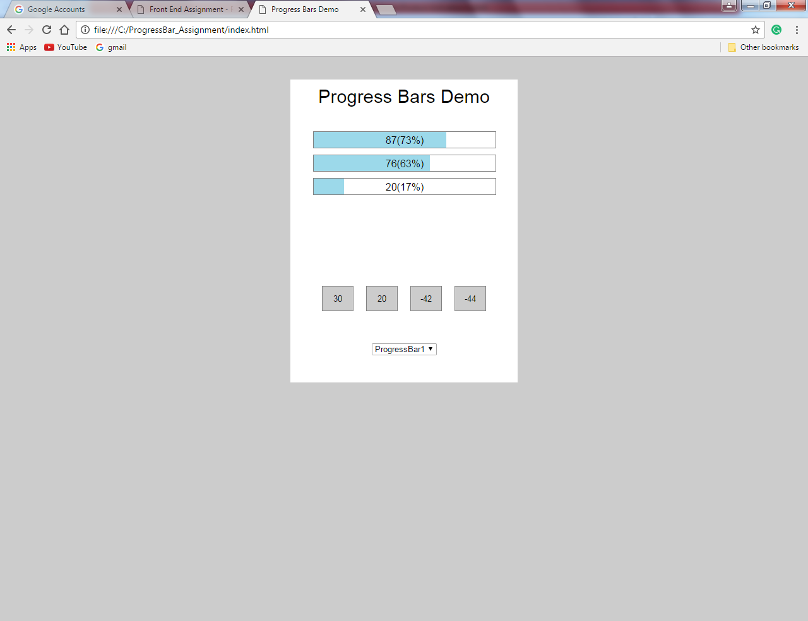

The demo is developed so that it adjusts according to the available area.

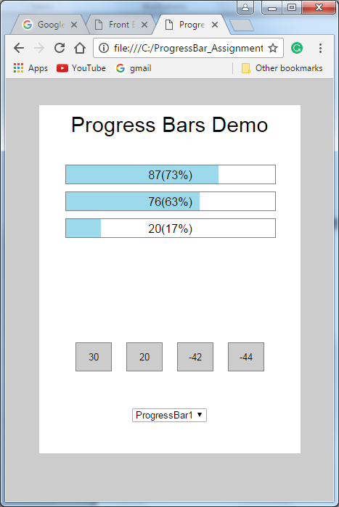

The data is fetched from data.json file.

{"buttons":[30,20,-42,-44],"bars":[87,76,20],"limit":120}

The demo is tested by entering different data values (as shown below):

{"buttons":[30,20,-42,-44,60],"bars":[87,76,20],"limit":120}---More buttons added

{"buttons":[30,20,-42,-44],"bars":[87,76,20,66,99],"limit":120}---More bars added

{"buttons":[30,20,-42,-44],"bars":[87,76,20,66,99],"limit":270}---Limit changed

**Note**:

I had worked on a non-development machine with no access to server (and no installation rights). Therefore the development is done considering two versions:

* debug: This is the version for my development without the need for server (JSON added as string in globalFunctions.js file.
* Server: This is the server version which gets json from ‘data/data.json’ file.

The demo has been tested across browsers (IE, Google Chrome).

Output in Internet Explorer:

