Huimin(Hermmy) Wang

CS 35L Lab 3

Professor Eggert

TA Alan Litteneker

29 May 2018

**Exploring Possibilities of Convolutional Neural Network in Medical Field:** Review of “Scientists Use AI to Predict Biological Age Based on Smartphone and Wearables Data”

**Introduction**

The availability of wearable devices integrated with human locomotion sensors has enabled easy access to our personal activity records. Products like Apple Watch and Fitbit seamlessly blend into the daily routines of millions of people and provide useful information for scientists to monitor our health. In March 2018, a research team from a Russian biotech company GERO and Moscow Institute of Physics and Technology has developed a computer algorithm which uses artificial intelligence and machine learning tools to predict biological age and mortality risk based on physical activities from the wearable devices that we have. The technology shows that we can “combine wearable sensors and deep learning technologies for applications involving continuous health risks monitoring and real-time feedback to patients and care providers” [Pyrkov 2018].

The team is led by Peter Fedichev, who is a Russian biologist, the head of the Laboratory of Biological Systems Simulation at MIPT, and also the Science Director at GERO. [MIPT News 2018]. The product of their research is a free iOS app called “GERO Lifespan” that reads health data from phones and wearable devices connected to the phones, such as walking distance and sleep time. With these kinds of information, GERO managed to calculate customers’ real time life span with a model built by the Convolutional Neural Network.

**How does a Convolutional Neural Network predict age?**

The computer algorithm adopted by GERO is called Convolutional Neural Network (“CNN”), which is a powerful tool to recognize patterns in the field of deep learning. In short, CNN is an artificial neural network that contains multiple convolution layers to detect patterns and is a branch of multilayer perceptron(“MLP”). An MLP consists of an input layer, an output layer, and an arbitrary number of middle layers; a CNN is a special kind of MLPs with convolution layers and pooling.

In a CNN, each convolution layer consists of many neurons that have weights and biases that are learned by the network itself during its training process. The architecture of CNN is inspired by biological processes in that the connectivity pattern between CNN neurons resemble to the organization of animal’s neural network. By sliding or convolving a filter over each convolution layer, we compute dot products and form a “Feature Map,” a matrix representation of input data. In practice, instead of scientists manually give values to filters, a CNN learns the values of these filters on its own during its training process. After ReLU that introduces non-linearity, the next step is max pooling in which we repetitively take the largest element from each small portion of a convolution layer and form a smaller matrix in the end to reduce the size of our input representation. After several cycles of convolution, the data enters a dense layer, which is also known as a fully connected layer. The purpose of a dense layer is to classify the input data by the features that we detect and turn them into various classes based on the training dataset. Then the scientists use dropout, a regularization process that prevents overfitting in which a model is too closely corresponded to one particular set of data and is not applicable to a bigger range. After all these complex processes, the final output is a single linear neuron, producing the resulting value of age prediction.

**My Opinion**

The application of convolutional neural network in medical field would sprout numerous opportunities in healthcare and illness prediction. Since CNN is a powerful tool of detecting patterns, scientists could use it to predict not only age, but also diseases and potential health risks. The research of GERO team which combines wearable technology with CNN should inspire more computer scientists, biologists, and physicians to explore possibilities of integrating prevalent technologies with CNN. By collecting the types of music or movies people listen to or watch, scientists could analyze, for example, the relationship between our mental health and entertainment genres via heart rate. The location tracking on phones and wearables enables detailed analysis on potential health risks related to people’s lifestyles. I agree with what Peter Fedichev believes, there are indeed countless possibilities associated with convolutional neural network and health risks assessment [MIPT News 2018].

**Possible Applications**

1. Medical Diagnosis and Predictive Models

Because of its strong ability to recognize patterns, convolutional neural network can be used to predict diagnosis result by learning and understanding clinical notes. A CNN model is supposed to have the ability to classify and read clinical notes in the form of texts in a similar fashion as reading numeric values in the CNN_Age model proposed by GERO. A research team from University of Pittsburgh Medical Center implemented a CNN model to analyze textual admission information from Electronic Health Records (EHRs) from MIMIC-III and “predict primary discharge diagnosis” [Li 2017]. Convolutional neural network once again shows its strength in recognizing patterns by achieving an overall 96.11% accuracy on 10 most frequent disease classes, such as coronary artery disease, hemorrhage, pneumonia [Li 2017].

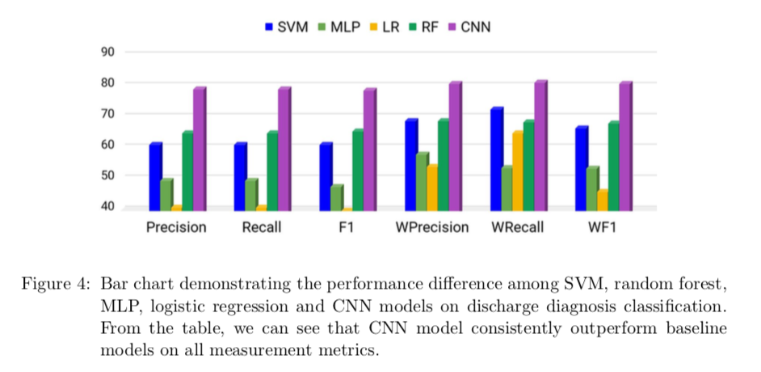

The CNN model to predict diagnosis result via clinical notes has to potential to reduce misdiagnoses caused by human errors, shorten patient waiting time, and increase the efficiency of medical services.

1. Medical Image Analysis

If convolutional neural network is able to learn patterns from texts and numbers, we can also apply it to recognize images, as pixels can be digitized as numbers. Reading and understanding medical images manually is time-consuming for healthcare providers and patients, and there are inevitable risks of misdiagnoses. CNN is a great artificial intelligence tool to do the work for us with higher accuracy and efficiency. Similar to the CNN_Age model, the CNN model here contains five layers of convolution, each followed by a max pooling layer, and three fully connected layers. Each filter in the convolution layer detects one specific feature and forms a smaller feature map. The architecture of CNN in analyzing medical images is shown below:

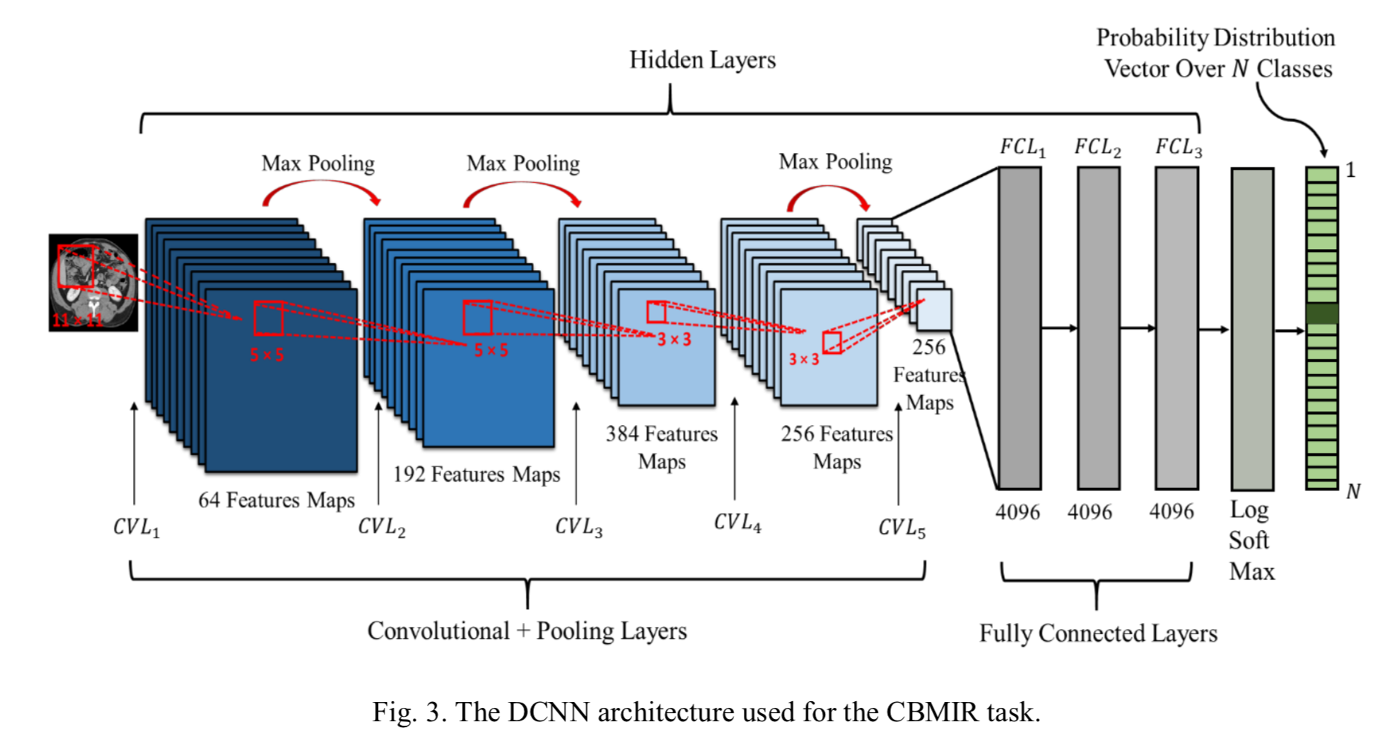

Many researches have already been done to train CNNs to understand medical images; however, one problem needs to be resolved before putting CNNs into practice: training CNNs with a large number of medical images is expensive and resource-consuming. Fortunately, many researchers have dedicated to solving this issue and have come up with some great ideas. Nima Tajbakhsh suggests that we can train CNNs with natural images, and the result shows that the CNN trained with natural images can also achieve sufficient accuracy in reading medical images [Tajbakhsh 2017].

**Reference**

“A Beginner’s Guide to Deep Convolutional Neural Networks (CNNs)”. Deeplearning4j.org. [cited May 2018]; Available from: https://deeplearning4j.org/convolutionalnetwork

“Scientists use AI to predict biological age based on smartphone and wearables data”. Mipt.ru. March 29, 2018. [cited May 2018]; Available from: https://mipt.ru/english/news/scientists_use_ai_to_predict_biological_age_based_on_smartphone_and_wearables_data?sphrase_id=231861

Adnan Qayyum, Syed Muhammad Anwar, Muhammad Awais, Muhammad Majid. Medical Image Retrieval using Deep Convolutional Neural Network. 2017. [cited May 2018]; Available from: <https://arxiv.org/pdf/1703.08472.pdf>

Byung Bok Ahn. The Compact 3D Convolutional Neural Network for Medical Images. 2017. [cited May 2018]; Available from: <http://cs231n.stanford.edu/reports/2017/pdfs/23.pdf>

Christy Yuan Li, Dimitris Konomis, Graham Neubig, Pengtao Xie, Carol Cheng, and Eric Xing. Convolutional Neural Networks for Medical Diagnosis from Admission Notes. 2017. [cited May 2018]; Available from:  [arXiv:1712.02768](https://arxiv.org/abs/1712.02768) [cs.CL]

Culurciello, Eugenio. The History of Neural Networks. Dataconomy.com. April 19, 2017. [cited May 2018]; Available from: http://dataconomy.com/2017/04/history-neural-networks/

Geitgey, Adam. Machine Learning is Fun! Part 3: Deep Learning and Convolutional Neural Networks. Medium.com. Jun 13, 2016. [cited May 2018]; Available from: https://medium.com/@ageitgey/machine-learning-is-fun-part-3-deep-learning-and-convolutional-neural-networks-f40359318721

Karn, Ujjwal. An Intuitive Explanation of Convolutional Neural Networks. Ujjwalkarn.me. August 11, 2016. [cited May 2018]; Available from: https://ujjwalkarn.me/2016/08/11/intuitive-explanation-convnets/

Nima Tajbakhsh, Jae Y. Shin, Suryakanth R. Gurudu, R. Todd Hurst, Christopher B. Kendall, Michael B. Gotway, and Jianming Liang. Convolutional Neural Networks for Medical Image Analysis: Full Training or Fine Tuning? 2017. [cited May 2018]; Available from: arXiv:1706.00712v1 [cs.CV]

Pyrkov, Timothy. Extracting biological age from biomedical data via deep learning: too much of a good thing? www.nature.com/scientificreports. March 26. 2018. [cited May 2018]; Available from: 10.1038/s41598-018-23534-9