Assignment 2
Hermmy Wang
704978214
Discussion 1B

Q1.
(a)
T | T | F | {S1, S2, S3, S7, S9, S10} | Yes | X<Y && Y>=Z && X+Y<135 | z'=135, y'=125, x'=x
T | F | T | {S1, S2, S4, S5, S7, S8, S10} | Yes | X<Y && Y<Z && X>0 | z'=x, y'=x, x'=x+10
F | T | T | {S1, S6, S7, S8, S10} | Yes | Y<0 && X+2Y>0 && X>=Y | x’=-y+10,  y’=y,  z’=-y
T | F | F | {S1, S2, S4, S5, S7, S9, S10} | Yes | X<Y && Y<Z (&& X<0) | x'=x, z'=x, y'=x-10
F | F | T | {S1, S6, S7, S8, S10} | Yes | Y<0 && X+2Y>0 && X>=Y | x’=-y+10,  y’=y,  z’=-y
F | T | F | {S1, S6, S7, S9, S10} | Yes | X>=Y && (Y>0 || X<-2Y) | x’=x  y’=-y-10  z’=-y
F | F | F | {S1, S6, S7, S9, S10} | Yes | X>=Y && (Y>0 || X<-2Y) | x’=x  y’=-y-10  z’=-y

(b)
{T1, T2, T4} covers {S1, S6, S7, S9, S10}
{T3} covers {S1, S2, S4, S5, S7, S8, S10}
{T5} covers {S1, S2, S3, S7, S8, S10}

Q2.
(a) 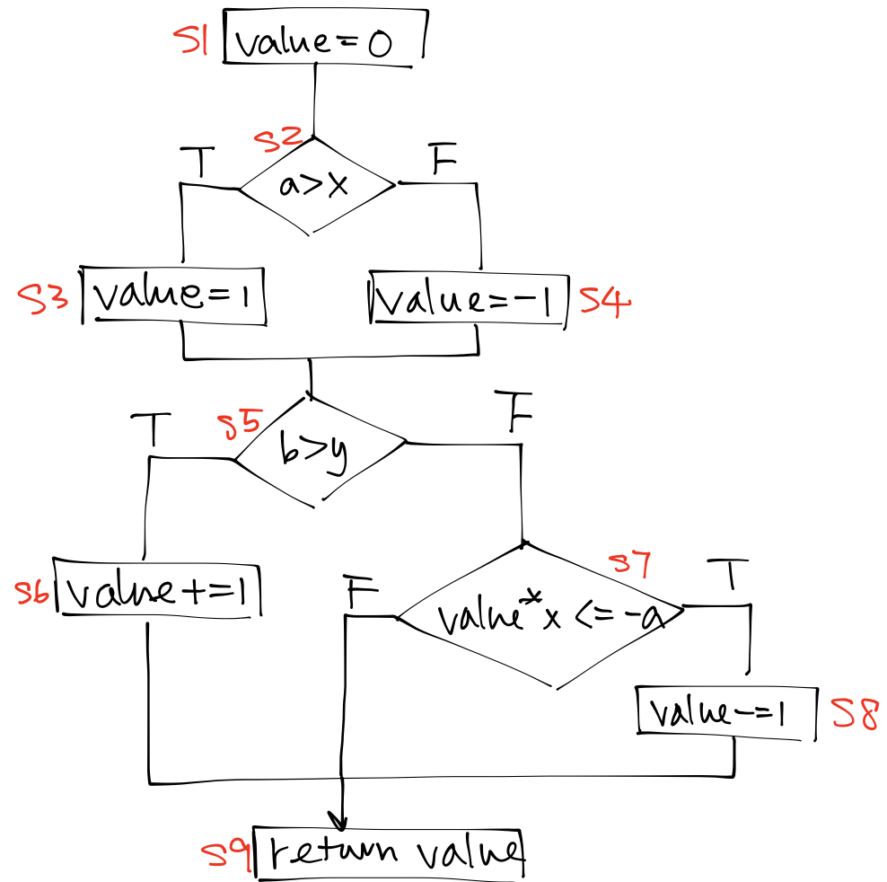

(b)
T1: a = 2 AND x = 1 AND b = 2 AND y = 1
T1 covers {S1, S2, S3, S5, S6, S9}
T2: a = 1 AND x = 2 AND b = 1 AND y = 2
T2 covers {S1, S2, S4, S5, S7, S8, S9}
@Test
public void testCoverage() {
assertEquals(2, coverage(2, 1, 2, 1));
assertEquals(-2, coverage(1, 2, 1, 2));
}

(c) Add T3
T1: a = 2 AND x = 1 AND b = 2 AND y = 1
T2: a = 1 AND x = 2 AND b = 1 AND y = 2
T3: a = 2 AND x = 1 AND b = 1 AND y = 2
@Test
public void testCoverage() {
assertEquals(2, coverage(2, 1, 2, 1));
assertEquals(-2, coverage(1, 2, 1, 2));
assertEquals(1, coverage(2, 1, 1, 2));
}

(d) Add T4, T5
T4: a = 0 AND x = -1 AND b = 1 AND y = 2
T5: a = 1 AND x = 2 AND b = 2 AND y = 1
@Test
public void testCoverage() {
assertEquals(2, coverage(2, 1, 2, 1)); //TT-
assertEquals(-2, coverage(1, 2, 1, 2)); //FFT
assertEquals(1, coverage(2, 1, 1, 2)); //TFF
assertEquals(0, coverage(0, -1, 1, 2)); //TFT
assertEquals(0, coverage(1, 2, 2, 1)); //FT-
}

(e) {F, F, F} or {S1, S2, S4, S5, S7, S9} is infeasible. This is because if we want S2 to be false, a has to be <= x, and then value is set to -1. In S7, if we want value*x = -x <= -a to be false, -x > -a, a > x. Contradiction.

Q3.
(a)
The outer loop has N operations, and the inner loops has 2^{3(i+2)} operations.
$$\sum_{i=0}^{N}{2^{3\left(i+2\right)}}=64*\left(8^{N}-1\right)/7$$

(b)
$$2^{\left(64*\left(8^{N}-1\right)/7\right)}$$

Q4.
(a) B
wp(len-5>=0 AND len-5<s.length AND s:=o.arr AND len:=o.s)
=== {o.s-5>=0 AND o.s-5<o.arr.length AND o.arr != null}
=== {o.s>=5 AND o.s<o.arr.length+5 && o.arr != null}

(b) A, D
wp(len-5>=0 AND len-5<s.length AND len:=len-index)
=== {len-index-5>= AND len-index-5<s.length}
=== {5+index<=len AND len<s.length+index+5}
stronger conditions:
{10+index<=len AND len<s.length+index+5}
{5+index<=len AND index+5>0}

(c) C
wp(len-5>=0 AND len-5<s.length)
==={len>=5 AND len<s.length+5}

(d) D
{o!=null AND len>= 0 AND wp(len-5>=0 AND len-5<s.length AND s:=o.arr AND len:=o.s)} OR {o==null AND len>=0 AND wp(len-5>=0 AND len-5<s.length AND len:=len-index)}
==={o!=null AND len>= 0 AND o.s>=5 AND o.s<o.arr.length+5 && o.arr != null} OR {o==null AND len>=0 AND 5+index<=len AND len<s.length+index+5}
==={o!=null AND len>= 0 AND o.s>=5 AND o.s<o.arr.length+5 && o.arr != null} OR {o==null AND len>=0 AND 0<=5+index AND len<s.length}
==={o!=null AND len>= 0 AND o.s>=5 AND o.s<o.arr.length+5 && o.arr != null} OR {o==null AND len>=0 AND index>-5}

Q5.
(a) C. The program returns [2,1] instead of [1,2]
(b) A

