**6.**

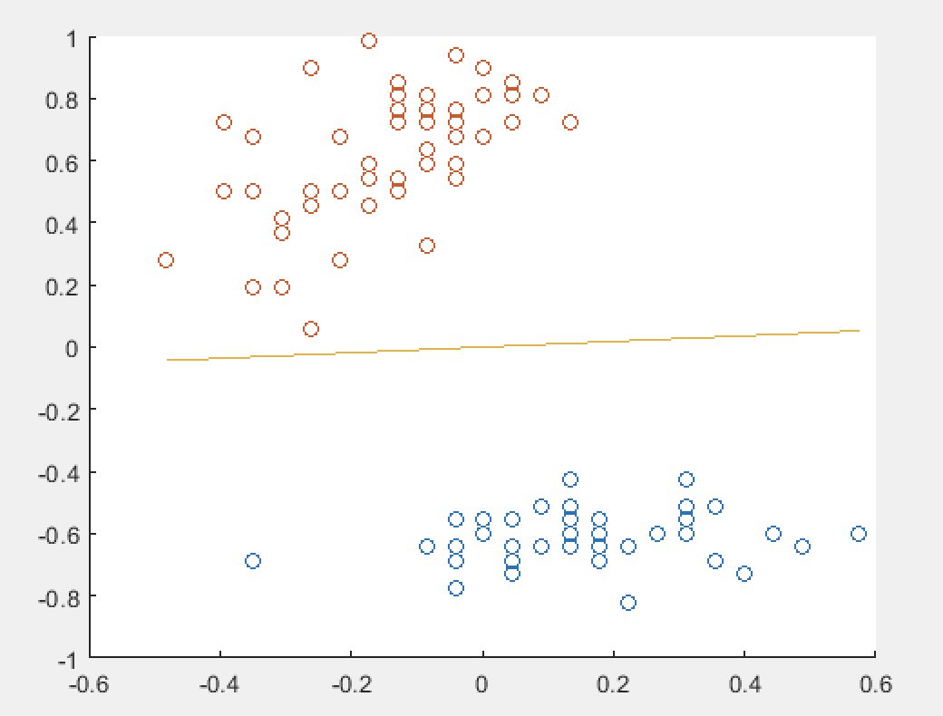

Data 1

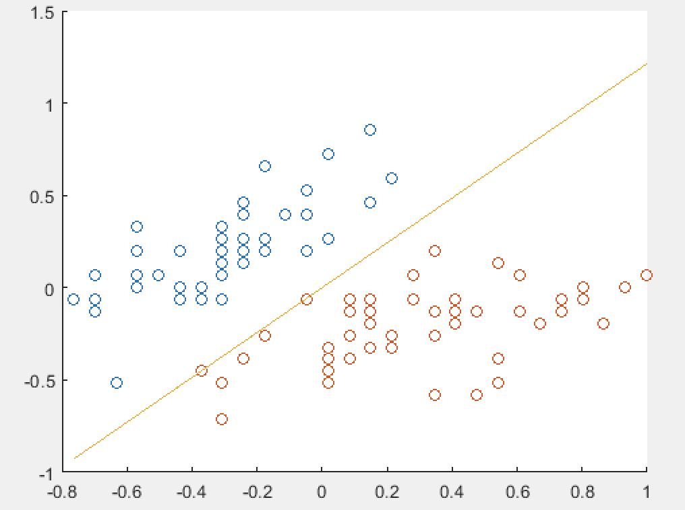

Data 2

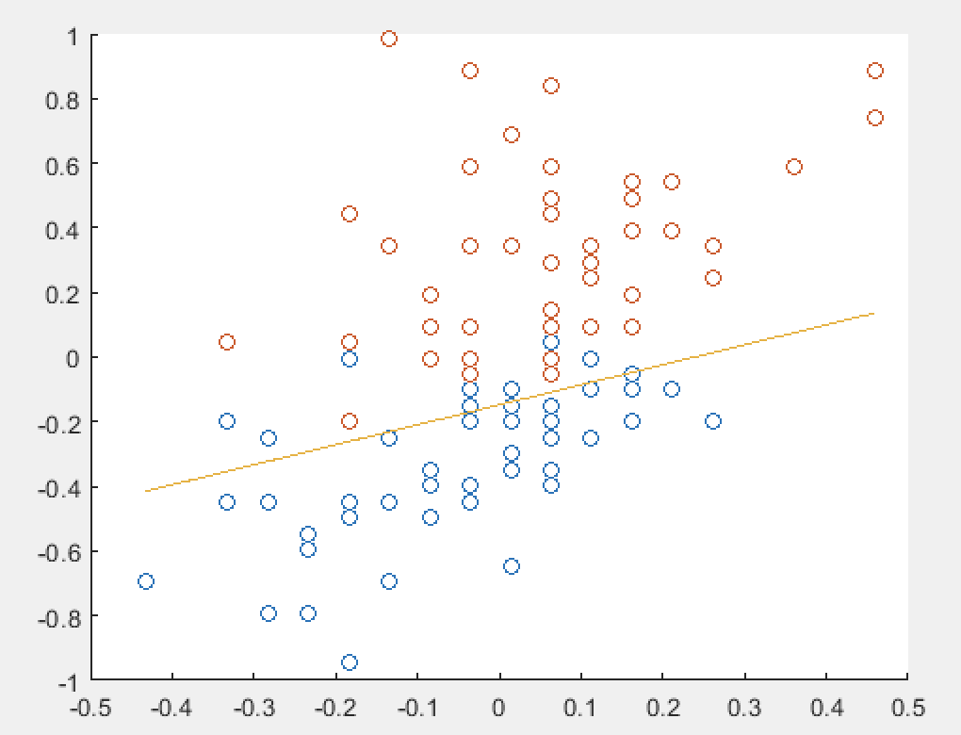

Data 3

(a) The first and the second data sets are linearly separable. The third data set is not.

(b)

**Data1:**

w1 = 0.1320

w2 = -1.4522

b = 0

#updates = 2

The perceptron algorithm converges after two updates. Due to the small number of updates, we can conclude that this learning problem is easy.

**Data2:**

w1 = -1.1092

w2 = 0.9134

b = 0

#updates = 4

The perceptron algorithm converges after four updates. Due to the small number of updates, we can conclude that this learning problem is easy but still harder than the first data set. The plot corresponds to this conclusion because the distance between the two classes of data is generally closer in data set 2 than in data set 1.

**Data3:**

w1 = 4.1929

w2 = -6.7798

b = -1

#updates = 4953

The perceptron algorithm does not converge in this data set. This problem cannot be learned by the given perceptron algorithm because it is not linearly separable.

(c)

$γ_{w,b}$:

data1: 0.0841

data2: 0.00026489

$\frac{1}{γ_{w,b}}$:

data1: 141.39

data2: $1.425*{10}^{7}$

The calculated gamma values for first two data sets fall into the theoretical upper bounds. The third data set is not linearly separable.