HW#4

**6(a)**

The data is linearly separable.

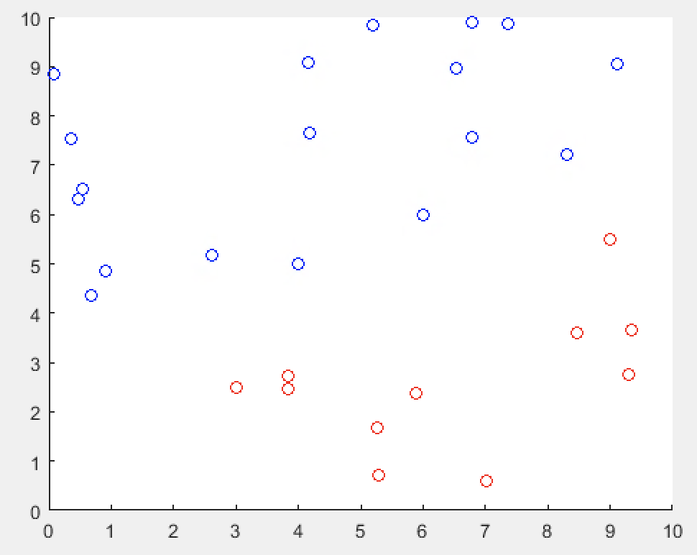

**6(b)**

b = -2.

w = <-0.5, 1>

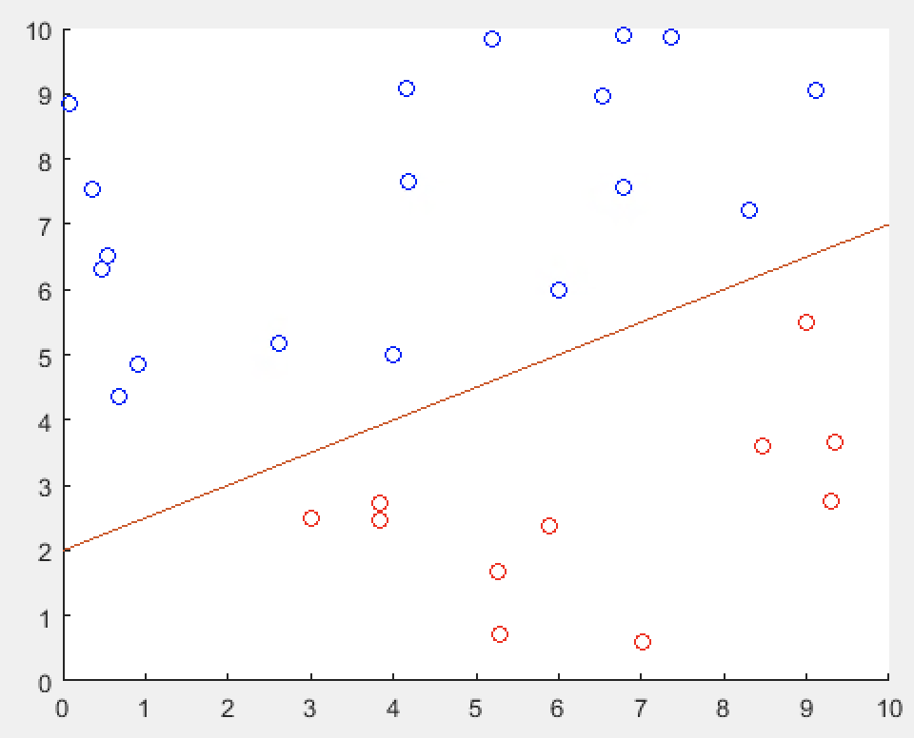

**6(c)**



α = 0.3347 => 3, 2.5, -1

α = 0.2903 => 9, 5.5, -1

α = 0.3165 => 4, 5, 1

α = 0.3085 => 6, 6, 1

x1 = table2array(Data(:,1));

x2 = table2array(Data(:,2));

y = table2array(Data(:,3));

x = table2array(Data(:,1:2));

hold on;

for i = 1:size(y)

if (y(i) == 1)

scatter(x1(i), x2(i), 'b');

else

scatter(x1(i), x2(i), 'r');

end

end

cvx_setup

cvx_begin

variable w(2);

variable b;

minimize( norm(w) ) subject to y.'.*(w.'*x.'+b) >= 1;

cvx_end

a = 0 : 0.01 : 10;

y = 0.5*a + 2;

plot(a, y);

hold off;

cvx_begin

variable a(29);

maximize( sum(a)- 0.5*sum(((x*x.') *(a.*y)).'*(a.*y))));

subject to

a >= 0;

sum (a .* y) == 0;

cvx_end

w_vec = zeros(1,2);

for j = 1 : 29

w_vec(1) = w_vec(1) + x1(j)*y(j)*a(j);

w_vec(2) = w_vec(2) + x2(j)*y(j)*a(j);

end