7(a).

A1 = 3.8469e6;

B1 = 325.6907;

C1 = 3.8469e6;

Ts = 1e-5;

t = 0:Ts:0.1;

num1 = [A1]

den1 = [1 B1 C1];

sys1 = tf(num1,den1);

h1 = impulse(sys1,t);

figure;

plot(t,h1);

xlabel('time');

ylabel('Amplitude');

title('Impulse response');

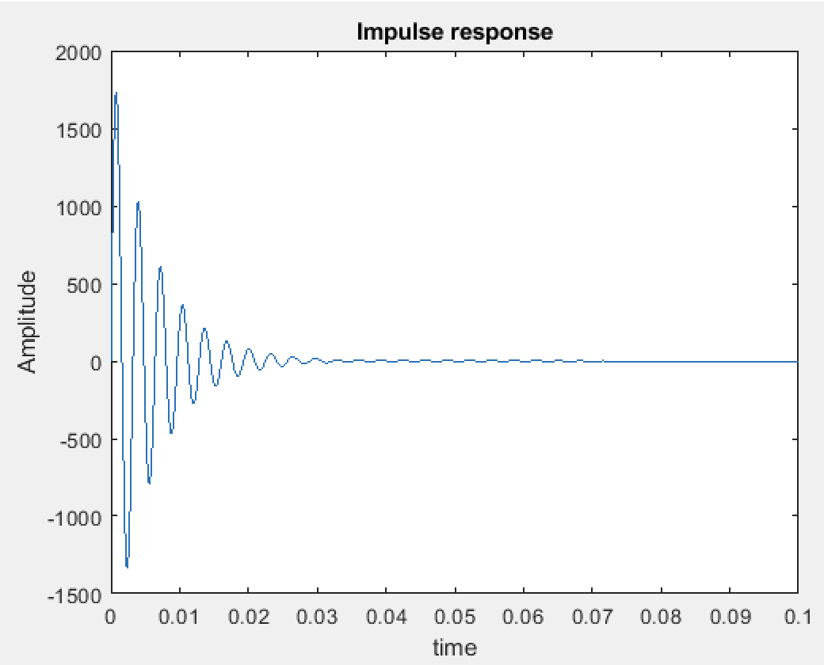

7(b).

f = 1/4e-3;

x1 = 0.5*square(2*pi*f*t,12.5)+0.5;

y1 = conv(x1,h1)*Ts;

figure;

t_axis = 0:Ts:2*max(t);

plot(t_axis,y1);

xlabel('time');

ylabel('Amplitude');

title('convolution y(t)');

axis([0.02 0.06 -1 1])

