**5(a).**

x1 = table2array(Data(:,1));

x2 = table2array(Data(:,2));

y = table2array(Data(:,3));

x = table2array(Data(:,1:2));

hold on;

for i = 1:size(y)

if (y(i) == 1)

scatter(x1(i), x2(i), 'b');

else

scatter(x1(i), x2(i), 'r');

end

end

%blue: Y = 1

%red: Y = 0

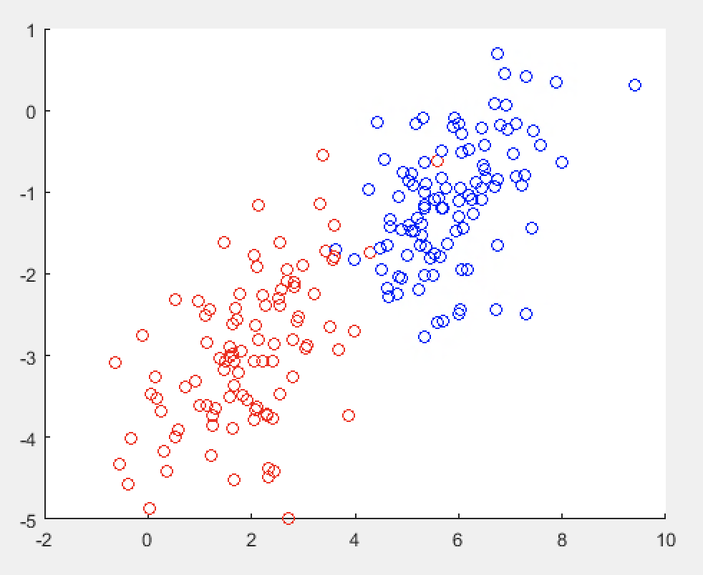

This plot shows that the data set is not linearly separable.

**5(b).**

p0 = 1 - sum(y)/200;

u0 = zeros(1, 2);

u1 = zeros(1, 2);

for i = 1 : 200

if (y(i) == 1)

u1(1) = u1(1) + x1(i);

u1(2) = u1(2) + x2(i);

else

u0(1) = u0(1) + x1(i);

u0(2) = u0(2) + x2(i);

end

end

u1 = u1/sum(y);

u0 = u0/(200-sum(y));

sum1 = zeros(2, 2);

sum0 = zeros(2, 2);

for i = 1:200

if (y(i) == 1)

sum1 = sum1 + transpose(x(i,:) - u1) * (x(i,:) - u1);

else

sum0 = sum0 + transpose(x(i,:) - u0) * (x(i,:) - u0);

end

end

E = (sum1 + sum0)/200;

P(Y = 0) = 0.4850

u0 = [1.9348, -2.9750]

u1 = [5.8565, -1.1175]

E = [1.1187, 0.4520; 0.4520, 0.7137]

**5(c).**

% from 2(b)

w = inv(E) * (transpose(u0-u1));

b = log(p0/(1-p0)) + 0.5*(u1*inv(E)*transpose(u1) - u0*inv(E)*transpose(u0));

x_axis = linspace(-2, 10, 1201);

y_axis = -(w(1)*x_axis+b)/w(2);

plot(x_axis, y_axis);

axis([-2 10 -5 1]);

w = [-3.2979, -0.5138]

b = 11.7360

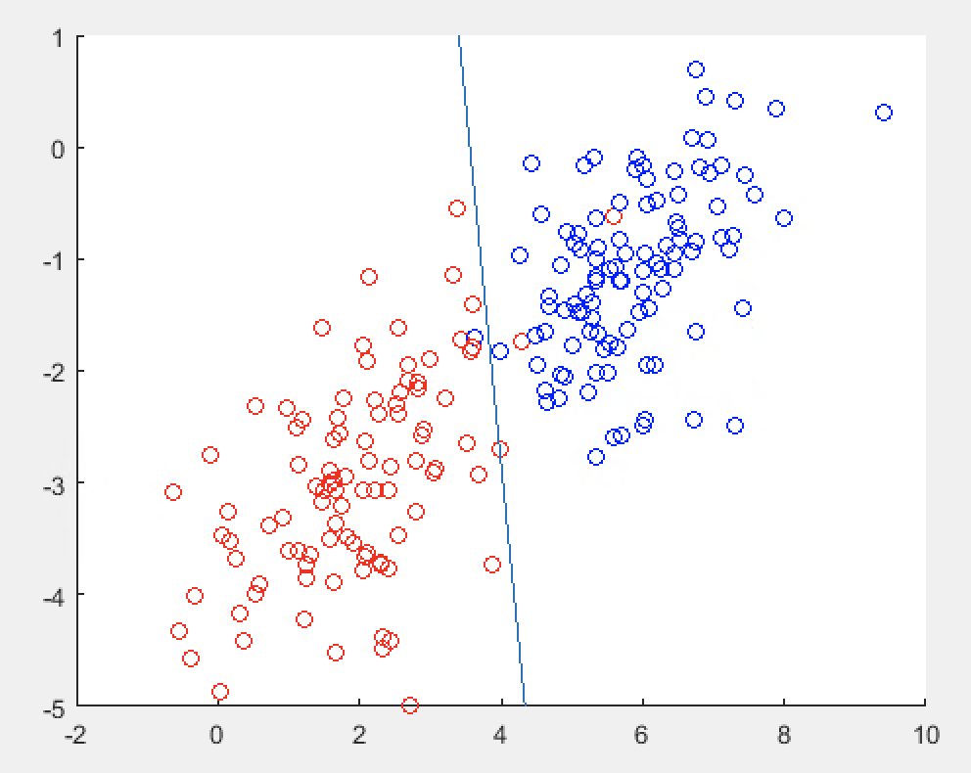

**5(d).**

[X1, X2] = meshgrid(-2:0.1:10, -8:0.1:2);

P0 = zeros(121, 121);

P1 = zeros(121, 121);

for i = 1:121

for j = 1:121

P0(i,j) = 1/(2*pi*det(E)^(0.5))* exp(-0.5*transpose([X1(i,j)-u0(1); X2(i,j)-u0(2)])*inv(E)*[X1(i,j)-u0(1); X2(i,j)-u0(2)]);

P1(i,j) = 1/(2*pi*det(E)^(0.5))* exp(-0.5*transpose([X1(i,j)-u1(1); X2(i,j)-u1(2)])*inv(E)*[X1(i,j)-u1(1); X2(i,j)-u1(2)]);

end

end

contour(X1,X2, P0, 'LevelList', logspace(-3,-1,7));

contour(X1,X2, P1, 'LevelList', logspace(-3,-1,7));

axis([-2 10 -8 2]);

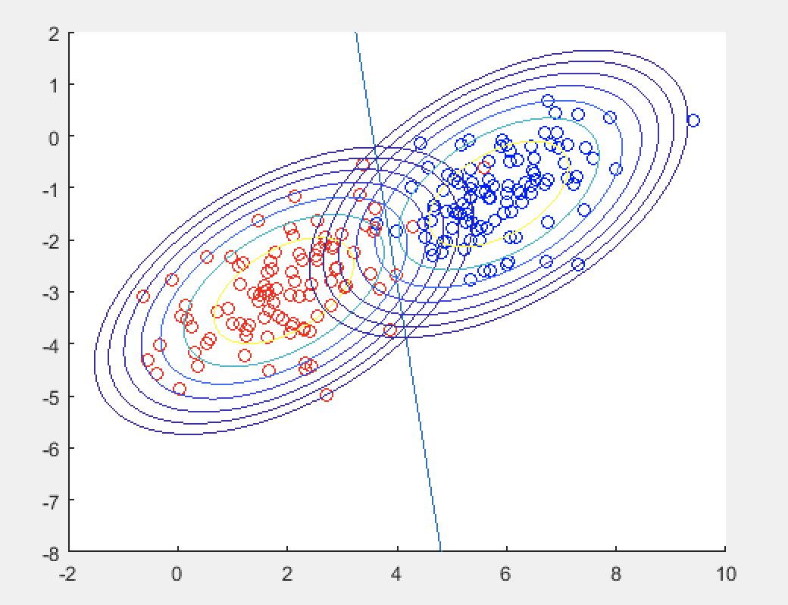

The decision boundary passes through points where the two distribution have equal probabilities because when the log of the Quotient of two probabilities equal to 0, we can find the decision boundary. This indicates that the two probabilities are the same.