Sprint 3

**Goals**

* Find angel investor

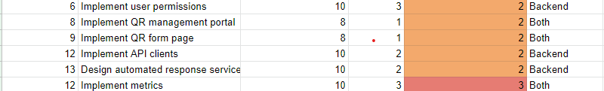

**Backlog**

*General:*

* Add/verify addition of DNS TXT record to hermodapp.com domain (to use domain name for ProtonMail account -- necessary to finish Postmark setup)
* Switch deployment - DO can’t handle large builds and crashes. Need to find alternate provider [rw].
* Make an updated API route doc

*Backend:*

* Optimization/improvements:
  + Streto cache for JWT lookups [rw]
  + Ordering for form fields [jp]
  + Forgotten password: [jp]
    - Hashing forgotten password ID
    - Limit valid time interval to 24hr
  + Add tracing to functions and standardize trace names [rw]
* New Features:
  + E-mail confirmation [rw]
  + Tests (jesus christ jonathan) [both?]
  + Responses websocket [rw]
  + QR code forms: [jp]
    - Set QR code form
    - Unset QR code form
    - Modify QR code form
  + QR code responses:
    - Set response type
    - Modify response type
    - Set automated payload
    - Unset automated payload
    - Modify automated payload
  + Metrics?
    - How often a QR code is scanned
    - Basic metrics on form responses

*Frontend:*

* Optimization/improvements
  + Connect forms to backend
    - Creating forms
    - Submitting forms
    - Viewing forms
* New Features:
  + Forgot password
  + Email Confirmation
  + Edit forms
  + QR management
    - Set/Unset form
    - Set/Unset automated responses