System architect 3NF violation, false alarm ?

1) ER-dijagram

Na ovaj ER dijagram se SA žali da 3NF nije zadovoljena:
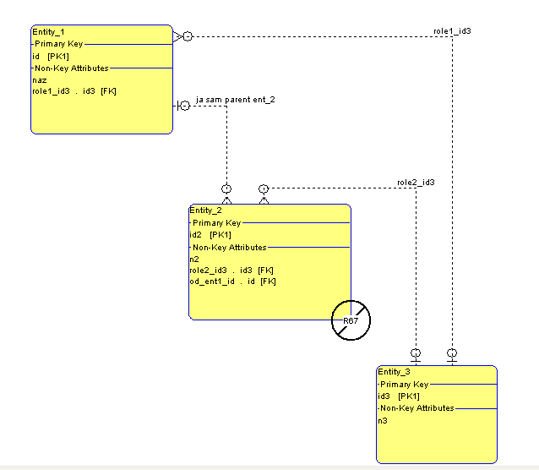

2) 3NF violation

Ovo je poruka o grešci:

Second and Third Normal Forms Check
Enter project name
test_3
Name Type
Normalize23
Entity_2 Entity
R67 - Attribute "role2_id3" violates 3NF.
Functionally dependent on "od_ent1_id"
Data matches attribute "role1_id3" in "Entity_1"
as of 2.7.2012

3) Fizički model

Na osnovu ER dijagrama generisani (SQL-92) fizički model:

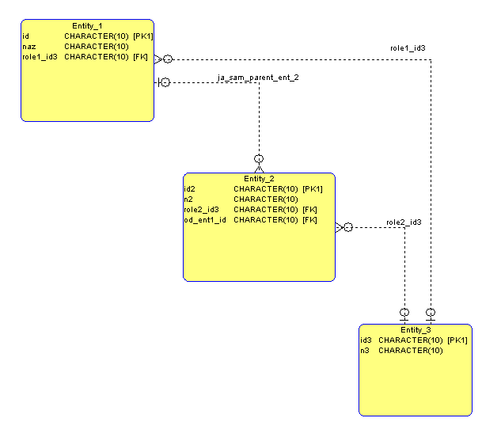

4) PostgreSQL DDL

Na osnovu fizičkog modela kreiran SQL-DDL:

CREATE TABLE Entity_3(
id3 CHARACTER(10) NOT NULL,
n3 CHARACTER(10) NOT NULL);

CREATE TABLE Entity_2(
id2 CHARACTER(10) NOT NULL,
n2 CHARACTER(10) NOT NULL,
role2_id3 CHARACTER(10),
od_ent1_id CHARACTER(10));

﻿
CREATE TABLE Entity_1(
id CHARACTER(10) NOT NULL,
naz CHARACTER(10) NOT NULL,
role1_id3 CHARACTER(10));

ALTER TABLE Entity_1 ADD
CONSTRAINT Entity_1_PK PRIMARY KEY (id);

ALTER TABLE Entity_2 ADD
CONSTRAINT Entity_2_PK PRIMARY KEY (id2);

ALTER TABLE Entity_3 ADD
CONSTRAINT Entity_3_PK PRIMARY KEY (id3);

ALTER TABLE Entity_1 ADD
CONSTRAINT role1_id3 FOREIGN KEY (role1_id3)
REFERENCES Entity_3 (id3)
ON UPDATE CASCADE;

ALTER TABLE Entity_2 ADD
CONSTRAINT role2_id3 FOREIGN KEY (role2_id3)
REFERENCES Entity_3 (id3)
ON UPDATE CASCADE;

ALTER TABLE Entity_2 ADD
CONSTRAINT ja_sam_parent_ent_2 FOREIGN KEY (od_ent1_id)
REFERENCES Entity_1 (id)
ON UPDATE CASCADE;

insert into Entity_3(id3, n3) values('1', 'n3-1');
insert into Entity_3(id3, n3) values('2', 'n3-2');
insert into Entity_3(id3, n3) values('3', 'n3-3');

insert into Entity_1(id, naz, role1_id3) values('100', 'n1-1', '2');
insert into Entity_1(id, naz, role1_id3) values('101', 'n1-2', '1');
insert into Entity_1(id, naz, role1_id3) values('102', 'n1-3', '3');

insert into Entity_2(id2, n2, od_ent1_id, role2_id3) values('200', 'n2-1', '102', '1');
insert into Entity_2(id2, n2, od_ent1_id, role2_id3) values('201', 'n2-2', '102', '2');
insert into Entity_2(id2, n2, od_ent1_id, role2_id3) values('202', 'n2-3', '101', '1');

5) Testni select

select Entity_2.id2, Entity_2.n2, Entity_1.naz AS E1_naz,
Entity_2.role2_id3, e3_role2.n3,
Entity_2.od_ent1_id, Entity_1.role1_id3, e3_role1.n3
FROM Entity_2
LEFT JOIN Entity_1 ON Entity_2.od_ent1_id = Entity_1.id
LEFT JOIN Entity_3 AS e3_role2 ON e3_role2.id3 = Entity_2.role2_id3
LEFT JOIN Entity_3 AS e3_role1 ON e3_role1.id3 = Entity_1.role1_id3;

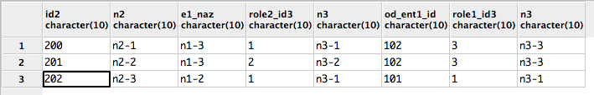
Grafički prikaz rezultata select izraza:

6) Zaključak

U ER-modelu nema redundantnosti podataka, niti međuzavisnosti role2_id3 i role1_id3.

To znači 3NF u gornjoj ER shemi nije narušena.

