Ansible windows

/mnt/c/dev/openjdk-infrastructure/ansible$

ansible-playbook -i hosts --tags clang_32bit playbooks/AdoptOpenJDK
_Windows_Playbook/main.yml

Release version – MSVC merge modules

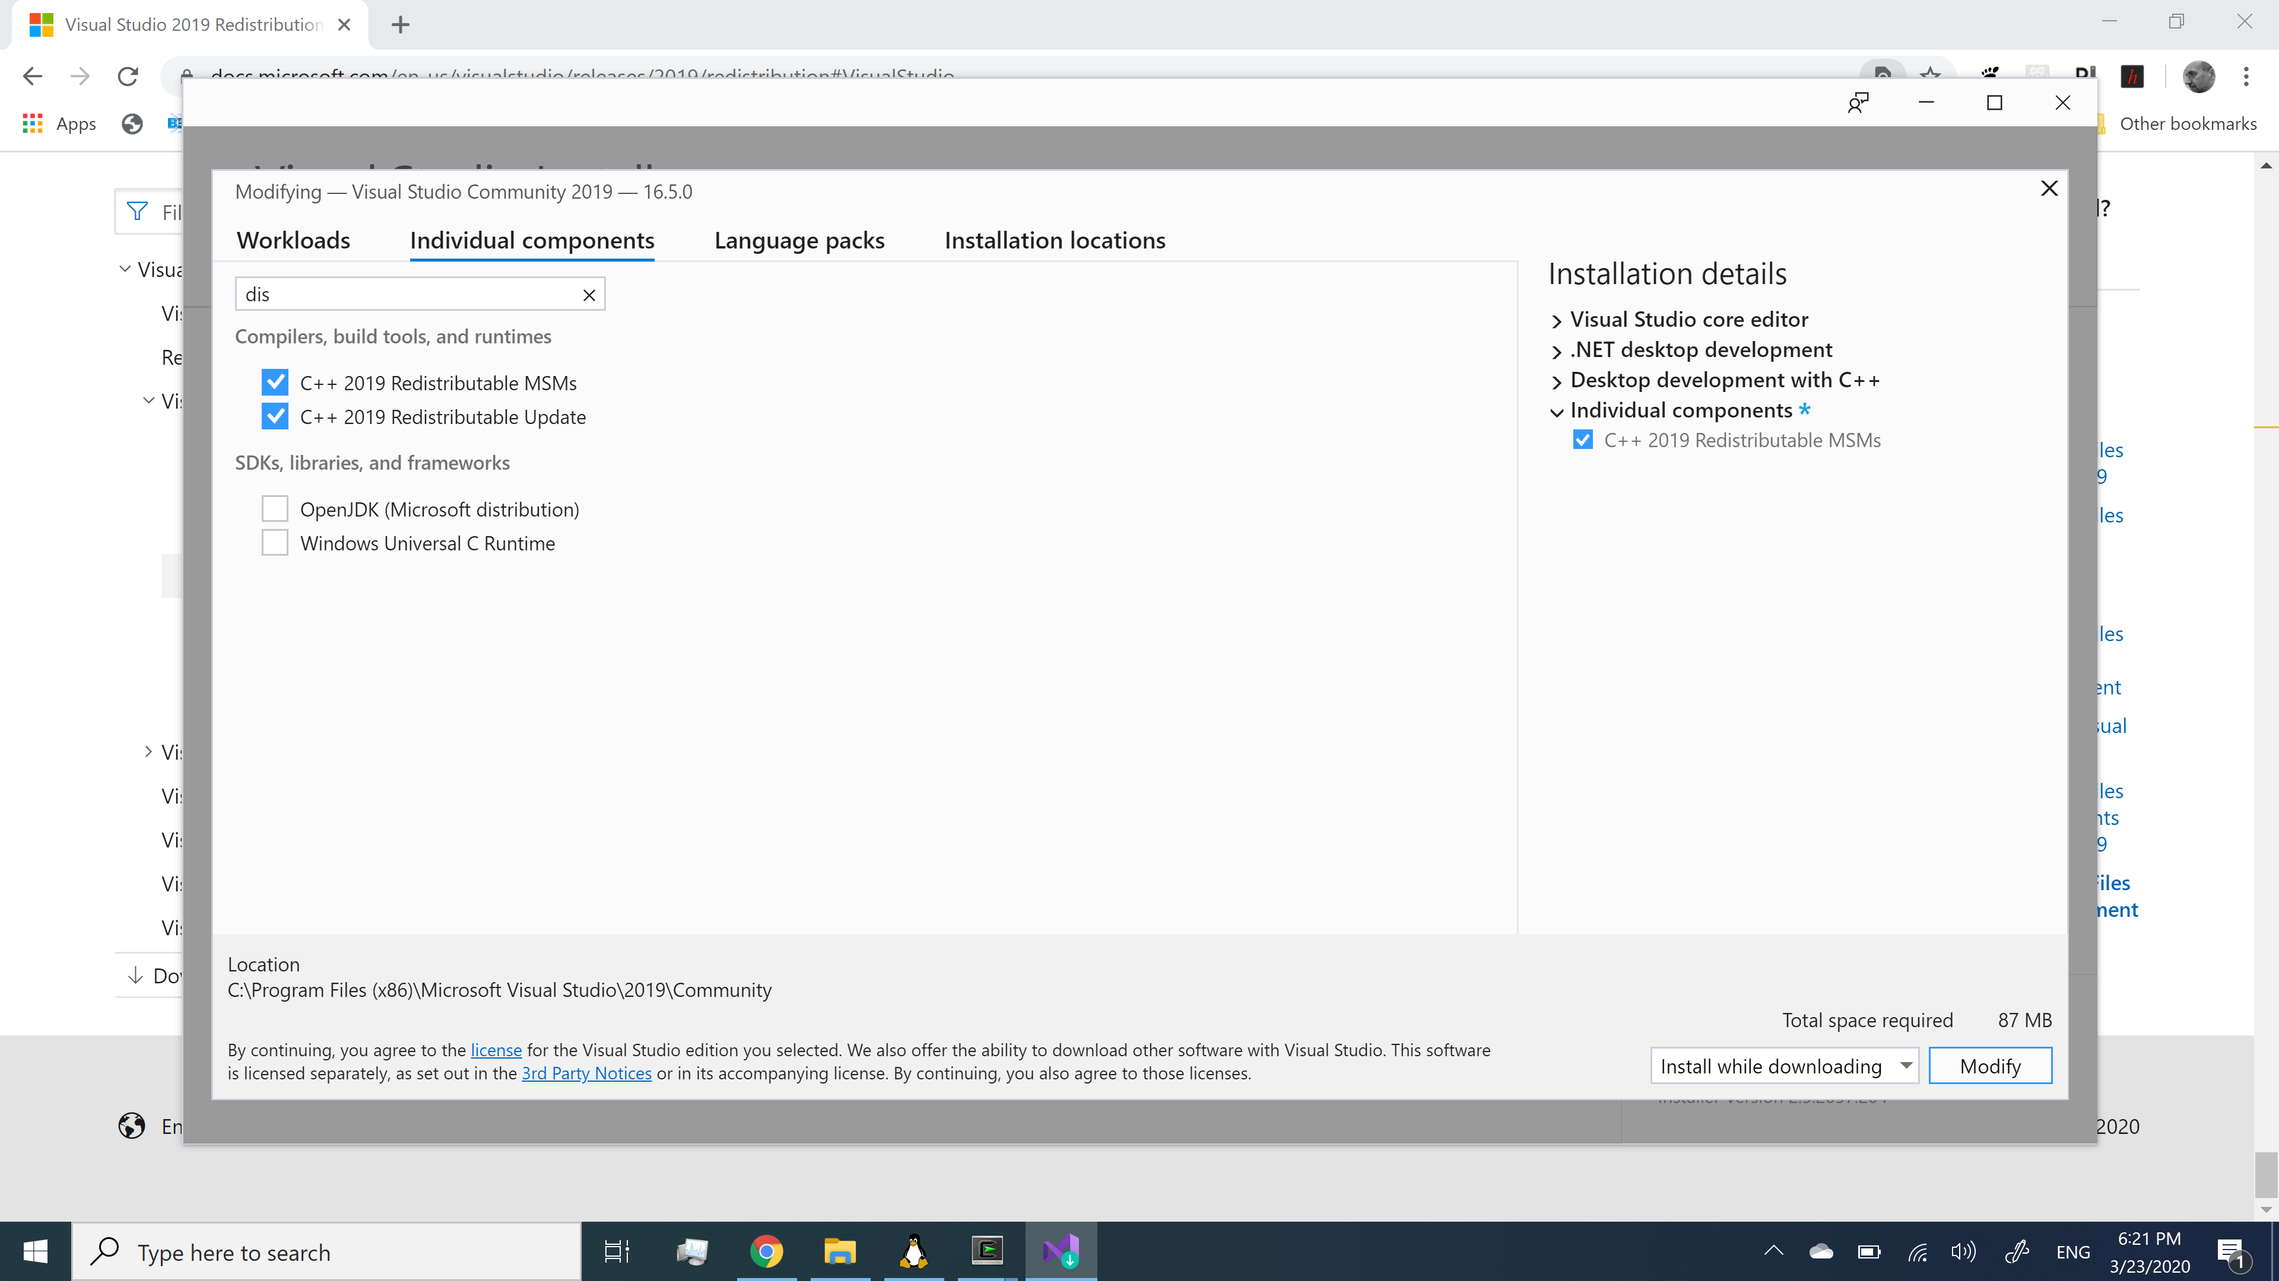

Configure:

checking for MSVC merge modules directory:

without java

./autogen.sh --with-lang="bs" \
--with-locales="bs" \
--with-vendor="hernad" \
--with-theme="colibre_svg" \
--with-visual-studio=2019 \
--without-doxygen \
--without-java \
--with-product-name="LO_Ziher"\
--with-package-version='7.0.0.10'\
-–enable-release-build

with java

./autogen.sh --with-lang="bs" --with-locales="bs" --with-vendor="hernad" --with-theme="colibre_svg" --with-visual-stu2019 --without-doxygen --with-jdk-home=c:/AdoptOpenJDK/jdk-14.0.0.36-hotspot --with-product-name="LO_Ziher" --with-package-version='7.0.0.10' –-enable-release-build

make build-nocheck

./g -f clone
Submodule 'translations' (https://gerrit.libreoffice.org/translations) registered for path 'translations'
Cloning into '/cygdrive/c/dev/libreoffice-core-meson/translations'...

git config windows

C:\dev\libreoffice-core-meson>git config --global --list
user.email=hernad@bring.out.ba
user.name=Ernad Husremovic
core.autocrlf=false

Panama

mklink /D "c:\openjdk\LLVM" "c:\Program Files (x86)\LLVM"

panama-foreign$

bash configure MAKE=/usr/bin/make -–with-target-bits=32 \
--with-libclang=/cygdrive/c/openjdk/LLVM

/usr/bin/make

