Watermarking for Large Language Models and Structured Time-Series Data
Final Group Project Report
Course | Artificial Intelligence
Report Format | Machine-learning paper style
Team Members | [replace with all team members' names]
Due Date | 30 June 2026

Abstract
This project studies watermarking as a practical mechanism for tracing machine-generated content. We reproduce two representative LLM text watermarking algorithms, KGW green-list watermarking and an unbiased probability-reweighting watermark, on Qwen2.5-0.5B-Instruct. We evaluate detectability, generation quality, runtime overhead, false positives on human text, parameter sensitivity, and robustness under deletion and synonym-substitution attacks. We further design a structured residual watermark for tabular and time-series foundation-model outputs, embedding a 12-bit payload into small numerical residuals while preserving the marginal distribution and time-series structure. Experiments show that KGW provides the strongest detection signal and robustness, while the unbiased method preserves text quality more closely. The structured residual watermark achieves perfect bit recovery under additive noise, row deletion, and quantization, but is more vulnerable to smoothing.

1. Introduction
Large language models can generate fluent text at low cost, which creates both useful applications and attribution risks. Watermarking addresses this problem by inserting a hidden statistical signal during generation and detecting the signal later without changing the visible task interface. A good watermark should be detectable, hard to remove, computationally lightweight, and minimally harmful to output quality.
Our project has two goals. First, we reproduce and evaluate two text watermarking methods for LLM generation: KGW, which biases tokens from a pseudorandom green list, and an unbiased probability-reweighting method inspired by distribution-preserving watermarking. Second, we extend the watermarking idea to structured data by embedding payload bits into residuals of synthetic time-series outputs. This extension is useful because modern foundation models increasingly generate tables, trajectories, forecasts, and other numerical sequences, not only text.

2. Problem Definition
For text generation, the watermarking problem is defined over a language model distribution p(x_t | x_<t). During decoding, a secret key partitions the vocabulary into green and red tokens based on context. A watermarking algorithm modifies the decoding distribution so that green tokens are sampled more often than expected under an unwatermarked model. Given a generated sequence, the detector computes a z-score measuring green-token enrichment relative to a binomial null distribution. A sequence is classified as watermarked when the z-score exceeds a threshold.
For structured time-series data, the problem is to embed an identity payload into numerical outputs while preserving statistical utility. The detector should recover the payload after realistic transformations such as noise injection, row deletion, quantization, and smoothing. The main constraints are imperceptibility, payload capacity, and robustness.

3. Algorithm Design

3.1 KGW Green-List Text Watermark
KGW constructs a pseudorandom green list using a stable hash of recent context tokens and a secret key. During generation, green-list logits receive an additive bias delta. The detector repeats the same green-list construction and computes:
z = (G - gamma n) / sqrt(n gamma (1 - gamma)), where G is the number of generated green tokens, n is the number of generated tokens, and gamma is the expected green-list fraction.

3.2 Unbiased Probability-Reweighting Watermark
The unbiased method uses the same secret-keyed green-list partition but modifies token probabilities by multiplying green-token probabilities by alpha and renormalizing. This generally produces a weaker detection signal than direct logit bias, but it is designed to reduce quality degradation because the transformation operates directly on the probability mass.

3.3 Structured Residual Watermark
For tabular and time-series outputs, we embed a 12-bit payload into small residual perturbations rather than token choices. Each entity-time record receives a deterministic assignment from a secret hash. Bit value 1 and bit value 0 correspond to opposite signed residual shifts. Detection aggregates residual signs over all records assigned to each bit and computes a bit-level z-score. The perturbation magnitude is only about 3% of the data standard deviation, so the watermark remains small relative to natural variation.

4. Experiments
The text experiments use Qwen2.5-0.5B-Instruct with 100 Chinese prompts, maximum generation length of 80 new tokens, temperature 0.9, and top-p 0.95. Human-written Chinese texts are used as negative samples for false-positive evaluation. We compare baseline generation, KGW, and unbiased watermarking across detection, perplexity, latency, ROC/AUC, and attack robustness.
The structured-data experiment uses 48 entities and 150 time steps, for 7200 total rows. The payload is 12 bits. We evaluate distribution preservation with summary statistics, correlations, and a Kolmogorov-Smirnov test, then test robustness under additive noise, random row dropping, smoothing, and quantization.

5. Evaluation

5.1 Text Watermark Reproduction
Method | Samples | Mean z-score | Mean PPL | Mean seconds | Mean tokens
Baseline | 100 | 0.13 | 9.24 | 1.73 | 80
KGW | 100 | 5.22 | 12.18 | 1.74 | 80
Unbiased | 100 | 2.75 | 9.91 | 1.77 | 80
Table 1. Assignment 1 reproduction results on 100 prompts.
KGW produces the strongest detection signal: its mean z-score is 5.22, clearly above the common threshold z=2. The unbiased method also produces a detectable signal with mean z=2.75, but its signal is weaker. The quality tradeoff is visible in perplexity: KGW increases mean PPL from 9.24 to 12.18, while the unbiased method stays closer to baseline at 9.91. Runtime overhead is small for both methods, with per-sample latency remaining near baseline.
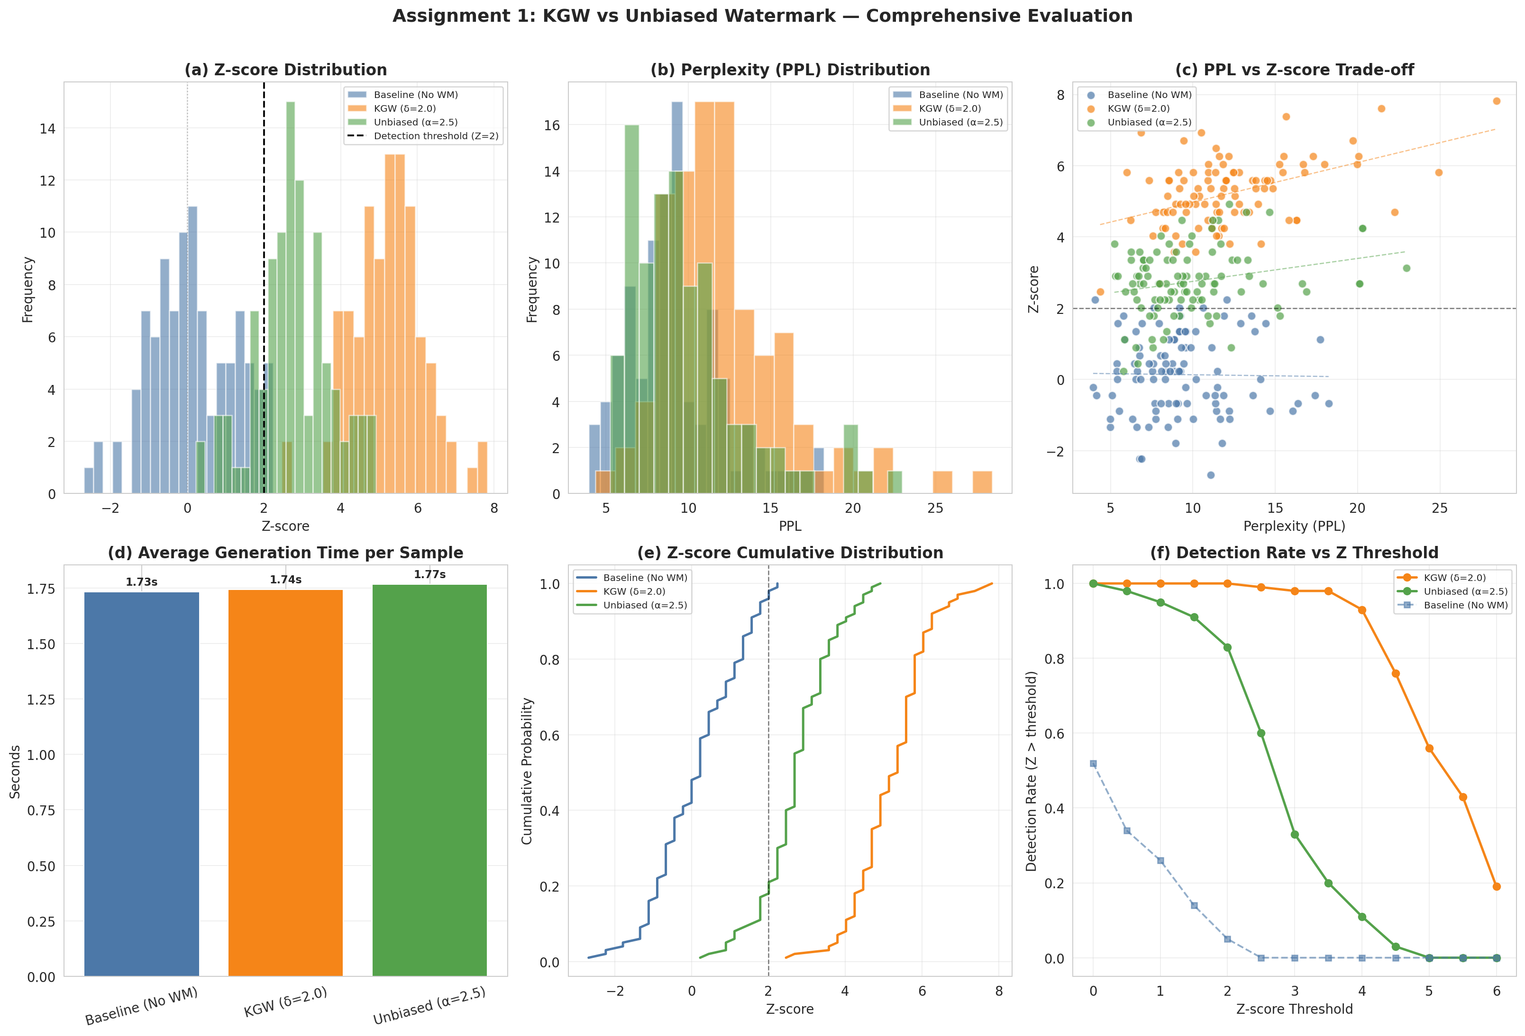
Figure 1. Detection, quality, and runtime comparison for baseline, KGW, and unbiased watermarking.

5.2 Detection Metrics and Parameter Sensitivity
Configuration | Threshold | Accuracy | Precision | Recall | F1 | AUC
KGW delta=1.5 | 2.0 | 0.985 | 0.990 | 0.980 | 0.985 | 0.999
KGW delta=2.0 | 2.0 | 0.995 | 0.990 | 1.000 | 0.995 | 1.000
KGW delta=2.5 | 2.5 | 0.995 | 1.000 | 0.990 | 0.995 | 1.000
KGW delta=3.0 | 3.0 | 1.000 | 1.000 | 1.000 | 1.000 | 1.000
Unbiased alpha=3.0 | 2.0 | 0.905 | 0.955 | 0.850 | 0.899 | 0.970
Unbiased alpha=3.5 | 2.0 | 0.970 | 0.961 | 0.980 | 0.970 | 0.994
Table 2. Representative detection results from the systematic evaluation.
Increasing delta or alpha monotonically strengthens the watermark signal. KGW reaches near-perfect or perfect AUC when delta is at least 1.5, and perfect classification appears for strong settings such as delta=3.0. The unbiased method requires a larger alpha to reach comparable recall. At z=2, false positives on human texts remain low; stronger thresholds reduce false positives further but can reduce recall, especially for weaker watermark parameters.
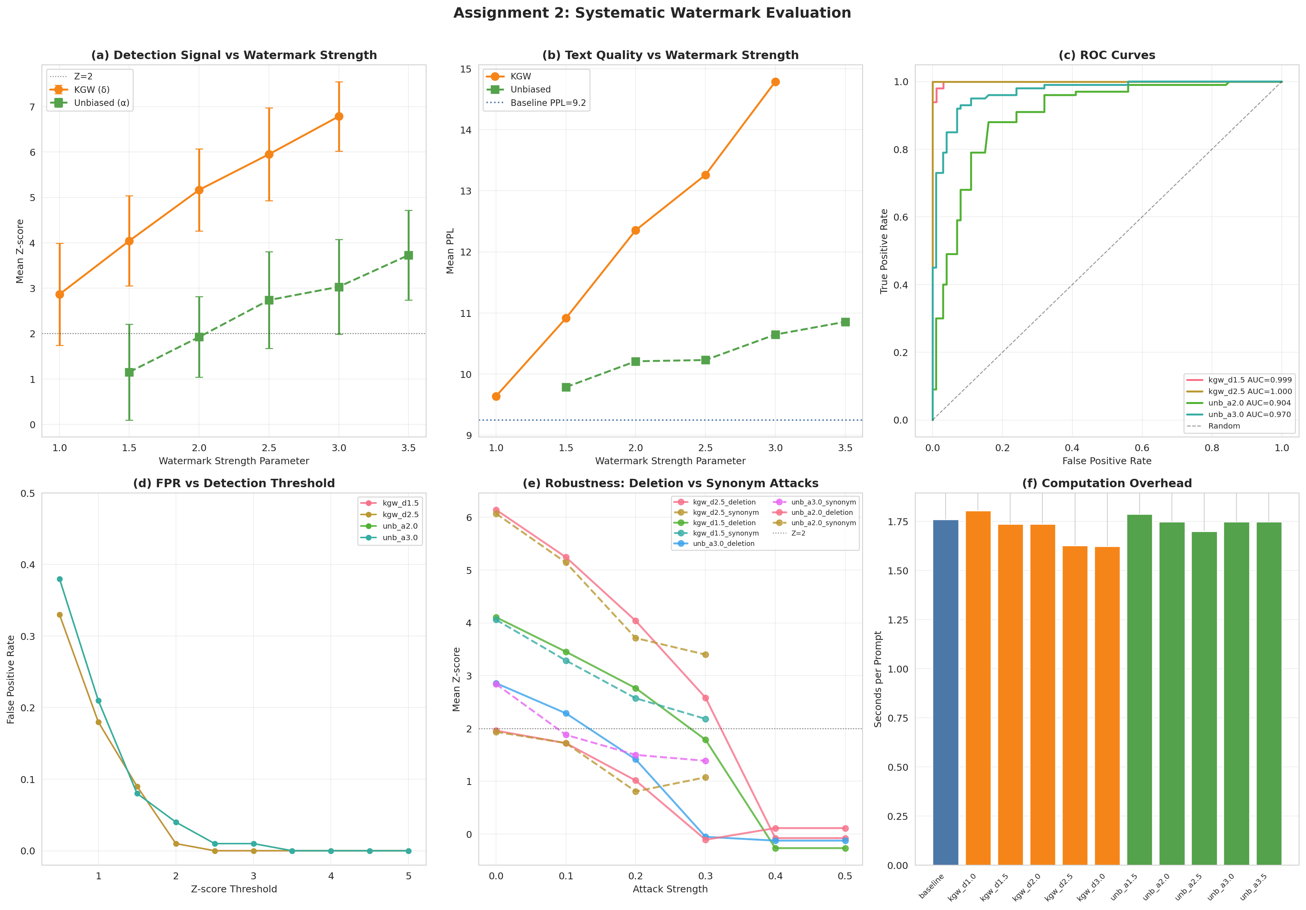
Figure 2. Systematic detection, ROC, quality, runtime, and robustness analysis.

5.3 Robustness
Deletion and synonym-substitution attacks reduce z-scores because they remove or alter the token-level evidence used by the detector. KGW is more robust overall because its additive logit bias creates a stronger initial signal. In the stored attack traces, KGW with delta=2.5 remains strongly detectable under moderate synonym replacement and light deletion, while weaker KGW and unbiased configurations lose evidence faster. This confirms a practical tradeoff: stronger watermarks survive attacks better but can increase distributional distortion.

5.4 Structured Time-Series Watermark
Metric | Original | Watermarked | Absolute change | Relative change
Mean | 16.5992 | 16.6545 | 0.0553 | 0.333%
Std | 3.6842 | 3.6867 | 0.0026 | 0.069%
Pearson corr. | 1.0000 | 0.9996 | 0.0004 | 0.043%
Spearman corr. | 1.0000 | 0.9996 | 0.0004 | 0.041%
KS p-value | 1.0000 | 0.9874 | 0.0075 | 0.000%
Table 3. Quality preservation for structured residual watermarking.
The structured residual watermark preserves data utility well. Mean and quantile shifts are below one percent, Pearson and Spearman correlations remain above 0.9995, and the KS p-value remains high at 0.9874. All 12 payload bits are recovered in the clean setting, with very large absolute bit-level z-scores between 48.88 and 55.06.
Attack | Max tested strength | Bit accuracy | Mean |z| | Main observation
Additive noise | 0.18 | 1.000 | 4.39 | Payload still fully recovered.
Row drop | 0.60 | 1.000 | 33.23 | Aggregation over many rows is highly robust.
Quantization | integer rounding | 1.000 | 9.60 | Signal survives coarse rounding.
Smoothing | window 5-15 | 0.750 | 5.04-7.94 | Main weakness: local averaging removes residual signs.
Table 4. Structured watermark robustness.
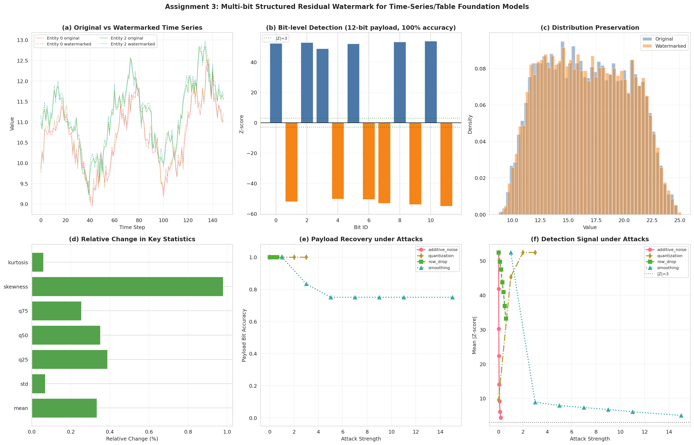
Figure 3. Structured time-series watermark detection, quality, and attack robustness.

6. Discussion
The experiments show that no single watermark setting is optimal for every objective. KGW is preferable when the priority is confident detection and attack robustness. The unbiased method is preferable when preserving generation quality is more important and moderate detection confidence is acceptable. For structured data, residual aggregation can produce extremely strong bit-level evidence while keeping visible statistical changes small, but smoothing attacks are a clear limitation because they specifically suppress high-frequency residual patterns.
A limitation of this project is scale. The text experiments use a small open-source model and 100 prompts, so the results should be viewed as a controlled reproduction rather than a full deployment study. Future work should evaluate larger models, longer generations, paraphrase attacks, multilingual prompts, and adaptive attackers who know the detector family but not the secret key.

7. Conclusion
We completed a full watermarking study in the required ML-paper structure. KGW achieved the strongest text watermark detection, with mean z=5.22 in the reproduction experiment and AUC up to 1.000 in systematic evaluation. The unbiased method reduced quality loss, with mean PPL close to baseline, but required stronger parameters to reach high recall. The proposed structured residual watermark embedded a 12-bit payload into time-series data with minimal statistical distortion and perfect recovery under several common attacks. Overall, the project demonstrates both the promise and the tradeoffs of watermarking across text and structured-data generation.

References
- Kirchenbauer, J., Geiping, J., Wen, Y., Katz, J., Miers, I., and Goldstein, T. A Watermark for Large Language Models. ICML, 2023.
- Thickstun, J. Robust Distortion-free Watermarks for Language Models. TMLR, 2023.
- Pan, X. et al. MarkLLM: An Open-Source Toolkit for LLM Watermarking. EMNLP, 2024.
- Li Lab. LLM Watermarking Tutorial. ACL, 2024.
- Qwen Team. Qwen2.5-0.5B-Instruct model documentation.

