**ELASTIC-CACHE**

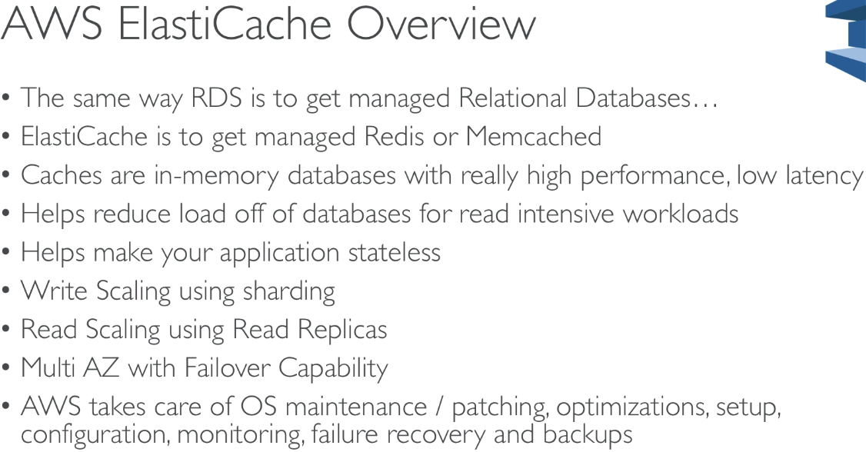

DB Cache:

* Cache hit
* Cache miss
  + Reads from DB
  + Writes to cache

Shared User Session Store:

* Write session
* Retrieve session

