CHAPTER 16: Essay Questions
1. A hormone is a biological compound used by multicellular organisms to organize, coordinate and control the functions of their cells and tissues with range of effects from metabolism and behavior.(Hormone - Definition, Function and Diseases | Biology Dictionary, n.d.).
Hormones fall into two major categories based on their chemical structure: peptides and steroid hormones. Majority of the hormones produced in the body are peptide in nature and circulate in the bloodstream in free form whereas steroid hormones are lipophilic and therefore need carrier proteins to reach the intracellular receptors(Russo-Picasso & Springer, 2023).
Membrane receptors are categorized as guanine-binding proteins, tyrosine kinase receptors and ion channel coupled receptors. Intracellular receptors bind to the DNA of the target genes and regulate transcription by interacting with other transcription factors (Russo-Picasso & Springer, 2023).
2. The pineal gland lies posterior to the midbrain the space known as the incisural space. It measures 5-10 mm and superior to it lies the splenium of the corpus callosum and the curving of the crura of the fornices on the anterior side and the pulvinar of the thalami on the lateral side(Shah et al., 2023).
Adrenal glands are located at the top of each kidney towards the front and each kidney weighs approximately 5 grams (Al-Suhaimi & Khan, 2022)
Parathyroid glands are four nodular structures occurring as a pair on each side, located on the posterior aspect of the thyroid gland with the fibrous capsule forming a thin border between the two(Sakr, 2022).
Pituitary gland is located within the sella turcica of the sphenoid bone near the center at the base of the cranium. It is made of two distinct regions called anterior and posterior lobes separated by an intermediate lobe between them(Prasanna & Kuzhali-Ganapathy, 2023).
3. Hormones stored in the posterior lobe of the pituitary gland:
- Oxytocin
- Antidiuretic hormone
4. Hormones secreted from adipose tissue and the skeleton:
- Leptin
- Angiotensinogen
- Adipsin
- Plasminogen activator inhibitor-1
- Adiponectin
- Osteocalcin
- Calcitonin
5. Major hormones released from adrenal cortex
- Aldosterone
- Cortisol
- Adrogens
- Estrogen
6. Mechanism of the renin-angiotensin-aldosterone system
The RAAS is a hormonal cascade critical for regulating blood pressure, fluid, and electrolyte balance. It begins with the secretion of renin by juxtaglomerular (JG) cells in the kidney, which is released in response to low renal perfusion, reduced NaCl delivery to the distal tubules, sympathetic stimulation, or feedback inhibition by angiotensin II (Ang II). Renin, produced from its precursor prorenin, cleaves angiotensinogen which is a protein primarily synthesized in the liver into the inactive decapeptide angiotensin I (Ang I).
Ang I is then converted to the potent vasoconstrictor angiotensin II (Ang II) by angiotensin-converting enzyme (ACE), predominantly located on endothelial cell membranes. Ang II increases blood pressure directly via vasoconstriction and indirectly by stimulating aldosterone release from the adrenal cortex, promoting sodium and water retention. Other Ang metabolites, such as Ang III, Ang IV, and Ang-(1-7), modulate blood pressure and tissue-specific effects. Overall, the RAAS maintains hemodynamic stability and electrolyte homeostasis through a tightly regulated enzymatic and hormonal network (Borregaard & Cowland, 2000).
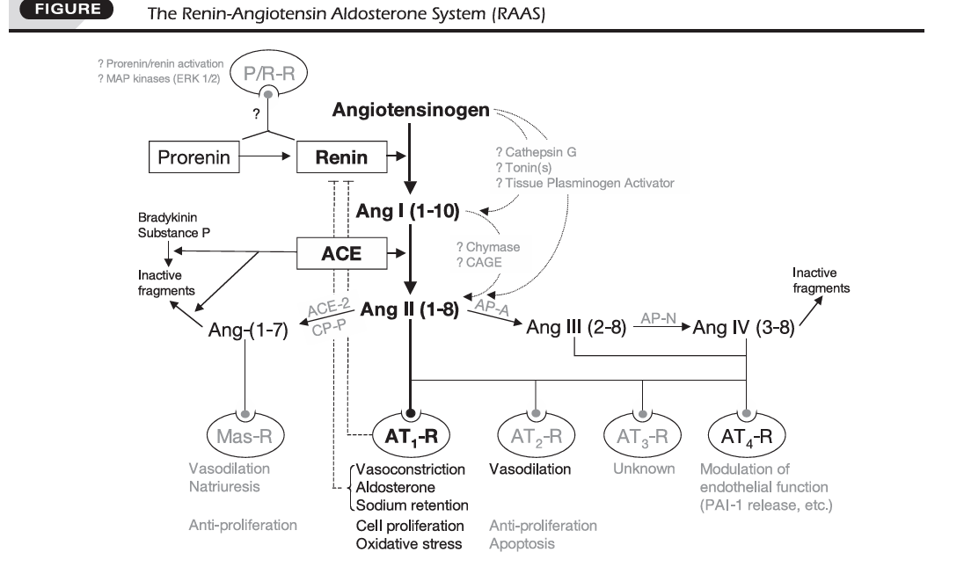
7. Explain the roles of insulin and glucagon on glucose in the blood.
Insulin and glucagon play complementary roles in regulating blood glucose levels. Insulin, secreted by the pancreatic β-cells, lowers blood glucose by promoting glucose uptake into cells, especially in muscle and adipose tissue, and by stimulating glycogen synthesis in the liver and muscles. It also inhibits glucose production by the liver and reduces the breakdown of glycogen, ensuring excess glucose is stored rather than left in the bloodstream.
In contrast, glucagon, secreted by the pancreatic α-cells, raises blood glucose levels, particularly during fasting or hypoglycemia, by stimulating glycogen breakdown (glycogenolysis) and glucose production (gluconeogenesis) in the liver. While insulin’s effect is to facilitate glucose storage and utilization, glucagon mobilizes stored glucose to maintain adequate blood sugar for energy needs. Together, they form a feedback system that maintains glucose homeostasis in the body (Samols et al., 2017.).
8. Describe how PRL and oxytocin affect the female reproductive system.
Prolactin (PRL) and oxytocin work together to support critical aspects of the female reproductive system, particularly during pregnancy, lactation, and maternal behavior. Prolactin, secreted from lactotrophs in the anterior pituitary. It plays a central role in preparing the mammary glands for milk production (lactogenesis) and maintaining milk secretion (galactopoiesis). Its release is normally under tonic inhibition by hypothalamic dopamine; however, stimuli such as suckling, mating, and rising estrogen levels can reduce dopamine input, allowing prolactin secretion to rise. During lactation, suckling triggers a rapid and sustained prolactin surge, which maintains milk synthesis for as long as the stimulus is present. After mating, prolactin surges help sustain progesterone secretion from the corpus luteum, which is essential for implantation and maintenance of early pregnancy. In cases of pseudopregnancy or sterile mating, prolactin surges still occur for a defined period, ensuring progesterone support even without conception.

Oxytocin, produced mainly in the hypothalamic paraventricular and supraoptic nuclei and released from the posterior pituitary, complements prolactin’s actions by facilitating milk ejection (let-down reflex) via contraction of myoepithelial cells in the mammary glands. It also induces uterine contractions during parturition and plays a role in maternal bonding and behavior. Oxytocin can also act as a prolactin-releasing factor by binding to oxytocin receptors on lactotrophs, initiating prolactin release through a calcium-dependent pathway. This dual role allows oxytocin to coordinate both milk release and the maintenance of prolactin secretion during lactation.
Together, prolactin ensures milk production and supports luteal function during early pregnancy, while oxytocin enables milk delivery and strengthens maternal behavior, making them essential partners in reproductive success and offspring survival (Kennett & Mckee et al., 2012).
9. Define and compare diabetes inspidus with diabetes mellitus.
Diabetes insipidus (DI) is a condition in which the kidneys are unable to concentrate urine, leading to the excessive excretion of large volumes of dilute urine (polyuria) and an intense feeling of thirst (polydipsia). This occurs either because the brain does not produce enough antidiuretic hormone (ADH) in the case of central or neurogenic DI, or because the kidneys do not respond properly to ADH in the case of nephrogenic DI. Blood glucose levels in DI are usually normal, and the urine does not contain glucose. The main complications arise from dehydration and electrolyte imbalances if fluid intake does not keep up with urinary losses.

Diabetes mellitus (DM), on the other hand, is a metabolic disorder characterized by persistently high blood glucose levels (hyperglycemia) resulting from either a lack of insulin production by the pancreas as in type 1. Or reduced responsiveness of the body’s cells to insulin combined with inadequate insulin secretion, as in type 2. Common symptoms include polyuria, polydipsia, polyphagia (increased hunger), weight loss in type 1 DM, fatigue, and blurred vision. Urine in DM is often concentrated and may contain glucose (glycosuria) when blood sugar levels exceed the kidney’s threshold for reabsorption. If uncontrolled, DM can lead to serious complications such as diabetic retinopathy, nephropathy, neuropathy, and cardiovascular disease (Bais et al., 2025).
10. Name two endocrine glands that are important in the body’s response to stress.
Adrenal glands : They release stress hormones such as cortisol, adrenaline (epinephrine), and noradrenaline (norepinephrine), which help mobilize energy, increase heart rate, and prepare the body for a fight or flight response(n.d.).
Pituitary gland: Also called the master gland, it secretes adrenocorticotropic hormone (ACTH), which stimulates the adrenal cortex to release cortisol during stress (Kennett & Mckee et al., 2012).

